**Steps for Installing .net application**

* Installation packages.
  + IIS server 7
  + .net framework 4.0
* The code package is available in –Use the back up one from the Production M3 servers
* Unizip the file and open xbox-restapi folder (the contants would be a bunch of dlls and webconfig)
* Create a Virutal directory called Xauth.univison.com in IIS
* Map it to the unzipped directory
* Restart the servers
* Add the following certificates to mmc
  + xbox-token-FullCert.pfx – change access permissions to every one
  + xauth.univision.com.pfx - change access permissions to every one
  + x_secure_token_service.xboxlive.com.cer
  + x_secure_token_service.part.xboxlive.com.cer
  + x_token_service.xboxlive.com

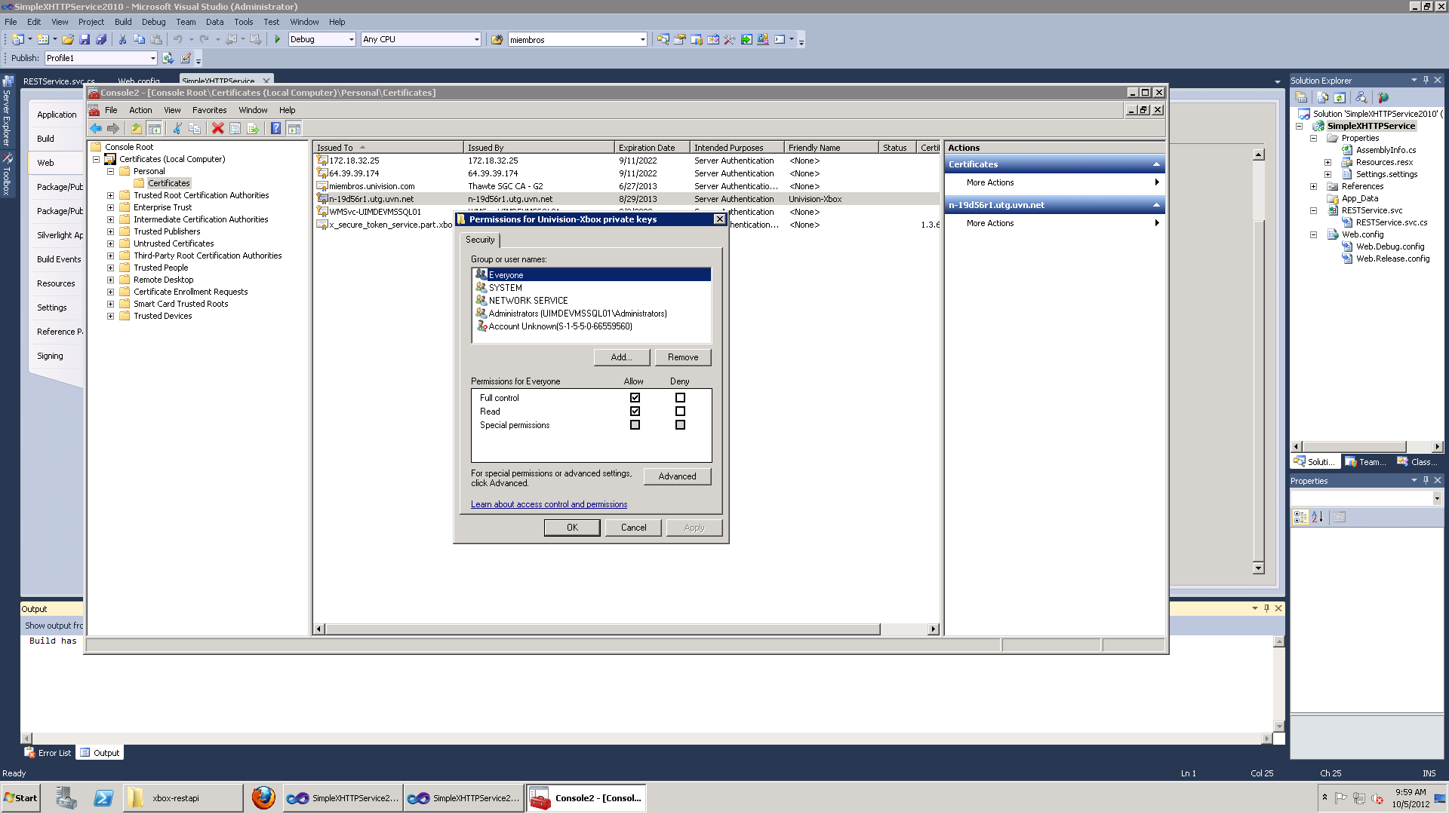

* Add Microsoft.IdentityModel.dll to the bin folder of the app if it’s not available

