Virtual Close Script

INTRO

Life Script: Hey (Client Name)?
(Client Name), it’s Easton calling you back about that request you had sent over for the discount life insurance quotes, I have (DOB/AGE) listed is that correct? And you are here in (X) state correct? (can confirm beneficiary or other info you have as well).

Ok perfect well I’m Easton, I’m the head underwriter assigned to figure out what you qualify for. Now obviously I got the life insurance request you sent over was it just for something smaller like 20,30, 40k or so or? For the mortgage?

WHY

Ok got it and do you have someone specific that would be in charge of handling all this when you pass? Like a main beneficiary? What’s the name and birthday? (find out of child or spouse etc).

Ok so short version is, if something happened to you, you are just trying to leave some financial help behind to keep any burden off of them? Ok understood.

Structure

Ok _____ my job is super easy, again I'm the underwriter for about 50 different insurance companies so i’m going to run through some suitability questions and then shop around to see who’s going to give you the most for the least.

Once we figure out what company to match you with, you will custom design your own plan and price, and then from there, I just take your information and send it to the insurance company as a request to make sure you get the green light on what you are asking for, does that sound easy enough? Ok great our job is just to try and get some kind of minimum offer so (beneficiary) will have some help instead of none. ok--

Now is this the best cell number for you? Email? **SEND STATE ID**

**This is where you offer your credentials to be emailed or texted or send a digital business card**

Ok perfect so let me confirm AGE ( jump into your suitability sheet).

Suitability – Fill out top down

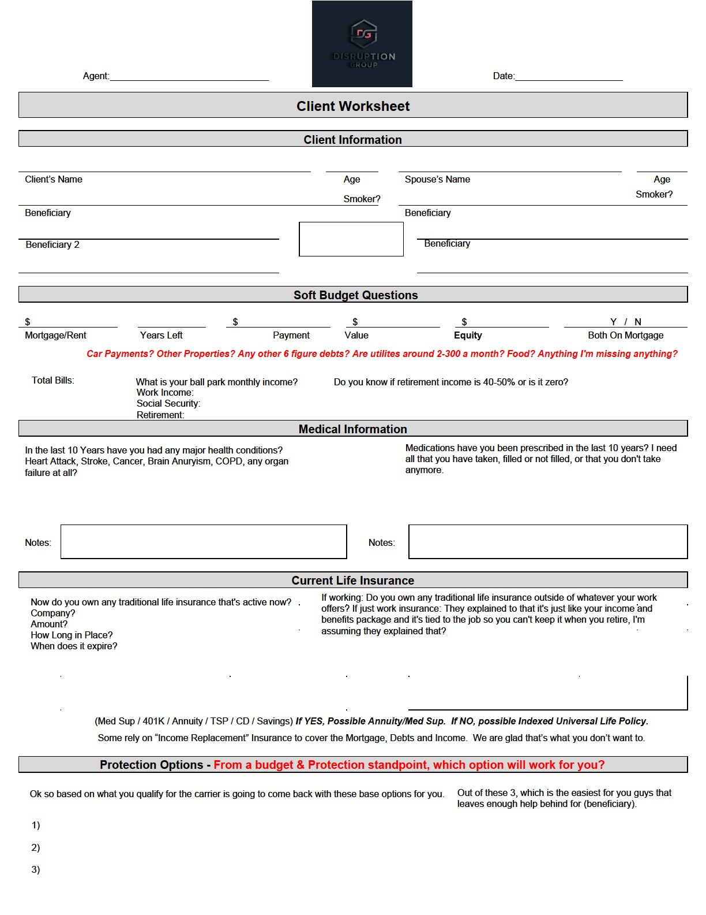

AFTER SUITABILITY IS COMPLETED: MAKE SURE YOU ARE CLEAR WITH WHATS NEXT:

Alright I’m going to do some quick shopping to get you paired up correctly, now you did get my text and email with my state ID correct? Perfect now John do you know how this works? Basically it’s the same process as last time you bought insurance: OR if first time buyers: Have you bought a car at the dealership before? Ok so they will ask you for all the same information except they don’t do the credit check part which is nice. They will grab your drivers license, address, DOB, Social, bank you’re going to use to pay, and your beneficiary info so I want to make sure you have access to that info because they ARE going to ask for it. (confirm). Ok great and you are all good letting me help send that in correct? Ok give me a couple of short minutes here and I’ll pull your rates up.

Presentation

**always bottom up sell**

Ok so it looks like your baseline recommendations from the insurance company are going to start with:

20K- $/mo
30K-$$/mo
40K- $$$/mo

Closing Statement:

Now out of these three which is the easiest place for you to start that leaves enough help behind for (beneficiary name)?

