

**Diverse Makers**

**User Manual**

*Version 1.0*

12-13-2024

**Project Sponsor: Dr. Jared Duval**

**Faculty Member:** Isaac Shaffer

**Project Mentor:** Vahid Nikoonejad Fard

**Team members:  
Daniel Minichetti (Team Lead)**

**Kane Davidson**

**Eduardo De La Rosa**

**Elleana Negrelli**

**Aaron Ramirez**

**Overview**

In this document, we outline the comprehensive installation, configuration, maintenance, and troubleshooting procedures for the Diverse Makers application, a mobile platform designed to connect individuals with disabilities to makerspaces and STEM learning resources.

**Table of Contents**

**1.0 INTRODUCTION 2**

**2.0 INSTALLATION 2**

2.1 Environment Prerequisites 3

2.1.1 Hardware Requirements 3

2.1.2 Software Requirements 3

2.1.3 Development Tools Installation 4

2.2 Required Packages 4

2.2.1 Repository Setup 4

2.2.2 List of Required Dependencies 5

2.3 Running the Application 8

2.4 Firebase Configuration 9

2.4.1 Initial Setup 9

2.4.2 Environment Variables 9

2.4.3 Verification Steps 9

**3.0 CONFIGURATION AND DAILY OPERATION 10**

3.1 Application Daily Operation 10

3.2 Application Walkthrough 11

3.2.1 User Authentication 11

3.2.2 Main Interface Navigation 12

3.2.3 Content Management 13

3.2.4 Accessibility Features Configuration 14

**4.0 MAINTENANCE 15**

4.1 Firebase Management 16

4.2 Application Package Updates 16

**5.0 TROUBLE-SHOOTING 16**

5.1 Setup Issues 16

5.2 Development Server 17

**6.0 CONCLUSION 17**

## 

## 1.0 INTRODUCTION

Our Diverse Makers application aims to bridge a critical gap in STEM education by connecting individuals with disabilities to maker spaces and STEM learning resources. With over 40 million Americans having a disability and only 3% representation in the STEM workforce, our mobile application serves as a centralized platform for sharing accessible STEM content and fostering connections between users and maker spaces.

Our primary goals include providing an accessible user interface for multiple disabilities, secure hosting of STEM learning resources, and facilitating connections with local maker spaces through features such as location-based maker space discovery. The application will be built using React Native for the front end implementation and Firebase for back end services, ensuring cross-platform compatibility and real-time data synchronization. It will also enable users to create an account, access and contribute to guides for STEM activities using a block-based interface, and customize their experience with intuitive accessibility settings.

Meeting the needs of the Diverse Makers application is vitally important to ensure we can increase STEM learning outcomes. The purpose of this user manual is to allow our client to successfully install, maintain, and troubleshoot the final version of the Diverse Makers application. Our aim is to ensure our client can smoothly navigate the transition of the application to another team, for future development purposes.

## 2.0 INSTALLATION

This section will provide instructions on setting up the toolchain for our application. With the instructions below, one can successfully set up our application to run on both Android and IOS devices. The following processes for running the application are in the following section, with each instruction being demonstrated on the terminal for a MacOS machine, but can be performed with equivalent terminal commands on the Windows 10 machine as well.

### 2.1 Environment Prerequisites

Before installing the Diverse Makers application, ensure your system meets the following requirements:

#### 2.1.1 Hardware Requirements

The following hardware requirements are necessary to successfully run our application on your device:

* Minimum 2 GB RAM (4GB is recommended for a smooth experience)
* 100MB of available storage space on device
* Stable internet connection

#### **2.1.2 Software Requirements**

To set up the environment for the Diverse Makers application, a user must ensure they have the following software installed:

* **Node.js**
  + The version of Node.js used for the development of our application was **v22.9.0**, although we anticipate that using the latest version will continue to work in the future.
  + Node.js can be installed via homebrew, a packet manager, on MacOS. An installation of Node.js can be done on Windows by visiting the official website, <https://nodejs.org/en>, and downloading the installer then running it in the setup wizard.
* **Expo CLI**
  + Running the version of Node.js just installed, the Expo CLI can be installed via the terminal with the command: **npm install**. This will install the required dependencies to run the application
* **Expo Go**
  + To run our application, Expo Go, a limited sandbox for app development, will need to be downloaded on your mobile device via the Google Play Store or Apple App Store. Alternatively, the app can be compiled for iOS or Android when you’re ready for deployment.
  + The mobile device with the Expo Go app installed will also need to be on the same local development server as the machine being used to run the application.

#### 2.1.3 Development Tools Installation

The following development tools can be installed using the following instructions based on your machine and operating system:

* **Node.js Installation**
  + **MacOS:** Install with homebrew
    - Run the following command into the terminal: **brew install node**
  + **Windows:** Download installer from official Node.js website
    - Visiting the following website: <https://nodejs.org/en>
* **Expo CLI Installation**
  + Installing the Expo CLI through the terminal for required dependencies
    - Run the following command into the terminal: **npm install --global expo-cli**
* **Expo Go Installation**
  + **IOS:** Download from the Apple App Store
  + **Android:** Download from the Google Play Store

**Note:** Your mobile device must be on the same local network as your development machine.

### 2.2 Required Packages

The required packages and setup steps needs to be completed to get our application up and running:

#### **2.2.1 Repository Setup**

1. **Clone the repository:**
   1. Link to project repository: <https://github.com/aaronr7734/Diverse-Makers>
      1. This address will change once the handoff of the project is complete
   2. Run the following command to clone the project repository: **git clone https://github.com/aaronr7734/Diverse-Makers**
      1. The downloaded files will be within the file system and directory of choice
   3. Enter the repository and change directories into the DiverseMakersApp folder with the following command: **cd DiverseMakersApp**
      1. This folder houses the main application files and packages
2. **Install dependencies:**
   1. Once here, run the **npm install** command into the command line to retrieve the required packages and dependencies for the project.

**Note:** Reference the troubleshooting section of this document if any warning or errors occur during this process.

#### 2.2.2 List of Required Dependencies

The complete list of dependencies can be found within the application’s package.json file located in the root directory of the DiverseMakersApp folder. Please ensure the following dependencies are correct within this file by referencing the complete list of dependencies below:

{

"name": "diversemakersapp",

"main": "expo-router/entry",

"version": "1.0.0",

"scripts": {

"start": "expo start",

"reset-project": "node ./scripts/reset-project.js",

"android": "expo start --android",

"ios": "expo start --ios",

"web": "expo start --web",

"test": "jest --watchAll",

"lint": "expo lint"

},

"jest": {

"preset": "jest-expo"

},

"dependencies": {

"@expo/vector-icons": "^14.0.2",

"@react-native-firebase/app": "^21.0.0",

"@react-navigation/stack": "^7.0.0",

"expo": "^52.0.17",

"expo-constants": "~17.0.3",

"expo-font": "~13.0.1",

"expo-linking": "~7.0.3",

"expo-router": "~4.0.11",

"expo-secure-store": "~14.0.0",

"expo-splash-screen": "~0.29.16",

"expo-status-bar": "~2.0.0",

"expo-system-ui": "~4.0.5",

"expo-web-browser": "~14.0.1",

"firebase": "^10.14.0",

"ios": "^0.0.1",

"metro": "^0.81.0",

"react": "18.3.1",

"react-dom": "18.3.1",

"react-native": "0.76.3",

"react-native-gesture-handler": "~2.20.2",

"react-native-get-random-values": "^1.11.0",

"react-native-paper": "^5.12.5",

"react-native-reanimated": "~3.16.1",

"react-native-safe-area-context": "4.12.0",

"react-native-screens": "~4.1.0",

"react-native-web": "~0.19.10",

"uuid": "^10.0.0"

},

"devDependencies": {

"@babel/core": "^7.20.0",

"@types/jest": "^29.5.12",

"@types/react": "~18.3.12",

"@types/react-native-vector-icons": "^6.4.18",

"@types/react-test-renderer": "^18.0.7",

"@types/uuid": "^10.0.0",

"jest": "^29.2.1",

"jest-expo": "~52.0.2",

"react-test-renderer": "18.2.0",

"typescript": "~5.3.3"

},

"private": true,

"resolutions": {

"glob": "^9.0.0"

}

}

### 2.3 Running the Application

After successfully installing all dependencies via npm install, you can launch the application using the following command:

* Run command into terminal: **npx expo start**

This command will start the development server and display a QR code in your terminal. You have several options for running the app at this point:

* **Mobile Device:**
  + Scan the QR code using the Expo Go app on your iOS or Android device
* **iOS Simulator:**
  + Press 'i' in the terminal to launch in an iOS simulator
* **Android Emulator:**
  + Press 'a' to launch in an Android emulator
* **Web Browser:**
  + Press 'w' to launch in your default web browser

**Note:** When using a mobile device, ensure it's connected to the same local network as your development machine.

### 2.4 Firebase Configuration

The application requires the Firebase configuration to function properly, follow the next steps to get the database configured:

#### 2.4.1 Initial Setup

The Firebase database can be configured by follow these steps:

1. Create a new **.env** file in the root of the DiverseMakersApp directory

2. Access the Firebase Console: <https://console.firebase.google.com/>

3. Create a new project or select your existing project

4. Navigate to Project Settings > General

5. Under “Your apps”, find your Firebase configuration object

#### 2.4.2 Environment Variables

Now, add the following variables to your **.env** file:

* FIREBASE_API_KEY=your_api_key
* FIREBASE_AUTH_DOMAIN=your_auth_domain
* FIREBASE_PROJECT_ID=your_project_id
* FIREBASE_STORAGE_BUCKET=your_storage_bucket
* FIREBASE_MESSAGING_SENDER_ID=your_messaging_sender_id
* FIREBASE_APP_ID=your_app_id
* FIREBASE_MEASUREMENT_ID=your_measurement_id

Replace each value with the corresponding value from your Firebase configuration. These credentials are essential for the app to communicate with Firebase services so keep them in a secure place.

**Note:** The **.env** file should never be committed to version control as it contains sensitive information.

#### 2.4.3 Verification Steps

After installation verify the following tasks to ensure the application is running properly:

1. Application launches without errors
2. Firebase connection is established
3. Authentication system works
4. Real-time updates to the database

## 3.0 CONFIGURATION AND DAILY OPERATION

The following section covers the daily operation of the Diverse Makers application, illustrating the configuration from the command line and an Apple mobile device running IOS 18 via the Expo Go application. A comprehensive walkthrough of the application will also be demonstrated with screenshots of the application’s functionality.

### 3.1 Application Daily Operation

Follow the required steps to get the app running from a local version of the source code. The following instructions were carried out through the terminal on a MacOS machine but can be performed with an equivalent operating system.

1. Change into the correct directory, this should be **DiverseMakersApp** folder within the root directory
2. Enter the npx expo start command to build and set up the code for successful execution. You should see the following output from this command:

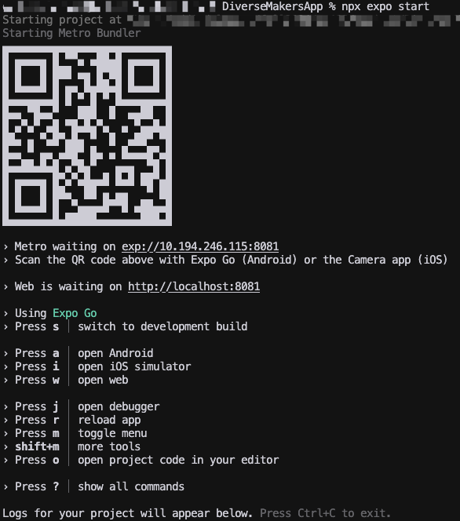

1. From here scan the QR code from your camera app and you will be taken to the Expo Go application which will connect to the same network as the PC running the terminal window and start the Diverse Makers Application.

### 3.2 Application Walkthrough

This section will detail a walkthrough of the app starting from the login screen which appears after starting the application from the terminal.

#### 3.2.1 User Authentication

1. **Login Screen**
   * Enter email and password
   * Option to create new account
2. **Account Creation**
   * Enter required information:
     + Email address
     + Password (minimum 8 characters)
   * Optional profile information:
     + Username
     + Disability Tag

#### 3.2.2 Main Interface Navigation

1. **Home Screen**

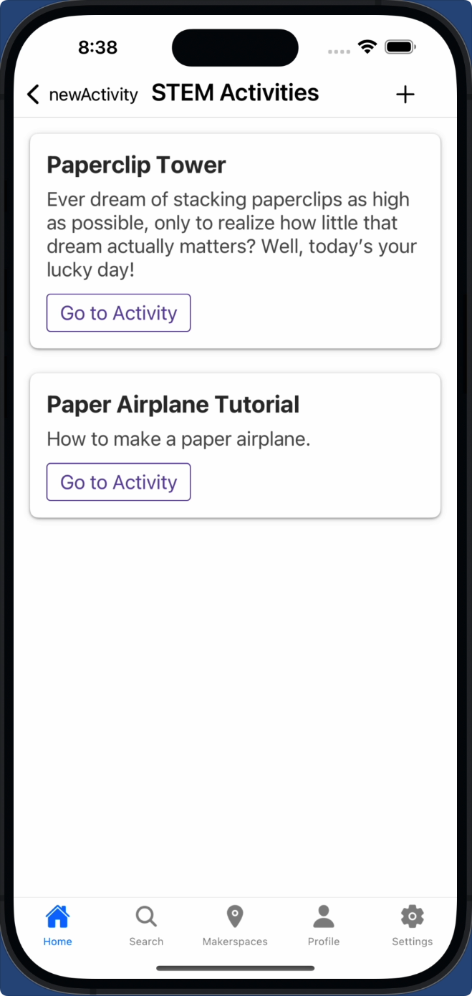

* + Browse STEM resources feed on Homepage
  + Add a new activity to your Homepage

1. **Profile Management**
   * Edit personal information
   * Customize accessibility preferences:
     + Font size adjustment
     + High contrast mode
2. **Makerspace Discovery**

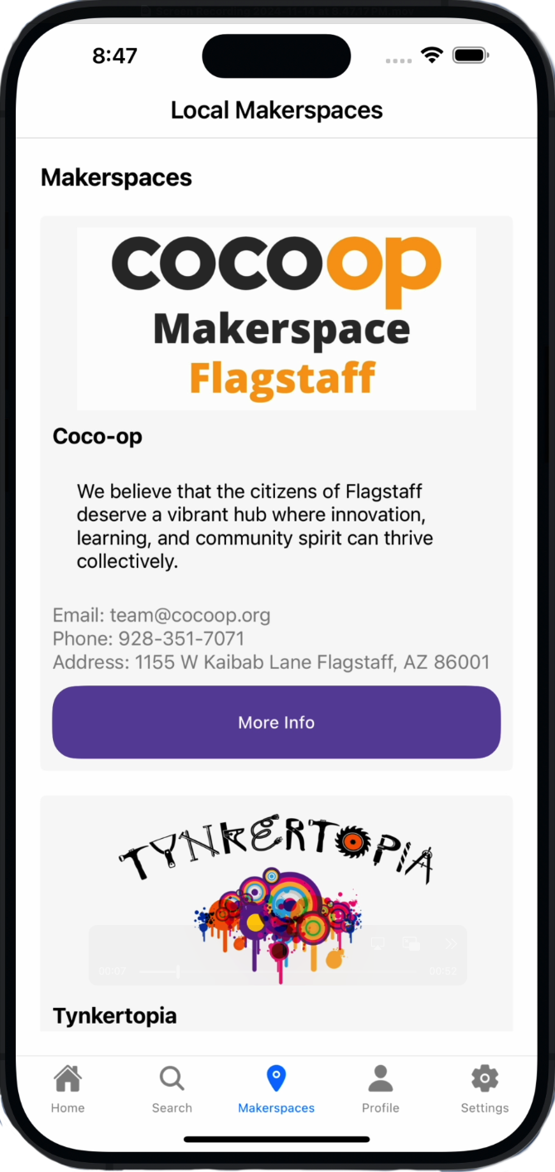

* + View nearby makerspaces
  + Access makerspace profiles

#### 3.2.3 Content Management

1. **For Users and Makerspaces**

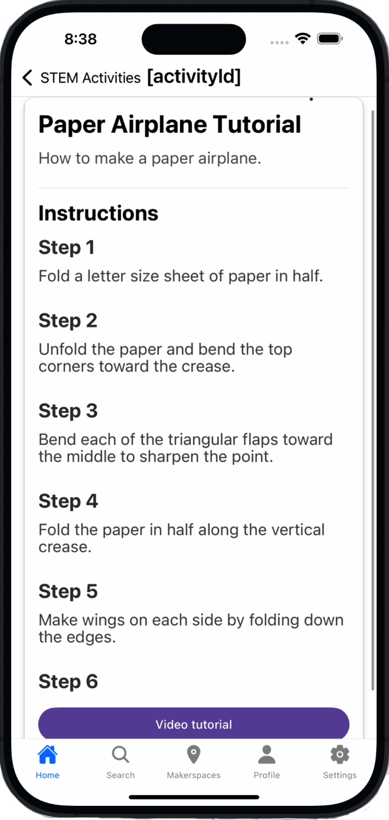

* + Browse STEM resources
  + Upload new STEM resources
  + Manage existing content

#### 3.2.4 Accessibility Features Configuration

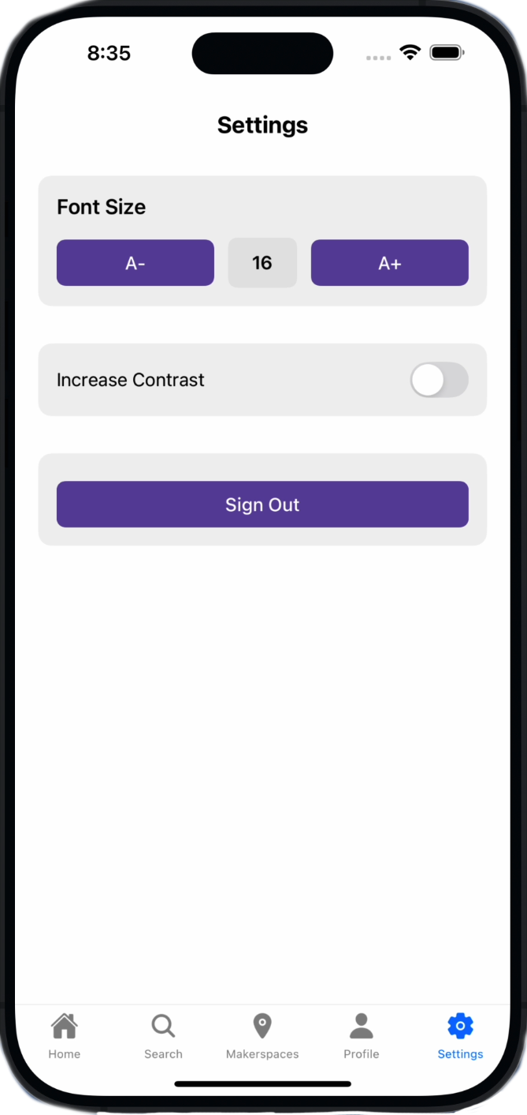

1. **Font Size Adjustment**
   * Access through Settings menu
   * Dynamic Scaling for your preference
   * Preview text while adjusting
2. **High Contrast Mode**
   * Toggle in Settings
   * Enhanced readability option

## 4.0 MAINTENANCE

The next section of our application will walk you through maintaining the Diverse Makers application based on its current state.

### 4.1 Firebase Management

The application's data is stored in Firebase, which handles its own backup and maintenance procedures. We recommend periodically monitoring your Firebase usage and quotas through the Firebase Console to ensure the application continues running smoothly.

### 4.2 Application Package Updates

The application relies on various npm packages that will require updating over time. When updating packages:

1. Create a new branch in your repository before making changes

2. Run npm outdated to check for available updates

3. Test the application thoroughly after any package updates

**Note:** Since the application uses Expo Go for development, maintaining compatibility with their latest SDK may require additional package updates over time. We recommend testing any major updates in a separate branch before deploying them.

## 5.0 TROUBLE-SHOOTING

This section will cover the comprehensive troubleshooting for common issues one might face while setting up and running the Diverse Makers Application.

### 5.1 Setup Issues

If you encounter issues during initial setup:

* Ensure all prerequisites (Node.js, Expo CLI) are at their required versions
* Verify your .env file contains all required Firebase configuration variables
* Confirm your development machine and mobile device are on the same network when using Expo Go
* Check that all dependencies were installed correctly by running npm install again

### 5.2 Development Server

If the development server (npx expo start) isn't working as expected, attempt the following steps:

* Try clearing the Metro bundler cache (npx expo start -c)
* Ensure no other instances of the development server are running
* Verify your mobile device has Expo Go installed and is on the same network
* Check your terminal for any error messages that might indicate specific issues

## 6.0 CONCLUSION

We at Team Diverse Makers are proud to deliver this application into your hands. Throughout its development, our focus has remained steadfast on making STEM education more accessible to everyone. We hope that the Diverse Makers platform will serve as a valuable tool in breaking down barriers and creating more inclusive STEM learning experiences. The application we've created, while fully functional, is just the beginning. We've laid a foundation that we hope will continue to grow and evolve under your guidance. The codebase has been structured with future development in mind, making it easier to add new features and capabilities as needs arise. Our team is excited to see how the Diverse Makers platform will contribute to making makerspaces and STEM activities more accessible. We believe that everyone deserves the opportunity to explore, create, and learn in ways that work best for them. We wish you the best as you continue to advance the mission of making STEM accessible to all.