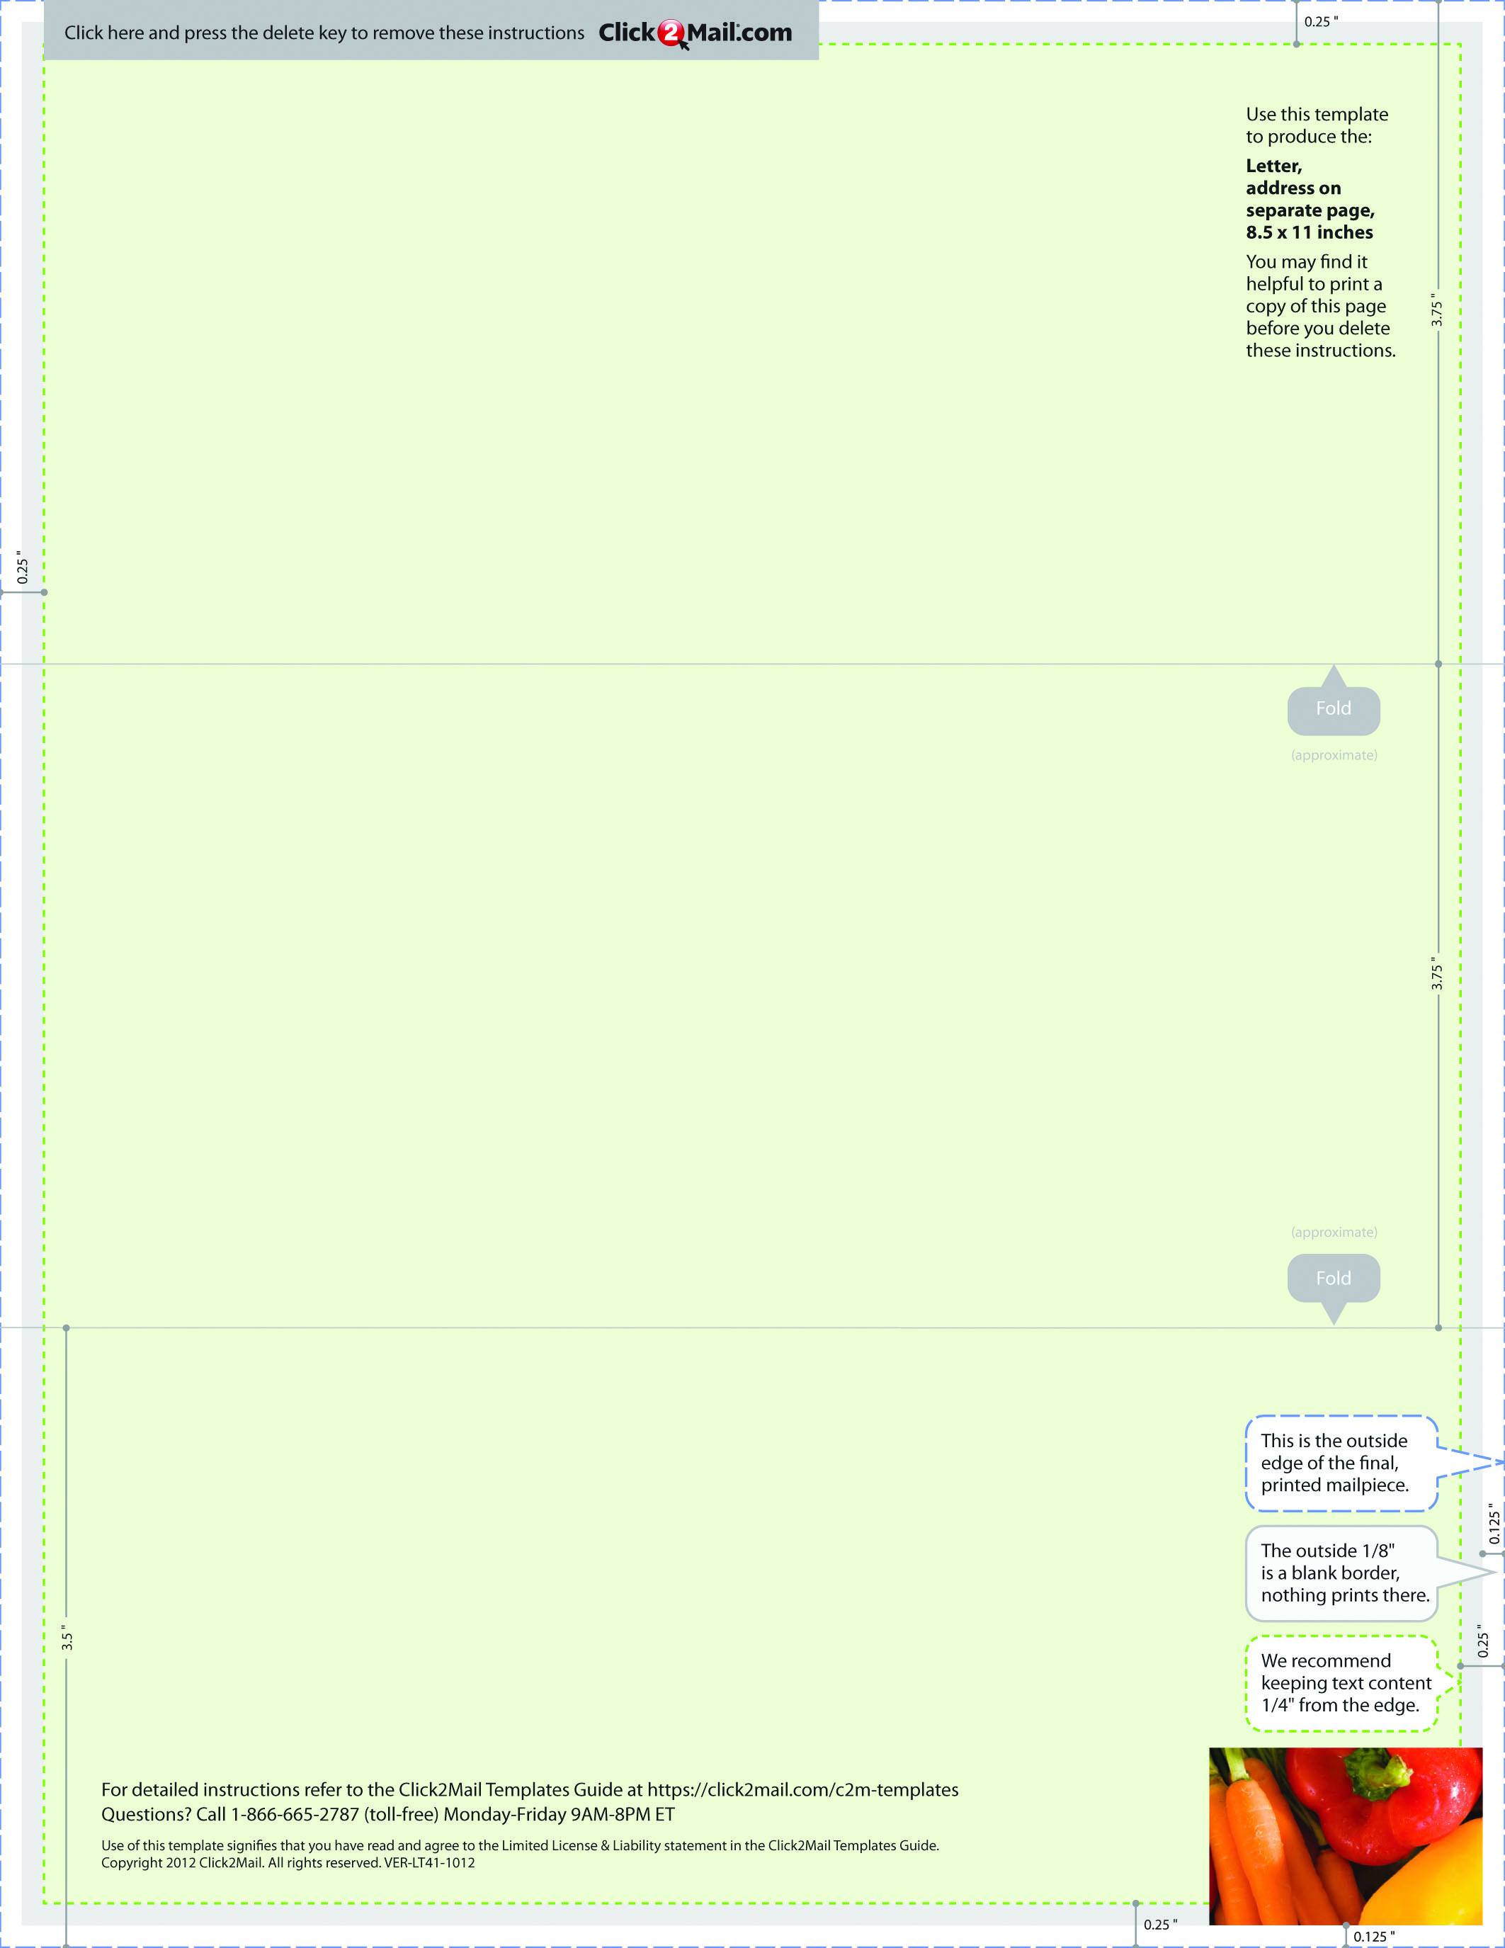

Placeholder text... Replace this placeholder text with text of your own. Use Click2Mail.com

to print, finish, post, and deliver your mailpieces quickly and economically. Click2Mail.com

makes it easy to design brilliant, full-color, affordable postal mail without permits, sorting,

stamps, or trips to the Post Office. How does it work? We use a network of strategically

located, high-quality printers to print, prep, and sort large volumes of mail daily. That

network and our understanding of strict postal requirements allows your mailpiece to

receive optimal handling and delivery. You benefit from high volume processing without setup fees or minimum quantities.