

BSc. Software/Multimedia Year 3

IPCV - Image Processing and Computer Vision

Automated Passport Photo Taking with Computer Vision

A03 - Home Assignment

Assignment Guidelines

This assignment is a home assignment that is to be completed by end of Monday 20th January 2020.

Some parts of the assignment require a certain amount of research to be completed successfully. It is entirely your responsibility to do so.

Assignments without a proper bibliography will not be accepted.

The College operates a cheating/plagiarism policy and any copied work will be penalized according to this policy.

All the institute procedures rules and regulations apply to this assignment.

At the end of the assignment you should submit the following in one Moodle submisssion:

- Document with Research tasks. (append any references at the end)
- Project Solution (zipped including source code and any data sets used)

Project Background

Identity Malta has strict requirements regarding the provision of photographs for passports. Hereunder is a list of the most important visual requirements for passport photographs to be accepted.

- The photos must be in colour;
- The photos should measure 40mm(H) x 30mm(W) (3:4 aspect ratio);
- The photos should portray a close-up of the applicant’s head and the top of his/her shoulders;
- The face should take up 70-80% of the vertical dimension of the photograph;
- The head of the person being photographed should not be tilted up, down or to the side, but centred.
- The photos need to be in sharp focus
- The photos need to show the applicant looking directly towards the camera, portraying his/her neutral expression. (Mouth closed);
- The photos should have the appropriate brightness and contrast, showing the person’s natural skin tone;
- The photos shall show the applicant with his/her eyes open and clearly visible;
- Normal glasses are acceptable but the eyes must remain visible;
- The applicant needs to look facing square to the camera, not looking over one shoulder (portrait style);
- The head should be upright so that an imaginary horizontal line drawn between the centres of the eyes may be parallel to the top edge of the picture;
- Both edges of the face shall be clearly visible;

The officers processing the applications frequently encounter lack of adherence to the guidelines. Moreover, prospective applicants find it difficult to take their own photographs in adherence to the regulations. To address these problems, you are being engaged on a project to develop an application with the following deliverables:

- Input a video stream or open a webcam live feed.
- Recognise conditions required for a good photograph.
- Save properly sized passport photos to disk if facial requirements are being met.

Task 1 – Prepare the scenario

- Create a new project within your Python+OpenCV environment. You are free to use any distribution, but for convenience you may wish to follow the instructions to set up a container environment supplied at: https://moodle.mcast.edu.mt/pluginfile.php/110226/mod_resource/content/1/Setup%20Python%20with%20OPENCV.pdf

- You are free to use either a pre-recorded video stream or a webcam. The webcam solution offers the advantage of allowing realtime processing, with the user able to adjust to the requirements.

a. Research and explain two useful geometric transformations.
b. Identify one geometric transformation which is required to extract a face from a webcam live feed and save it as a 3:4 image.

KU6 - Discuss the effects of geometric transformations on images
 | Maximum | Awarded
3a. Geometric transformation 1  (1 mark for choice, 1 mark for explanation) | 2
3a. Geometric transformation 2  (1 mark for choice, 1 mark for explanation) | 2
3b. Correct choice of transformation from live feed to 3:4 photo | 1
Total | 5

Task 2 – Research face detection and facial landmarks.

SE2 -Evaluate and research possible scenarios for the application of object detection and tracking algorithms

- Three popular algorithms for facial landmarks (features) detection are:

  - Haar cascades.
  - Histogram of Oriented Gradients. (HOG)
  - Convolutional Neural Networks using dlib.

Research each of the above detection mechanisms and write down:

  - A brief definition of each method.
  - One advantage and one disadvantage of each.
  - Choose a one of the above methods to implement facial landmarks detection for the passport photo project and justify your answer.

SE2 -Evaluate and research possible scenarios for the application of object detection and tracking algorithms
 | Maximum | Awarded
4a. Explanation of each method (1 mark each) | 3
4b. One advantage and one disadvantage of each method. | 6
4c. Justification of method chosen for project. | 1
Total | 10
Task 3 – Detect and save face as a 3:4 image.

AA4 - Develop and test an algorithm which involves the use of geometric transformations

- Research and implement an algorithm to:

  - Detect the presence of a face.

  - Draw a bounding box around the face.

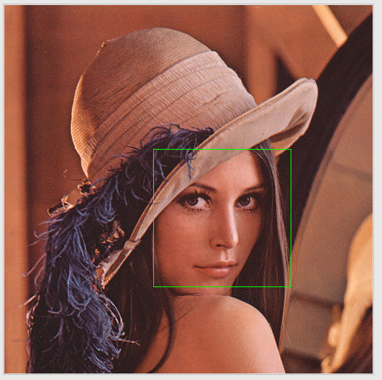

  - Enlarge the bounding box transform width by 1.5x and height by 2x to include the whole head and part of the shoulders.

  - Check that the aspect ratio of the bounding box is approximately 3:4.

  - Crop and save a copy of the frame when the user presses SPACEBAR.

AA4 - Develop and test an algorithm which involves the use of geometric transformations
 | Maximum | Awarded
Detect face | 2
Draw bounding box | 1
Resize bounding box (1 mark for partially correct resizing) | 2
Save 3:4 image to disk  (1 mark for correct aspect ratio, 1 mark for save) | 2
Total | 7

Task 4 – Research face feature finding algorithms.

KU7 - Discuss the relevance of edge-finding and feature-finding algorithms

- Investigate algorithms that perform the following:

  - Eye open/ close or eye-blink detection.
  - Mouth open or close detection.
  - Focus detection.
  - Head- pose detection. (Rotation, head direction)

Research each of the above face feature/tracking detection mechanisms and write down a brief description of each algorithm.

KU7 - Discuss the relevance of edge-finding and feature-finding algorithms
 | Maximum | Awarded
Eye open/close or eye-blink detection | 1
Mouth open/close detection. | 1
Focus detection. | 1
Head-pose detection. (1 mark for head direction, 1 mark for rotation) | 2
Total | 5

Task 5 – Create a working AI passport photo taking application

SE1 - Compare algorithms that can be used for feature / corner detection
SE3 - Combine algorithms in order to create a working object recognition application

- Implement the algorithms discussed in Task 4 to create the passport photo taking application implementing the following features:

  - Head looking straight towards camera.
  - Face not tilted/rotated.
  - Eyes open.
  - Mouth closed.
  - Good focus.

SE1 - Compare algorithms that can be used for feature / corner detection
 | Maximum | Awarded
7a. Head looking straight towards camera | 2
7b. Face not tilted/rotated | 2
7c. Eyes open | 2
7d. Mouth closed | 2
7e. Good focus | 2
Total | 10

- For each algorithm in Question 7. generate output values (in appropriate variables) for head-pose/rotation, eyes/open closed, mouth open/closed and focus.

- Display output values or TRUE/FALSE for head-pose, rotation, mouth open/close, eyes open/closed and focus. You may also draw points, circles/boxes to identify head pose/rotation, eyes and mouth.

- Use output values in a condition to decide whether to save a photo or not.

- For a positive result you may do on of the following:

  - Indicate a positive match, automatically save a 3:4 image to disk, and wait 3 seconds before continuing.

  - Indicate a positive match, freeze image and allow user to press SPACEBAR to save or press ‘c’ to skip save and continue.

SE3 - Combine algorithms in order to create a working object recognition application

 | Maximum | Awarded
8a. Output values for head pose, eyes, mouth and focus  (1 mark each) | 4
8b. Display output values on screen. (0.5 mark each) | 2
8c. Correct positive match according to set passport photo requirements. (1 mark if partially correct) | 2
9. Output of positive matches to disk  (1 mark for save operation, 1 mark for correct image requirements and format) | 2
Total | 10

