Urban forest wildfires in New York City drive dramatic shifts in understory plant, pollinator and soil microbial communities
Sexton et al.
Supplemental Files

Supplemental File 1 – Total understory vegetative cover in burned and unburned subplots across the growing season.
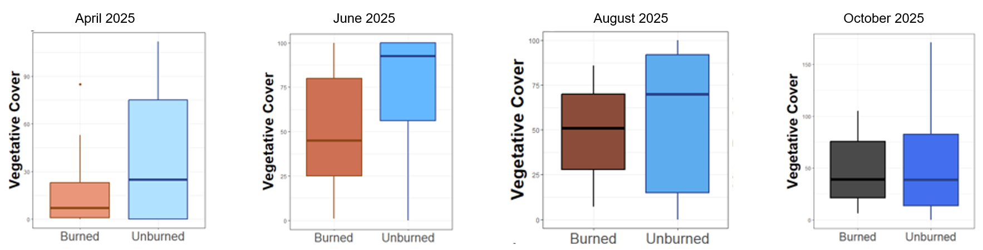
Supplemental File 2 – Full season species pools in burned and unburned forests across the two parks.
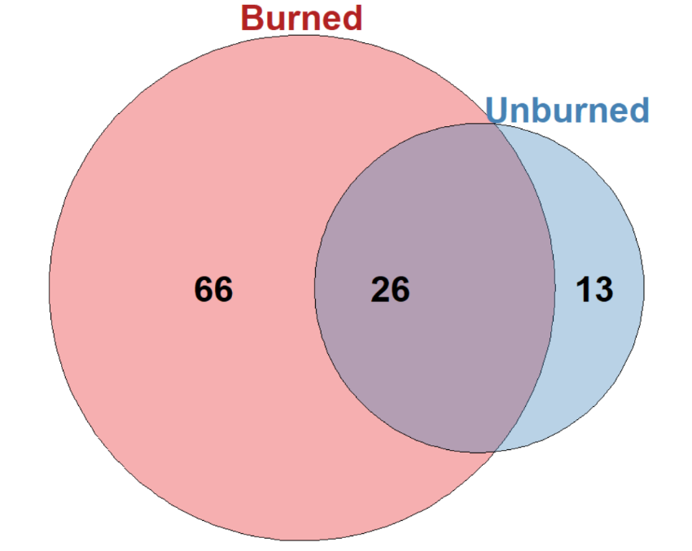
Supplemental File 3 – Litter mass (fresh & dried) in burned and unburned forests. Burn units separated.
