Certified ground-state filtering from DMRG trial states — pipeline overview
J1–J2 Heisenberg chain · Stetcu–Baroni projection · what we built, what we proved, what it costs

0. One-paragraph summary
We want the ground state $|E_{0}⟩$ of the open spin-½ $J_{1}$–$J_{2}$ chain on a quantum computer. DMRG (classical) gives a matrix-product state (MPS) that we compile into a shallow circuit; that circuit has ground-state weight $γ<1$. We repair it with the Stetcu–Baroni–Carlson (SBC) projection: a single ancilla, controlled time evolution, and post-selection implement a filter FE=i​cosEti+ϕi that suppresses excited states. We optimise the filter classically, certify how well it suppresses the spectrum, and control the Trotter error three ways (certified, hybrid, oracle). Result: the mathematics is sound and verified, the rigorous guarantee is ${10}^{2}$–${10}^{3}×$ more conservative than reality, a hybrid protocol recovers most of that gap — but for $N≤12$ an MPS-based circuit is still 5–74× cheaper than the filter, so no resource advantage on these 1D chains. The value is the certified-filtering method and its verification harness.
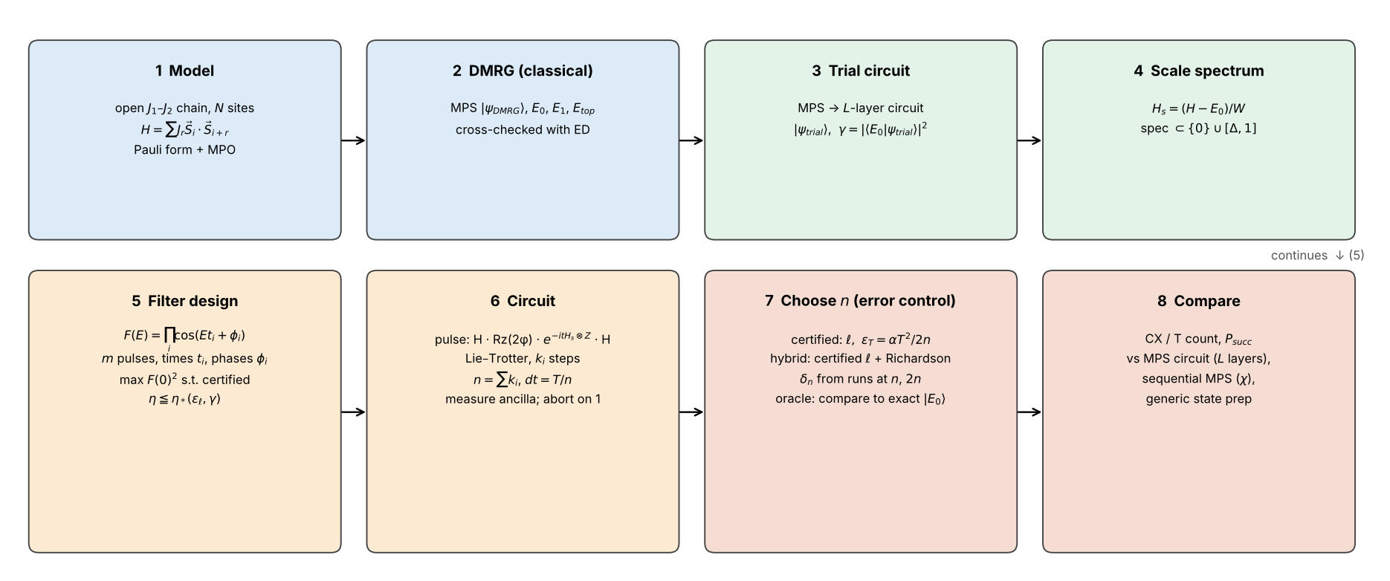
Pipeline

1. The problem and the physics
Symbol | Meaning
$N$ | number of spins (even; open boundaries)
$J_{1},J_{2}$ | nearest / next-nearest-neighbour couplings; we use $J_{1}=1$, $J_{2}∈\{0, 0.2411, 0.4, 0.5\}$
$H$ | i​J1 Si​⋅​Si+1+i​J2 Si​⋅​Si+2, with $S_{i}​⋅​S_{j}=1/4\left(XX+YY+ZZ\right)$ → $3\left(N−1\right)+3\left(N−2\right)$ Pauli terms
$E_0,\,E_1,\,E_{\rm top}$ | ground, first-excited and highest energy
gap | $E_{1}−E_{0}$ (a triplet; shrinks like $1/N$ near criticality)
$J_{2}=0.5$ | Majumdar–Ghosh point: the ground state is a product of dimers, exactly representable by one circuit layer ⇒ $γ=1$ (a sanity check, not a benchmark)
The ground state is a non-degenerate singlet for even $N$, the Hamiltonian conserves total spin, and every bond exponential $e^{−iθ S_{i}⋅S_{j}}$ is SU(2)-symmetric — this matters later for symmetry-resolved certification.

2. Stage by stage

Stage 1–2: Hamiltonian and DMRG (classical)
- hamiltonians.py builds the Pauli form (for circuits and ED) and the MPO (for DMRG); check_mpo_matches_pauli verifies they agree to ${10}^{−9}$.
- get_energies.py runs two-site DMRG (bond dims $\{8,16,32,64,64\}$, cutoff ${10}^{−10}$) for $E_{0}$ and the MPS $|\psi_{\rm DMRG}\rangle$; DMRG on $−H$ gives $E_{\rm top}$; DMRG on $H+λ\left|ψ_{0}⟩⟨ψ_{0}\right|$ with $\lambda=1.1\,(E_{\rm top}-E_0)$ gives $E_{1}$ (penalty method).
- Cross-check against exact diagonalisation (ED): DMRG matches $E_0,E_1,E_{\rm top}$ to $≲2×{10}^{−9}$ up to $N=16$.
- Caveat that drives the certification discussion: DMRG gives estimates, not bounds. The penalty-method $E_{1}$ is variational ($≥$ true), i.e. on the unsafe side if used as a gap lower bound.

Stage 3: trial circuit
- mps_to_circuit (qiskit-community mps-to-circuit) compiles the MPS to an $L$-layer brickwork circuit of two-qubit isometries (method="approximate"); the "exact" method is a sequential (Schön et al.) preparation of an MPS with bond dimension $χ$.
- $\gamma=|\langle E_0|\psi_{\rm trial}\rangle|^2$ is the ground-state weight of the trial state. It is what the filter must repair ($1−γ$ is the “error to remove”). On the certified path $γ$ is computed against the ED ground state (exact for $N≤12$).

Stage 4: scaling the spectrum
$$H_s=\frac{H-E_0}{W},\qquad W\ge E_{\rm top}-E_0,\qquad \operatorname{spec}(H_s)\subset\{0\}\cup[\Delta,1],\quad \Delta=\frac{E_1-E_0}{W}.$$
All pulse times are in units of $W^{−1}$. $W$ drops out of the Trotter step count ($αT^{2}$ is $W$-independent), so the choice only affects how wide a window $\left[Δ,1\right]$ the filter must suppress. The code can take $W$ from ED (exact), or certify it as $c_{I}+∑\left|c_{β}\right|−E_{0}$ (valid but ≈3× too large because $XX+YY+ZZ$ is bounded term by term; the per-bond bound $E_{\rm top}\le\tfrac14[J_1(N-1)+J_2(N-2)]$ is tighter).

Stage 5: the filter (the core idea)
One pulse acts on the system and one ancilla (prepared in $|0⟩$):
$$\mathcal W(t,\phi)=\mathsf H_{\rm a}\;e^{-itH_s\otimes Z_{\rm a}}\;\mathrm{Rz}_{\rm a}(2\phi)\;\mathsf H_{\rm a},\qquad \langle0_{\rm a}|\mathcal W|0_{\rm a}\rangle=\cos(H_st+\phi).$$
Measuring the ancilla after each of $m$ pulses and keeping only outcome 0 applies
$$F(E)=\prod_{i=1}^{m}\cos(Et_i+\phi_i)\quad\text{to the trial state},\qquad P_{\rm succ}=\sum_k|c_k|^2F(E_k)^2\;\ge\;\gamma\,F(0)^2 .$$
Symbol | Meaning
$m$ | number of pulses (4–11 in practice)
$t_{i}, ϕ_{i}$ | pulse duration and phase (optimised)
$T=∑t_{i}$ | total scaled evolution time; $x=TΔ/π$ is its natural dimensionless form
$η$ | $\sup_{E∈\left[Δ,1\right]}\left|F\left(E\right)\right| / \left|F\left(0\right)\right|$ — how strongly excited states are suppressed relative to the ground state (smaller is better)
$F{\left(0\right)}^{2}$ | $∏\cos^{2}ϕ_{i}$ — the factor multiplying the ground-state success probability
$P_{\rm succ}$ | probability that every ancilla reads 0 (otherwise abort and retry; expected cost ÷ $P_{\rm succ}$)
Design problem (floor.py). For a target leakage $ε_{ℓ}$, set $η_{*}=\sqrt{γε_{ℓ}/\left(\left(1−ε_{ℓ}\right)\left(1−γ\right)\right)}$; then choose $\left(t_{i},ϕ_{i}\right)$ to maximise $F{\left(0\right)}^{2}$ subject to certified $η≤η_{*}$ (SLSQP with analytic Jacobians; sweep over $x$, $m$ and leakage fraction). Certification (R1): since $\left|F′\right|≤L=∑\left|t_{i}\right|$ and $\left|F″\right|≤L^{2}$, interval bisection with a second-order envelope gives a rigorous upper bound on $sup\left|F\right|$ (tested against $2×{10}^{6}$-point brute force: 0 violations).

Stage 6: the circuit
Each $e^{−it_{i}H_{s}⊗Z}$ is split into $k_{i}$ first-order Lie–Trotter steps over the Pauli terms (term order preserved). Total steps n=i​ki, step size $dt=T/n$, pulse times snapped to $t_{i}=k_{i} dt$ (zero-length pulses dropped: after post-selection they are a scalar). One ancilla, mid-circuit measure+reset, early abort as soon as an outcome is 1. Per-step cost for $N=6$: 35 CX; total CX $≈n×$ step cost $+$ trial CX.

Stage 7: how do we choose $n$ and claim an error? — three ways
The final state differs from $|E_{0}⟩$ for two reasons:
- Leakage $ℓ$ — the (ideal, exact-evolution) filter does not remove excited states completely. R2: $F_{\rm exact}\ge\gamma/(\gamma+(1-\gamma)\eta^2)$, so $ℓ≤\left(1−γ\right)η^{2}/\left(γ+\left(1−γ\right)η^{2}\right)$. Rigorous, needs $γ$ and $Δ$.
- Trotter error — time evolution is discretised. Worst-case theory (Childs et al.): $∥W−\tilde{W}∥≤αt^{2}/2k$, with α=g​∥Hg,g′>g​Hg′∥; telescoping over pulses and renormalising gives $ϵ_{T}=αT^{2}/\left(2n\right)$ and a state distance $d_{T}≤2ϵ_{T}/\sqrt{p_{g}}$ with $p_{g}=γF{\left(0\right)}^{2}$.
Composition. Original code: $1−F≤{\left(\sqrt{2ℓ}+d_{T}\right)}^{2}$. Our proven sharpened version: $1−F≤\sin^{2}​\left(arcsin\sqrt{ℓ}+arcsin\left(ϵ_{T}/\sqrt{p_{g}}\right)\right)$ — about 3× tighter (verified, 0 violations).
Mode | Leakage | Trotter error | Uses exact $|E_{0}⟩$? | Rigorous?
Certified (“guaranteed”) | R1+R2 | worst-case $αT^{2}/2n$ | no | yes (given $γ$, $Δ$)
Oracle (“empirical”) | simulated | simulated | yes | no — a lower envelope, not usable by a practitioner
Hybrid (our protocol) | R1+R2, rigorous | measured, Richardson-type | no | leakage yes, Trotter no

What “hybrid” means, precisely
Hybrid = rigorous for the part we can prove tightly, empirical for the part where the proof is too pessimistic. The leakage half is a theorem (certified $η$). The Trotter half is replaced by a convergence test:
- Pick $n$ from a geometric grid; build the snapped design at $n$ and at $2n$ and run both circuits (classically now; on hardware, compare an observable such as energy at $n$ vs $2n$).
- $δ_{n}=1−\left|⟨ψ_{n}\right|ψ_{2n}⟩|^{2}$. Because the first-order error vector scales as $1/n$, $ψ_{n}−ψ_{∞}≈2\left(ψ_{n}−ψ_{2n}\right)$, so the distance to the converged state is $≈2\sqrt{δ_{n}}$.
- Accept the smallest $n$ with $(\sqrt{ℓ\left(n\right)}+2\sqrt{δ_{n}})^{2}≤ε$ and certified $η<1$.
It never looks at the exact ground state (that is used afterwards only to validate). It is not a theorem: it assumes the asymptotic $1/n$ regime. Why it is needed: the worst-case constant $α$ is attained on high-energy states, but the state we care about feels a first-order coefficient 28–41× smaller ($J_{2}=0$; 9–13× at $J_{2}=0.4$), a gap that grows with $N$ (§4.2).

3. Variable cheat-sheet
Symbol | Where | Meaning
$γ$ | trial state | ground-state weight $|\langle E_0|\psi_{\rm trial}\rangle|^2$
$L$ | trial circuit | brickwork layers (more ⇒ larger $γ$, more CX)
$χ$ | MPS | bond dimension (sequential-MPS baseline cost grows with $χ$)
$W, Δ$ | scaling | bandwidth; scaled gap $\left(E_{1}−E_{0}\right)/W$
$m, t_{i}, ϕ_{i}, T, x$ | filter | pulses, times, phases, total time, $TΔ/π$
$η, F{\left(0\right)}^{2}$ | filter | suppression of excited states; ground-state amplitude²
$ε, ε_{ℓ}$ | targets | total infidelity target $1−F$; leakage share of it
$k_{i}, n, dt$ | Trotter | steps per pulse, total steps, step size $T/n$
$α$ | Trotter | worst-case commutator constant
$ℓ$ | error | leakage (ideal-filter infidelity)
$ϵ_{T}, d_{T}, δ_{n}$ | error | Trotter operator error; state distance; Richardson estimate
$P_{\rm succ},\ p_g$ | cost | success probability; lower bound $γF{\left(0\right)}^{2}$
CX | cost | two-qubit gate count including the trial circuit

4. What we found

4.1 Correctness (verified)
Pulse convention; R1 certificates (60 random designs vs brute force); R2 ($2×{10}^{4}$ random spectra); $α$ vs dense commutator norms; pulse-level Trotter error ($≤0.24×$ bound); both composition bounds ($5×{10}^{4}$ random trials) — no violation anywhere, and every simulated design respected its bound.

4.2 Conservatism: why certified ≫ empirical
At $N=6, ε={10}^{−2}$: certified $n=1450$ vs oracle $n=5$ (290×); measured error is ≈270× below the bound’s prediction. Decomposition: low-energy suppression ≈28× (the ground state is almost annihilated by the Trotter commutator), pulse-level ≈4×, composition ≈2× ⇒ ≈240×.
$N$ | $J_{2}$ | $α$ (worst case) | $∥Cψ_{0}∥$ (ground state) | $α/∥Cψ_{0}∥$ | $α/∥Cψ_{E_{1}}∥$
4 | 0 | 0.2679 | 0.0000 | (=0) | 2.3
6 | 0 | 0.2141 | 0.0075 | 28.5 | 4.8
8 | 0 | 0.1713 | 0.0050 | 34.1 | 7.9
10 | 0 | 0.1417 | 0.0034 | 41.2 | 11.6
4 | 0.4 | 0.4177 | 0.0574 | 7.3 | 3.5
6 | 0.4 | 0.3480 | 0.0369 | 9.4 | 6.4
8 | 0.4 | 0.2832 | 0.0251 | 11.3 | 9.0
10 | 0.4 | 0.2361 | 0.0184 | 12.8 | 11.2

4.3 Hybrid protocol vs certified vs oracle
$N$ | $J_{2}$ | $ε$ | $n$ (protocol) | CX | measured $1−F$ | $P_{\rm succ}$ | oracle $n$ / CX | certified $n$ / CX | certified ÷ protocol (CX)
6 | 0 | 0.1 | 4 | 155 | 0.015 | 0.58 | 2 / 85 | 150 / 5,265 | 34×
6 | 0 | 0.01 | 8 | 295 | 0.00099 | 0.6 | 5 / 190 | 1523 / 53,320 | 181×
6 | 0 | 0.001 | 20 | 715 | 0.00036 | 0.55 | 16 / 575 | 10286 / 360,025 | 504×
8 | 0 | 0.1 | 6 | 315 | 0.023 | 0.53 | 3 / 168 | 555 / 27,216 | 86×
8 | 0 | 0.01 | 20 | 1,001 | 0.00092 | 0.54 | 14 / 707 | 4903 / 240,268 | 240×
8 | 0 | 0.001 | 56 | 2,765 | 0.00022 | 0.54 | 25 / 1,246 | 32653 / 1,600,018 | 579×
10 | 0 | 0.1 | 12 | 783 | 0.0064 | 0.44 | 7 / 468 | 1212 / 76,383 | 98×
10 | 0 | 0.01 | 28 | 1,791 | 0.0013 | 0.51 | 21 / 1,350 | 11060 / 696,807 | 389×
10 | 0 | 0.001 | – † | – | – | – | 50 / 3,177 | – / – | –
6 | 0.4 | 0.1 | 5 | 330 | 0.014 | 0.91 | 3 / 204 | 177 / 11,166 | 34×
6 | 0.4 | 0.01 | 10 | 645 | 0.0028 | 0.55 | 6 / 393 | 882 / 55,581 | 86×
6 | 0.4 | 0.001 | 28 | 1,779 | 0.00053 | 0.49 | 22 / 1,401 | 8323 / 524,364 | 295×
8 | 0.4 | 0.1 | 6 | 567 | 0.015 | 0.88 | 4 / 385 | 518 / 47,159 | 83×
8 | 0.4 | 0.01 | 20 | 1,841 | 0.0046 | 0.53 | 14 / 1,295 | 3128 / 284,669 | 155×
8 | 0.4 | 0.001 | 80 | 7,301 | 0.00043 | 0.8 | 54 / 4,935 | 28715 / 2,613,086 | 358×
10 | 0.4 | 0.1 | 12 | 1,455 | 0.0076 | 0.79 | 5 / 622 | 1051 / 125,096 | 86×
10 | 0.4 | 0.01 | 28 | 3,359 | 0.006 | 0.66 | 22 / 2,645 | 8251 / 981,896 | 292×
10 | 0.4 | 0.001 | 96 | 11,451 | 0.00054 | 0.8 | 73 / 8,714 | 70053 / 8,336,334 | 728×
12 | 0.4 | 0.1 | 12 | 1,797 | 0.023 | 0.67 | 9 / 1,356 | 1979 / 290,946 | 162×
12 | 0.4 | 0.01 | 40 | 5,913 | 0.0064 | 0.53 | 35 / 5,178 | 18004 / 2,646,621 | 448×
12 | 0.4 | 0.001 | 256 | 37,665 | 0.00035 | 0.82 | 122 / 17,967 | 175985 / 25,869,828 | 687×

4.4 Is the filter competitive with classical-then-quantum MPS preparation? (equal-fidelity comparison)
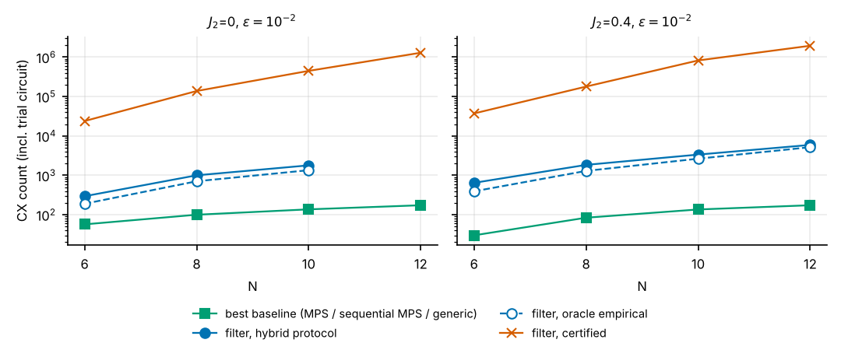
$N$ | $J_{2}$ | $ε$ | best baseline (CX) | filter: certified (CX) | filter: hybrid protocol (CX) | certified / baseline | hybrid / baseline
6 | 0 | 0.1 | MPS circuit (30) | 4,000 | 155 | 133× | 5.2×
6 | 0 | 0.01 | generic prep (57) | 23,880 | 295 | 419× | 5.2×
6 | 0 | 0.001 | generic prep (57) | 215,260 | 715 | 3776× | 13×
8 | 0 | 0.1 | MPS circuit (63) | 14,861 | 315 | 236× | 5.0×
8 | 0 | 0.01 | sequential MPS (100) | 137,998 | 1,001 | 1380× | 10×
8 | 0 | 0.001 | generic prep (247) | 1,066,499 | 2,765 | 4318× | 11×
10 | 0 | 0.1 | MPS circuit (81) | 43,551 | 783 | 538× | 9.7×
10 | 0 | 0.01 | sequential MPS (137) | 447,822 | 1,791 | 3269× | 13×
10 | 0 | 0.001 | sequential MPS (519) | 3,802,824 | – | 7327× | –
12 | 0 | 0.1 | sequential MPS (174) | 125,532 | – | 721× | –
12 | 0 | 0.01 | sequential MPS (174) | 1,292,390 | – | 7428× | –
12 | 0 | 0.001 | sequential MPS (709) | – | – | – | –
6 | 0.4 | 0.1 | MPS circuit (15) | 9,117 | 330 | 608× | 22×
6 | 0.4 | 0.01 | MPS circuit (30) | 37,215 | 645 | 1240× | 22×
6 | 0.4 | 0.001 | generic prep (57) | 285,372 | 1,779 | 5007× | 31×
8 | 0.4 | 0.1 | MPS circuit (21) | 36,554 | 567 | 1741× | 27×
8 | 0.4 | 0.01 | MPS circuit (84) | 178,878 | 1,841 | 2130× | 22×
8 | 0.4 | 0.001 | sequential MPS (99) | 1,828,526 | 7,301 | 18470× | 74×
10 | 0.4 | 0.1 | MPS circuit (27) | 100,755 | 1,455 | 3732× | 54×
10 | 0.4 | 0.01 | sequential MPS (136) | 823,204 | 3,359 | 6053× | 25×
10 | 0.4 | 0.001 | sequential MPS (136) | 6,707,397 | 11,451 | 49319× | 84×
12 | 0.4 | 0.1 | MPS circuit (33) | 249,852 | 1,797 | 7571× | 54×
12 | 0.4 | 0.01 | sequential MPS (174) | 1,943,145 | 5,913 | 11168× | 34×
12 | 0.4 | 0.001 | sequential MPS (174) | 17,365,356 | 37,665 | 99801× | 216×
Reading the table: at every size/coupling tested, an MPS circuit with bond dimension 4–8 (sequential mps-to-circuit) reaches $ε≲{10}^{−2}$ with 63–174 CX at $N=6$–$12$, whereas the hybrid filter needs hundreds to thousands of CX and the certified filter ${10}^{4}$–${10}^{7}$. The filter’s cost is set by the gap ($T∝1/Δ$) and Trotter error, not by how entangled the state is — so it only wins where MPS preparation gets expensive, which none of these chains do.

4.5 DMRG’s actual role
DMRG accuracy is excellent ($∼{10}^{−9}$ up to $N=16$), but (i) in the certified path the spectral inputs come from ED ($N≤12$), (ii) DMRG’s $E_{1}$ is variational (unsafe for a gap lower bound), (iii) $e_0=\sqrt{\rm Var}/W$ is “indicative”, not a bound, and (iv) all downstream simulation uses dense vectors ($N≲14$), so DMRG’s large-$N$ reach is unused. For large $N$ the guarantees are conditional on three assumptions: gap lower bound, $γ$ lower bound, ground-energy offset.

5. Code audit (what we fixed / what remains)
Fixed: $γ=1$ now means no filter (previously a million-CX filter was built for an exact state); ORDER≠1 raises (bound is first-order only); dense $2^{N}×2^{N}$ check restricted to $N≤12$; study.py imports/defaults corrected (guaranteed designs, $J_{2}$ list, $N≤12$). Open: cost-proxy mismatch in the floor search ($x^{2}/F{\left(0\right)}^{2}$ vs the true $x^{2}/F{\left(0\right)}^{3}$), early-abort expected cost, over-wide window ($hi=1$), energy-shift rotation per step, verification of T-count constants and citations, tests directory and pinned environment. Full list: paper §6.

6. Suggested talk outline (8 slides)
- Goal & setting — SBC projection on top of DMRG; the pipeline figure.
- The filter — pulse circuit, $F\left(E\right)=∏cos\left(Et_{i}+ϕ_{i}\right)$, $\gamma,\ \eta,\ P_{\rm succ}$.
- Certified error analysis — R1 (suppression), R2 (leakage), R3 (Trotter), composition (+ our sharpening).
- Verification — every ingredient tested against brute force; zero violations.
- Why the guarantee is loose — table of §4.2; ground state feels 28–41× less Trotter error.
- Hybrid protocol — definition, validation, 30–600× fewer CX than certified.
- Baselines — equal-fidelity comparison; MPS preparation wins for $N≤12$.
- Takeaways & next steps — methodology + harness; where an advantage might exist (large $χ$, 2D, large $N$ with tensor-network simulation of the filter); certified gap bound for large $N$.
Numbers in §4.2–4.4 are regenerated from the raw result files; rerun paper/build_paper.py after new experiments.

