Certified Ground-State Filtering with DMRG Trial States and Stetcu–Baroni Projection: An Evaluation of the J1–J2 Chain Workflow
Draft prepared from the AARON/j1j2_filter code base (internal evaluation; authors to be added)
6 October 2026

Abstract
We evaluate a workflow that prepares the ground state of the open spin-½ $J_{1}$–$J_{2}$ Heisenberg chain on a quantum computer by (i) running DMRG to obtain a matrix-product-state (MPS) approximation, (ii) compiling it into a shallow brickwork circuit, and (iii) refining that trial state with the ancilla-based projection algorithm of Stetcu, Baroni and Carlson, using a classically optimised, certified product-of-cosines filter and first-order Lie–Trotter evolution with a rigorous a-priori error bound. We re-derive the mathematics, test every analytic building block against brute force, and run the full pipeline for $N=4$–$12$ sites. Findings. (1) The analytic ingredients are sound: pulse convention, spectral-suppression certificates, leakage bound, Trotter commutator constant and the composed error bound showed no violation in any test (0 of 60 certificate designs, 0 of $2×{10}^{4}$ random spectra, 0 of $5×{10}^{4}$ random state pairs, and every simulated design). (2) The composed bound is conservative by a large factor: at the guaranteed step count the measured infidelity is 8–60× below the bound, and the guaranteed step number is 17–1200× the oracle-empirical one. A sharpened angle-based composition we prove tightens the bound by 2.5–3.1× and lowers the a-priori step count by 2.3–3.2×. (3) The guaranteed cost scales as $n∝N^{4}$ and CX $∝N^{5}$ at fixed target; for $N=6$–$10$ it is 700–1000× the CX count of exact state preparation (57–1013 CX) and orders of magnitude above shallow MPS circuits, so the current evidence does not support a resource advantage. (4) Where DMRG matters for certification it cannot supply the needed quantities: in the default configuration the certified spectrum comes from exact diagonalisation ($N≤12$), and the DMRG excited-state energy errs on the unsafe side for a gap lower bound. (5) The $J_{2}=0.5$ benchmark is trivial (Majumdar–Ghosh dimer state, $γ=1$) and exposes a code path that builds a million-CX filter for a state that is already exact. We list the code defects found, and the experiments and proofs that a publishable version would still need.

1. Introduction
Ground-state preparation is the entry point of most quantum simulation workflows. For one-dimensional gapped or critical spin chains, DMRG supplies classically excellent but not exactly circuit-preparable states; a natural hybrid is to compile the MPS into a low-depth circuit with fidelity $γ<1$ and repair the remainder with a quantum projection step. The Stetcu–Baroni–Carlson (SBC) projection algorithm [1] does this with one ancilla, controlled time evolution and post-selection; its randomised-time variant is the rodeo algorithm [2,3]. Here the pulse times and phases are instead optimised and certified classically, and the Trotter error is controlled by a commutator bound [4].
This document is an independent evaluation of that workflow as implemented in AARON/j1j2_filter. Its aim is to state precisely what has been established, what is conditional, and what is still missing for a publishable paper, supported by reproducible experiments (AARON/evaluation/experiments, results in AARON/evaluation/results). We deliberately report negative as well as positive findings; the conclusions in §7 are written so they can be carried into a manuscript unchanged once the open items are closed.
Contributions. (i) A self-contained derivation of the error analysis, including a sharpened composition bound (Proposition in §3). (ii) Independent verification of each analytic component and of the end-to-end bound. (iii) Quantitative comparison of the guaranteed and empirical resource counts and of the scaling with $N$. (iv) A baseline comparison with shallow MPS circuits and with exact state preparation. (v) An assessment of the DMRG-derived inputs and of the effect of symmetry. (vi) A code audit with concrete fixes. ## 2. Model, algorithm and conventions
Model. We study the open-boundary spin-½ $J_{1}$–$J_{2}$ chain
$$H=\sum_{i=1}^{N−1}{J_{1}} S_{i}​⋅​S_{i+1}+\sum_{i=1}^{N−2}{J_{2}} S_{i}​⋅​S_{i+2}, S_{i}​⋅​S_{j}=1/4\left(X_{i}X_{j}+Y_{i}Y_{j}+Z_{i}Z_{j}\right),$$
with $J_{1}=1$, even $N$ (so that the ground state is a non-degenerate singlet) and $J_{2}∈\{0, 0.2411, 0.5\}$ (Heisenberg, the Okamoto–Nomura dimerisation point, and the Majumdar–Ghosh point). The Pauli form has $3\left(N−1\right)+3\left(N−2\right) \left[J_{2}≠0\right]$ terms. $H$ conserves total spin $S^{2}$ and spatial reflection; the lowest excitation is a triplet.
Scaled Hamiltonian. With $E_{0}$ the ground energy and $W≥E_{max}−E_{0}$, define $H_{s}=\left(H−E_{0}\right)/W$ so that $spec\left(H_{s}\right)⊂\{0\}∪\left[Δ,1\right]$ with $Δ=\left(E_{1}−E_{0}\right)/W$. All pulse times below are in units of $W^{−1}$.
Projection pulse (Stetcu–Baroni–Carlson). One pulse acts on the system register and one ancilla initialised in $|0⟩$:
$$W\left(t,ϕ\right)=\left(H_{a}\right) e^{−it H_{s}⊗Z_{a}} {Rz}_{a}\left(2ϕ\right) \left(H_{a}\right).$$
Using $Rz\left(2ϕ\right)=diag\left(e^{−iϕ},e^{iϕ}\right)$ one finds
$$⟨0_{a}\left|W\right|0_{a}⟩=1/2\left(e^{−i\left(H_{s}t+ϕ\right)}+e^{+i\left(H_{s}t+ϕ\right)}\right)=cos\left(H_{s}t+ϕ\right), ⟨1_{a}\left|W\right|0_{a}⟩=−isin\left(H_{s}t+ϕ\right).$$
Measuring the ancilla and keeping only outcome $0$ after each of $m$ pulses (with the ancilla reset between pulses) applies, up to normalisation, the filter
FE=i=1mcosEti+ϕi, T=i​ti,
to the trial state. The probability of the all-zeros record is Psucc=k​ck2FEk2 for a trial state ψ⟩=k​ckEk⟩; because $F$ is a product of cosines, a failed pulse aborts the run immediately (“early abort”). We verified the sign convention (including that $ϕ→−ϕ$ is rejected) directly on a random, non-commuting, field-carrying $H$ and a random complex state (verify_pulse_convention, error $<{10}^{−8}$).
Relation to prior work. The pulse is the deterministic-time, optimised-phase version of the projection/“rodeo” circuit of Stetcu, Baroni and Carlson (Phys. Rev. C 105, 064308 (2022)); with $ϕ_{i}=0$ and random $t_{i}$ it reduces to the rodeo algorithm. The product-of-cosines filter is a real trigonometric polynomial in $E$ of total frequency $T$ and is therefore a restricted member of the family realised by quantum eigenvalue transformation of unitaries / QSVT (Lin–Tong, Dong–Lin–Tong), which achieve $T=O\left(Δ^{−1}log\left(1/η\right)\right)$ with a single ancilla but need coherent (not measurement-based) control. The present scheme trades that for a classically optimised filter that can be certified and for early-abort statistics.

3. Rigorous error analysis
Notation: $γ=\left|⟨E_{0}\right|ψ⟩|^{2}$ is the trial-state ground-state weight; $η=\sup_{E∈\left[Δ,1\right]}\left|F\left(E\right)\right|/\left|F\left(0\right)\right|$; L=i​ti; α=g​∥Hg,g′>g​Hg′∥ for the Pauli terms $H_{g}$ of $H_{s}$ in circuit order.
R1 (certified suppression). Since $\left|cos\right|≤1$ and $\left|∂_{E}cos\left(Et_{i}+ϕ_{i}\right)\right|≤\left|t_{i}\right|$, $\left|F′\right|≤L$ and $\left|F″\right|≤L^{2}$. On an interval of half-width $d$ centred at $E_{c}$, $\left|F\left(E\right)\right|≤\left|F\left(E_{c}\right)\right|+\left|F′\left(E_{c}\right)\right|d+1/2L^{2}d^{2}$. Interval bisection with this envelope (floor.certify) returns a rigorous upper bound on $sup\left|F\right|$; a cheaper variant (grid maximum $+ Lh/2$, filter_design.certify_filter) is also provided. The ground-state amplitude is bounded below by $\left|F\left(0\right)\right|−L e_{0}$ where $e_{0}$ is the (scaled) uncertainty of the ground-state energy.
R2 (leakage). If $specH_{s}⊂\{0\}∪\left[Δ,1\right]$ then for the exact filter
$$F_{exact} ≥ \frac{γ}{γ+\left(1−γ\right)η^{2}}, \text{i.e. leakage } ℓ≤\frac{\left(1−γ\right)η^{2}}{γ+\left(1−γ\right)η^{2}}.$$
(Proof: numerator $γF{\left(0\right)}^{2}$, denominator $≤γF{\left(0\right)}^{2}+\left(1−γ\right)sup{\left|F\right|}^{2}$.) The design problem is therefore: given $γ$ and a target leakage $ε_{ℓ}$, find $\left(t_{i},ϕ_{i}\right)$ with certified $η≤η_{*}=\sqrt{γε_{ℓ}/\left(\left(1−ε_{ℓ}\right)\left(1−γ\right)\right)}$ that maximises $F{\left(0\right)}^{2}=∏\cos^{2}ϕ_{i}$ (so $P_{succ}≥γF{\left(0\right)}^{2}$) at fixed $T$ and pulse number $m$ (floor.py).
R3 (Lie–Trotter error of the post-selected state). Replace $e^{−itH_{s}⊗Z}$ by $k$ first-order Lie–Trotter steps over the Pauli terms. Because $\left[H_{g}Z,H_{g′}Z\right]=\left[H_{g},H_{g′}\right]⊗1$, the commutator constant of $H_{s}⊗Z$ equals $α$, and the standard bound (Childs et al., Phys. Rev. X 11, 011020, Eq. for $p=1$) gives $∥W_{i}−{\tilde{W}}_{i}∥≤αt_{i}^{2}/\left(2k_{i}\right)=:ϵ_{i}$. The post-selected blocks $A_{i}=⟨0\left|W_{i}\right|0⟩$ are contractions, so telescoping gives for the un-normalised vectors $a=A_{m}⋯A_{1}ψ$, $b={\tilde{A}}_{m}⋯{\tilde{A}}_{1}ψ$
∥a−b∥≤ϵT:=i​αti22ki =ti=ki dt αT22n, n=i​ki.
Renormalisation after each pulse is irrelevant because the projections commute with global rescaling. The code uses $∥a/\left|a\right|−b/\left|b\right|∥≤2ϵ_{T}/\sqrt{p_{g}}$ with $p_{g}=∥a∥^{2}≥γF{\left(0\right)}^{2}$. Scope: this is a first-order statement; the identical formula is used by the code whatever ORDER is set to (see §7).
R4 (composition). The code combines the two contributions as $1−F≤{\left(\sqrt{2ℓ}+d_{T}\right)}^{2}$, $d_{T}=2ϵ_{T}/\sqrt{p_{g}}$. This is valid (proved in the code docstring, re-derived by us: $1−\sqrt{1−ℓ}≤ℓ$ plus the triangle inequality for phase-optimised distance, and $1−F≤2\left(1−\left|⟨g\right|\tilde{ϕ}⟩|\right)$; 0 violations in $5×{10}^{4}$ random trials) but not tight. Working with the Fubini–Study angle $θ$ instead of the Euclidean distance:
Proposition (sharpened composition). If $∥a−b∥<∥a∥$ then $sin∠\left(a,b\right)≤∥a−b∥/∥a∥$. With $sinθ_{ℓ}=\sqrt{ℓ}$ and the triangle inequality for $∠$,
$$1−F ≤ \sin^{2}​\left(arcsin\sqrt{ℓ}+arcsin\frac{ϵ_{T}}{\sqrt{p_{g}}}\right) ≤ (\sqrt{ℓ}+\frac{ϵ_{T}}{\sqrt{p_{g}}})^{2}.$$
Proof. $dist\left(a,spanb\right)≤∥a−b∥$ and $dist\left(a,spanb\right)=∥a∥sin∠\left(a,b\right)$. The angle between rays is a metric on projective space, so $θ\left(\tilde{ϕ},g\right)≤θ\left(\tilde{ϕ},ϕ\right)+θ\left(ϕ,g\right)$; finally $1−F=\sin^{2}θ\left(\tilde{ϕ},g\right)$ and $sin$ is increasing on $\left[0,π/2\right]$. $▫$
Relative to R4 this removes a factor 2 in the Trotter distance and a factor $\sqrt{2}$ in the leakage distance. Because the required step number scales as $n∝ϵ_{T}∝\sqrt{ε}−\sqrt{ℓ}$ (first-order Trotter gives $n∝ε^{−1/2}$ for an infidelity target), the proposition lowers the guaranteed $n$ by about a factor 2 and the guaranteed $ε$ by about 4 at fixed $n$ (quantified in §6.2).
Cost model. One Trotter step of one pulse costs $c_{step}$ CX (transpiled once); a design with $n$ steps and $m_{nz}$ non-zero pulses costs $n c_{step}+c_{trial}$ CX and $n r_{step}+m_{nz}$ non-Clifford rotations; the expected cost to obtain a success is divided by $P_{succ}$. ## 4. The DMRG-to-filter workflow as implemented
The workflow in AARON/j1j2_filter has five stages. For each, we record what the code does, what it certifies and what it merely assumes.
Stage | Module | What it produces | Status of the output
1. Hamiltonian | hamiltonians.py | Pauli form (qiskit) and MPO (quimb); check_mpo_matches_pauli compares them for $N≤10$ | Verified to ${10}^{−9}$
2. DMRG | get_energies.py | $E_{0}$, MPS $|ψ_{0}⟩$ (two-site DMRG, $χ≤64$); $E_{top}$ from DMRG on $−H$; $E_{1}$ from DMRG on $H+λ\left|ψ_{0}⟩⟨ψ_{0}\right|$, $λ=1.1\left(E_{top}−E_{0}\right)$ | Estimates, not bounds
3. Spectral inputs | core/spectrum.py | shift, $W$, scaled gap $Δ$, $e_{0}$ | ED path: exact ($N≤12$). DMRG path: $W$ certified, $Δ$ not, $e_{0}$ indicative only
4. Trial state | mps_to_circuit (external) | $L$-layer brickwork circuit approximating $|ψ_{0}⟩$; $γ$ computed by overlap with the ED ground state if available, else with the DMRG MPS | Certified only on the ED path
5. Filter + Trotter | floor.py, core/filter_design.py, core/trotter.py, pipeline.py | $\left(t_{i},ϕ_{i},k_{i}\right)$, certified $η$, a-priori $n$, rigorous $1−F$ bound, CX/T counts | Rigorous conditional on stages 3–4

4.1 Where DMRG enters, and what depends on it
- Trial state. The MPS is compiled to an $L$-layer circuit. $L$ controls $γ$ and the circuit cost; the filter exists to repair $1−γ$.
- Spectral inputs. In the default configuration (SPECTRUM_SOURCE="ed") no DMRG number enters the certificate: $E_{0},E_{1},E_{top}$ come from dense ED and DMRG is used only for the trial circuit and as a cross-check (ed_cross_check). This restricts every certified result to $N≤12$, where DMRG is not needed. With SPECTRUM_SOURCE="dmrg" the scaled window $\left[Δ,1\right]$ is built from DMRG quantities, and the guarantees of §3 become conditional on three assumptions that DMRG cannot certify:
  - (A1) $E_{1}^{DMRG}≤E_{1}$ (so that $Δ$ is a lower bound on the true gap). The penalty method returns an energy of a state orthogonal to an approximate $|ψ_{0}⟩$, i.e. an upper bound on $E_{1}$ when $ψ_{0}$ is exact; the wrong side for a certificate (§6.4 quantifies the consequence).
  - (A2) $γ$ is a lower bound. A DMRG–circuit overlap is an overlap with an approximation of $|E_{0}⟩$.
  - (A3) the scaled ground energy is within $e_{0}$ of zero; get_spectrum sets $e_{0}=\sqrt{VarH}/W$, which the code itself calls “indicative” (some eigenvalue lies within $\sqrt{Var}$ of $⟨H⟩$, not necessarily the lowest).
- The bandwidth, in contrast, is certified: $W=\left(c_{I}+∑\left|c_{β}\right|\right)−E_{0}^{DMRG}≥E_{top}−E_{0}^{DMRG}$.
- Hilbert-space dimension. Every number in stage 5 (exact reference, Trotter simulation, trial-circuit statevector) is computed with dense $2^{N}$ vectors, so the pipeline never exploits DMRG’s ability to reach large $N$. It is a verification harness for $N≲14$, not (yet) a large-$N$ workflow.

4.2 Filter design (“floor” problem)
For fixed $\left(x=TΔ/π, m\right)$ the solver (floor.solve_floor) maximises $F{\left(0\right)}^{2}$ subject to certified $η≤η_{*}$ using SLSQP with analytic Jacobians, a ladder of feasibility guards, a cutting-plane refinement of the constraint grid and a certification fixed point. Across $\left(x,m\right)$ and leakage budgets $ε_{ℓ}=fε$, $f∈\{0.4,…,0.01\}$, the pipeline picks the candidate minimising $n_{req}/p_{g}^{lb}$. The continuous design is then snapped to $n$ equal steps (largest-remainder), zero-length pulses are dropped (a $t=0$ pulse is a scalar $cosϕ$ after post-selection, so $η$ and the state are unchanged), phases are re-optimised at the snapped times and $η$ is re-certified.

4.3 Two reported operating points
- Guaranteed: smallest $n$ (5 % search) whose a-priori bound $ε_{bound}≤ε$.
- Empirical: smallest $n$ (sweep + bisection) whose measured infidelity to the ED ground state is $≤ε$.
The second is an oracle quantity (it uses the exact ground state that the algorithm is supposed to produce) and, as §6.2 shows, it can sit in a regime where the Trotterised filter is not an approximation of the designed filter at all. ## 5. Verification and results
All experiments use noiseless exact statevector (or exact-unitary) simulation, $J_{1}=1$, open boundaries, a one-layer ($L=1$) brickwork trial circuit from the DMRG MPS unless stated, and the pipeline defaults (first-order Lie–Trotter, ED spectrum, floor design). DMRG: two-site, bond dimensions $\{8,16,32,64,64\}$, cutoff and tolerance ${10}^{−10}$ (quimb 1.15; qiskit 2.5.2; mps-to-circuit, Python 3.12). Environment note: mps-to-circuit does not install on Python ≥ 3.13.

5.1 The analytic building blocks hold
Check | Test | Result
Pulse convention | random non-commuting $H$, random complex $ψ$, $ϕ→−ϕ$ rejected | errors $<{10}^{−8}$ (code’s own check)
R1 certificates | 60 random designs vs. $2×{10}^{6}$-point brute-force sup | 0 violations; branch-and-bound/brute $∈\left[1.0000002, 1.0023\right]$; grid+Lipschitz $∈\left[1.000006, 1.0013\right]$
R2 leakage bound | $2×{10}^{4}$ random spectra, trial states, filters | 0 violations
$α$ (commutator constant) | dense commutator norms, $N=4$–$6$, both term orders | code equals dense value to ${10}^{−15}$; the triangle-inequality value is up to 40 % larger at $J_{2}≠0$
Lie–Trotter pulse error | $∥W−\tilde{W}∥$ for $H⊗Z$, $N=4$, $t≤6$, $k≤20$; system-level first-order error, $N=4$–$6$ | pulse level always $≤0.24×$ the bound; system level $≤0.47×$
Composition R4 and sharpened version | $5×{10}^{4}$ random unit-vector triples | 0 violations of either; sharpened is 2.2× tighter on median
Normalisation lemma $sin∠\left(a,b\right)≤∥a−b∥/∥a∥$ | $5×{10}^{4}$ random pairs | 0 violations (max ratio 0.99999)
The Lie–Trotter ordering that qiskit realises with preserve_order=True was identified by explicit comparison with both ordered products (forward matches to $<{10}^{−9}$); the code nevertheless takes the maximum of the two orderings, which is safe.

5.2 Guaranteed versus empirical, and tightness of the bound
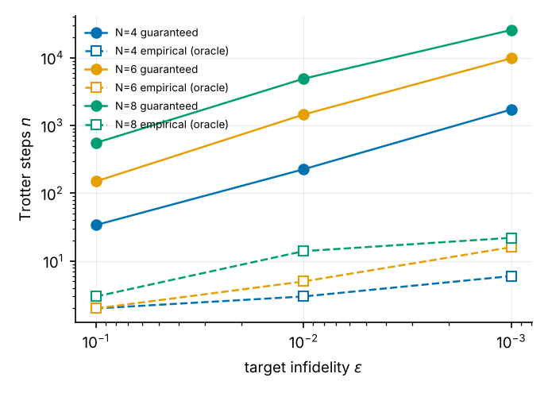
Guaranteed (solid) and empirical (open markers) Trotter step counts versus target infidelity.
$N$ | $ε$ | $n_{guar}$ | $n_{emp}$ | ratio | bound $1−F$ | measured $1−F$ at $n_{guar}$ | sharpened bound | $n_{guar}^{sharp}$ | CX guar. | CX emp.
4 | ${10}^{−1}$ | 34 | 2 | 17 | 0.0999 | 3.2e-3 | 0.035 | 14 | 723 | 51
4 | ${10}^{−2}$ | 226 | 3 | 75 | 0.0100 | 2.7e-4 | 3.2e-3 | 100 | 4 755 | 72
4 | ${10}^{−3}$ | 1 719 | 6 | 287 | 0.0010 | 3.1e-5 | 3.2e-4 | 760 | 36 108 | 135
6 | ${10}^{−1}$ | 150 | 2 | 75 | 0.0996 | 6.6e-3 | 0.034 | 60 | 5 265 | 85
6 | ${10}^{−2}$ | 1 450 | 5 | 290 | 0.0100 | 7.6e-4 | 3.5e-3 | 589 | 50 765 | 190
6 | ${10}^{−3}$ | 9 797 | 16 | 612 | 0.0010 | 2.8e-5 | 3.2e-4 | 4 328 | 342 910 | 575
8 | ${10}^{−1}$ | 555 | 3 | 185 | 0.0962 | 1.2e-2 | 0.038 | 175 | 27 216 | 168
8 | ${10}^{−2}$ | 4 903 | 14 | 350 | 0.0100 | 1.6e-4 | 3.2e-3 | 2 164 | 240 268 | 707
8 | ${10}^{−3}$ | 25 634 | 22 | 1 165 | 0.0010 | (not simulated) | – | 11 317 | 1 256 087 | 1 099
($J_{2}=0$, $L=1$, floor design. $n_{guar}^{sharp}$ is the a-priori step number if the sharpened composition of §3 replaced R4, computed on the un-gridded design, i.e. indicative.)
Three observations.
(a) The guarantee is sound but loose. No design violated its bound. The measured infidelity at $n_{guar}$ is 8–63× below the bound, and the sharpened composition (valid in every case) tightens the bound by 2.5–3.1× and reduces the a-priori $n$ by 2.3–3.2×. Two further sources of slack remain: the commutator norm is a worst case over the full Hilbert space (the pulse-level operator error is already only $≤0.24$ of the bound, §5.1) and the state error on low-energy states is far smaller than the operator error (measured state error $2×{10}^{−4}$ vs. bound $5.6×{10}^{−2}$ at $N=6$, $ε={10}^{−2}$).
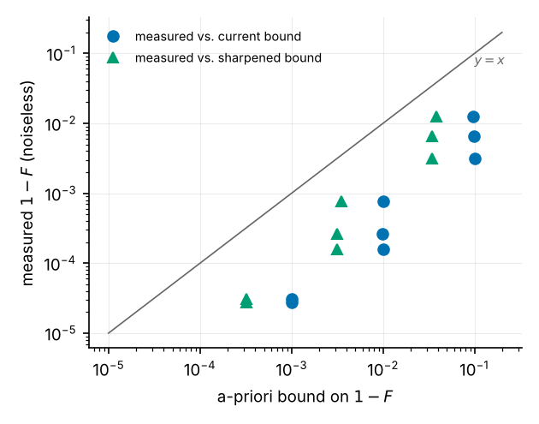
Measured infidelity vs. a-priori bound. All points lie below $y=x$.
(b) The “empirical” point is an oracle and sometimes not a filter at all. $n_{emp}$ is defined by comparison with the exact ground state. In several rows (e.g. $N=6$, $ε={10}^{−1},{10}^{−2}$; $N=8$, $ε={10}^{−1}$) the certified $η$ at $n_{emp}$ is $≈1$: the snapped Trotter step ($dt≈3.6$ in scaled units, i.e. $W dt≈13$ rad) is so coarse that the circuit is no longer an approximation of the designed filter, and the measured improvement is a property of that particular discretisation, not something a bound can certify or a user could know a priori. The empirical numbers should be presented as a lower envelope, not as the algorithm’s cost.
(c) Cost. The guaranteed circuits for $N=6$ at $ε={10}^{−2}$ have 1450 Trotter steps, 50 765 CX, depth $≈2×{10}^{5}$ and $≈7×{10}^{4}$ non-Clifford rotations, i.e. $∼1.4×{10}^{6}$ T gates under the code’s own synthesis estimate, with success probability $P_{succ}≈0.72$.

5.3 Is the filter worth it? Baselines
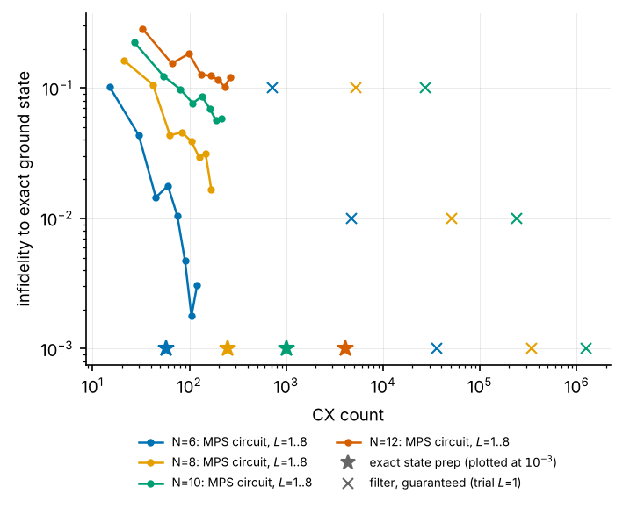
CX versus infidelity for the DMRG-derived MPS circuit ($L=1..8$), exact state preparation (stars, plotted at a nominal ${10}^{−3}$) and the guaranteed filter (crosses).
Exact preparation of the ED ground state with qiskit’s generic isometry synthesis costs 57, 247, 1013 and 4083 CX for $N=6,8,10,12$ ($≈2^{N}$). The guaranteed filter at $ε={10}^{−2}$ costs 50 765, 240 268 and 696 807 CX for $N=6,8,10$, i.e. 890×, 970× and 690× more than exact preparation, and 2–3 orders of magnitude more than the entire $L≤8$ MPS-circuit family (15–264 CX). The MPS-circuit baseline is itself imperfect and non-monotone in $L$ (e.g. $N=6$: infidelity $1.4×{10}^{−2}$ at $L=3$, $1.8×{10}^{−2}$ at $L=4$; the compilation is a local optimisation), and at $N=10,12$ it has not converged by $L=8$ (5.8 % and 12 % infidelity). Extrapolating the fitted $N^{5}$ filter cost against the $2^{N}$ exact cost suggests a crossover near $N≈26$ — but dense isometry synthesis is not available at that size and the extrapolation ignores the decay of $γ$ with $N$; the relevant comparators there are MPS-based sequential preparation [7] and QETU/Lin–Tong filters [5,6]. This comparison is the most important missing piece of the present study.

5.4 Scaling with system size
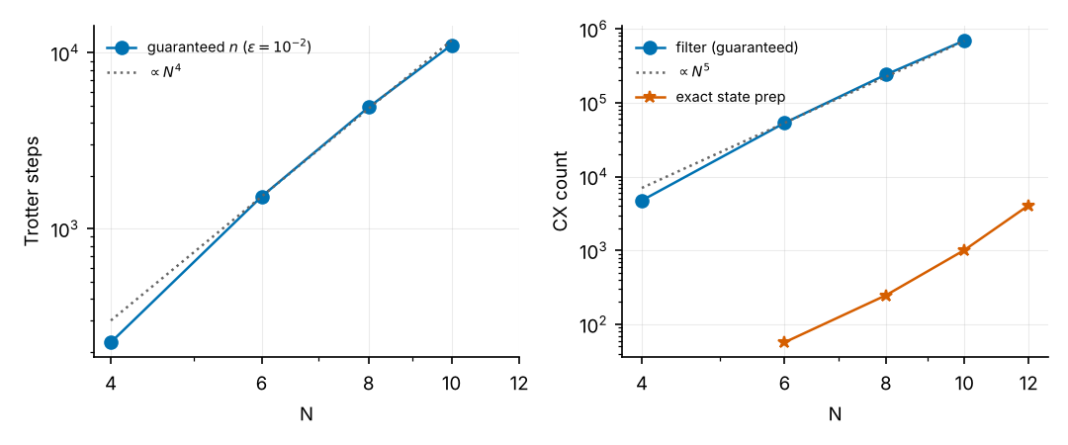
Left: guaranteed Trotter steps at $ε={10}^{−2}$ versus $N$. Right: guaranteed CX versus $N$, compared with exact state preparation.
Guaranteed $n$ for $N=4,6,8,10$: 226, 1523, 4903, 11 060 (fit exponent 4.3 over 4–10, 3.9 over 6–10); CX: $4.8×{10}^{3}$, $5.3×{10}^{4}$, $2.4×{10}^{5}$, $7.0×{10}^{5}$ (exponent 5.0–5.5). This agrees with the structure of the bound, $n∝α_{phys}T_{phys}^{2}/\left(\sqrt{p_{g}} d_{T}\right)$ with $α_{phys}∝N$ (3.0, 4.5, 6.0 for $N=6,8,10$ at $J_{2}=0$), $T_{phys}∝1/Δ_{gap}∝N$ (gap 0.49, 0.39, 0.33) giving $N^{3}$, with the remaining power from $γ\left(N\right)$ falling at fixed $L$ (0.90, 0.84, 0.78) and hence tighter $η_{*}$, plus the per-step CX growing $∝N$. (Note that rescaling by $W$ cancels: $αT^{2}$ is $W$-independent.) Using $L=3$ trial layers raises $γ$ (0.98, 0.94, 0.90 for $N=6,8,10$) and lowers guaranteed CX by 3.2×, 1.7× and 1.5× respectively: the benefit of a better trial state shrinks with $N$ because the evolution time $T∝1/Δ_{gap}$ is set by the gap, not by $γ$.

5.5 The DMRG-derived inputs
$N$ | $\left|ΔE_{0}\right|$ | $ΔE_{1}=E_{1}^{DMRG}−E_{1}$ | rel. gap error | $\left|ΔE_{top}\right|$ | $Var\left(H\right)$ | $\left|⟨ψ_{DMRG}\right|E_{0}⟩|^{2}$
6 | 3e-15 | −4e-16 | −7e-15 | 3e-15 | ≈0 | 1.0
8 | 2e-15 | 2e-15 | 1e-15 | 5e-15 | ≈0 | 1.0
10 | 5e-10 | 3.5e-10 | −3.7e-10 | 3e-13 | 2.5e-9 | 1.0
12 | 1.2e-9 | 9.3e-10 | −8.5e-10 | 4e-12 | 5.8e-9 | 1.0
14 | 1.8e-9 | 1.3e-9 | −2.0e-9 | 7e-12 | 8.3e-9 | 1.0
16 | 2.2e-9 | 2.4e-9 | 7e-10 | 1e-11 | 1.0e-8 | 1.0
($J_{2}=0$. Rows with ≈0 variance are at rounding level. $J_{2}=0.2411$ ($N=6$–$16$) and $J_{2}=0.5$ ($N=6$–$10$) show the same behaviour: $\left|ΔE_{0}\right|,\left|ΔE_{1}\right|≤2.6×{10}^{−9}$, overlap 1; the full table is in results/exp3a_*.json, which is written when the sweep finishes.) DMRG reproduces $E_{0}$, $E_{1}$ and $E_{top}$ to $≲2×{10}^{−9}$ and the ground state to overlap 1 against sparse-Lanczos ED up to $N=16$. Three caveats are relevant to certification, not to accuracy:
- $ΔE_{1}≥0$ (up to rounding), as expected for a variational excited-state energy — the unsafe direction for a gap used as a lower bound. The size is negligible here, but nothing guarantees it for large $N$ or frustrated $J_{2}$.
- The relative gap error changes sign, so the sign of the error is not controlled either.
- The code’s $e_{0}=\sqrt{VarH}/W$ (e.g. ${10}^{−4}/W$ at $N=16$) is five orders of magnitude larger than the true energy error ($2×{10}^{−9}$): it is simultaneously non-rigorous (an eigenvalue within $\sqrt{Var}$ need not be the lowest) and wasteful (it enters $\left|F\left(E_{0}\right)\right|≥\left|F\left(0\right)\right|−Le_{0}$). A Temple-type lower bound $E_{0}≥⟨H⟩−Var/\left({\tilde{E}}_{1}−⟨H⟩\right)$, which is quadratically smaller, becomes available as soon as a rigorous lower bound ${\tilde{E}}_{1}$ on the first excitation is accepted — the same quantity the certificate already needs.
(The DMRG penalty state $ψ_{1}$ has weight 0.03–0.56 on any single ED vector at $E_{1}$ because $E_{1}$ is a threefold-degenerate triplet; this is not an error.)

5.6 Over-estimating the gap, and what symmetry could buy
We designed filters for a gap over-estimated by $s∈\{−20\%,…,+100\%\}$ ($N=6$, $J_{2}=0$, $ε_{ℓ}={10}^{−3}$) and evaluated them on the true spectrum.
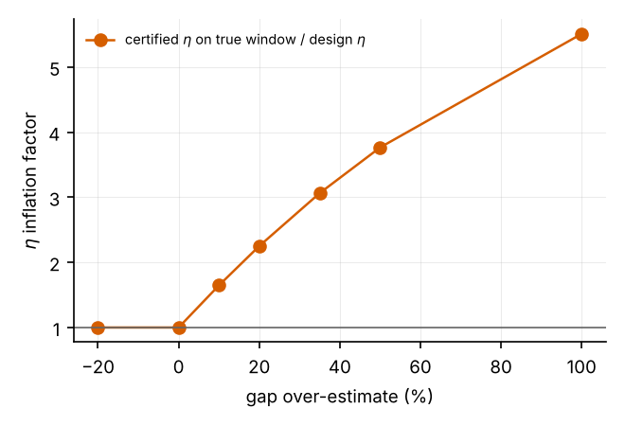
Inflation of the certified $η$ when the design gap exceeds the true gap.
The certificate fails as soon as the design gap exceeds the true one: certified $η$ on the true window rises from 0.092 to 0.15, 0.21, 0.28, 0.34 and 0.50 for $s=10,20,35,50,100\%$ (design target 0.092). The measured leakage of this particular trial state nevertheless stays below the ${10}^{−3}$ target ($≤7×{10}^{−4}$). The reason is symmetry: the $L=1$ trial state has 96.3 % of its weight in $S=0$, 0.49 % in $S=1$, 3.2 % in $S=2$, and the triplet that fixes the gap carries almost none of it, while the first $S=0$ excitation lies at 2.66× the triplet gap ($N=6$, $J_{2}=0$). A rigorous statement therefore needs the sector weights, which suggests a concrete improvement (§6): because every bond exponential is SU(2)-symmetric (“bond” ordering) the Trotterised evolution preserves $S$, so one may certify with sector-dependent windows. The potential saving, since $n∝Δ^{−2}$, is ${\left(Δ_{sector}/Δ_{any}\right)}^{2}$:
$J_{2}$ | $N=6$ | $N=8$ | $N=10$
0 | 7.1× | 7.0× | 6.9×
0.2411 | 4.2× | 4.1× | 4.1×
0.5 | 1.8× | 1.6× | 1.4×
(ratio ${\left(Δ_{sector}/Δ_{any}\right)}^{2}$ from exact diagonalisation; $N=12$, $J_{2}=0$: 6.8×.)

5.7 The $J_{2}=0.5$ case is trivial, and exposes a defect
At the Majumdar–Ghosh point the open even chain has the product-of-dimers ground state [8], which a single brickwork layer reproduces exactly: we find $γ=1$ (to double precision) for $N=4$–$12$. floor_vs_precision then correctly returns “no filter needed” rows ($m=0$), but choose_floor_design counts them as infeasible and make_design silently falls back to the legacy builder design with a hard-coded $P_{succ}≥0.9$. The pipeline then reports guaranteed circuits of 24 261, 511 068 and 1 157 409 CX for $N=4,8,10$ to prepare a state it already has, and the oracle-empirical search “meets” $ε=0.1$ with a state that has lost 9 % fidelity. The near-MG regime is therefore a poor benchmark for the algorithm; the interesting frustrated regime is $J_{2}∼0.3$–$0.45$ or non-dimerised trial limits (small $L$ at larger $N$). ## 6. Code audit and recommended changes
Severity: H invalidates a claim or can silently produce a wrong/ruinous result; M weakens a claim or wastes resources; L hygiene. Line references are to AARON/j1j2_filter.
# | Sev | Location | Finding | Recommended fix
1 | H | pipeline.choose_floor_design, make_design | $γ≥1−ϵ_{mach}$ produces $m=0$ rows that are counted infeasible; fallback to builder (hard-coded $P_{succ}≥0.9$, no $η$ target) builds a filter for an already-exact state (24 k–1.2 M CX at $J_{2}=0.5$, §5.7). Mixed floor/builder rows are also not comparable. | Return the identity (“no filter, cost 0”) when $γ$ is within tolerance of 1, and never mix design sources in one table.
2 | H | core/spectrum.get_spectrum (DMRG path), pipeline.build_ctx | Certificates are rigorous only if (A1) $Δ≤Δ_{true}$, (A2) $γ≤γ_{true}$, (A3) $\left|E_{0}^{shift}−E_{0}\right|≤e_{0}$ hold; DMRG supplies none of them (§4.1, §5.5–5.6). In the default ED mode the certified results are limited to $N≤12$. | State the theorem conditional on (A1)–(A3) with these labels; report $Δ$ with an explicit safety margin; for large $N$ obtain a gap lower bound by an independent method (e.g. symmetry-resolved DMRG plus a Temple/Weinstein-type bound) or present the large-$N$ numbers as estimates.
3 | H | pipeline.ORDER, core/trotter.trotter_bounds | The bound is first-order; setting ORDER=2 changes the circuits but the same $αt^{2}/2k$ bound is still reported (and lie_trotter_order only checks order 1). | assert ORDER == 1 next to the bound, or implement the second-order commutator bound.
4 | H | pipeline.build_ctx (if N <= 16: ... eigvalsh(Hs.toarray())) | Dense $2^{N}×2^{N}$ complex matrix: 4.3 GB at $N=14$, 68.7 GB at $N=16$; SOURCE='dmrg' is advertised for $N>12$. | Cap the dense check at $N≤12$ or use eigsh for the two extremal eigenvalues.
5 | H | repo | Not reproducible as shipped: scripts/run_study.py imports a study module that is absent; mps_to_circuit is an unpinned external dependency that fails on Python ≥ 3.13; main.ipynb imports a stale 831-line monolith builder.py, and hamiltonians.py/get_energies.py exist twice; comments cite tests (“T1”, “T8”, audit items A1–A14) that are not in the repository. | Add study.py, a pinned requirements.txt/lock file, delete or archive builder.py, single-source the two duplicated modules, and add a tests/ directory containing the checks of §5.1 (our exp1_primitives.py can be the seed).
6 | M | floor.floor_vs_precision vs. pipeline.choose_floor_design | The $\left(x,m\right)$ winner for each $ε$ is picked with proxy $x^{2}/F{\left(0\right)}^{2}$, but the true cost is $n/P∝x^{2}/F{\left(0\right)}^{3}$ (since $n∝1/\sqrt{p_{g}}$); the later choice over leakage fractions uses the correct cost, so the two stages optimise different objectives. | Pass cost_fn=lambda x,f,m: x*x/f**1.5.
7 | M | pipeline.find_empirical | “Empirical” $n$ uses the exact ground state and can land where $η≈1$ (§5.2b). | Report it only as an oracle lower envelope; require certified $η<1$.
8 | M | pipeline.costs | Expected cost $={CX}_{total}/P_{succ}$ ignores early abort (a failed pulse stops the run), so it overestimates; correct form: ctrial+i​cstepkij<i​pj/j​pj. | Implement with the per-pulse $p_{j}$ that the simulation already has.
9 | M | pipeline (hi=1.0 everywhere); core/spectrum | The filter must suppress $\left[Δ,1\right]$, but the spectrum ends at $\left(E_{top}−E_{0}\right)/W<1$ when $W$ is the certified (looser) bandwidth; $W=c_{I}+∑\left|c_{β}\right|−E_{0}$ overstates $E_{top}$ by 3× because $XX+YY+ZZ$ is bounded termwise (true per-bond bound $J/4$, so $E_{top}≤\frac{1}{4}\left[J_{1}\left(N−1\right)+J_{2}\left(N−2\right)\right]$ for $J≥0$). | Pass hi=(E_top_bound-E0)/W and use the per-bond bound, which is also rigorous and 3× tighter.
10 | M | core/trotter.total_error_bound | Composition ${\left(\sqrt{2ℓ}+d_{T}\right)}^{2}$ with $d_{T}=2ϵ_{T}/\sqrt{p_{g}}$ is valid but 2.5–3.1× loose. | Use $\sin^{2}\left(arcsin\sqrt{ℓ}+arcsin\left(ϵ_{T}/\sqrt{p_{g}}\right)\right)$ (Proposition, §3; verified in all simulated cases).
11 | M | core/__init__, core/resources.rotation_synthesis_t_count | The authors themselves flag the Trotter theorem statement and the synthesis constants ($1.15\log_{2}\left(1/ϵ\right)+9.2$) as “quoted from memory”. | Verify against the sources and cite them in the paper before reporting T-counts.
12 | L | core/circuits.h_tensor_z | The shift term $−E_{0}/W⋅Z_{anc}$ is applied as a separate non-Clifford $R_{z}$ in every Trotter step; it commutes with everything and can be folded into $ϕ_{i}$ ($ϕ_{i}→ϕ_{i}−E_{0}t_{i}/W$), saving one of 47 non-Clifford rotations per step ($N=6$). | Fold into the phase.
13 | L | pipeline.build_ctx | $γ$ is clipped with min(·,1) but the $γ=1$ branch is never propagated (see 1); the ED-vs-DMRG $γ$ fallback is labelled but not carried into reports. | Carry gamma_src into every exported number.

6.1 Methodological improvements that follow from the analysis
- Sharpened composition (item 10): a free, proven 2.5–3.1× tighter bound and 2.3–3.2× fewer guaranteed steps.
- Symmetry-resolved certification: let $w_{s}$ be the trial weight in sector $s$ and $Δ_{s}$ the gap of that sector. Then ℓ≤s​ws supΔs,1F2/F02 over the ground-state sector and the (small) remainder bounded with the global gap. Because bond-ordered Trotter steps are exactly SU(2)-symmetric, the sector weights are conserved by the (Trotterised) evolution, so this is rigorous given the sector weights, which are cheap to compute from the trial MPS. Potential saving up to ${\left(Δ_{s}/Δ\right)}^{2}≈7×$ in $n$ at $J_{2}=0$ (§5.6).
- Subspace-restricted Trotter bounds: replace the global $α$ by commutator norms restricted to the low-energy subspace populated by the trial state (the observed state error is ≈ 300× below the bound), or use higher-order formulas with the matching commutator bound.
- Tensor-network simulation of the filter. The DMRG advantage is lost as long as every number comes from dense vectors; the controlled evolution $e^{−itH⊗Z}$ is an MPO-friendly operation, so MPS/TEBD simulation of the Trotterised filter would allow $N∼30$–$100$ and show the real DMRG→circuit→filter story.

7. Conclusions and what a publishable paper still needs
Established. The mathematics of the filter, leakage, Trotter and composition bounds is correct, and verified numerically in every test performed; the pipeline’s reference implementation (pulse convention, MPO/Pauli agreement, circuit-vs-numpy agreement to ${10}^{−16}$) is consistent; DMRG supplies ground-state and excitation energies to $∼{10}^{−9}$ up to $N=16$.
Not established. (i) A resource advantage: at $N≤12$ the guaranteed filter costs ${10}^{2}$–${10}^{3}×$ exact preparation and $≫$ shallow MPS circuits, and the empirical savings come from an oracle. (ii) A DMRG-specific role in certification: the certified numbers are ED-based. (iii) Anything at $N>12$, near criticality or in the frustrated regime away from the exactly solvable MG point.
Required for submission (in priority order).
- Baselines. Compare resources at equal fidelity against (a) deeper/optimised MPS circuits and sequential MPS preparation, (b) QETU/Lin–Tong filtering with the same trial state, (c) rodeo with random times. Without this the paper cannot claim usefulness.
- Large-$N$ data from a tensor-network simulation of the filter (item 4 above), with $γ\left(N,L\right)$ and the gap from DMRG labelled as estimates, and a stated rigorous or heuristic gap input.
- Tighter guarantees: items 10 and 2 of §6.1 at minimum, to close the 100–1000× gap to the empirical cost, and an honest empirical definition (certified $η<1$).
- Benchmarks that stress the algorithm: $J_{2}∈\left[0.2,0.45\right]$, $N≥16$, and trial states with $γ≪1$; drop $J_{2}=0.5$ or use it only as a sanity check.
- Repository hygiene (items 1–5 of §6), a test suite, pinned environment, and archived raw data for every table and figure.
- Resource model: Hamiltonian-aware compilation of $e^{−it h_{b}⊗Z}$ (bond exponentials are SU(2)-symmetric), verified T-count constants, and a fault-tolerant estimate with early-abort statistics.
Suggested framing if the above is only partially achievable: a methods paper on certified SBC filtering — rigorous a-priori bounds, symmetry-resolved certification, and a verification harness — rather than a performance paper.

8. Reproducibility
Code: AARON/evaluation/experiments (exp1_primitives.py building-block tests; exp2_end_to_end.py N J2 L; exp3_dmrg_inputs.py; exp3b_baseline.py; exp4_gap_and_symmetry.py; exp5_scaling.py; make_figures.py). Raw outputs: AARON/evaluation/results/*.json; logs: AARON/evaluation/logs. All experiments call AARON/j1j2_filter unmodified. Environment: Python 3.12, numpy 2.x, scipy 1.18, qiskit 2.5.2, quimb 1.15, mps-to-circuit; run with OMP_NUM_THREADS=1 (multi-threaded BLAS made the SLSQP filter design several times slower). Floor-design settings for the scaling study were reduced for speed (FLOOR_EPS_FRACS=[0.2,0.1,0.05], FLOOR_M=[4,6]); end-to-end runs used the defaults.
Limitations of this evaluation. Single trial-circuit compilation per $\left(N,J_{2},L\right)$ (the compiler is a local optimiser, so $γ$ is not unique); $J_{2}≠0,0.5$ end-to-end runs and $N>10$ end-to-end runs were not completed; the $N=8$, $ε={10}^{−3}$ guaranteed design was not simulated (beyond the simulation cap); the scaling fits use four sizes; the crossover estimate is an extrapolation. References were written from memory and must be checked before submission.

References
- I. Stetcu, A. Baroni, J. Carlson, Projection algorithm for state preparation on quantum computers, Phys. Rev. C 105, 064308 (2022).
- K. Choi, D. Lee, J. Bonitati, Z. Qian, J. Watkins, Rodeo algorithm for quantum computing, Phys. Rev. Lett. 127, 040505 (2021).
- Z. Qian et al., Demonstration of the rodeo algorithm on a quantum computer, arXiv:2110.07747.
- A. M. Childs, Y. Su, M. C. Tran, N. Wiebe, S. Zhu, Theory of Trotter error with commutator scaling, Phys. Rev. X 11, 011020 (2021).
- L. Lin, Y. Tong, Near-optimal ground state preparation, Quantum 4, 372 (2020).
- Y. Dong, L. Lin, Y. Tong, Ground-state preparation and energy estimation on early fault-tolerant quantum computers via quantum eigenvalue transformation of unitary matrices, PRX Quantum 3, 040305 (2022).
- C. Schön, E. Solano, F. Verstraete, J. I. Cirac, M. M. Wolf, Sequential generation of entangled multiqubit states, Phys. Rev. Lett. 95, 110503 (2005).
- C. K. Majumdar, D. K. Ghosh, On next-nearest-neighbor interaction in linear chain, J. Math. Phys. 10, 1388 (1969).
- S. R. White, Density matrix formulation for quantum renormalization groups, Phys. Rev. Lett. 69, 2863 (1992); U. Schollwöck, Ann. Phys. 326, 96 (2011).
- K. Okamoto, K. Nomura, Phys. Lett. A 169, 433 (1992).

