Measurement error associated with gait cycle selection in treadmill running at various speeds

TODO: Insert abstract…

# Introduction

Collecting and analysing biomechanical data is a common method for understanding relationships between running technique and performance ***[ADD REFS]*** or injury/pain ***[ADD REFS]***, and evaluating changes in running technique following training or interventions ***[ADD REFS]***. A common approach across this form of study is to average data from a number of gait cycles to compute a given biomechanical measure. Calculating this ‘representative mean’ is therefore thought to be representative of the individuals broader running technique. Given the inherent variability in human movement (**vanEmmerik2000?**), the number of and how gait cycles are selected to create this ‘representative mean’ appears an important choice in accurately quantifying an individuals running gait. However, the number of gait cycles used in biomechanical studies of running varies across the literature (**Oliveira2021?**). Further, from our groups experience reading such studies — very rarely (if ever) has the decision process underpinning how many gait cycles are used been specifically explained.

We can collect a significant number of gait cycles from runners during laboratory- or clinic-based testing, particularly if a treadmill is used. Having participants settle into a steady rhythm via an extended period of running may be advantageous in producing a more habitual running pattern ***[REF for this???]***. The use of a significant number of gait cycles becomes a greater issue when analysing these data. Inflated data cleaning (e.g. labelling and gap filling motion capture data) and analysis (e.g. processing frames via inverse kinematics) times will occur when processing a running trial that uses many versus fewer gait cycles. Similarly, the increased data storage needs (i.e. larger file sizes) associated with trials including more gait cycles could introduce difficulties in circumstances where data storage access is limited. There is subsequently a need to understand the impact gait cycle selection processes have on biomechanical measures, to help optimise data collection and analysis practices without adversely impacting the testing outcomes.

Oliveira and Pirscoveanu(**Oliveira2021?**) recently examined the typical number of gait cycles used in running biomechanics studies. Studies used 12 cycles on average per runner to describe running biomechanics, while Very few (5 out of 56 studies examined) used more than 10 cycles (**Oliveira2021?**). Oliveira and Pirscoveanu(**Oliveira2021?**) subsequently performed a study investigating the impact of sample size (i.e. 10 to 40 runners) and the number of gait cycles (i.e. 5 to 40 steps) used on running measures — specifically, foot contact time, loading rate, peak vertical ground reaction force, peak braking force, running speed, and foot contact angle. They suggested greater than 10 steps are typically required to achieve stable biomechanical measures in runners, and collecting at least 25 steps will increase the likelihood of achieving stability in the range of biomechanical measures examined (**Oliveira2021?**). These findings are, however, specific to overground running and the set of biomechanical measures analysed. Treadmill running is often used in research (**VanHooren2020?**), and it is plausible that treadmill running may incur a different pattern with respect to the number of gait cycles needed for analyses. Further, Oliveira and Pirscoveanu(**Oliveira2021?**) did not examine lower limb kinematic variables commonly used in gait biomechanics studies. These kinematic variables can be presented as both ‘zero-dimensional’ (0D; e.g. peak values) and ‘one-dimensional’ (1D; e.g. time-normalised kinematic waveform) variables ***[ADD REFS]***. Analyses of these common kinematic variables in both their 0D and 1D forms may yield additional details with respect to the number of gait cycles required in biomechanical research. Lastly, Oliveira and Pirscoveanu’s(**Oliveira2021?**) analyses were driven by understanding data stability and statistical significance between two running conditions (i.e. ‘normal’ vs. ‘silent’ running). A different approach focused on understanding the magnitude of ‘error’ introduced by analysing different numbers of gait cycles can further our understanding of how gait cycle selection practices impact biomechanical measures. Specifically, understanding the potential ‘error’ or variability introduced by selecting a different number of gait cycles can aid in interpreting the legitimacy of an effect (i.e. could small effects be due to the set of gait cycles selected).

We sought to extend our current understanding of how the number of gait cycles selected for analysis impact lower limb kinematic measures from a continuous bout of treadmill running. First, we examined the magnitude of ‘error’ introduced in the representative mean compared to the entire bout of treadmill running when the number of gait cycle samples is varied. Second, we examined the potential variation introduced in the representative mean when sampling a specific number of gait cycles from different sections of the running bout.

# Methods

## Dataset

We used the public dataset of treadmill running biomechanics from Fukuchi et al.(**Fukuchi2017?**). The specifics of this dataset can be found in the associated paper (**Fukuchi2017?**). Briefly, this dataset contains lower-extremity kinematics and kinetics of 28 regular runners (27 male, 1 female; age = 34.8 ± 6.7 years; height = 176.0 ± 6.8 cm; mass = 69.6 ± 7.7 kg; running experience = 8.5 ± 7.0 years; running pace = 4.1 ± 0.4 min/km) (**Fukuchi2017?**). Running kinematics were collected using a 12-camera 3D motion capture system (Raptor-4, Motion Analysis, Santa Rosa, CA, United States) and ground reaction force (GRF) data via an instrumented dual-belt treadmill (FIT, Bertec, Columbus, OH, United States) (**Fukuchi2017?**). Participants ran on the treadmill at three designated speeds (2.5m·s-1, 3.5m·s-1 and 4.5m·s-1), during which a three-minute accommodation period was provided followed by a 30-second data collection period (**Fukuchi2017?**).

We processed the experimental data from Fukuchi et al.(**Fukuchi2017?**) using OpenSim 4.0(**Delp2007?**). Segment geometry of the generic musculoskeletal model of the pelvis and lower limb provided by Lai et al.(**Lai2017?**) were scaled for each participant using their static calibration trial, which was also used as a reference for adjusting marker positions on the model. Lower limb joint angles were calculated using filtered (10Hz low-pass 4th order Butterworth) marker trajectory data within inverse kinematics analysis. GRF data were filtered using the same cut-off frequency and filter. The filtering procedures reflected those originally performed by Fukuchi et al.(**Fukuchi2017?**). Foot strike and toe-off events were determined when the vertical GRF crossed a 20N threshold, also in line with the original work(**Fukuchi2017?**).

## Data Analysis

Kinematic variables common to gait biomechanics studies (i.e. hip flexion/extension, hip adduction/abduction, hip internal/external rotation, knee flexion and ankle plantarflexion/dorsiflexion) were extracted from the right limb for all participants. Data between consecutive foot strikes were extracted and time-normalised to 0-100% of the gait cycle. The time-normalised one-dimensional (1D) curves were used in subsequent 1D analyses, while a set of peak variables (hip flexion, hip adduction, hip internal rotation, knee flexion, ankle dorsiflexion) were calculated and extracted for the zero-dimensional (0D) analyses.

To examine how the number of gait cycles used impacts a participants representative kinematic mean, we determined ‘ground truth’ values to compare to for the 0D and 1D kinematic variables by calculating the mean from all available gait cycles in the 30-second bout of treadmill running. This value was thought to be the ‘most representative’ of each participants average running kinematics, and was not influenced by the selection of a subset of gait cycles from the running bout. We then iteratively calculated mean values across the kinematic variables using a range (*n* = 5 — 30) of gait cycles from the treadmill running bout. For each iteration, a random sample of *n* consecutive gait cycles were extracted from the treadmill running bout and used to calculate a representative kinematic mean. We then compared this representative kinematic mean to the ‘ground truth’ value for the respective variable to determine the ‘error’ that gait cycle number selection could introduce. For 0D variables, the absolute difference between the representative mean and ‘ground truth’ was recorded in each sampling iteration. For 1D variables, the absolute difference between the representative mean and ‘ground truth’ at each point across the time-normalised gait cycle were calculated, and the peak difference recorded. The random sampling process for each *n* of gait cycles was repeated 1,000 times for each participant at each running speed — and the ‘error’ values collated to present descriptive statistics (i.e. mean ± standard deviation [SD], median, range, inter-quartile range) for each gait cycle number across the kinematic variables and running speeds.

To examine how sampling gait cycles from different sections of the running bout impacts a participants representative kinematic mean, we iteratively calculated representative kinematic means using a range (*n* = 5 — 15) of randomly sampled consecutive gait cycles from different sections of the running bout. A smaller range of gait cycles was required for this analysis to avoid sharing gait cycles between the calculated means. For each sampling iteration, we randomly sampled *n* consecutive gait cycles from two sections of the running bout. We then compared the calculated representative kinematic means between the two sampled sections to determine the ‘error’ or variation that selection of gait cycles from different sections of the running bout could introduce. For 0D variables, the absolute difference between the two representative means was recorded in each sampling iteration. For 1D variables, the absolute difference between the two representative means was calculated at each point across the time-normalised gait cycle, and the peak difference recorded. The random sampling process for each *n* of gait cycles was repeated 1,000 times for each participant at each running speed — and the error values collated to present descriptive statistics (i.e. mean ± standard deviation [SD], median, range, inter-quartile range) for each gait cycle number across the kinematic variables and running speeds.

# Results

## How does the number of gait cycles used impact the representative kinematic mean?

The mean, variance and range of the absolute error of the representative kinematic mean (i.e. compared to the mean from all gait cycles) for the peak 0D kinematic variables progressively reduced as the number of gait cycles used increased (see Figures , and ). In particular, increasing the number of gait cycles used reduced the range of potential error compared to the ‘ground truth’ mean. Similar magnitudes of ‘error’ were observed between the 2.5m·s-1 and 3.5m·s-1 speeds across the 0D kinematic variables at comparable gait cycle numbers — where the maximum errors were less than 1 degree even when using a small number of gait cycles. This contrasted to the 4.5m·s-1 speed where maximum errors typically exceeded 1-2 degrees, particularly for peak hip and knee joint angles when a lower number of gait cycles were used. Subsequently, a much higher number of gait cycles (i.e. 25-30) achieved similar magnitudes of error to fewer gait cycles (i.e. < 10) for running at 4.5m·s-1 versus the other two speeds, respectively. The larger ‘error’ values observed at 4.5m·s-1 appeared to be driven by a bimodal distribution of the error — whereby certain sampling iterations within the same biomechanical measure could produce relatively higher versus lower errors (see Figure ). The exception to this difference at the higher speed was for peak ankle dorsiflexion, where similarly low ‘error’ values and ranges (i.e. < 0.5 degrees) were observed across all speeds.

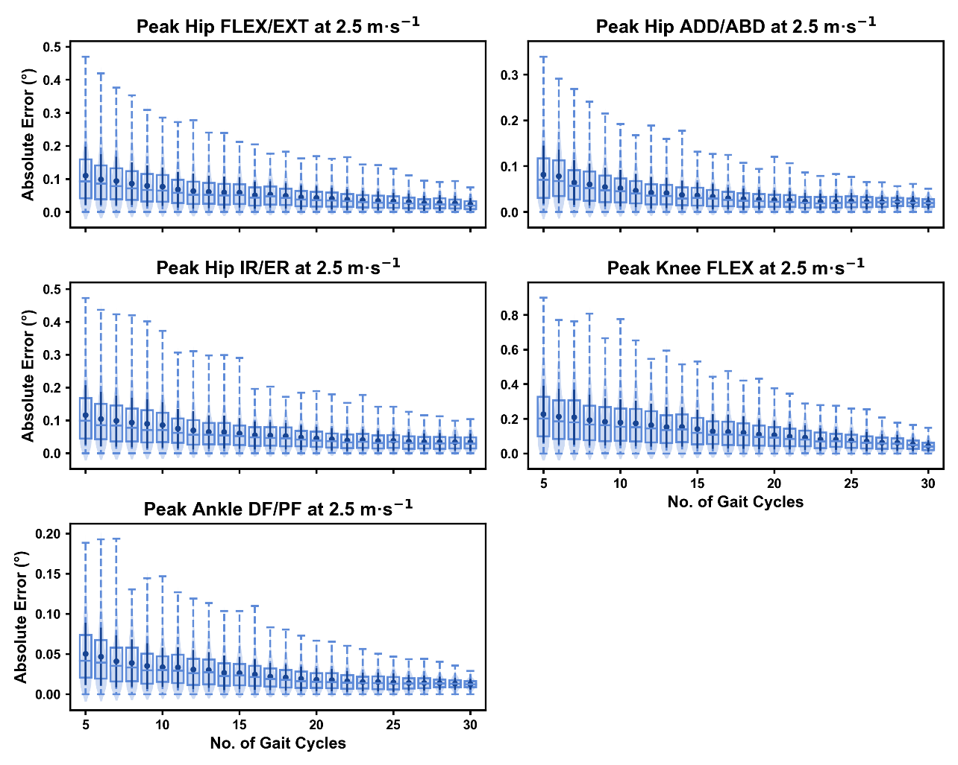

Absolute error in peak kinematic variables (i.e. zero-dimensional [0D]) when running at 2.5m·s using a subset of gait cycles versus all gait cycles from the 30-second treadmill bout. Darker points and solid lines equate to the mean ± standard deviation. Horizontal lines within boxes equate to the median value, boxes indicate the 25 to 75 percentile, and dashed whiskers indicate the range. Shaded violins are included to illustrate the distribution of values. FLEX — flexion; EXT — extension; ADD — adduction; ABD — abduction; IR — internal rotation; ER — external rotation; DF — dorsiflexion; PF — plantarflexion.

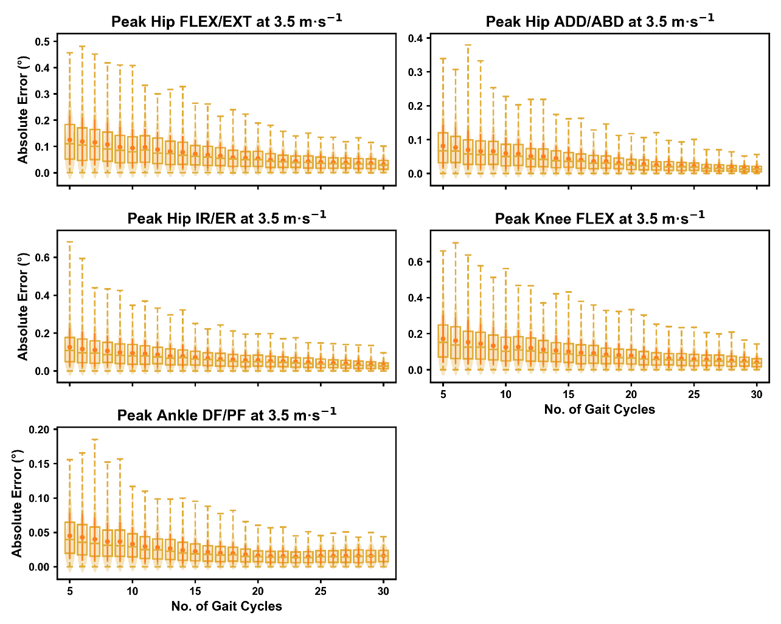

Absolute error in peak kinematic variables (i.e. zero-dimensional [0D]) when running at 3.5m·s using a subset of gait cycles versus all gait cycles from the 30-second treadmill bout. Darker points and solid lines equate to the mean ± standard deviation. Horizontal lines within boxes equate to the median value, boxes indicate the 25 to 75 percentile, and dashed whiskers indicate the range. Shaded violins are included to illustrate the distribution of values. FLEX — flexion; EXT — extension; ADD — adduction; ABD — abduction; IR — internal rotation; ER — external rotation; DF — dorsiflexion; PF — plantarflexion.

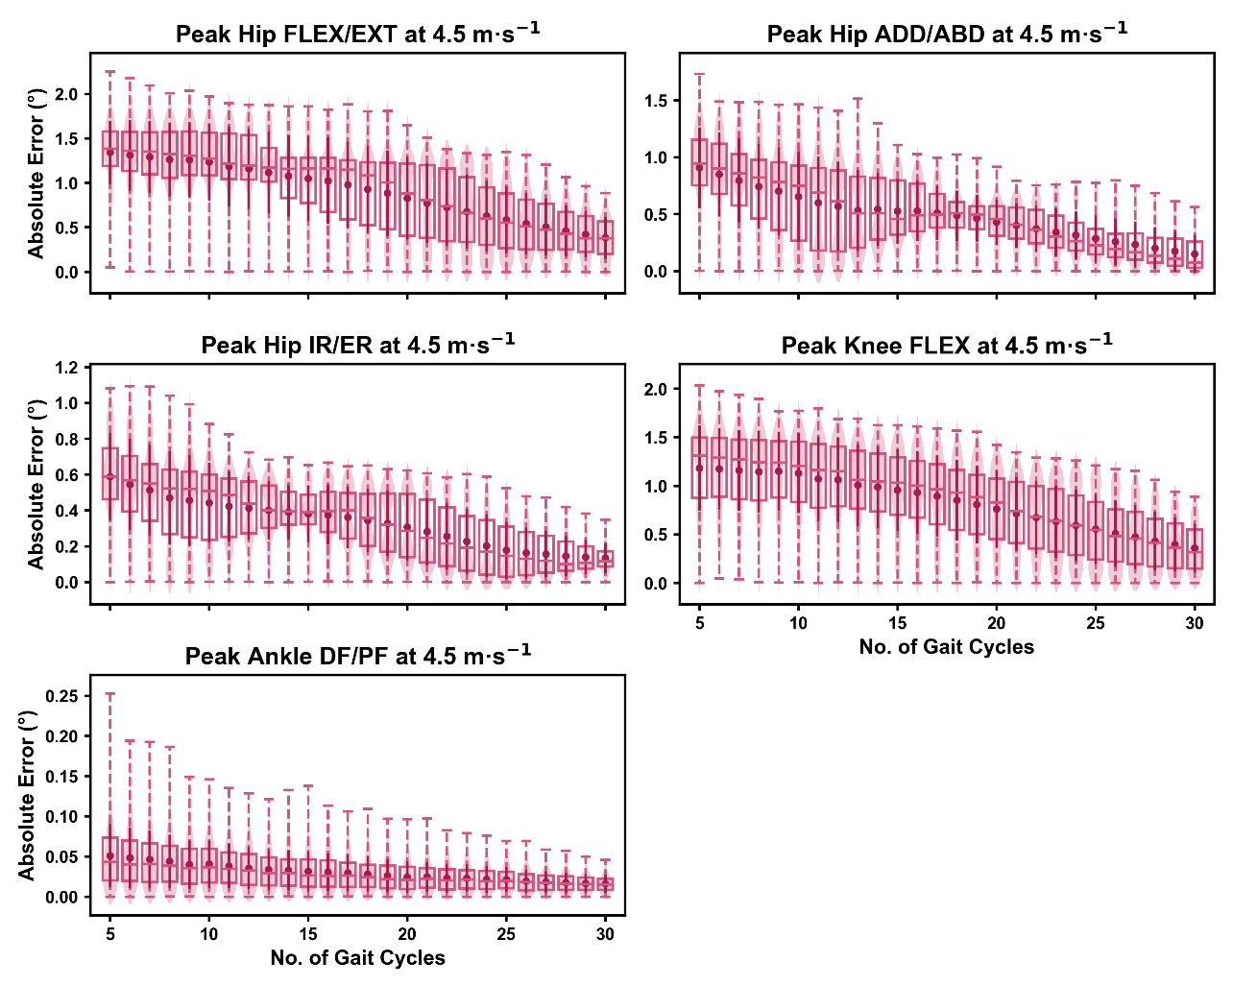

Absolute error in peak kinematic variables (i.e. zero-dimensional [0D]) when running at 4.5m·s using a subset of gait cycles versus all gait cycles from the 30-second treadmill bout. Darker points and solid lines equate to the mean ± standard deviation. Horizontal lines within boxes equate to the median value, boxes indicate the 25 to 75 percentile, and dashed whiskers indicate the range. Shaded violins are included to illustrate the distribution of values. FLEX — flexion; EXT — extension; ADD — adduction; ABD — abduction; IR — internal rotation; ER — external rotation; DF — dorsiflexion; PF — plantarflexion.

We observed near identical characteristics of the mean, variance and range of the peak absolute error of the representative kinematic mean (i.e. compared to the mean from all gait cycles) for the 1D kinematic variables (see Figures , and ). As with the 0D variables, the potential ‘error’ reduced as the number of gait cycles increased, and similarly low magnitudes of ‘error’ (i.e. < 1 degree) were observed between the 2.5m·s-1 and 3.5m·s-1 speeds across the 1D kinematic variables at comparable gait cycle numbers. Larger ‘errors’ exceeding 1-2 degrees with lower gait cycle numbers were present at the 4.5m·s-1 speed (with the exception of ankle dorsi/plantarflexion), with this again appearing to be driven by a more bimodal distribution of samples (see Figure ).

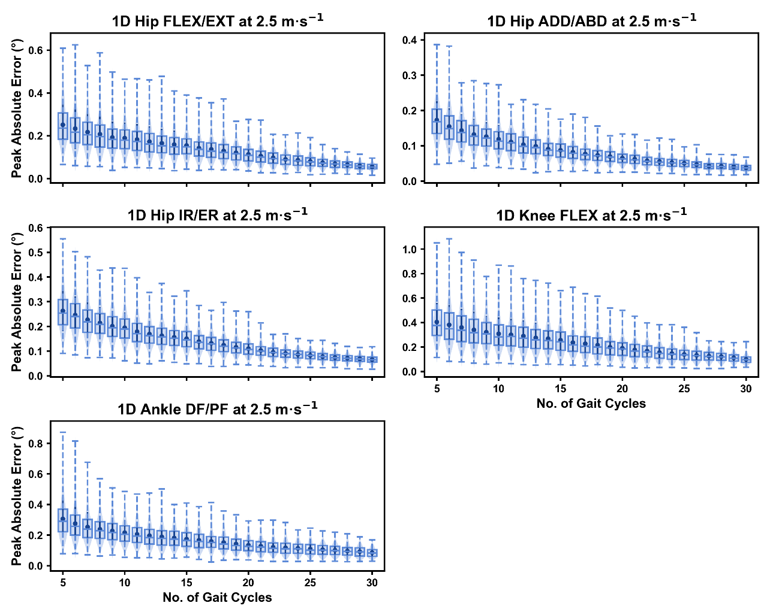

Peak absolute error in kinematic variables across the gait cycle (i.e. one-dimensional [1D]) when running at 2.5m·s using a subset of gait cycles versus all gait cycles from the 30-second treadmill bout. Darker points and solid lines equate to the mean ± standard deviation. Horizontal lines within boxes equate to the median value, boxes indicate the 25 to 75 percentile, and dashed whiskers indicate the range. Shaded violins are included to illustrate the distribution of values. FLEX — flexion; EXT — extension; ADD — adduction; ABD — abduction; IR — internal rotation; ER — external rotation; DF — dorsiflexion; PF — plantarflexion.

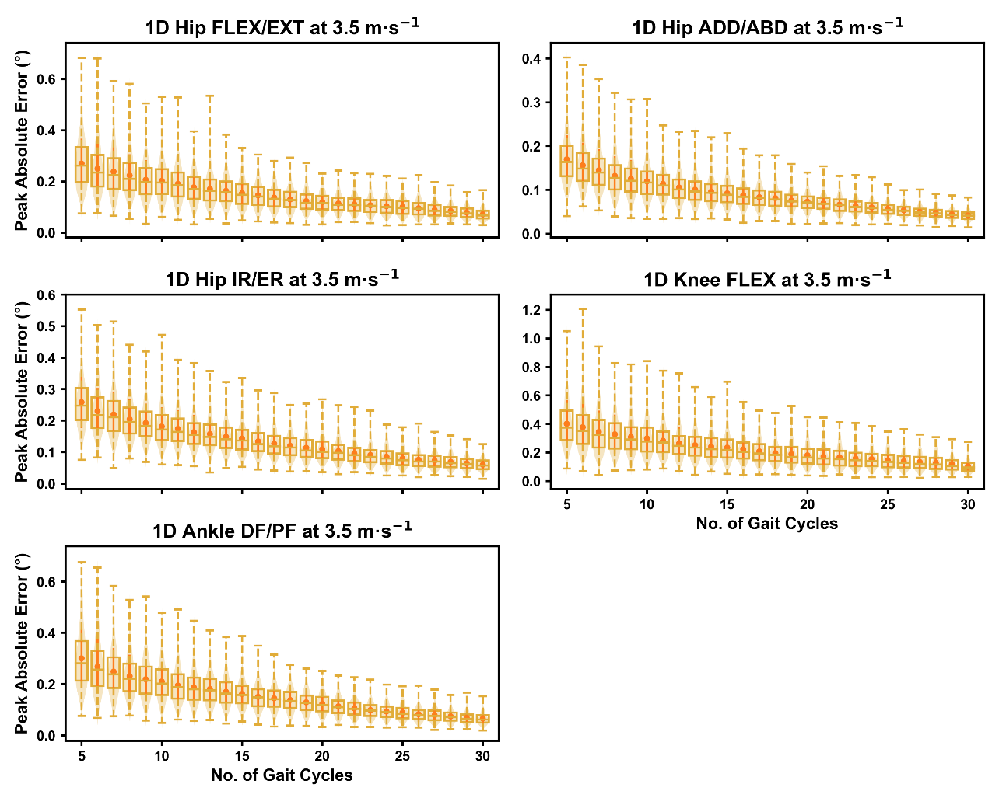

Peak absolute error in kinematic variables across the gait cycle (i.e. one-dimensional [1D]) when running at 3.5m·s using a subset of gait cycles versus all gait cycles from the 30-second treadmill bout. Darker points and solid lines equate to the mean ± standard deviation. Horizontal lines within boxes equate to the median value, boxes indicate the 25 to 75 percentile, and dashed whiskers indicate the range. Shaded violins are included to illustrate the distribution of values. FLEX — flexion; EXT — extension; ADD — adduction; ABD — abduction; IR — internal rotation; ER — external rotation; DF — dorsiflexion; PF — plantarflexion.

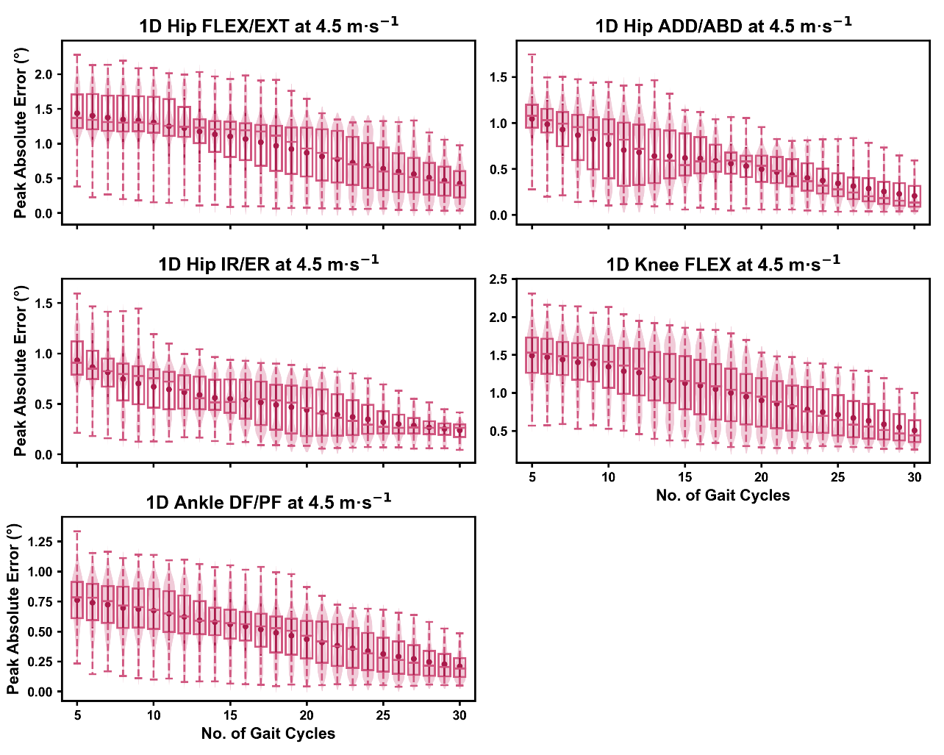

Peak absolute error in kinematic variables across the gait cycle (i.e. one-dimensional [1D]) when running at 4.5m·s using a subset of gait cycles versus all gait cycles from the 30-second treadmill bout. Darker points and solid lines equate to the mean ± standard deviation. Horizontal lines within boxes equate to the median value, boxes indicate the 25 to 75 percentile, and dashed whiskers indicate the range. Shaded violins are included to illustrate the distribution of values. FLEX — flexion; EXT — extension; ADD — adduction; ABD — abduction; IR — internal rotation; ER — external rotation; DF — dorsiflexion; PF — plantarflexion.

## How does the selection of gait cycles impact the representative kinematic mean?

The mean, variance and range of the absolute error (or variation) of the representative kinematic mean (i.e. compared to the mean from all gait cycles) for the peak 0D kinematic variables remained relatively consistent irrespective of the number of gait cycles used (see Figures , and ). At the 2.5m·s-1 and 3.5m·s-1 speeds, the variation in peak kinematic variables depending on where gait cycles were sampled from in the running bout was always less than 1.5 degrees — however, certain kinematic variables had the potential to produce larger variation than others (e.g. peak knee flexion vs. peak ankle dorsiflexion) (see Figures and ). While the potential variation between gait cycle samples was consistent with increasing gait cycle numbers at the 4.5m·s-1 speed, a higher average and range of potential variation (i.e. up to 2-4 degrees) appeared evident across the peak kinematic variables (with the exception of peak ankle dorsiflexion). As in the previous analysis, we observed a bimodal distribution of the samples at the 4.5m·s-1 speed (see Figure ).

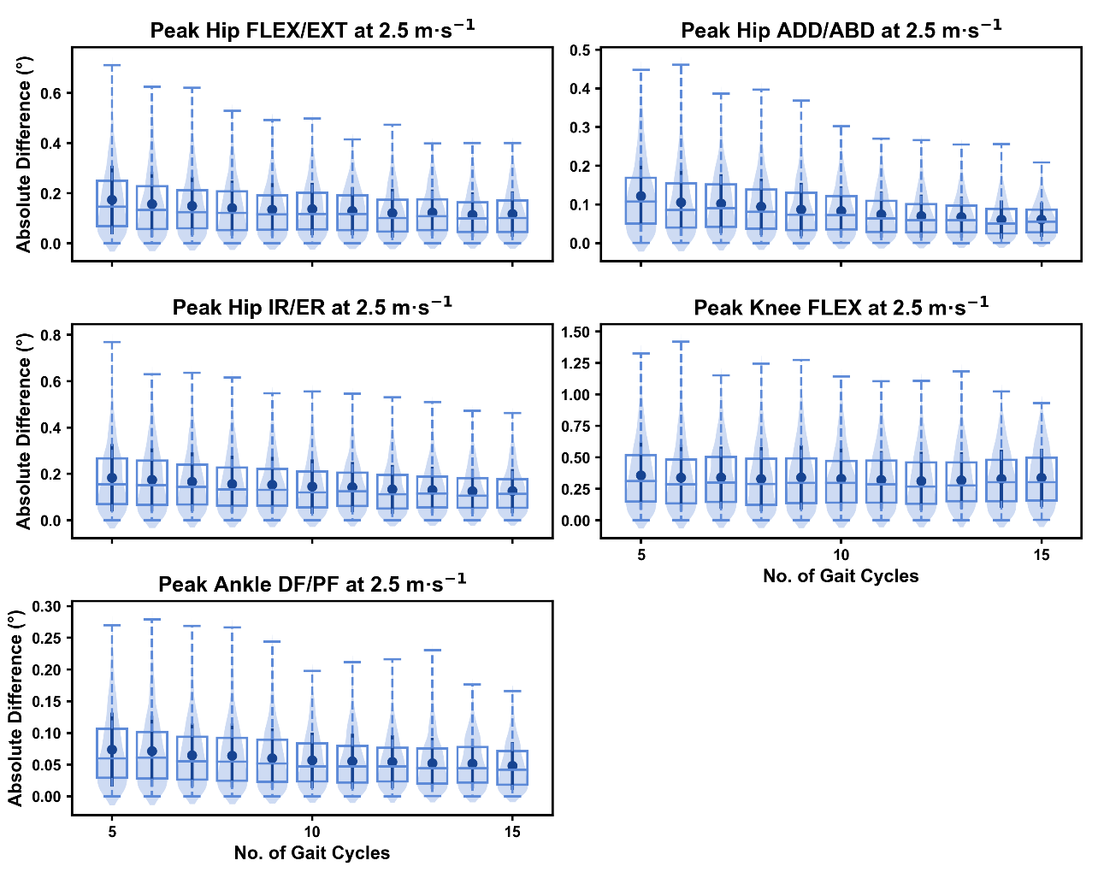

Absolute error in peak kinematic variables (i.e. zero-dimensional [0D]) when running at 2.5m·s using a two comparative subsets of gait cycles from the 30-second treadmill bout. Darker points and solid lines equate to the mean ± standard deviation. Horizontal lines within boxes equate to the median value, boxes indicate the 25 to 75 percentile, and dashed whiskers indicate the range. Shaded violins are included to illustrate the distribution of values. FLEX — flexion; EXT — extension; ADD — adduction; ABD — abduction; IR — internal rotation; ER — external rotation; DF — dorsiflexion; PF — plantarflexion.

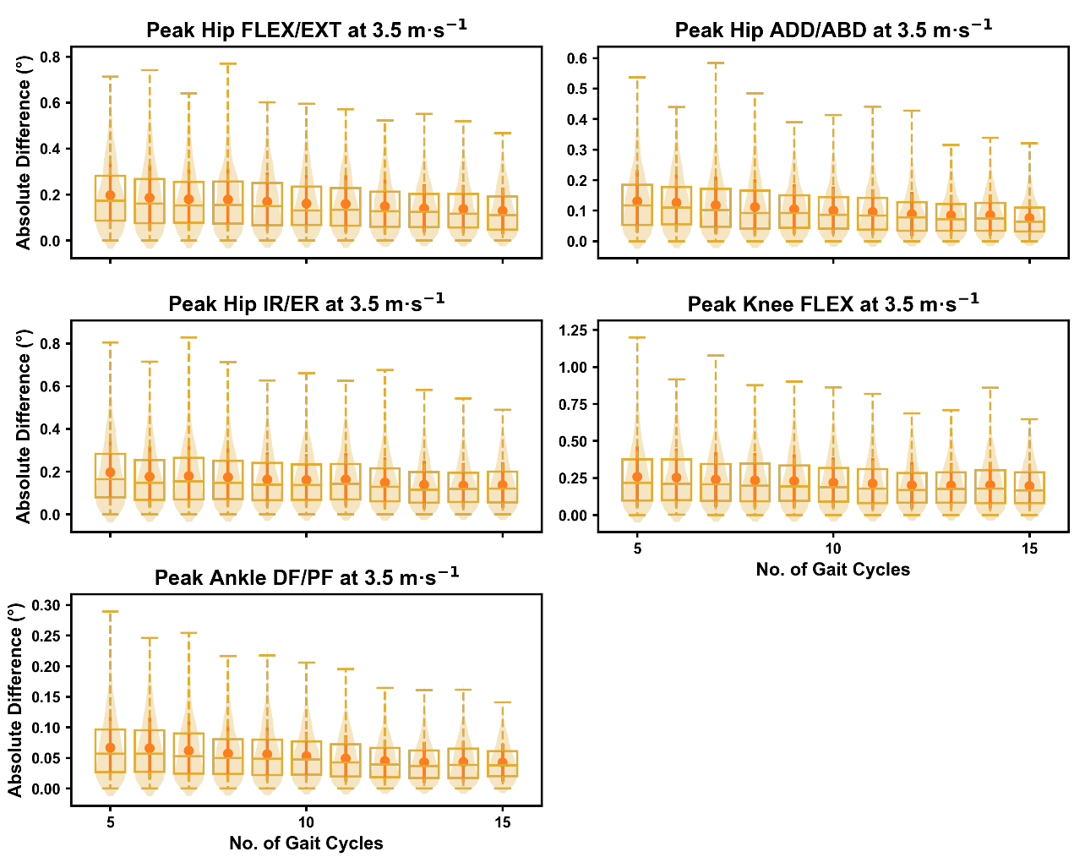

Absolute error in peak kinematic variables (i.e. zero-dimensional [0D]) when running at 3.5m·s using a two comparative subsets of gait cycles from the 30-second treadmill bout. Darker points and solid lines equate to the mean ± standard deviation. Horizontal lines within boxes equate to the median value, boxes indicate the 25 to 75 percentile, and dashed whiskers indicate the range. Shaded violins are included to illustrate the distribution of values. FLEX — flexion; EXT — extension; ADD — adduction; ABD — abduction; IR — internal rotation; ER — external rotation; DF — dorsiflexion; PF — plantarflexion.

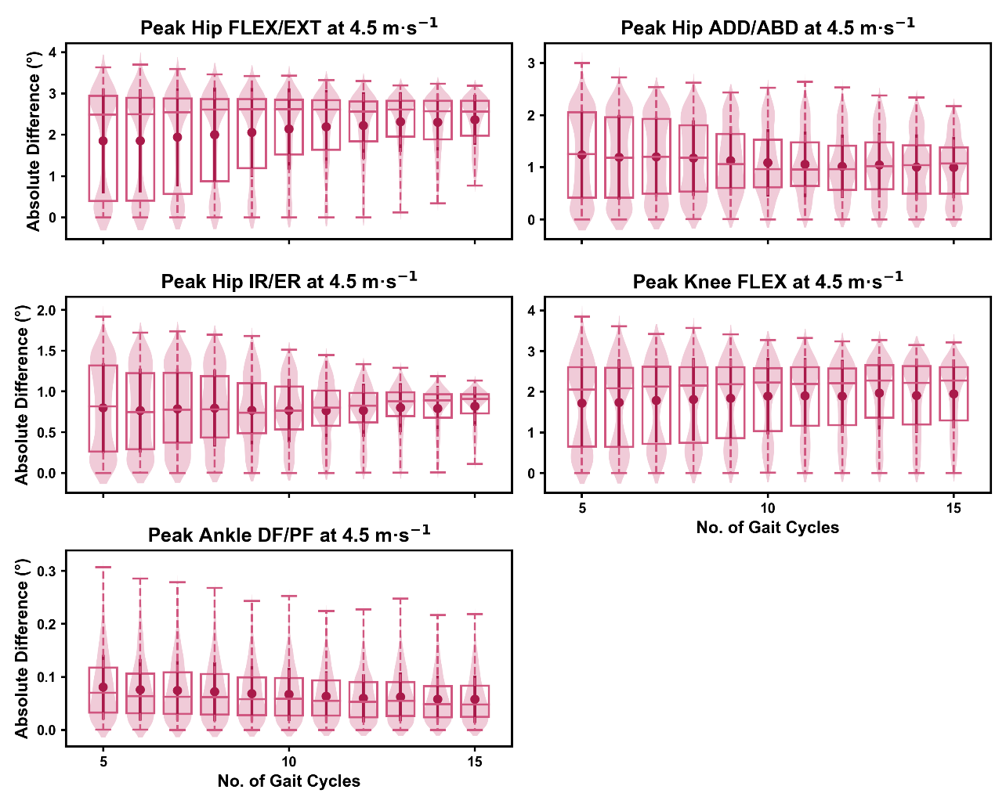

Absolute error in peak kinematic variables (i.e. zero-dimensional [0D]) when running at 4.5m·s using a two comparative subsets of gait cycles from the 30-second treadmill bout. Darker points and solid lines equate to the mean ± standard deviation. Horizontal lines within boxes equate to the median value, boxes indicate the 25 to 75 percentile, and dashed whiskers indicate the range. Shaded violins are included to illustrate the distribution of values. FLEX — flexion; EXT — extension; ADD — adduction; ABD — abduction; IR — internal rotation; ER — external rotation; DF — dorsiflexion; PF — plantarflexion.

We observed similar characteristics for the mean, variance and range of the absolute error (or variation) of the representative kinematic mean (i.e. compared to the mean from all gait cycles) for the 1D kinematic variables when sampling gait cycles from different sections of the treadmill bout (see Figures , and ). The potential variation remained low (i.e. < 1.5 degrees) and consistent across the different number of gait cycles at the 2.5m·s-1 and 3.5m·s-1 speeds (see Figures and ), whereas the potential variation remained consistent but increased (i.e. up to 2-4 degrees), and shifted to a bimodal distribution at the 4.5m·s-1 speed (see Figure ). In contrast to the 0D variables, this shift was evident in all 1D kinematic variables (including ankle dorsi/plantarflexion).

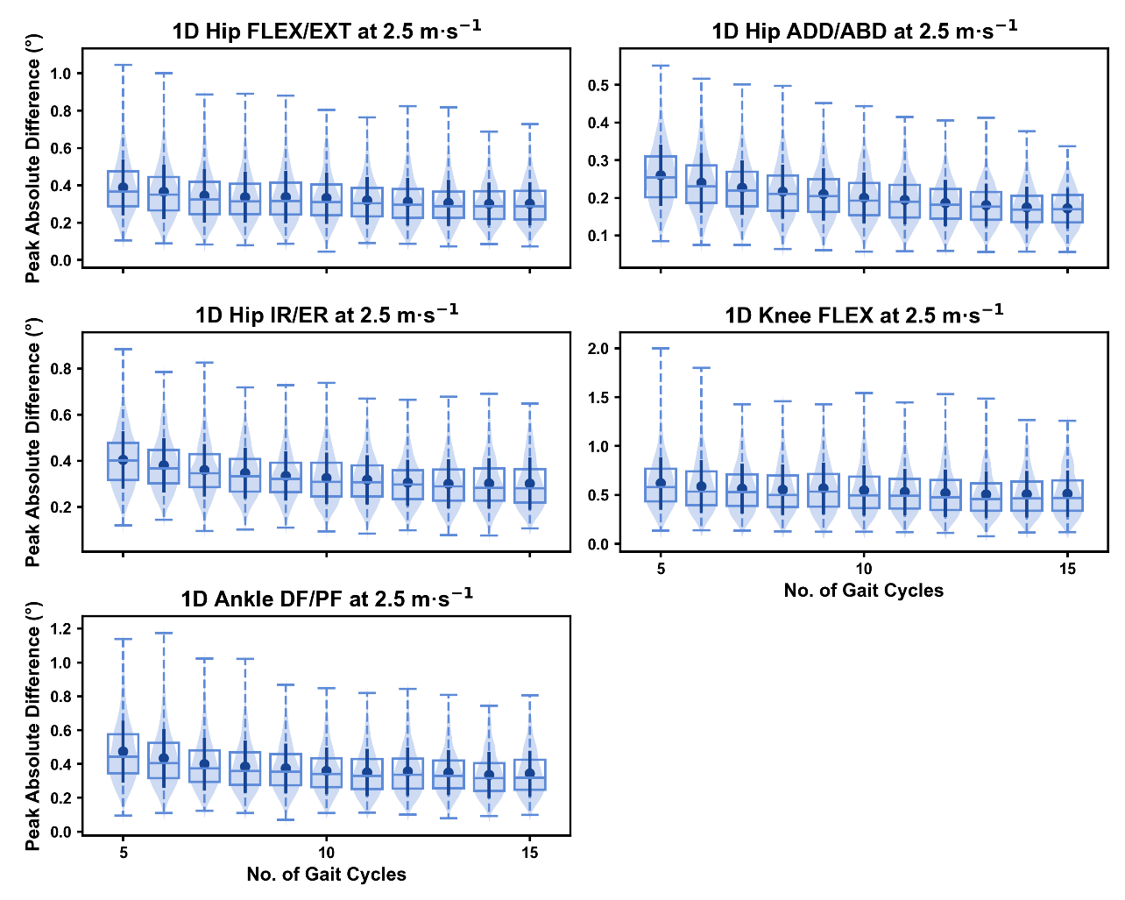

Peak absolute error in kinematic variables across the gait cycle (i.e. one-dimensional [1D]) when running at 2.5m·s using two comparative subsets of gait cycles from the 30-second treadmill bout. Darker points and solid lines equate to the mean ± standard deviation. Horizontal lines within boxes equate to the median value, boxes indicate the 25 to 75 percentile, and dashed whiskers indicate the range. Shaded violins are included to illustrate the distribution of values. FLEX — flexion; EXT — extension; ADD — adduction; ABD — abduction; IR — internal rotation; ER — external rotation; DF — dorsiflexion; PF — plantarflexion.

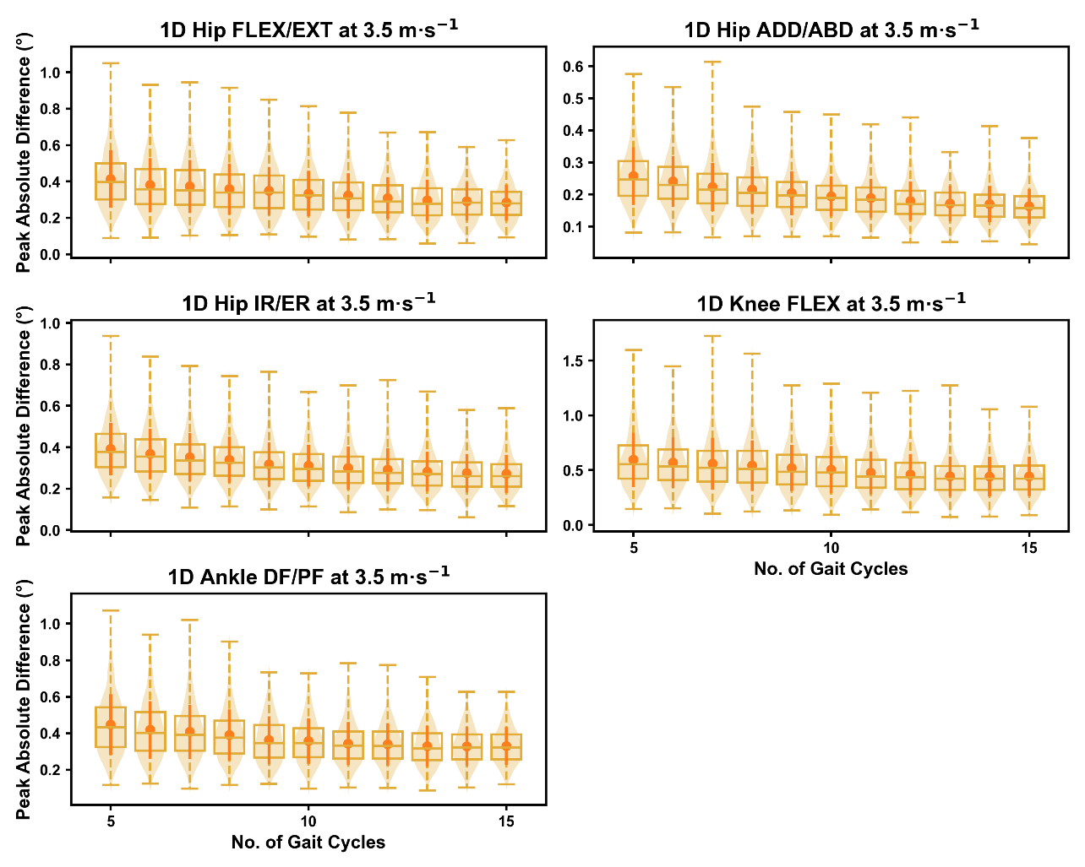

Peak absolute error in kinematic variables across the gait cycle (i.e. one-dimensional [1D]) when running at 3.5m·s using two comparative subsets of gait cycles from the 30-second treadmill bout. Darker points and solid lines equate to the mean ± standard deviation. Horizontal lines within boxes equate to the median value, boxes indicate the 25 to 75 percentile, and dashed whiskers indicate the range. Shaded violins are included to illustrate the distribution of values. FLEX — flexion; EXT — extension; ADD — adduction; ABD — abduction; IR — internal rotation; ER — external rotation; DF — dorsiflexion; PF — plantarflexion.

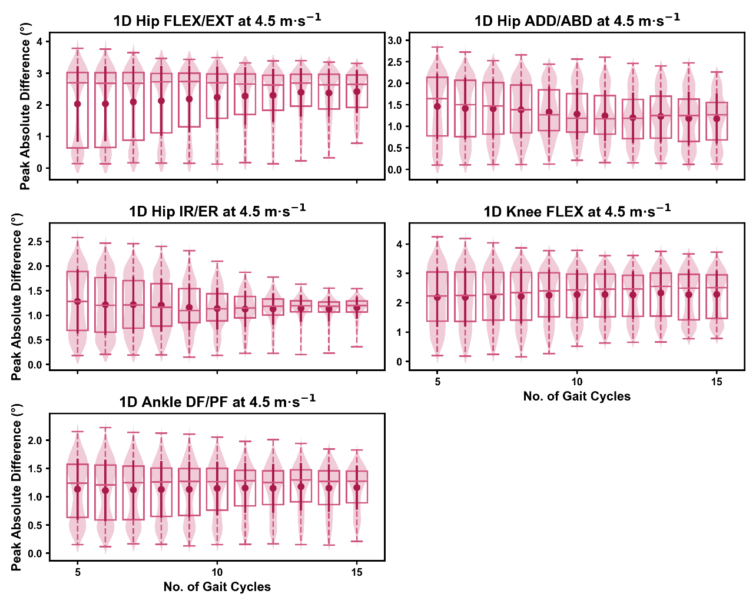

Peak absolute error in kinematic variables across the gait cycle (i.e. one-dimensional [1D]) when running at 4.5m·s using two comparative subsets of gait cycles from the 30-second treadmill bout. Darker points and solid lines equate to the mean ± standard deviation. Horizontal lines within boxes equate to the median value, boxes indicate the 25 to 75 percentile, and dashed whiskers indicate the range. Shaded violins are included to illustrate the distribution of values. FLEX — flexion; EXT — extension; ADD — adduction; ABD — abduction; IR — internal rotation; ER — external rotation; DF — dorsiflexion; PF — plantarflexion.

# Discussion

A common approach in biomechanical studies of running is to use a subset of gait cycles from a bout of running, and average across these cycles to calculate a representative mean for each participant. There is very little objective analysis or understanding of what underpins the number and selection of gait cycles used, and the impact this can have on the error or variation in biomechanical measures. We aimed to understand how the number of gait cycles selected, and where these are selected from, during a continuous bout of treadmill running impact the magnitude of ‘error’ and variation in lower limb kinematic measures. We found that including a greater number of gait cycles in the calculation of a representative kinematic mean has the potential to reduce the magnitude and range of potential ‘error’ in kinematic measures. The potential error using a reduced number of gait cycles (i.e. *n* = 5-10) was relatively small (i.e. typically < 1 degree) when running at 2.5m·s-1 and 3.5m·s-1, but slightly inflated (i.e. 1-4 degrees) as running speed increased to 4.5m·s-1. We found similarly small magnitudes and patterns of variation in representative kinematic means across the different running speeds when selecting gait cycles from different sections of the running bout, and these remained relatively consistent irrespective of the number of gait cycles used.

We found that the ‘error’ between the representative kinematic means and the associated ‘ground truth’ values progressively reduced with an increasing number of gait cycles. Using a greater number of gait cycles equated to using a higher proportion of data that were used to create the ‘ground truth’ — hence this result is not surprising. More noteworthy is the scale of ‘error’ when using a reduced number of gait cycles (i.e. *n* = 5-10) and the diminishing effect using a larger number of gait cycles (i.e. *n* > 15) had. We typically observed that the maximum ‘error’ or variation with respect to the ‘ground truth’ was less than one degree even at the lowest number of gait cycles used with running at the 2.5m·s-1 and 3.5m·s-1 speeds, but this could increase up to three degrees at the faster 4.5m·s-1 speed. Reducing the potential variation of ‘error’ compared to the ground truth appeared to be the main effect of increasing the number of gait cycles used. However, this typically plateaued and a diminished benefit observed when using above 15-20 gait cycles. These patterns were consistent across both the 0D and 1D kinematic approaches. The notion of diminishing returns above 15-20 gait cycles contrasts with the findings of Oliveira and Pirscoveanu(**Oliveira2021?**) — whereby data stability was not achieved in the majority of runners using this number of gait cycles. A clear difference between our study and this existing work(**Oliveira2021?**) was the biomechanical measures analysed (i.e. joint kinematics vs. mostly kinetic variables). Forrester(**Forrester2015?**) performed a series of simulations using a similar sequential analysis technique to Oliveira and Pirscoveanu(**Oliveira2021?**) to determine the number of trials required for biomechanical measures with typical means and standard deviations. This work(**Forrester2015?**) proposed that nine (± 8) trials were required to achieve stability of the mean, which is more in line with our findings of diminishing returns in ‘error’ at 15-20 gait cycles. The mean and variation of the biomechanical measure being examined likely plays a significant role in the potential ‘error’ when using a reduced number of trials (or gait cycles). We saw the largest potential ‘errors’ in hip and knee flexion when using a smaller number of gait cycles — and this is perhaps not surprising given these measures had the largest means and standard deviations within the dataset used(**Fukuchi2017?**).

Despite the potential for diminishing returns, our data suggests that researchers can minimise the potential ‘error’ in representative kinematic means by using more gait cycles. A simplistic recommendation from our analyses would therefore be to use as many gait cycles as possible within such calculations. This does, however, ignore the practical considerations of storing, cleaning and processing larger biomechanical data files. If there are no limitations to using a large number of gait cycles (i.e. 20-30) then this will minimise potential ‘error’ or variation in calculations. Certain circumstances, such as a large participant sample or timely computational measures, may subsequently make using 20+ gait cycles per sample impractical. Our recommendation is therefore to balance the practical considerations against the potential ‘error’ or variation in the data that can be tolerated. Most of the time this will come down to the accuracy of the measure, or size of the effect researchers or clinicians are interested in measuring. For example, based on our analyses — using less than ten gait cycles to explore a small effect (i.e. < 1-2 degrees) in 1D hip or knee flexion continua may be unwise, as the potential variation in the calculated means could exceed the magnitude of the effect of interest. Our data suggests as a general recommendation — the smaller the expected effect or magnitude of effect of interest, the greater number of gait cycles should be used for analyses.

We observed relatively small variations (i.e. < 1.5 degrees) between representative kinematic means calculated from gait cycle samples extracted from different sections of the 2.5m·s-1 and 3.5m·s-1 running bouts, while these slightly increased (i.e. 2-4 degrees) when examining the 4.5m·s-1 speed. This magnitude of variation did remain consistent irrespective of the total number of gait cycles used. These findings suggest that once the number of gait cycles used for analysis is selected — the decision of where these are selected from will introduce a small, but consistent amount of variation. The inherent variability in human movement(**vanEmmerik2000?**) is the likely and potentially unavoidable cause of this variation. We randomly sampled differing sections of the running bout as part of our analyses, and at-times this generated near zero variation between the two representative means. Without further inspection of our data we cannot confirm what generated the reduced variation, but we hypothesise that the samples with minimal to no variation likely stemmed from using sections of the running bout in close proximity to one another. We also cannot determine which section of the running bout is more representative or ‘accurate,’ as we only compared between samples and did not extend this comparison to the ‘ground truth’ values. Our data can only be used to infer the potential magnitude of variation one can expect when using gait cycles from different sections of the running bout. The magnitude of this variation once again appears to be driven by the scale of the mean and standard deviation of the measure (i.e. kinematic measures with higher means and standard deviations incur a greater magnitude of variation). Much like the earlier point raised, the practical implications of these findings relate to the confidence we can have in our accuracy of measuring an effect on lower limb kinematics during treadmill running. If our observed effect does not exceed the typical variation seen when sampling from different sections of the running bout, there is a possibility that the observed effect is simply noise due to the gait cycles sampled. Researchers and clinicians must therefore be wary of this, particularly when interpreting very small effects.

A point of difference across our analyses was the impact of speed on inducing greater ‘error’ relative to the ‘ground truth’ and between representative means from different sections of the gait bout. Specifically, the 4.5m·s-1 trials induced higher values in these metrics relative to the 2.5m·s-1 and 3.5m·s-1 trials. There are various potential reasons for why we observed these results. Faster running speeds induce larger means and standard deviations across kinematic variables(**Fukuchi2017?**)***[OTHER REFS?]***, particularly in those we observed a more dramatic increase in ‘error’ for at 4.5m·s-1 (i.e. hip and knee flexion). Much like our theory when comparing ‘error’ between different kinematic variables, we propose that the larger means and standard deviations at higher speeds introduce a greater magnitude of variation across gait cycles — and hence greater potential for ‘error’ when sampling from different gait cycles. Similar kinematic differences are typical between all of running speeds we examined(**Fukuchi2017?**)***[OTHER REFS?]***. It is therefore surprising that the increase in ‘error’ or variation was not consistent, and most evident and prominent only when examining the 4.5m·s-1 speed. This suggests other factors may contribute to the increase in ‘error’ we observed. Within the dataset we examined, participants ran for a three minute accommodation period at each speed, following which data were collected over a 30 second period(**Fukuchi2017?**). The order of running conditions (i.e. 2.5m·s-1, 3.5m·s-1, 4.5m·s-1) was kept consistent for each participant(**Fukuchi2017?**). It is possible that these experimental procedures (i.e. running at the fastest speed towards the end of the running period) could have introduced some form of fatigue in the 4.5m·s-1 speed bout. Running in a fatigued state can increase biomechanical variability ***[ADD REFS]***, while also altering running kinematics compared to a non-fatigued state ***[ADD REFS]***. If fatigue was present during the final bout of running, it could theoretically have induced an increase in kinematic variability during the 30 second period of data collection. Alternatively, fatigue may have begun to set in within the final 30 seconds of the run — potentially inducing a change in running kinematics within the period where data were collected. This latter explanation may explain the bimodal distribution in ‘error’ we observed in the 4.5m·s-1 running bout, whereby larger ‘errors’ may have been observed when sampling gait cycles from earlier versus later sections of the 30 second data collection period. Given we did not explicitly record the sections where gait cycles were sampled from, this notion is purely speculative. It should also be noted that the studies identifying changes in running biomechanics with fatigue***[ADD REFS]*** used exercise protocols of higher intensity and longer duration than what participants experienced with the dataset used in our study. Despite the lack of understanding around the potential mechanism — our study demonstrates a greater need to consider gait cycle sampling practices with running at faster speeds, and potentially when fatigue is present.

Although we identified the potential for measurement ‘error’ or variation to present based on gait cycle selection — these were comparatively small relative to other noted sources of error across the biomechanical literature(**Ceseracciu2014?**). The magnitude of ‘error’ in the present study is eclipsed by the errors or variation introduced by soft-tissue artefact associated with skin-mounted markers(**DIsidoro2020?**), different joint coordinate systems(**Sauret2016?**) or gait models(**Mentiplay2018?**), kinematic algorithm choice(**Kainz2016?**), individual testing experience(**Sinclair2014?**), or different measurement systems (i.e. marker vs. marker-less)(**Ceseracciu2014?**). ***[SOMETHING NEEDS TO BE ADDED HERE TO WRAP THIS UP…?]***

Our results must be considered with respect to the limitations in our approach. We only examined conditions where *n* consecutive gait cycles were sampled from a continuous bout of treadmill running at three set speeds. Different results might be expected with non-consecutive selection of samples from the running bout, or under different running conditions (e.g. outdoor overground running and slower or faster speeds). Similarly, we focused on peak and 1D waveform data of lower limb kinematic variables. Other variables used in gait analysis (e.g. joint moments, estimates of muscle activation and forces) may incur variable magnitudes of ‘error’ or variation with respect to gait cycle selection. Our findings are therefore most applicable to situations where the analyses and running conditions replicate those of our experiment. We also inferred ‘error’ via comparison to values calculated from all gait cycles in an individuals running bout (i.e. our ‘ground truth’ value). Although we deemed this the best approach within our study, it is important to acknowledge that these values may still not represent the individuals exact or true running kinematics.

# Conclusions

We identified the range of potential ‘error’ or variation in lower limb kinematics associated with selecting different gait cycles from a bout of continuous treadmill running. Our findings suggest that selecting as many gait cycles as possible from the running bout will minimise ‘error’ — however, analysing a smaller sample (i.e. 5-10 gait cycles) will typically result in ‘errors’ or variation less than 3 degrees. Larger potential ‘errors’ or variation can likely be expected when analysing kinematic variables with larger means and standard deviations, and during running at faster speeds. Researchers and clinicians should consider the balance between the benefits of collecting, processing and analysing a greater number of gait cycles against the potential reductions in ‘error’ when determining their methodological approach. Irrespective of the number of gait cycles used, we recommend that the potential ‘error’ or variation introduced by this choice be considered when interpreting effects from treadmill-based running studies (i.e. is the magnitude of potential ‘error’ larger than the identified effects between groups or following an intervention).

# References

***[TODO: add citation library]***