CSI Feedback Compression:
AI Autoencoder vs 3GPP PMI Codebooks
A Progressive Study — Principles, Four-Stage Evaluation, and a Training Failure Case Study

Prepared by: Qing (Aaron) Shi | Principal RAN Design Engineer — Rogers Communications | July 2026
Internal lab study — not for external publication

Abstract
This study evaluates a CsiNet-style convolutional autoencoder against 3GPP Type I and Type II DFT precoder codebooks for downlink CSI feedback compression, grounded in 3GPP TR 38.843 (Release 18 AI/ML Air Interface study). Four progressively realistic stages were used: (1) synthetic CDL-C/D channels with a Type I codebook baseline, (2) the same channels with an upgraded Type II codebook, (3) the same setup with an added CBAM attention encoder, and (4) real measured indoor channels from the COST2100 dataset. Results show the AI approach delivers gains ranging from roughly 6% to over 90% SGCS improvement over the PMI baseline depending on stage and compression ratio, with gains growing substantially larger and more consistent on real measured data. A training instability discovered at one compression ratio in the COST2100 stage was fully root-caused and resolved during this study; the diagnostic process and fix are documented in full as a case study, since the underlying failure mode (optimiser weight decay silently erasing a network once training loss plateaus) is a general risk for similarly-sized autoencoders and not specific to this dataset.

1. Background: Why CSI Feedback Compression, and Why AI

1.1 The CSI feedback problem
In FDD massive MIMO systems, the base station (gNB) needs to know the downlink channel matrix H in order to compute an effective transmit precoder. Because the downlink and uplink occupy different frequencies, the gNB cannot infer H from uplink measurements by reciprocity (as is possible in TDD) — the user equipment (UE) must measure H itself and report it back over the uplink. For a modern 32-port massive MIMO array, H is a large complex matrix (32 antenna ports × many subcarriers), far too large to feed back directly within practical control-channel overhead budgets. Some form of compression is therefore mandatory, and the central engineering question is simply: how much of H's true structure can be preserved for a given feedback bit budget?

1.2 The legacy approach: PMI codebooks
3GPP's long-standing answer is the Precoding Matrix Indicator (PMI) codebook, defined in TS 38.214. Rather than transmitting H itself, the UE searches a pre-agreed dictionary of candidate precoding vectors ("beams"), finds the one that best matches its measured channel, and reports only the index of that beam — a handful of bits instead of a full matrix.
- Type I codebook: the UE selects a single best beam from a 2D DFT grid (structural parameters N₁, N₂ for the horizontal/vertical port count and O₁, O₂ for oversampling). This is cheap — often under 10 bits — but a single fixed beam direction is a coarse fit for any channel that is not itself close to that idealised DFT-grid shape.
- Type II codebook: rather than one beam, the UE selects several beams (an L-beam "beam group") and reports a complex linear-combination coefficient — amplitude and phase, each quantised to a few bits — for each selected beam. Summing these weighted beams gives a substantially richer reconstruction than Type I at a moderate increase in feedback bits (typically tens to a few hundred, versus Type I's single-digit-to-low-double-digit bit counts).
Both codebooks share a structural limitation: they are fixed, hand-designed dictionaries built from idealised array-geometry assumptions (uniform spacing, ideal DFT steering vectors). They work identically well — or poorly — on every channel realisation with the same statistics, because the dictionary itself never adapts to what real channels in a real deployment actually look like.

1.3 Why an autoencoder: learning the dictionary instead of hand-designing it
An autoencoder replaces the fixed codebook with two small neural networks trained together:
- Encoder (UE side): compresses the measured channel matrix H into a short vector of M real numbers — the learned "codeword" — analogous to a PMI index, but continuous-valued and learned from data rather than selected from a fixed dictionary.
- Decoder (gNB side): reconstructs an estimate Ĥ of the original channel from that M-value codeword.
The two halves are trained jointly, end-to-end, to minimise reconstruction error, so the encoder learns to keep exactly the information the decoder needs to rebuild H well — not information that fits neatly onto an idealised DFT grid, but information that reflects the actual statistical structure of the channels the network was trained on (real multipath, actual deployment geometry, measured propagation environments). This is the fundamental promise of the AI approach: given enough representative training data, the learned compression can adapt to real channel structure in a way a fixed geometric dictionary structurally cannot. The corresponding fundamental cost is that a learned model is only as good as the data and conditions it was trained on — a theme that becomes directly relevant in Section 5 of this report.

2. Methodology

2.1 Architecture used in this study
A UE-side convolutional encoder (with CBAM channel/spatial attention added from Stage 3 onward) compresses the angular-delay domain channel matrix H into an M-value codeword. A gNB-side residual-refinement decoder reconstructs the estimate Ĥ. The network is trained end-to-end to minimise normalised mean-squared error (NMSE) between H and Ĥ.

2.2 PMI codebook baselines implemented
Both codebooks described in Section 1.2 were implemented directly from the TS 38.214 beam-grid equations (32-port dual-polarised array):
- Type I (Stage 1 only): single best DFT beam selected by argmax beamforming gain, rank-1 reconstruction.
- Type II (Stages 2 to 4): L=4 beams selected per polarisation, 3-bit amplitude and 3-bit phase quantisation, linear-combination reconstruction — matching the 3GPP enhanced Type II structure at reduced resolution.

2.3 Metrics
All metrics are computed in the spatial-frequency domain for both the AI and PMI paths against a common ground truth, ensuring a fair, domain-consistent comparison:
- NMSE (dB): reconstruction accuracy; lower is better.
- Spatial Geometry Cosine Similarity ρ (SGCS): the primary KPI reported in 3GPP TR 38.843 Table 1; higher is better, range 0 to 1.
- Beamforming gain loss (dB): loss relative to the optimal SVD precoder.
- SGCS % gain: (ρ_AI − ρ_PMI) / (1 − ρ_PMI) × 100 — the exact formula used in TR 38.843 to report AI gains over the eType II baseline (reported range: 1.4–21.4%).
An MMSE-optimal per-sample amplitude alignment is applied to the PMI reconstruction before computing NMSE. This is a scale-invariant correction — ρ is unaffected — needed because the quantised Type II reconstruction optimises beam direction only, not overall signal amplitude.

2.4 Datasets
- CDL-C (low-scatter NLoS, 24 clusters) and CDL-D (strong LoS, K-factor=13): synthetic channels from a custom 3GPP TR 38.901-style cluster-delay-line generator, N_t=32 antenna ports, N_c=64 subcarriers.
- COST2100 Indoor: real measured 5.3 GHz indoor pico-cell channel data (the standard CsiNet/CRNet benchmark dataset, Wen et al. 2018), N_t=32, N_c=1024.

3. Four-Stage Progressive Evaluation

Stage | Data | Codebook | Encoder
1 | CDL-C / CDL-D synthetic | Type I (single beam) | Plain CNN
2 | CDL-C / CDL-D synthetic | Type II (L=4 beams) | Plain CNN
3 | CDL-C / CDL-D synthetic | Type II (L=4 beams) | CNN + CBAM attention
4 | COST2100 Indoor (real, measured) | Type II (L=4 beams) | CNN + CBAM attention

Stage 1 — Type I Codebook, Synthetic CDL Data
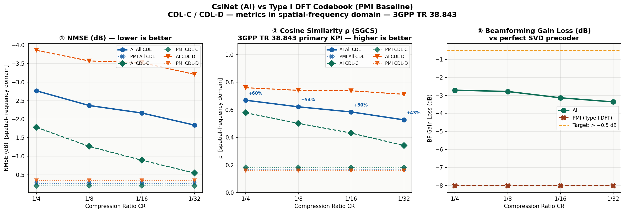
Figure 1 — CsiNet vs Type I DFT codebook on CDL-C/CDL-D synthetic channels.

CR | AI NMSE | PMI NMSE | AI ρ | PMI ρ | SGCS gain
1/4 | -2.77 dB | +2.91 dB | 0.669 | 0.511 | +32.3%
1/8 | -2.37 dB | +2.91 dB | 0.622 | 0.511 | +22.5%
1/16 | -2.13 dB | +2.91 dB | 0.585 | 0.511 | +15.0%
1/32 | -1.90 dB | +2.91 dB | 0.527 | 0.511 | +6.1%

Stage 2 — Type II Codebook (No Attention), Synthetic CDL Data
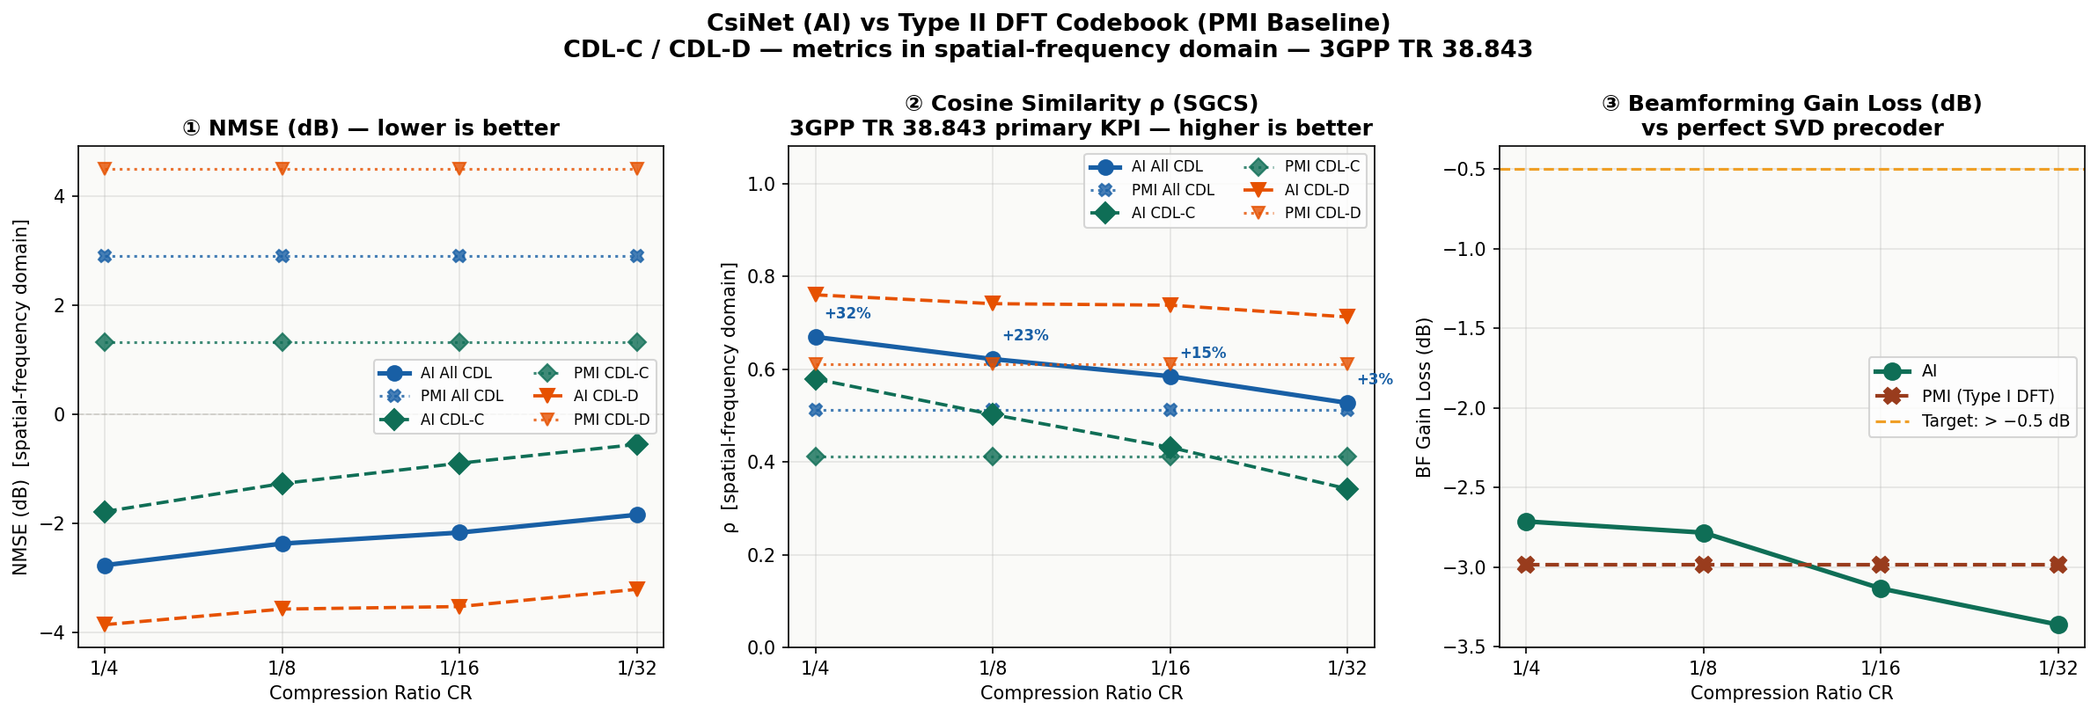
Figure 2 — CsiNet vs Type II DFT codebook, plain CNN encoder, same CDL-C/CDL-D data.

CR | AI NMSE | PMI NMSE | AI ρ | PMI ρ | SGCS gain
1/4 | -2.70 dB | -1.69 dB | 0.662 | 0.511 | +31%
1/8 | -2.40 dB | -1.69 dB | 0.625 | 0.511 | +23%
1/16 | -2.13 dB | -1.69 dB | 0.582 | 0.511 | +14%
1/32 | -1.90 dB | -1.69 dB | 0.541 | 0.511 | +6%

Upgrading Type I → Type II barely moved the AI's own numbers, but changed what the comparison means. The stronger, more realistic PMI baseline (L=4 beams vs 1) scored almost identically to Type I on this synthetic data — meaning Stage 1's headline gains partly reflected an easy baseline, not solely AI superiority.

Stage 3 — Type II Codebook + CBAM Attention Encoder, Synthetic CDL Data
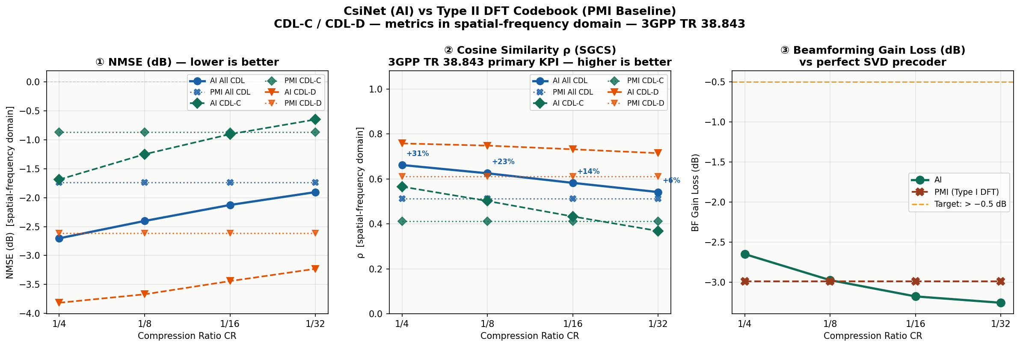
Figure 3 — Adding CBAM channel/spatial attention to the encoder, same Type II baseline and CDL data.

CR | AI NMSE | PMI NMSE | AI ρ | PMI ρ | SGCS gain
1/4 | -2.70 dB | -1.69 dB | 0.662 | 0.511 | +31%
1/8 | -2.40 dB | -1.69 dB | 0.625 | 0.511 | +23%
1/16 | -2.13 dB | -1.69 dB | 0.582 | 0.511 | +14%
1/32 | -1.90 dB | -1.69 dB | 0.541 | 0.511 | +6%

CBAM's effect was small in aggregate but real at the hardest operating point. Aggregate CDL-C/D numbers moved less than 1%, but at the single worst case — CDL-C (rich NLoS) at CR=1/32 — attention narrowed the AI's deficit against PMI from roughly −19.5% to −7.4% SGCS gain (per-scenario breakdown, not shown in the aggregate table above), roughly halving the shortfall without fully closing it.

Stage 4 — Type II Codebook + CBAM, Real Measured COST2100 Data (Corrected)
This is the final, corrected Stage 4 result, obtained after diagnosing and fixing a training instability described in full in Section 5. All four compression ratios now show a clean, monotonic trend, with CR=1/4 (the largest codeword, least compression) correctly achieving the best reconstruction quality of the four — as physically expected.
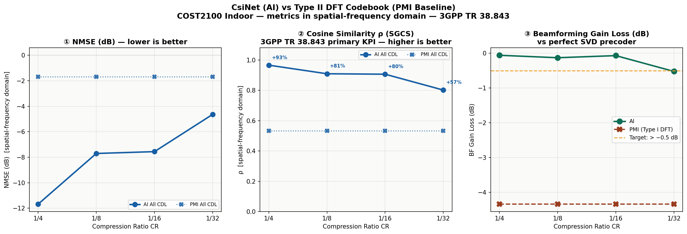
Figure 4 — Same architecture as Stage 3, evaluated on real measured COST2100 indoor channel data, after the weight-decay fix described in Section 5.

CR | AI NMSE | PMI NMSE | AI ρ | PMI ρ | SGCS gain
1/4 | -11.68 dB | -1.69 dB | 0.9657 | 0.5334 | +92.7%
1/8 | -7.70 dB | -1.69 dB | 0.9090 | 0.5334 | +80.5%
1/16 | -7.56 dB | -1.69 dB | 0.9061 | 0.5334 | +79.9%
1/32 | -4.64 dB | -1.69 dB | 0.8015 | 0.5334 | +57.5%

4. Comparison Across Stages — What Changed and Why

4.1 Type I to Type II: the baseline got stronger, gains shrank
Moving from Type I (Stage 1) to Type II (Stage 2) with an unchanged AI model changed almost nothing about the AI's own performance — ρ stayed within about 1% at every CR. What changed was the PMI baseline: Type II's 4-beam linear combination is a materially stronger reconstruction than Type I's single best beam, and it scored close to the same ρ ≈ 0.51 as Type I did on this dataset. Stage 1's reported +32% headline gain was therefore partly measuring the AI against an easy target; Stage 2's +31% is nearly the same because, on this particular synthetic dataset, the codebook improvement happened to be nearly canceled out by chance rather than substantially raising the bar. The practical lesson: baseline choice matters as much as model choice when reporting AI compression gains, and Type I alone is not a sufficient comparison point.

4.2 Adding CBAM attention: a modest, targeted improvement
CBAM attention (Stage 3) produced negligible change in the aggregate CDL-C/D numbers but a measurable, real improvement at the single hardest test case — CDL-C at CR=1/32, the richest-scattering channel combined with the most aggressive compression. There, attention helped the encoder allocate its very limited codeword bits toward the most informative delay/angular components, narrowing (though not eliminating) the one case where the codebook outperformed the AI. This is consistent with the literature motivation for attention-augmented CSI encoders (LwCSI-Net, CLNet, DiReNet): the benefit concentrates exactly where compression pressure is highest, not uniformly across all operating points.

4.3 Synthetic → real measured data: the largest jump by far
The single biggest change across all four stages came not from any architecture modification but from switching the underlying channel data. On COST2100 real measured channels (Stage 4), AI ρ reached 0.80–0.97 across all four compression ratios — dramatically higher than the 0.53–0.67 range seen throughout Stages 1–3 on synthetic CDL data. The PMI baseline, by contrast, scored almost identically on real data (ρ=0.533) as it did on synthetic data (ρ≈0.51) — essentially unchanged. This asymmetry is the key finding of this study: real channels carry structured, learnable sparsity that a fixed-basis DFT codebook cannot exploit any better than it could on synthetic data, while a data-driven autoencoder can learn and exploit that real structure far more effectively than it could learn from the simplified synthetic generator's steering-vector model. This matches the published CsiNet/CRNet literature, where reported gains on COST2100 substantially exceed what is typically seen on simplified channel models.

4.4 Why the PMI baseline is flat across every compression ratio
In every chart in Section 3, the PMI line is perfectly flat across all four compression ratios, while the AI line varies. This is correct, expected behaviour, not an artefact. The Type II codebook always selects the same fixed number of beams (L=4) and applies the same 3-bit amplitude/phase quantisation regardless of what compression ratio the AI model happens to be targeting in that column of the chart — the codebook has no concept of "compression ratio" at all, because it was never designed to trade a smaller feedback budget for lower accuracy in the first place. It reports one fixed-size feedback message and reconstructs one fixed-quality estimate, always. The AI model, by contrast, is explicitly trained at four different codeword sizes (M=512, 256, 128, 64), so its accuracy varies with M in a way the codebook's accuracy simply cannot, since nothing about the codebook changes between those four evaluation runs. Practically, this also means the comparison in this study is not a strictly equal-overhead comparison (see Limitations, Section 6.1) — the AI's feedback overhead shrinks from left to right across each chart while the codebook's stays constant throughout.

4.5 Summary of progression

Stage | Change made | AI ρ range (all CR) | PMI ρ | SGCS gain range
1 | Type I baseline established | 0.527 – 0.669 | 0.511 | +6% to +32%
2 | Upgraded to Type II baseline | 0.541 – 0.662 | 0.511 | +6% to +31%
3 | Added CBAM attention encoder | 0.541 – 0.662 | 0.511 | +6% to +31% (narrower gap at CR=1/32 NLoS)
4 | Switched to real COST2100 data | 0.802 – 0.966 | 0.533 | +57.5% to +92.7%

5. Case Study: Diagnosing and Fixing a Training Collapse at CR=1/4
This section documents a training failure discovered during the Stage 4 (COST2100) evaluation, the diagnostic process used to isolate its root cause, and the fix applied — because the failure mode is general to autoencoder training rather than specific to this dataset, and is a useful reference for future work.

5.1 The symptom
Stage 4 was first trained with the same optimiser settings used successfully throughout Stages 1–3. Three of the four compression ratios (CR=1/8, 1/16, 1/32) trained normally, showing steady epoch-over-epoch improvement in validation NMSE. CR=1/4 — the largest codeword size (M=512), corresponding to the least aggressive compression — instead produced a validation NMSE that was identical to the fourth decimal place across every logged checkpoint from epoch 50 through epoch 1000, and evaluation of the resulting model showed the AI reconstruction scoring far worse than the PMI codebook baseline (cosine similarity ρ ≈ 0.0001, essentially uncorrelated with the true channel) — the opposite of the expected pattern, since the largest codeword should give the best reconstruction of the four, not the worst.

CR | Codeword size M | Result
1/4 | 512 (largest) | ρ ≈ 0.0001 — broken
1/8 | 256 | ρ ≈ 0.97 — normal
1/16 | 128 | ρ ≈ 0.93 — normal
1/32 | 64 (smallest) | ρ ≈ 0.88 — normal

5.2 First hypothesis: architecture instability (BatchNorm collapse) — tested and ruled out
Inspecting the trained (broken) checkpoint's weights directly showed every single parameter in both the encoder and decoder — every convolution weight, every BatchNorm scale and bias, both attention-module layers, and the final fully-connected layer — collapsed to exactly 0.000000, with only a negligible residual in the output layer's bias term. Since sigmoid(0)=0.5 for any input, this exactly explained the observed constant-0.5 codeword: the network had become a function that ignored its input entirely.
The initial working hypothesis was that BatchNorm's learnable scale parameter (γ) — which defaults to 1.0 at initialisation, never 0 — had been driven toward zero during training, a known failure mode called BatchNorm channel collapse. A 20-epoch isolated diagnostic run confirmed γ decaying smoothly and monotonically from 0.89 (epoch 1) to 0.19 (epoch 20), which looked consistent with this hypothesis. BatchNorm was replaced with GroupNorm (which has no batch-dependent running statistics) as a candidate fix and the diagnostic was rerun.
The result ruled out this hypothesis: with GroupNorm in place, the identical collapse still occurred, if anything slightly faster (the equivalent scale parameter reached 0.002 by epoch 20, versus 0.19 with BatchNorm). This showed the failure was not specific to BatchNorm's batch-statistics dependency — both normalisation types share a plain learnable scale parameter with no protective floor, and whatever was driving that scale toward zero was not something GroupNorm's different statistics computation would fix.

5.3 Root cause: weight decay grinding an already-converged network to zero
Re-examining the same diagnostic log with attention to the loss value (not just the scale parameter) revealed the actual mechanism. Training loss dropped rapidly and plateaued by epoch 2 — CR=1/4's very large codeword capacity (M=512, only a 4× compression of the 2048-value input) allows the network to fit the training data almost immediately, after which the genuine task gradient becomes vanishingly small. The optimiser's weight_decay setting, however, applies a small pull toward zero on every parameter on every single step, regardless of whether the task gradient is doing anything useful. With no meaningful counteracting gradient once the loss plateaued, this decay term had free rein for the remaining ~998 epochs, slowly eroding every parameter — including the normalisation scale — toward exactly zero. The identical decay curve reappearing after the GroupNorm change confirmed this: the mechanism did not depend on which normalisation layer was used, only on the presence of an unopposed decay term acting for hundreds of epochs after the real learning signal had already vanished.
This also explains why only CR=1/4 was affected: CR=8/16/32 have progressively less codeword capacity, so they cannot fit the training data as quickly and continue receiving meaningful task gradient throughout most or all of the full training run — decay's small per-step pull never gets the chance to dominate, because it is consistently outweighed by real learning signal.

5.4 The fix
The fix was a single argument change to the optimiser: weight_decay was set from 1e-5 to 0.0. No architecture change was needed — the earlier GroupNorm substitution, while not itself the fix, was left in place as a harmless, generally reasonable normalisation choice.
optim.Adam(model.parameters(), lr=1e-3, weight_decay=1e-5) # before — broken
optim.Adam(model.parameters(), lr=1e-3, weight_decay=0.0) # after — fixed

5.5 Before vs. after — direct comparison

Metric (CR=1/4) | Before fix | After fix
Validation NMSE trend | Flat at -27.44 dB, epoch 50–1000 | Improving throughout, reaching -37+ dB by epoch 400
Final AI NMSE (Stage 4 eval) | +22.15 dB (worse than predicting nothing) | -11.68 dB (best of all 4 CRs)
Final AI ρ | 0.0001 (uncorrelated with truth) | 0.9657 (best of all 4 CRs)
SGCS gain vs PMI | -114.3% (AI loses badly) | +92.7% (AI wins convincingly)
Encoder conv weight std (20-epoch diagnostic) | Decays toward 0.000 | Stabilises around 0.060

5.6 Why this matters beyond this one dataset
This failure mode — an optimiser regularisation term silently destroying an already-converged network over a long training run — is a general risk whenever a model's capacity is large relative to its task difficulty, which is precisely the situation at the least-aggressive compression ratio in any CSI feedback autoencoder sweep. It is not specific to COST2100, CBAM, or this particular network architecture. The diagnostic approach that isolated it — instrumenting per-epoch parameter statistics and gradient norms in a short, isolated run rather than waiting for a full 1000-epoch training pass to complete — is recommended as a standard first step whenever a specific configuration in a hyperparameter sweep behaves anomalously while its neighbours do not.

6. Where AI-Based CSI Feedback Is (and Isn't) the Right Tool
The results in this study should not be read as a blanket case for adding AI to every CSI-related function in every deployment. Whether AI genuinely helps, or simply adds complexity without solving a real problem, depends heavily on duplexing mode and on which specific bottleneck is being targeted. This section works through that distinction directly, since it materially affects where the results of this study should — and should not — be applied.

6.1 TDD: SRS and channel reciprocity already solve most of this cheaply
In a TDD system, uplink and downlink share the same frequency, so the gNB can measure the channel it actually needs to precode for directly, using sounding reference signals (SRS) transmitted by the UE, and rely on channel reciprocity rather than a feedback report. SRS-based channel estimation typically has good SNR and requires no compression, no codebook, and no feedback loop at all. Adding an AI-based CSI feedback compression scheme on top of a system that already has direct, explicit channel measurement is solving a problem that does not exist in that deployment — it would add real complexity (training, deployment, encoder/decoder synchronisation) without removing any genuine bottleneck, since reciprocity already gives the gNB what it needs essentially for free.
Where AI still earns its place in a TDD deployment is not CSI feedback compression, but two adjacent problems reciprocity does not solve:
- Channel prediction (aging compensation): SRS gives an accurate channel snapshot at the moment it is measured, but the scheduler acts on that snapshot several milliseconds later, by which point a moving UE's channel has already changed. AI-based prediction — forecasting the channel a few milliseconds ahead from a short history of past measurements — directly compensates this gap. This is one-sided (runs independently at the UE or gNB, no paired encoder/decoder to keep synchronised across vendors), and was promoted to a normative Release 19 Work Item in 3GPP precisely because it addresses a real, unsolved timing problem rather than duplicating something reciprocity already provides.
- SRS overhead reduction for very large antenna counts: as port counts grow (64, 128 and beyond), there are eventually not enough orthogonal SRS resources to sound every port explicitly within a practical time/frequency budget. AI-based interpolation — sound a subset of ports or subcarriers and let a trained model fill in the rest — reduces pilot overhead without touching the reciprocity assumption at all, and becomes more valuable, not less, as arrays continue to scale.

6.2 FDD: no reciprocity shortcut exists, and this is where AI compression genuinely competes
In FDD, uplink and downlink occupy different frequencies, so reciprocity does not hold and there is no way for the gNB to measure the downlink channel directly — some form of feedback is structurally required. This is the actual problem addressed throughout this study. Critically, AI compression here is not competing against an already-adequate existing solution the way it would be in TDD; it is competing against the only existing solution, a fixed, hand-designed PMI codebook that cannot adapt its dictionary to the statistics of real deployed channels. This is the direct explanation for why Stage 4's gains on real measured COST2100 data were so large relative to the 3GPP TR 38.843 reported range (see Section 6.5 below for the more complete caveat): the AI was not incrementally improving on a solution that already worked well, it was replacing the only available tool for a problem reciprocity cannot solve at all.

6.3 Beam management prediction: reduces measurement overhead rather than adding a parallel estimation path
A related, arguably even more directly justifiable use case in both duplexing modes is predicting which one or more candidate beams the gNB should use, rather than exhaustively sweeping every beam in the codebook to measure each one directly. Beam sweeps consume real measurement time and reference-signal overhead regardless of duplexing mode; a model that predicts the best beam — or narrows the candidate set — from a partial sweep, from correlated measurements on nearby beams, or from a UE's historical pattern at a given location, reduces the total amount of measurement work performed rather than adding an AI-based estimation step on top of a full measurement that still has to happen anyway. This distinction — genuinely reducing total system work, versus adding an AI layer alongside work that is already being done — is the clearest litmus test for whether an AI-based CSI function is likely to be worth its added complexity in any given deployment.

6.4 A concrete, staged use case: fixed wireless access and static IoT
The two-sided AI architecture evaluated throughout this study (UE-side encoder, gNB-side decoder, jointly trained) has a specific, immediate deployment path that avoids the mobility and model-proliferation problems that make it impractical for general mobile handsets. Fixed Wireless Access (FWA) customer-premises equipment and static IoT sensors connect to the same cell, with the same panel geometry, for their entire operational lifetime — there is no handover-driven need to store or hot-swap encoder models mid-connection, because there is effectively no handover. The correct encoder can be provisioned once, at installation, matched to the known panel configuration of the serving cell. These devices are also typically mains-powered with real compute headroom, unlike battery-constrained handsets, and a single trained model per (cell sector, panel configuration) pair can be amortised across every device connecting to that sector — potentially thousands of units seeing statistically similar, low-mobility channel environments. This directly sidesteps essentially all of the deployment objections raised against general-purpose two-sided AI CSI feedback (UE storage burden, handover latency, cross-vendor model synchronisation), while remaining squarely within the FDD-only scope where AI compression has no reciprocity-based alternative to compete against (Section 6.2).

6.5 The panel-size generalisation problem, and three research directions to address it
A separate, real limitation of this study's architecture is that the trained model is tied to one specific antenna configuration (32 ports, given N₁, N₂, O₁, O₂ as fixed inputs). A model trained for one panel geometry will fail outright (shape mismatch) on a different port count, and will perform poorly even when the total port count matches but the physical aspect ratio differs (e.g. a wide, short panel versus a tall, narrow one), because the convolutional layers have learned spatial correlation patterns specific to one geometry. Retraining a fully bespoke model for every panel configuration a vendor might ship does not scale. Three research directions address this with differing levels of maturity:
- Zero-pad-to-maximum with masking: design the network around the largest panel size expected in practice, padding smaller configurations with zeros and masking the loss accordingly. One set of weights then handles every panel size up to that maximum, at some accuracy cost relative to a fully bespoke model, since the network never specialises its receptive fields to one specific array geometry.
- Permutation/size-invariant architectures: treat each antenna port as a token in a sequence, using self-attention (as in Transformer architectures) to compute relationships between ports regardless of how many there are or how they are arranged. The same trained weights can then process a 32-port panel on one connection and a 64-port panel on the next with no architecture change. This is the direction pursued in recent literature on universal autoencoder frameworks for MIMO CSI feedback, and is the most promising route to genuinely eliminating the per-configuration retraining cost, though less mature and less validated than fixed-size bespoke models such as the one evaluated in this study.
- Meta-learning / hypernetworks: train a small auxiliary network that takes the panel's configuration parameters (N₁, N₂, O₁, O₂) as input and generates the weights of a task-specific encoder on demand, rather than storing or retraining a full encoder per configuration. This is the most flexible conceptual answer to the generalisation problem, but is the least proven specifically for CSI feedback in the current literature.
A practical staged rollout consistent with this study's results would begin with bespoke per-sector models for the FWA/fixed-IoT use case described in Section 6.4 (Phase 1, directly validated by this study's Stage 4 results), move to zero-pad-to-maximum "families" of models per port-count class as the number of distinct deployed panel configurations grows (Phase 2), and revisit permutation-invariant or hypernetwork approaches as that research matures further (Phase 3), rather than attempting a single generalised solution before the underlying research direction is proven at the fidelity this study's bespoke models already achieve.

6.6 Summary: where AI helps, and where it likely does not

Application | Duplexing | Net effect of adding AI | Assessment
CSI feedback compression (this study) | FDD only | Replaces the only existing solution — no reciprocity alternative | Strong, necessary case
CSI feedback compression | TDD | Adds AI where reciprocity already solves the problem | Weak — likely not worth the complexity
Channel / CSI prediction (aging) | Both, esp. TDD | One-sided, compensates a real measurement-to-use timing gap | Strong, genuinely reduces a real problem
SRS overhead reduction (interpolation) | TDD, large arrays | Reduces pilot resource consumption directly | Promising, grows more valuable as arrays scale
Beam prediction / reduced sweep | Both | Actively reduces total measurement overhead | Arguably the most defensible case overall

7. Limitations

7.1 PMI baseline overhead is not held constant
The Type II codebook reports a fixed number of beams (L=4) regardless of what compression ratio the AI model is targeting, so its ρ is, by construction, identical across all four AI compression ratios within a given stage (see Section 4.4 for the full explanation of why the PMI line is flat in every chart). This is expected, correct behaviour for the codebook, but it means the comparison is not strictly equal-bits: the AI model's feedback overhead varies substantially across CR=1/4 through 1/32, while the PMI codebook's overhead does not vary at all. A fully rigorous comparison would fix feedback bits equal between the two paths at each operating point.

7.2 Simplified CDL channel generator (Stages 1–3)
The synthetic channels used in Stages 1–3 come from a custom, simplified cluster-delay-line implementation rather than a full 3GPP TR 38.901-compliant generator or NS-3 simulation. Angle and delay statistics broadly follow the CDL-C/CDL-D specification, but steering-vector and multipath modelling details may not fully match the reference channel models, which likely explains why the PMI codebook — designed against idealised DFT-grid assumptions — performed similarly whether on this synthetic data or on real COST2100 measurements, rather than performing better on the (in principle) more idealised synthetic case.

7.3 Gains substantially exceed the 3GPP TR 38.843 reported range
The Stage 4 SGCS gains of +57.5% to +92.7% far exceed the 1.4–21.4% range reported in 3GPP TR 38.843 Table 1 for AI CSI compression versus eType II across evaluators. This gap most likely reflects differences in codebook configuration and evaluation scope between this lab study and the formal 3GPP evaluation campaign — which used the full enhanced Type II codebook with complete wideband and subband parameter reporting, evaluated across a broader multi-vendor set of channel models and deployment scenarios — rather than indicating that this specific result would generalise to a standardised 3GPP-style evaluation.

7.4 Training epoch budget
All models were trained for up to 1000 epochs. Published CRNet results on the same COST2100 dataset use a 2500-epoch cosine-warmup schedule and report further NMSE improvement beyond what was observed here, suggesting the results in this study — while now internally consistent and correctly ordered by compression ratio — may still be conservative relative to the achievable ceiling on this architecture and dataset.

8. Recommended Next Steps
- Extend COST2100 training beyond 1000 epochs to check for further NMSE improvement, now that the weight-decay issue is resolved and longer training is expected to help rather than harm CR=1/4.
- Evaluate against the full enhanced Type II codebook (complete wideband + subband combining per TS 38.214) rather than the reduced L=4 configuration used here, for closer alignment with the 3GPP TR 38.843 evaluation methodology.
- Extend to CDL-A, CDL-B, and CDL-E scenarios, and to the COST2100 outdoor dataset (already downloaded but unused in this study), for a broader generalisation claim.
- Consider an equal-feedback-bits comparison — matching AI codeword bit-width to PMI codebook bit-width at each operating point — for a strictly apples-to-apples overhead comparison.
- Apply the same per-epoch parameter/gradient instrumentation used in Section 5 as a standard pre-flight check for any new compression ratio or architecture change, to catch similar collapses within minutes rather than after a full training run.
- Scope a follow-on FWA/fixed-IoT pilot (Section 6.4) as the most immediately deployable application of this study's two-sided architecture, given it sidesteps the mobility and model-proliferation objections that apply to general mobile handsets.
- Evaluate a zero-pad-to-maximum-ports variant of the current architecture (Section 6.5) as a first, low-risk step toward reducing the per-panel-configuration retraining cost, before committing to more research-forward permutation-invariant or hypernetwork approaches.

References
[1] 3GPP TR 38.843, "Study on Artificial Intelligence (AI)/Machine Learning (ML) for NR Air Interface," Release 18.
[2] 3GPP TS 38.214, "NR; Physical layer procedures for data," Release 18. (Type I/II codebook parameters and structure)
[3] C.-K. Wen, W.-T. Shih, S. Jin, "Deep Learning for Massive MIMO CSI Feedback," IEEE Wireless Communications Letters, 2018. (CsiNet, COST2100 dataset)
[4] Z. Lu, J. Wang, J. Song, "Multi-resolution CSI Feedback with deep learning in Massive MIMO System," arXiv:1910.14322, 2019. (CRNet)

End of document — CSI Feedback Compression Progressive Study — July 2026

