

Data Technician

Name: Aaron Singh Rana
Course Date: 05/01/25
Table of contents
Day 1: Task 1 3
Day 1: Task 2 4
Day 1: Task 3 5
Day 1: Task 4 6
Day 2: Task 1 7
Day 2: Task 2 8
Day 2: Task 3 12
Day 3: Task 1 13
Day 3: Task 2: Skillable 14
Day 3: Task 3: Skillable 16
Day 4: Task 1: MS Fabric using Just IT 17
Day 4: Task 2: Skillable 17
Day 4: Task 3 (Optional) 18
1. Scenario Background 18
2. Data Laws and Regulations 18
3. Azure Service Recommendations 18
4. Data Types and Data Modelling 18
5. Data Storage Formats and Structures in Azure 19
6. Additional Considerations 19
Submission Guidelines: 19
Course Notes 22
Additional Information 23

Day 1: Task 1

Please research and complete the below questions relating to key concepts of cloud.

Be prepared to discuss the below in the group following this task.

What can cloud computing do for us in the real-world? | Cloud computing powers everyday activities like streaming (Netflix), email (Gmail), and social media, while enabling businesses to store data, run apps, analyse big data and collaborate remotely, offering cost savings, disaster recovery by delivering on-demand IT resources over the internet without needing physical hardware.
How can it benefit a business? | Cloud computing benefits businesses by cutting costs, enhancing security, remote access, disaster recovery, and automated updates, allowing companies to focus on innovation rather than IT management.
What’s the alternative to cloud computing? | On-Premises (owning your servers for control).
What cloud providers can we use, what are their features and functions? | Amazon Web Services (AWS), Microsoft Azure, and Google Cloud Platform (GCP).  AWS - virtual servers (EC2), object storage (S3), managed databases (RDS), serverless computing (Lambda), and AI services.  Azure - a vast array of cloud services for computing (VMs, AKS), storage (Blob, Files), databases (SQL DB, Cosmos DB), networking (VNet, App Gateway), analytics (Synapse, Databricks), security (Entra ID, Defender), and developer tools (DevOps, Visual Studio).  GCP - virtual machines (Compute Engine), serverless (App Engine, Cloud Functions), managed databases (Cloud SQL, Firestore), Kubernetes (GKE), data analytics (BigQuery), and advanced AI tools (Vertex AI).  AWS – Best for enterprises and startups needing the widest range of flexible, scalable, and reliable services.  Azure – Best for organizations heavily invested in Microsoft software and those requiring seamless on-premises to cloud integration.  GCP – Best for teams focused on data-intensive workloads or those preferring a developer-friendly, open-source environment.

Day 1: Task 2

Pricing Calculator: In this exercise, you use the Pricing calculator to estimate the cost of running a basic web application on Azure.
Exercise - Estimate workload costs by using the Pricing calculator - Training | Microsoft Learn

Cost of a basic web application | 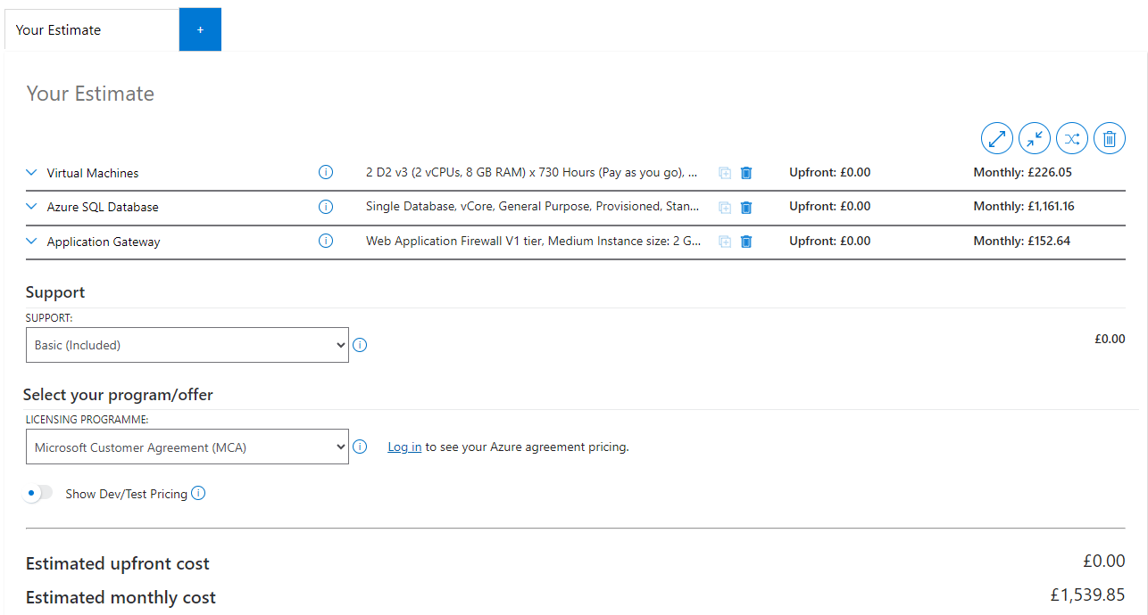

Day 1: Task 3

Please research the below cloud offerings, explain what they are and examples of use cases.

Cloud Offerings | Explain what it is | When / how might you use this service in the real-world?
IaaS (Infrastructure as a service) | A cloud computing model that delivers on-demand servers, storage and networking, allowing businesses to rent resources, scale flexibly and reduce hardware costs. | E-commerce and Website Hosting: Online retailers use IaaS to scale their web servers and infrastructure to handle sudden traffic spikes during major sales events like Black Friday and then scale back down to save costs during off-peak times.
PaaS (Platform as a service) | A cloud computing model that provides developers with a platform to build, deploy and manage applications without worrying about the underlying infrastructure. It allows developers to focus on writing code, while the cloud provider handles the infrastructure, maintenance and scalability. | Building Custom Web and Mobile Applications: Companies use PaaS to quickly develop and deploy customer-facing applications, such as mobile banking apps, e-commerce platforms and online portals. PaaS provides the necessary databases, authentication services and scaling capabilities, allowing developers to focus on features and user experience.
SaaS (Software as a service) | a cloud-based software delivery model where individuals or organizations subscribe to applications rather than purchasing and installing them locally. Customers access software over the internet, typically through a web browser, while the cloud service provider manages the underlying infrastructure, security, maintenance, and updates. | It is used everywhere for daily tasks like emailing (Gmail), collaborating (Google Docs, Zoom), managing customers (Salesforce) and entertainment (Netflix, Spotify).

Day 1: Task 4

Please research the below terms and explain what they are, when they would be appropriate and a real-world example of where it could be implemented (i.e. what type of organisation).

Public Cloud | A cloud computing model where IT resources (servers, storage, databases, networking, software) are owned, managed, and operated by a third-party cloud provider and delivered to users over the internet.  Appropriate when an organisation:  - Wants to reduce upfront costs (No need to buy servers, data centres, or networking equipment).  - Needs scalability and flexibility (Resources can be scaled up or down quickly based on demand).  A medium-sized online retailer could use a public cloud to:  - Handle spikes in traffic during sales events (e.g. Black Friday).
Private Cloud | A cloud computing model where all computing resources are dedicated to a single organisation only. Unlike the public cloud, resources are not shared with other customers.  Appropriate when an organisation:  - Handles sensitive or regulated data (e.g. financial, healthcare, or government data).  - Requires high levels of security and compliance (Greater control over data location, access, and security policies).  A bank may use a private cloud to:  - Store customer account data  - Process transactions securely
Hybrid Cloud | A cloud computing model that combines two or more different cloud environments.  Appropriate when an organisation:  - Needs both security and scalability (Keeps sensitive data private while using public cloud for demand spikes).  - Has existing on-premises infrastructure (Gradual migration to the cloud without replacing everything at once).  A hospital could use a hybrid cloud to:  - Store patient medical records in a private cloud.  - Run appointment booking systems and websites in the public cloud.
Community Cloud | A cloud computing model where infrastructure is shared by several organisations that have similar requirements, such as security or compliance.  Appropriate when organisations:  - Operate in the same industry or sector.  - Require collaboration and data sharing between members.  Multiple government departments could share a community cloud to:  - Host internal applications.  - Share data securely.

Day 2: Task 1
You are a Cloud Consultant hired by a client. You will identify the most suitable cloud service model for a client requiring control over infrastructure, estimate potential cloud costs, and explain the benefits of cloud adoption.
🏭 Client – "DataCore Enterprises"
- A large enterprise wants to move its internal database servers to the cloud.
- They already have IT staff.
- They want full control over operating systems and storage configuration.
Questions for you:
- Which service model suits them? (IaaS, PaaS, Saas)
IaaS
- How can they estimate the cost of using cloud services?
They need to list which resources they need. Then, use a pricing calculator to estimate the cost (pay-as-you-go).
- What are the possible benefits of using cloud services?
Scalability & Flexibility – scale up or down depending on demand.
Cost Efficient – pay only for what you use.
- Bonus: What might be potential risks?
Security & Data Breaches – exposure of data.

Day 2: Task 2

Describe, with examples, the three major areas that the Computer Misuse Act deals with.

Area | Description | Example
Unauthorised access to computer material | Accessing a computer system or data without permission, even if no data is changed or damaged. | A student guesses a teacher’s password and logs into the school system to view exam papers.
Unauthorised access with intent to commit further offences | Gaining unauthorised access with the intention of committing another crime, such as fraud or blackmail. | A hacker breaks into a company system to steal customer credit card details for fraud.
Unauthorised modification of computer material | Changing, deleting, or damaging data or software without permission, including spreading malware. | Deploying a virus that deletes files or alters data on a business network.

The computer misuse act 1990 is an act where an individual can be criminalised because of computer related offense. Describe three extra powers that the Police and Justice Act 2006 (Computer Misuse) has added.

Description
Creation and supply of hacking tools made illegal. It became an offence to make, supply, or obtain tools (software or scripts) intended for hacking, malware, or cyberattacks.
Increased penalties for offences. Maximum prison sentences were increased, especially for serious offences such as unauthorised modification (e.g. malware attacks).
Extended jurisdiction (overseas offences). UK courts can prosecute individuals outside the UK if their cybercrime affects UK systems or citizens.

Look at the below website to answer the questions:
https://www.gov.uk/personal-data-my-employer-can-keep-about-me

Write down three items of data which a company can store about an employee.
Name

Address

National Insurance number

Give three more examples of data that an employer can only store if they first get the employee’s permission.
Race and ethnicity

Religion

Health and Medical Conditions

Conduct further research to answer the below questions.

Question | Answer
Provide one example of: Copyright infringement | Uploading and sharing a full movie on the internet without the permission of the copyright owner.
Provide one example of: Plagiarism | A student copies and pastes several paragraphs from a published article into their essay and submits it as their own work without referring to the source.
What are two consequences of copyright infringement and software piracy? | Legal penalties – Infringers can face fines, court-ordered damages or criminal charges depending on how serious the infringement is.  Civil lawsuits – Copyright owners can sue to stop the infringement and seek monetary compensation.
Give three possible consequences for individuals when using pirated software | Exposure to malware and security risks – Pirated software often contains viruses, spyware, or other harmful code that can compromise personal data or devices.  No access to support, updates, or warranties – Users of pirated software do not receive technical support, patches or legitimate updates.  Legal trouble – Individuals can face fines, legal action or criminal consequences for using unlicensed software.

Listed below are some laws which we have covered today:

1. Computer Misuse Act 1990
2. Police and Justice Act 2006 (Computer Misuse)
3. Copyright, Designs and Patents Act 1988
4. Copyright (Computer Programs) Regulations 1992
5. The Health and Safety (Display Screen Equipment) Regulations 1992
6. Data Protection Act 2018
7. Consumer Rights Act 2015
- Insert a number in the first column of each row to match each of the statements with one of the above Acts.

- One of statements is incorrect and not illegal. For this statement, write ‘Not illegal’.

Act number | Clause
3 | With some exceptions, it is illegal to use unlicensed software
7 | Any product, digital or otherwise, must be fit for the purpose it is supplied for
1 | Unauthorised modification of computer material is illegal
Not illegal | It is illegal to create or use a hacking tool for penetration testing
6 | Personal data may only be used for specified, explicit purposes
5 | Employers must provide their computer users with adequate health and safety training for any workstation they work at
2 | It is illegal to distribute hacking tools for criminal purposes
3 | It is illegal to distribute an illicit recording
6 | Personal data may not be kept longer than necessary
1 | Gaining unauthorised access to a computer system is illegal
5 | Employers must ensure that employees take regular and adequate breaks from looking at their screens
2 | It is illegal to prevent or hinder access (e.g. by a denial-of-service attack) to any program or data held in any computer
6 | Personal data must be accurate and where necessary kept up to date

Day 2: Task 3

Please complete this activity to the best of your ability. This is an introduction to Azure Cloud Computing. You can skip Exercises as we will complete day later.
Introduction to Cloud Infrastructure: Describe Azure Architecture and Services - Training | Microsoft Learn

https://learn.microsoft.com/api/achievements/share/en-us/AaronSinghRana-2589/2JGF36HV?sharingId=93E59B99A527BAD7

Day 3: Task 1

Please complete the below lab (1) ‘Explore relational data in Azure’ and paste evidence of the completed lab in the box provided.


Completed lab | 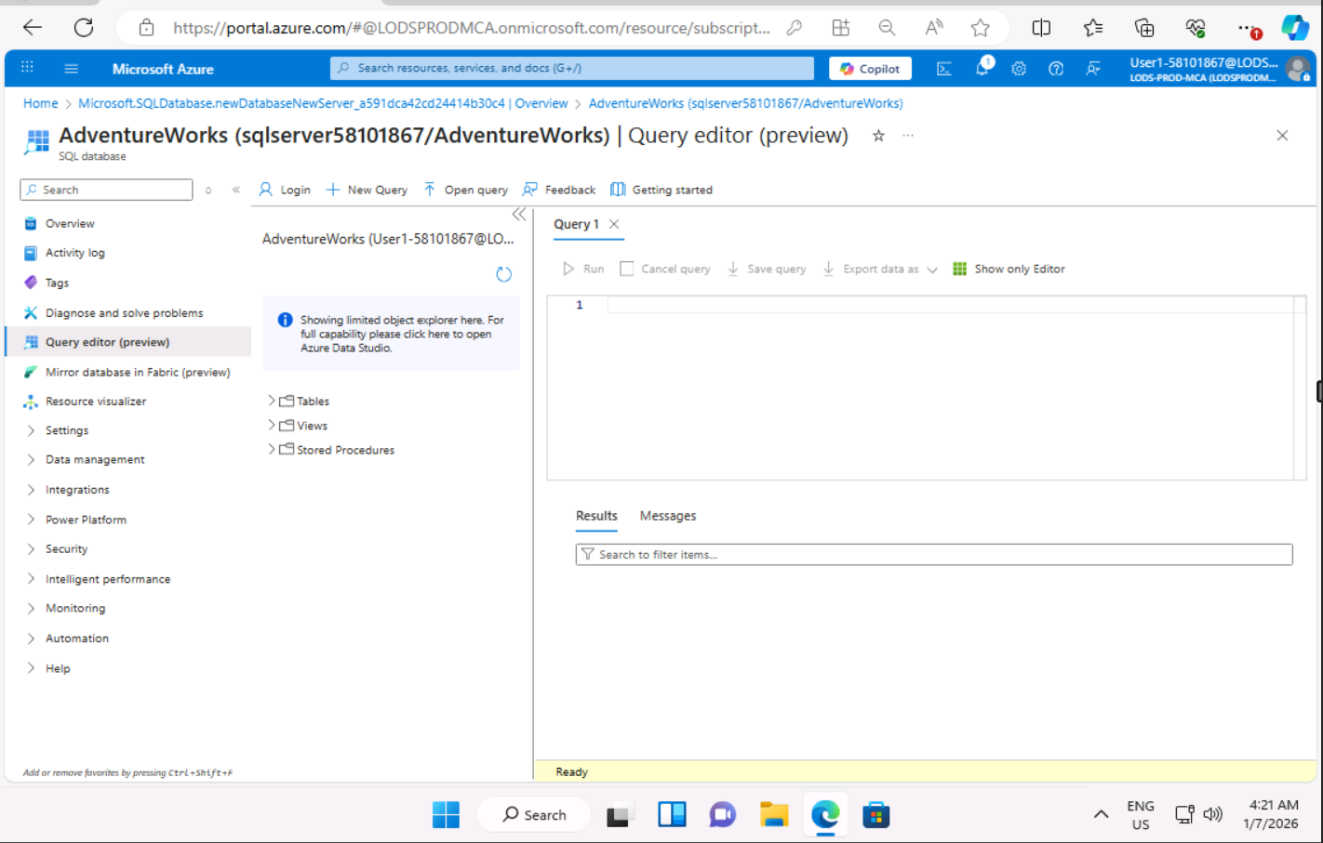  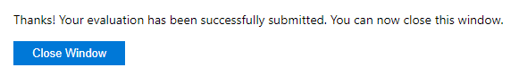

Day 3: Task 2: Skillable
Complete below exercises in lab environment using AdventureWorks DB.
You can view Schema Design here.
-- 1. Customers with last names starting with 'A'
-- Scenario: The marketing department is preparing a campaign targeting customers whose last names begin with the letter 'A'. They need a list of these customers to personalize outreach messages.

select *
from [SalesLT].[Customer]
where LastName like 'A%'

-- 2. Customers with first name starting with 'A' and last name ending with 'a'
-- Scenario: The CRM team is analyzing customer name patterns for personalization strategies. They're particularly interested in users with a first name starting with 'A' and a last name ending in 'a'.

select *
from [SalesLT].[Customer]
where FirstName like 'A%' and LastName like '%a'

-- 3. Count of customers with first name starting with 'A' and last name including 'o'
-- Scenario: A data analyst is generating statistics for a name segmentation report and needs to count how many customers meet both criteria: first name starts with 'A' and last name contains the letter 'o'.

select count(*)
from [SalesLT].[Customer]
where FirstName like 'A%' and LastName like '%o%'

-- 4. Top 3 black products of size 'S' ordered by list price
-- Scenario: The merchandising team is curating a list of 'Black' colored products in size 'S' for a limited-time promotion. They want to showcase the top 3 most affordable options first.

SELECT TOP 3 ProductID, Name, Color, Size, ListPrice
from [SalesLT].[Product] as p
where color like 'Black' and size like 'S'
order by ListPrice

-- 5. Average standard cost of products
-- Scenario: The finance team is calculating the average standard cost across all products to assess baseline production expenses.

SELECT avg(StandardCost)
from [SalesLT].[Product]

-- 6. Difference between average standard cost and average list price
-- Scenario: The pricing strategy team is examining the average markup between the standard cost and the list price to evaluate profitability trends.

SELECT AVG(ListPrice) - AVG(StandardCost) AS AvgPriceCostDifference
FROM [SalesLT].[Product]

-- 7. Product with highest profit margin
-- Scenario: Management wants to identify the most profitable product by finding the item with the highest difference between list price and standard cost.

SELECT TOP 1
ProductID,
Name,
ListPrice,
StandardCost,
(ListPrice - StandardCost) AS ProfitMargin
FROM [SalesLT].[Product]
ORDER BY ProfitMargin DESC;

-- 8. Number of products per category
-- Scenario: Inventory control needs a summary of how many products exist in each product category to manage stock levels effectively.

SELECT c.Name, COUNT(p.Name) AS Total
FROM SalesLT.Product AS p
INNER JOIN SalesLT.ProductCategory AS c
ON p.ProductCategoryID = c.ProductCategoryID
GROUP BY c.Name
ORDER BY Total DESC;

-- 9. Average list price by category
-- Scenario: The product pricing team is reviewing average list prices by category to adjust pricing strategies and identify outliers.

SELECT
pc.Name AS CategoryName,
AVG(p.ListPrice) AS AverageListPrice
FROM [SalesLT].[Product] as p
JOIN [SalesLT].[ProductCategory] as pc
ON p.ProductCategoryID = pc.ProductCategoryID
GROUP BY pc.Name;

-- 10. Orders with customer information
-- Scenario: The operations team needs a comprehensive report of customer orders, including order details and basic customer info, to review sales performance.

SELECT h.salesorderid, orderqty, h.customerid, Title, FirstName, LastName
FROM [SalesLT].[SalesOrderDetail] as o
JOIN [SalesLT].[SalesOrderHeader] as h
ON h.salesorderid = o.salesorderid
join [SalesLT].[Customer] as c
on c.customerid = h.customerid

-- 11. Products priced above average list price
-- Scenario: The sales team wants to identify premium products that are priced above the average list price for highlighting in high-end marketing campaigns.

SELECT ProductID, Name, ListPrice
FROM [SalesLT].[Product]
WHERE ListPrice > (SELECT AVG(ListPrice) FROM [SalesLT].[Product])
ORDER BY ListPrice DESC

-- 12. Total quantity sold per product
-- Scenario: The business intelligence team is evaluating product performance by analyzing the total quantity sold for each product across all orders.

SELECT sum(sod.orderqty) as TotalQty, p.productid, p.name
FROM [SalesLT].[SalesOrderDetail] as sod
join [SalesLT].[Product] as p
on sod.productid = p.productid
group by p.productid, p.name

-- 13. Total sales per customer
-- Scenario: The customer success team wants to calculate the total value of orders placed by each customer to identify high-value clients for loyalty programs.

SELECT c.customerid, sum(soh.totaldue) as TotalSales, c.FirstName, c.LastName
FROM [SalesLT].[SalesOrderHeader] as soh
join [SalesLT].[Customer] as c
on soh.customerid = c.customerid
group by c.customerid, c.FirstName, c.LastName
order by TotalSales desc

Day 3: Task 3: Skillable

Please complete the below lab (4) ‘Explore non-relational data in Azure’ and paste evidence of the completed lab in the box provided.



Completed lab | 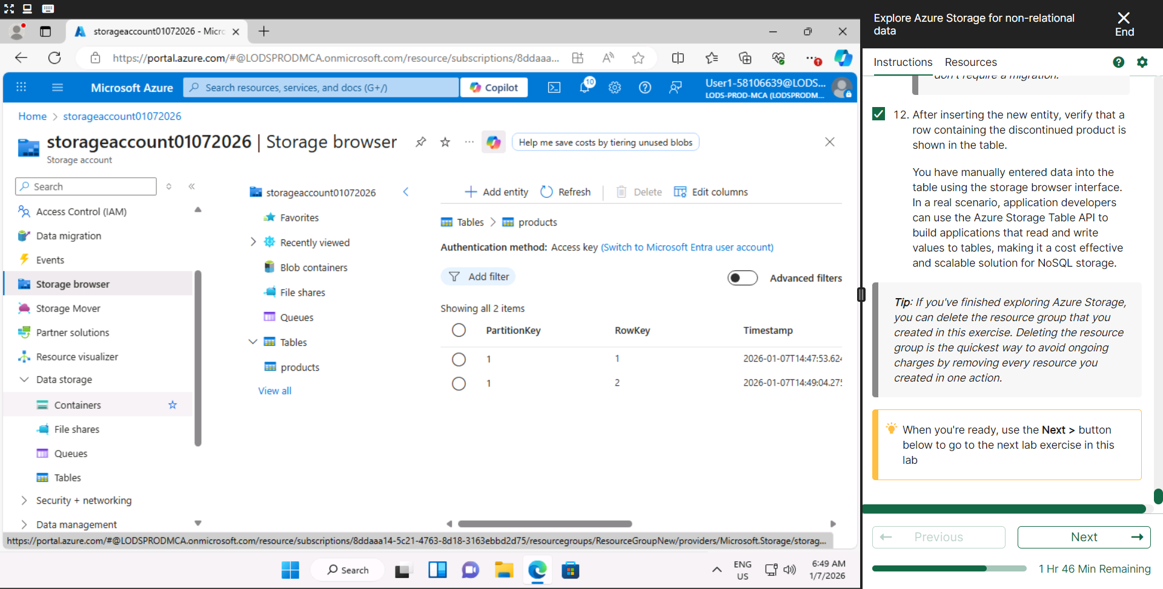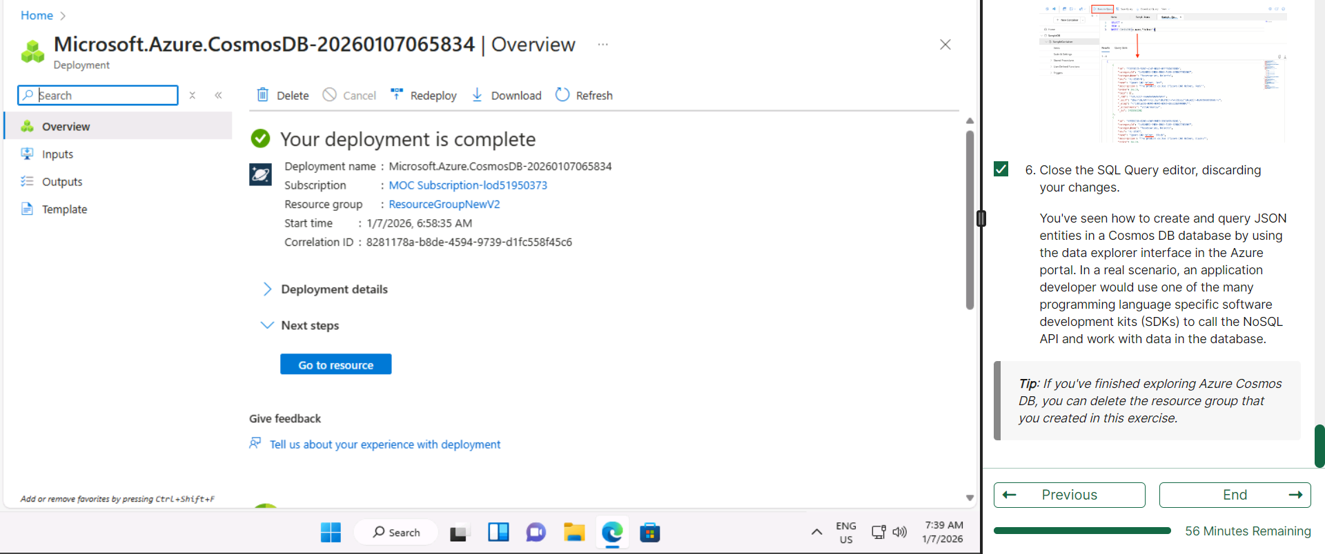

Day 4: Task 1: MS Fabric using Just IT
Please follow the link below to complete the lab using your Just IT account in MS Fabric.
There are 3 modules to complete.

Data Factory end-to-end tutorial introduction and architecture - Microsoft Fabric | Microsoft Learn

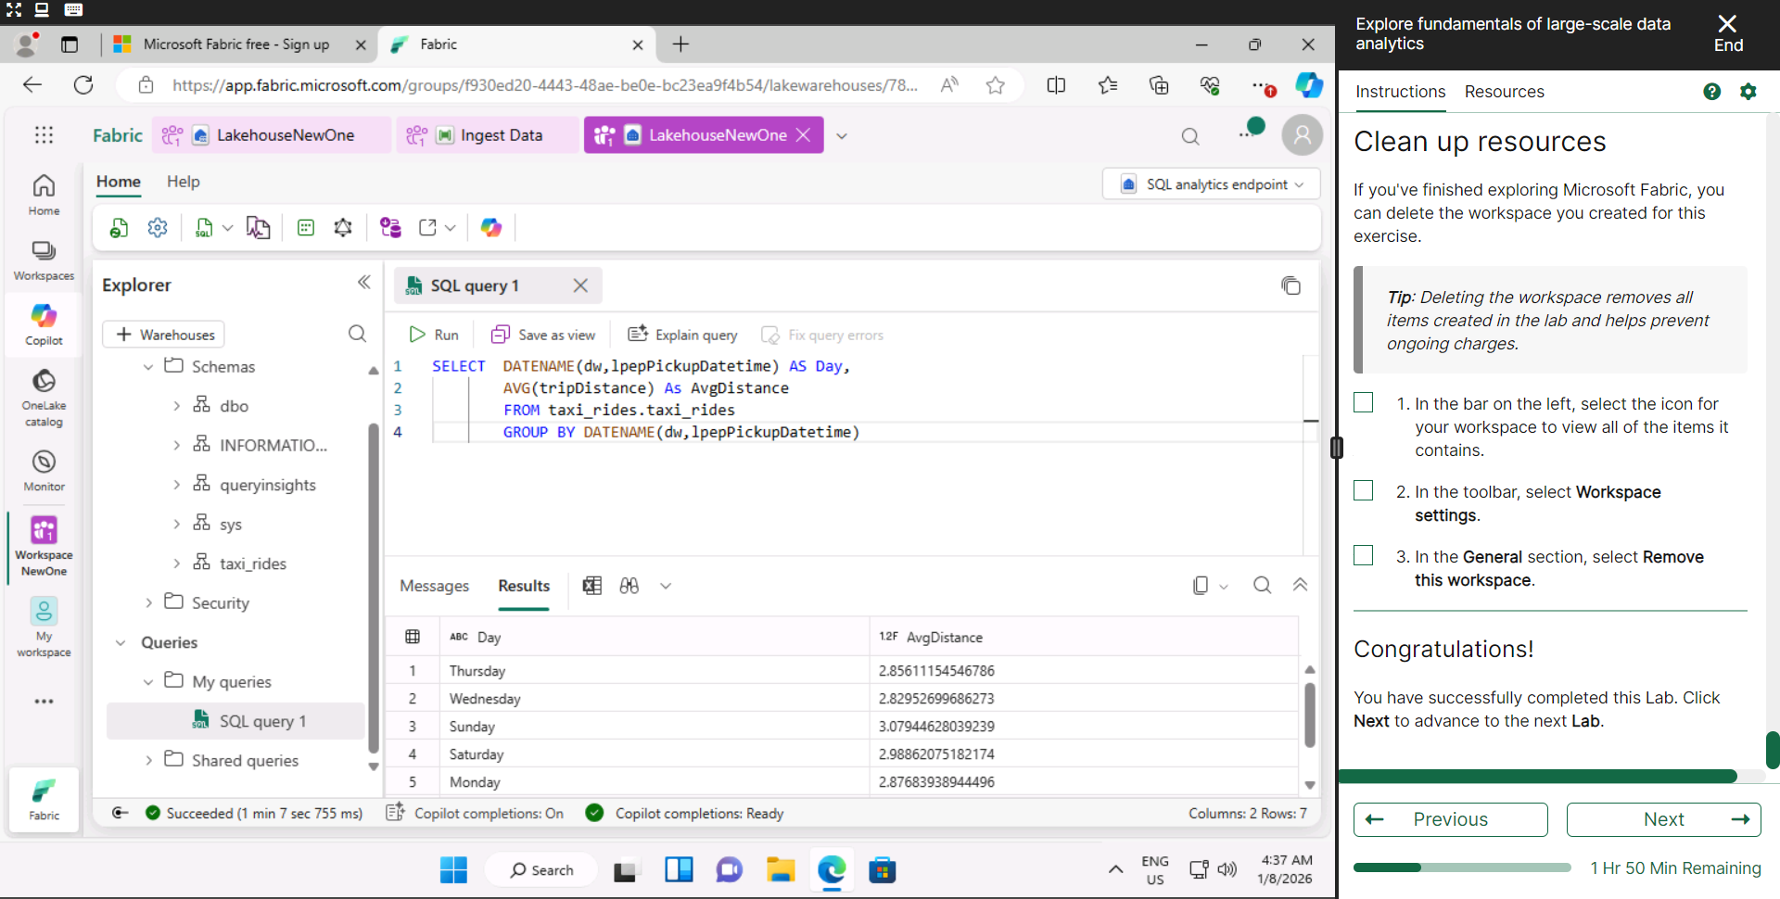
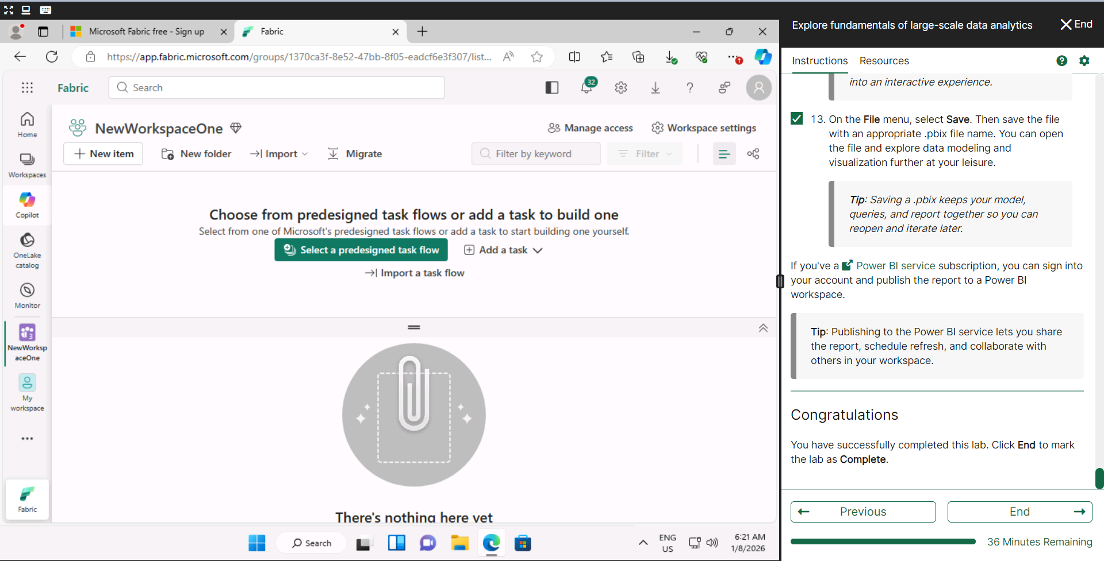
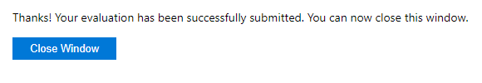
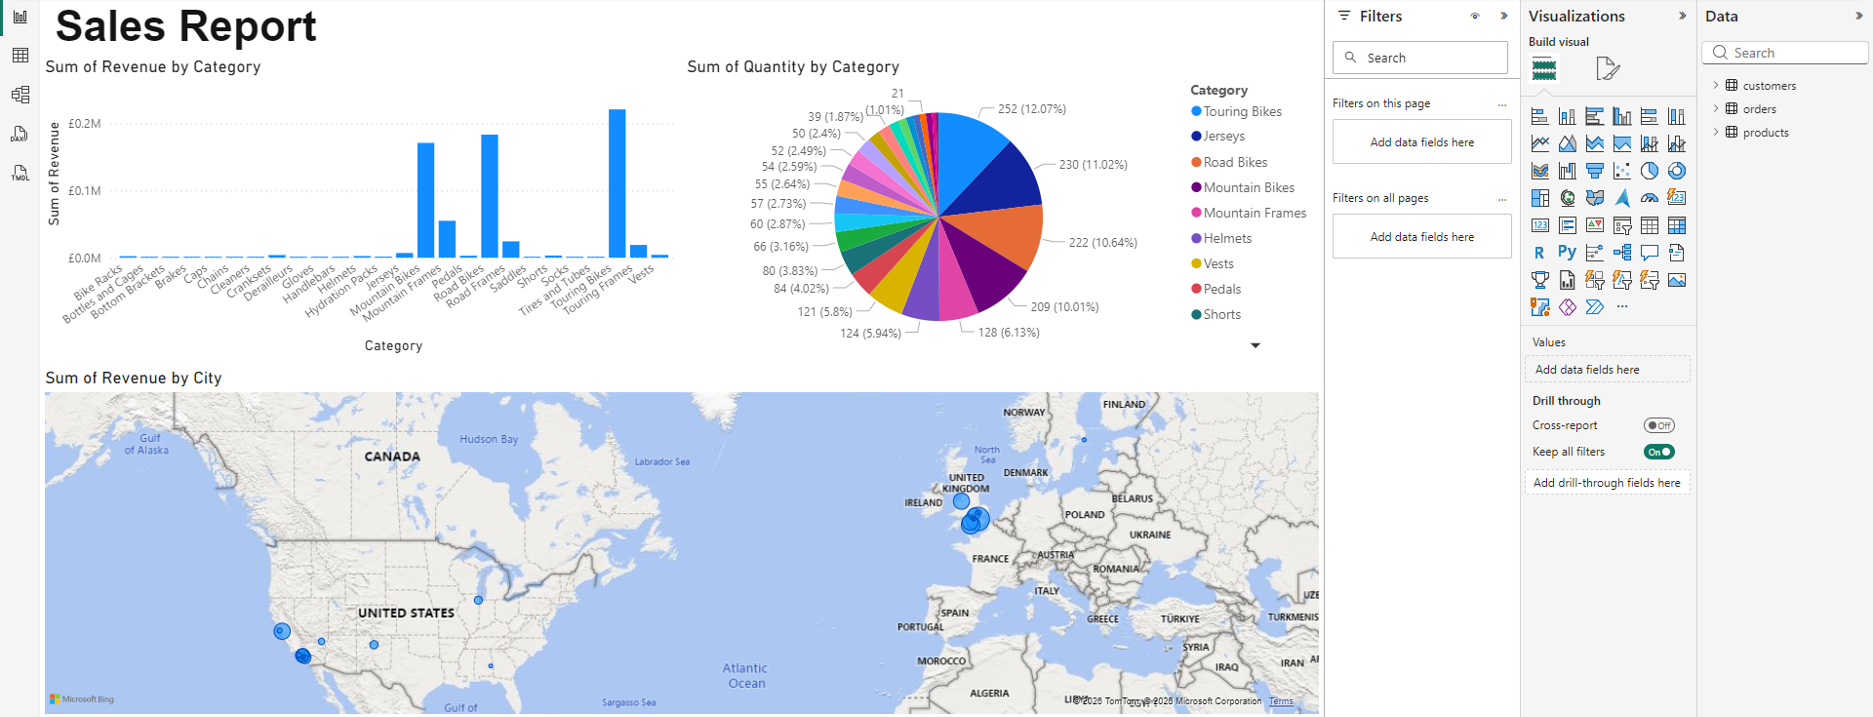

Day 4: Task 2: Skillable

In your teams, complete the Azure DP-900 practice exam and paste your result below – this is open book and please research and discuss your answers as a team.


Result | 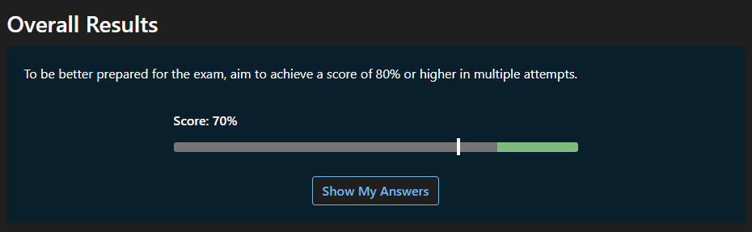

Course Notes

It is recommended to take notes from the course, use the space below to do so, or use the revision guide shared with the class:

Additional Information

We have included a range of additional links to further resources and information that you may find useful, these can be found within your revision guide.

END OF WORKBOOK

Please check through your work thoroughly before submitting and update the table of contents if required.

Please send your completed work booklet to your trainer.

