

Data Technician

Name: Aaron Singh Rana
Course Date: 09/12/2025
Table of contents
Day 4: Task 1 3
Day 4: Task 2 3
Day 4: Task 3 4
Day 4: Task 4 ((If completed other tasks early) 6
Course Notes 8
Additional Information 9

Day 4: Task 1
Please complete Tutorial: From Excel workbook to stunning report in Power BI Desktop - Power BI | Microsoft Learn.
Once complete, publish your report in Power BI service and paste a print screen below and in the collaboration board.
You can also watch this video how to publish and share power bi report.webm. and share with your trainer.
“Teaching is the best way to learn, so please listen out for support requests from the class and we’ll work through the challenges together”

Paste your completed lab here | 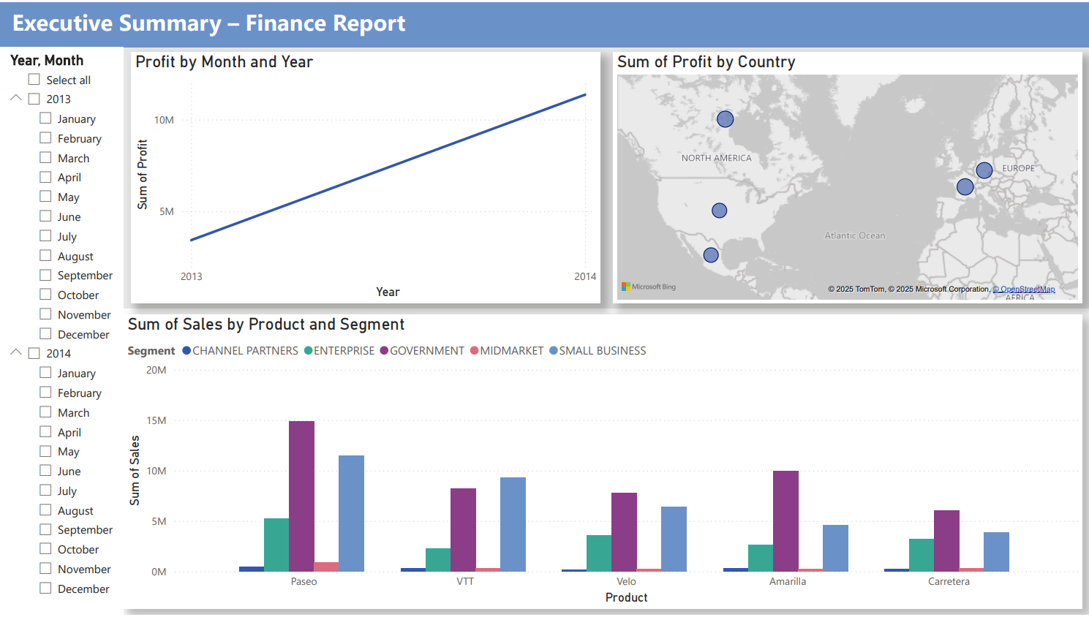

Day 4: Task 2

Please complete Tutorial: Combine data from Excel and an OData feed in Power BI Desktop - Power BI | Microsoft Learn.
Once complete, publish your report in Power BI service and paste a print screen below and share with your trainer.
You can also watch this video how to publish and share power bi report.webm.
Paste your completed lab here | 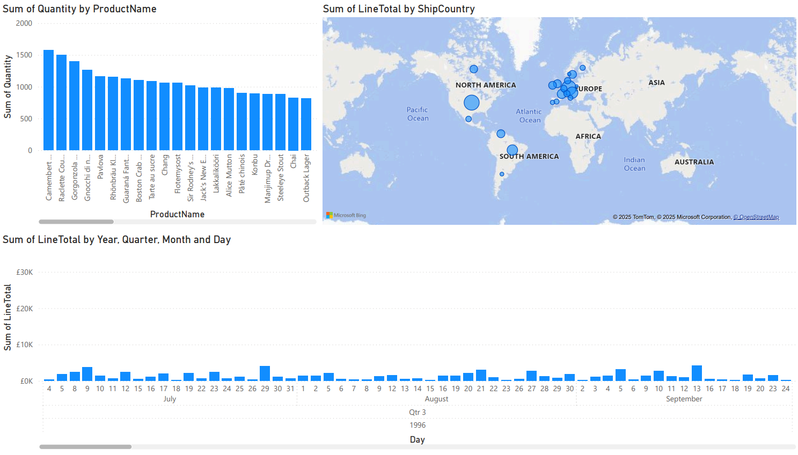

Day 4: Task 3

Please complete Exercise - Load Data in Power BI Desktop - Training | Microsoft Learn.
- Visit that page
- Select Sing in to launch Lab
- Sign in using Just IT email
- Complete puzzle
- Start Lab

Once complete, publish your report in Power BI service and paste a print screen below and share with your trainer.
You can also watch this video how to publish and share power bi report.webm.

Paste your completed lab here | 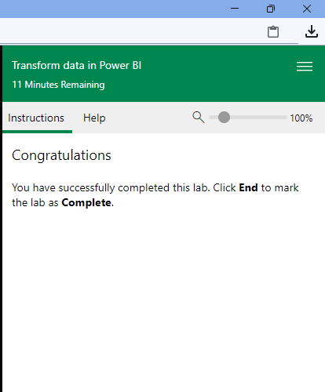  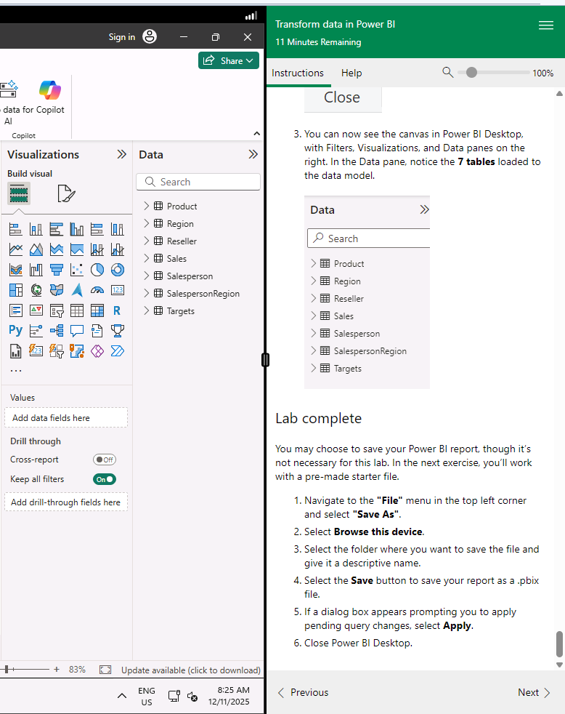

Day 4: Task 4 ((If completed other tasks early)

Please complete Exercise - Design Power BI Reports - Training | Microsoft Learn.
- Visit that page
- Select Sing in to launch Lab
- Sign in using Just IT email
- Complete puzzle
- Start Lab

Once complete, publish your report in Power BI service and paste a print screen below and share with your trainer.
You can also watch this video how to publish and share power bi report.webm.

Paste your completed lab here | 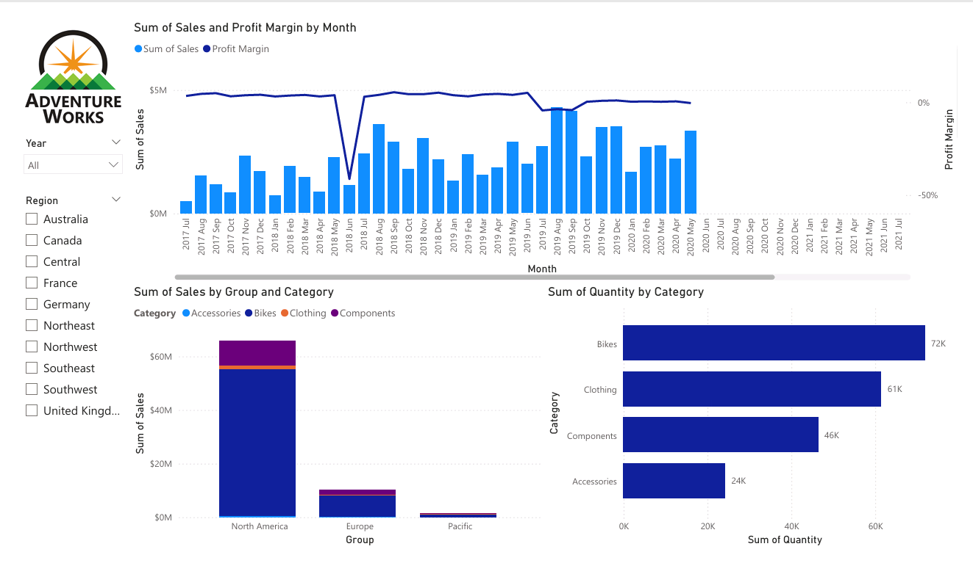  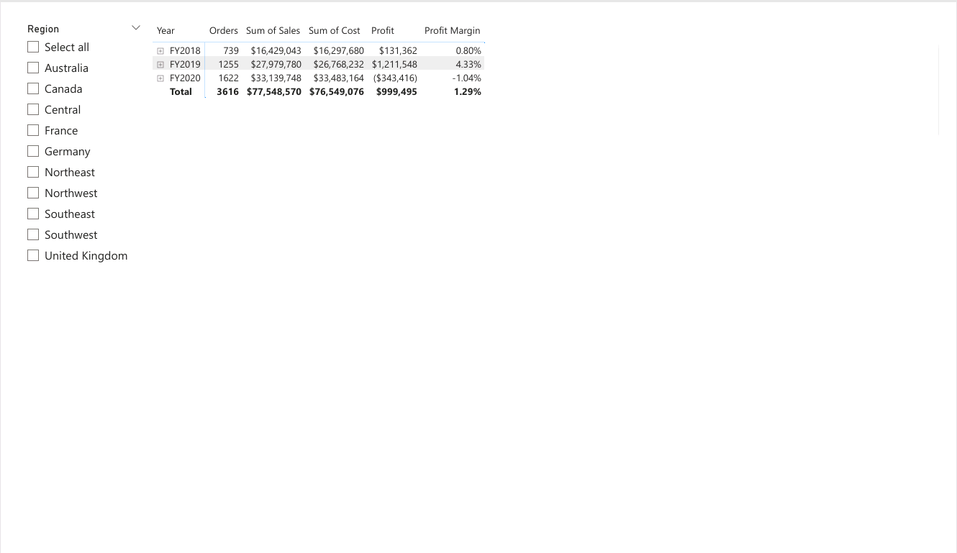  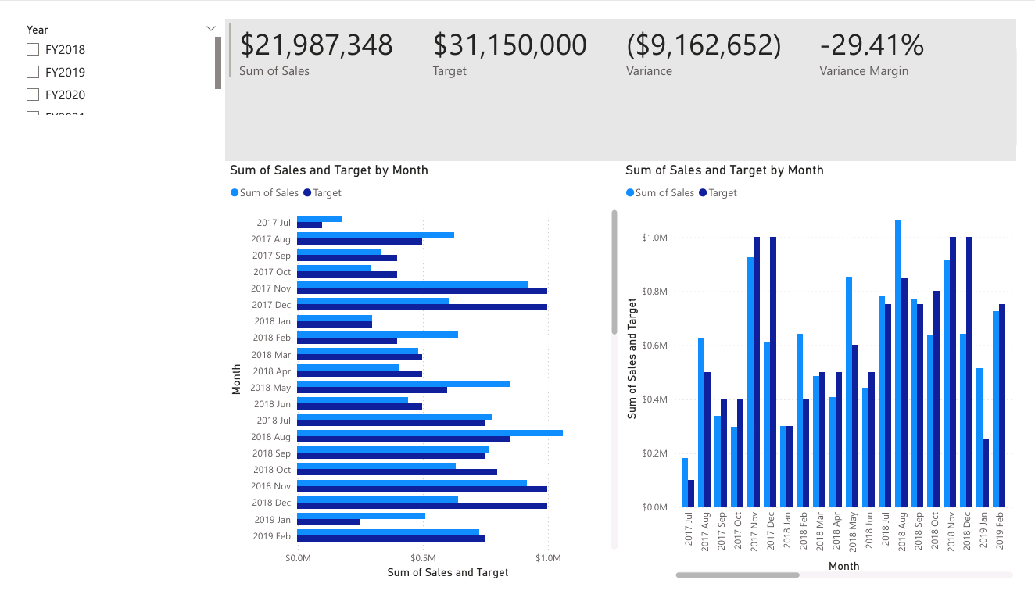  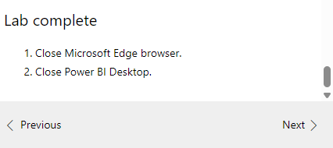  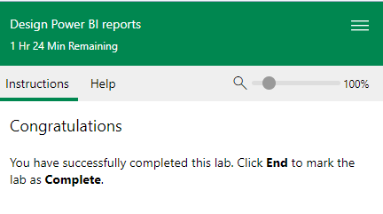

Course Notes

It is recommended to take notes from the course, use the space below to do so, or use the revision guide shared with the class:

Additional Information
We have included a range of additional links to further resources and information that you may find useful, these can be found within your revision guide.

END OF WORKBOOK

Please check through your work thoroughly before submitting and update the table of contents if required.

Please send your completed work booklet to your trainer.

