

Data Technician

Name: Aaron Singh Rana
Course Date: 12/01/25
Table of contents
Day 1: Task 1: Monday Morning 2
Day 1: Task 2 3
Day 2: Task 1 3
Day 2: Task 2 4

Day 1: Task 1: Monday Morning
Please sign up on Cisco Academy website and complete learning.
- follow the link
Free Python Course by Cisco: No Prior Experience Necessary!
- Select get started with self-pace
- sing up using Just IT email
- This is free beginner python course.

How to Share your notebook
- Select share
- Enter and add trainers’ email yusufs@justit.co.uk
- Make sure that you set General access to Anyone with the link.
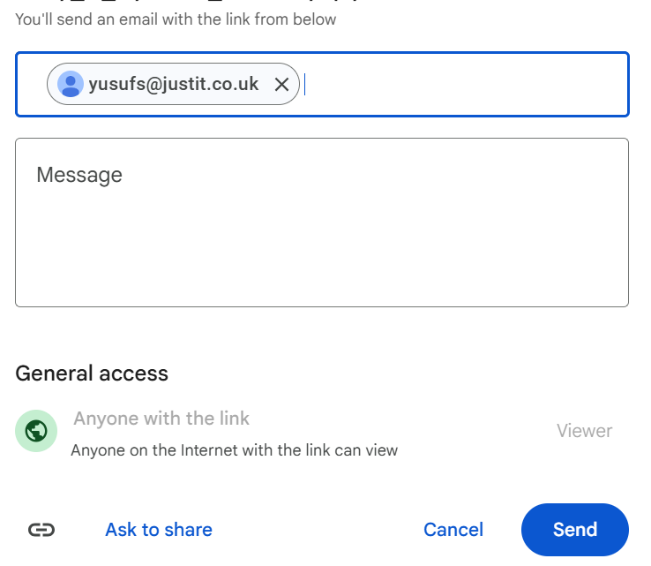
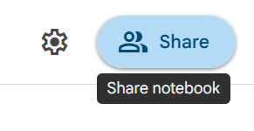
- Press send.

Day 1: Task 2
- Follow below link. https://colab.research.google.com/drive/1X2y7wcJ768lPnnq4HEOK2hpeefz3Bzl5?usp=sharing
- Save a copy of this notebook in your Drive and rename by adding your name to the end.
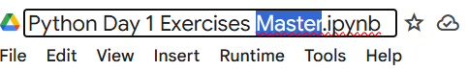

- Go through the notebook and complete the exercises at the end.
- Share your notebook with your trainer.

Day 2: Task 1
- Follow below link.
- https://colab.research.google.com/drive/1FMs6Dqg_tTSqn0wAuTa0aTX_vkYwkEJM?usp=sharing
- Save a copy of this notebook in your Drive and rename by adding your name to the end.
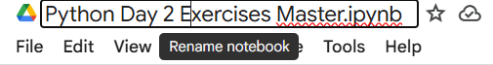

- Go through the notebook and complete the exercises at the end.
- Share your notebook with your trainer.

Day 2: Task 2

It is a common software development interview question to create the below with a certain programming language. Create the below using Python syntax, test it and past the completed syntax and output below.

FizzBuzz:

Go through the integers from 1 to 100.
If a number is divisible by 3, print "fizz."
If a number is divisible by 5, print "buzz."
If a number is both divisible by 3 and by 5, print "fizzbuzz."
Otherwise, print just the number.
Use loops and if statements.

Paste your completed work to the right | 