R Notebook for Computational Finance 2021, Homework 1 2021

# Introduction to Notebooks

Coding notebooks are the standard tool for data science. Notebooks allow you to combine text and code in a single document. For work in R (e.g., homework labs, class project), we will use the Rstudio notebook (see <https://rstudio.com/resources/webinars/introducing-notebooks-with-r-markdown/> ) which is integrated into Rstudio.

In an Rstudio notebook, text is formatted using R Markdown (see **Help/Markdown Quick Reference** from the Rstudio menu for a brief overview of R Markdown syntax)

Executable R code is placed in code chunks (which can be inserted using the keyboard shortcut Ctrl-Alt-I)

# this is a code chunk

Any valid R code can be placed in a code chunk. The code is executed by pressing the green triangle at the right side of the code chunk. For example, running the code chunck below prints “Hello world!”:

print("Hello world!")

## [1] "Hello world!"

Notebooks are a great tool to organize work and facilitate reproducable research. In Rstudio, notebooks can be output to a number of formats including html, pdf and Microsoft Word. This can be done using the **Preview** dropdown on the notebook toolbar. When you click **Preview**, there are 4 main options:

* Preview Notebook
* Knit to html
* Knit to pdf
* Knit to Word

Selecting “Preview to Notebook” shows the formatted notebook in an Rstudio html viewer. This is the prefered way to view the notebook as you are creating it. You can keep the viewer window open and it will automatically update when you save the notebook.

Selecting “Knit to html” will show the output in your default web browser and create a .html file.

Selecting “Knit to pdf” will show the output in a pdf viewer and create a .pdf file. This will be our default for submitting class assignments.

Try out these different Preview options now on this notebook.

# Read data in R from text file

Here, we illustrate how to get data into R from a text file in comma separated value (.csv) format. We will use the base R function read.csv().

The file sbuxPrices.csv contains monthly adjusted closing price data on sbux from March, 1993 through March 2008. It is assumed to be in the directory D:\\NCKU\\courses\\2021\\CompFin\\Homework\\hw1 (which is my computer). Use the setwd() function to change to the appropriate directory where you have saved the data. Edit the code chunk below and change the path to the path where the sbuxPrices.csv is on your computer.

setwd("C:\\Users\\Aaron Lin\\Desktop\\Comp_Finance")

Read the Starbucks prices into a data.frame object. First look at the online help file for read.csv()

?read.csv

## starting httpd help server ... done

You should see the help for read.table in the **Help** tab of Rstudio (on the right).

Now read in the data using read.csv():

sbux.df = read.csv(file="sbuxPrices.csv",   
 header=TRUE, stringsAsFactors=FALSE)

The object sbux.df is a data.frame object, which are rectangular data objects with observations in rows and variables in columns. The class() function tells you the class of an R object:

class(sbux.df)

## [1] "data.frame"

The str() function gives you information about the structure of the object:

str(sbux.df)

## 'data.frame': 181 obs. of 2 variables:  
## $ Date : chr "3/31/1993" "4/1/1993" "5/3/1993" "6/1/1993" ...  
## $ Adj.Close: num 1.13 1.15 1.43 1.46 1.41 1.44 1.63 1.59 1.32 1.32 ...

The head() function returns the first observations of the object:

head(sbux.df)

## Date Adj.Close  
## 1 3/31/1993 1.13  
## 2 4/1/1993 1.15  
## 3 5/3/1993 1.43  
## 4 6/1/1993 1.46  
## 5 7/1/1993 1.41  
## 6 8/2/1993 1.44

The tail() function shows you the last observations:

tail(sbux.df)

## Date Adj.Close  
## 176 10/1/2007 25.37  
## 177 11/1/2007 22.24  
## 178 12/3/2007 19.46  
## 179 1/2/2008 17.98  
## 180 2/1/2008 17.10  
## 181 3/3/2008 16.64

colnames() extract column names:

colnames(sbux.df)

## [1] "Date" "Adj.Close"

The “Date” column contains character values:

class(sbux.df$Date)

## [1] "character"

The “Adj.Close” column contains numeric values:

class(sbux.df$Adj.Close)

## [1] "numeric"

Notice how dates are not the end of month dates. This is Yahoo!’s default when you download monthly data. Yahoo! doesn’t get the dates right for the monthly adjusted close data.

# Working with data.frame objects

Extract the first 5 rows of the price data.

sbux.df[1:5, "Adj.Close"]

## [1] 1.13 1.15 1.43 1.46 1.41

sbux.df[1:5, 2]

## [1] 1.13 1.15 1.43 1.46 1.41

sbux.df$Adj.Close[1:5]

## [1] 1.13 1.15 1.43 1.46 1.41

In the above operations, the dimension information was lost. To preserve the dimension information use drop=FALSE

sbux.df[1:5, "Adj.Close", drop=FALSE]

## Adj.Close  
## 1 1.13  
## 2 1.15  
## 3 1.43  
## 4 1.46  
## 5 1.41

Find indices associated with the dates 3/1/1994 and 3/1/1995:

idx1 = which(sbux.df$Date == "3/1/1994")  
idx2 = which(sbux.df$Date == "3/1/1995")

Now, extract prices between 3/1/1994 and 3/1/1995 by subsetting using the extracted indices:

sbux.df[c(idx1, idx2),]

## Date Adj.Close  
## 13 3/1/1994 1.45  
## 25 3/1/1995 1.43

Next, create a new data.frame containing the price data with the dates as the row names (using drop = FALSE prevents dropping the row and column dimensions)

sbuxPrices.df = sbux.df[, "Adj.Close", drop=FALSE]  
rownames(sbuxPrices.df) = sbux.df$Date  
head(sbuxPrices.df)

## Adj.Close  
## 3/31/1993 1.13  
## 4/1/1993 1.15  
## 5/3/1993 1.43  
## 6/1/1993 1.46  
## 7/1/1993 1.41  
## 8/2/1993 1.44

With dates as rownames, you can subset directly on the dates. For example, find prices associated with the dates 3/1/1994 and 3/1/1995

sbuxPrices.df[c("3/1/1994", "3/1/1995"), 1, drop = FALSE ]

## Adj.Close  
## 3/1/1994 1.45  
## 3/1/1995 1.43

To show the rownames use drop=FALSE

sbuxPrices.df["3/1/1994", 1, drop=FALSE]

## Adj.Close  
## 3/1/1994 1.45

# Plotting data

The base R function ’plot()` can be used for simple plots. The default plot is a “points” (e.g. x-y) plot

plot(sbux.df$Adj.Close)

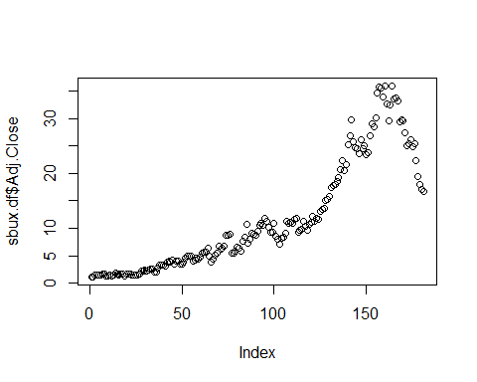

Let’s make a better plot. Set type="l" to specify a line plot, col="blue" to set the line color to blue, lwd=2 to double the line thickness, ylab="Adjusted close" to add a y axis label, and main="Monthly closing price of SBUX" to add a title. Also, use legend() to add a legend to the plot.

plot(sbux.df$Adj.Close, type="l", col="blue",   
 lwd=2, ylab="Adjusted close",  
 main="Monthly closing price of SBUX")  
legend(x="topleft", legend="SBUX",   
 lty=1, lwd=2, col="blue")

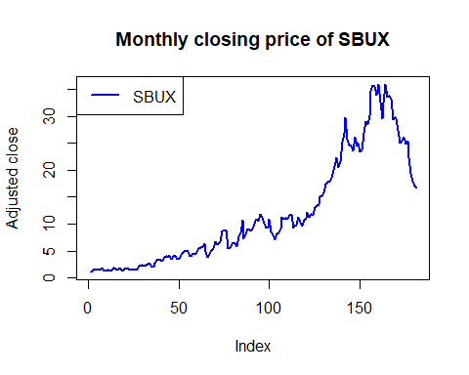

Notice there are no dates on the x-axis. We will see how to fix this later using data stored in specialized “time series” objects.

# Computing returns

First, compute simple 1-month returns from prices

n = nrow(sbuxPrices.df)  
sbux.ret = (sbuxPrices.df[2:n,1] - sbuxPrices.df[1:(n-1),1])/sbuxPrices.df[1:(n-1),1]  
head(sbux.ret)

## [1] 0.01770 0.24348 0.02098 -0.03425 0.02128 0.13194

Notice that the object sbux.ret is not a data.frame, but a numeric vector.

class(sbux.ret)

## [1] "numeric"

Now add dates as names to the vector.

names(sbux.ret) = rownames(sbuxPrices.df)[2:n]  
head(sbux.ret)

## 4/1/1993 5/3/1993 6/1/1993 7/1/1993 8/2/1993 9/1/1993   
## 0.01770 0.24348 0.02098 -0.03425 0.02128 0.13194

To ensure that sbux.ret is a data.frame use drop=FALSE when computing returns

sbux.ret.df = (sbuxPrices.df[2:n,1,drop=FALSE] - sbuxPrices.df[1:(n-1),1,drop=FALSE])/  
 sbuxPrices.df[1:(n-1),1,drop=FALSE]  
head(sbux.ret.df)

## Adj.Close  
## 4/1/1993 0.01770  
## 5/3/1993 0.24348  
## 6/1/1993 0.02098  
## 7/1/1993 -0.03425  
## 8/2/1993 0.02128  
## 9/1/1993 0.13194

Next, compute continuously compounded 1-month returns

sbux.ccret = log(1 + sbux.ret)  
head(sbux.ccret)

## 4/1/1993 5/3/1993 6/1/1993 7/1/1993 8/2/1993 9/1/1993   
## 0.01754 0.21791 0.02076 -0.03485 0.02105 0.12394

Alternatively,

sbux.ccret = log(sbuxPrices.df[2:n,1]) - log(sbuxPrices.df[1:(n-1),1])  
names(sbux.ccret) = rownames(sbuxPrices.df)[2:n]  
head(sbux.ccret)

## 4/1/1993 5/3/1993 6/1/1993 7/1/1993 8/2/1993 9/1/1993   
## 0.01754 0.21791 0.02076 -0.03485 0.02105 0.12394

# Compare the simple and cc returns

head(cbind(sbux.ret, sbux.ccret))

## sbux.ret sbux.ccret  
## 4/1/1993 0.01770 0.01754  
## 5/3/1993 0.24348 0.21791  
## 6/1/1993 0.02098 0.02076  
## 7/1/1993 -0.03425 -0.03485  
## 8/2/1993 0.02128 0.02105  
## 9/1/1993 0.13194 0.12394

Plot the simple and cc returns in separate graphs. Split screen into 2 rows and 1 column using the par() function:

par(mfrow=c(2,1))  
# plot simple returns first  
plot(sbux.ret, type="l", col="blue", lwd=2, ylab="Return",  
 main="Monthly Simple Returns on SBUX")  
abline(h=0)   
# next plot the cc returns  
plot(sbux.ccret, type="l", col="blue", lwd=2, ylab="Return",  
 main="Monthly Continuously Compounded Returns on SBUX")  
abline(h=0)

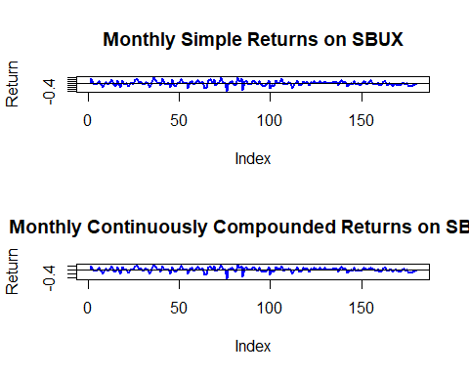

# reset the screen to 1 row and 1 column  
par(mfrow=c(1,1))

Next, plot the returns on the same graph

plot(sbux.ret, type="l", col="blue", lwd=2, ylab="Return",  
 main="Monthly Returns on SBUX")  
# add horizontal line at zero  
abline(h=0)   
# add the cc returns  
lines(sbux.ccret, col="red", lwd=2)  
# add a legend  
legend(x="bottomright", legend=c("Simple", "CC"),   
 lty=1, lwd=2, col=c("blue","red"))

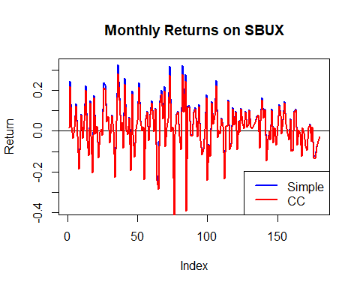

Notice that the cc returns are different from the simple returns when the simple returns are either big positive or negative values.

# Calculate growth of $1 invested in SBUX

First, compute gross returns

sbux.gret = 1 + sbux.ret

Next, compute future values using the cumulative product of the gross returns:

sbux.fv = cumprod(sbux.gret)  
plot(sbux.fv, type="l", col="blue", lwd=2, ylab="Dollars",   
 main="FV of $1 invested in SBUX")

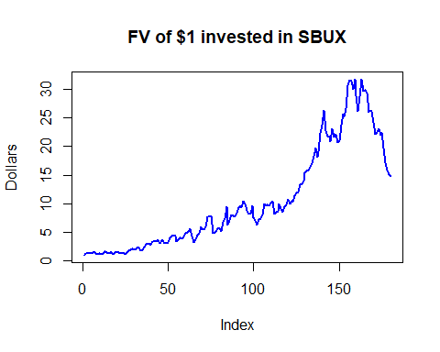

Here we see that $1 invested grows to about $15 over the sample

# Dynamic JavaScript web graphics

See the examples at <https://rstudio.github.io/dygraphs/>.

In R you can create interactive web graphics based on a number of JavaScript graphics libraries (e.g. D3, Hightcharts, dygraphs, etc). Here we will use the dygraphs JavaScript library through the R package **dygraphs**. You will also use the R packages **xts** and **zoo**. Make sure all of these packages are installed before running the code below.

First we need to create a specialized time series object called an “xts” object using the R package **xts**.

suppressPackageStartupMessages(library(xts))  
sbuxPrices.x = xts(sbuxPrices.df, as.Date(rownames(sbuxPrices.df), format="%m/%d/%Y"))  
sbuxRet.x = xts(sbux.ret, as.Date(names(sbux.ret), format="%m/%d/%Y"))  
head(sbuxRet.x)

## [,1]  
## 1993-04-01 0.01770  
## 1993-05-03 0.24348  
## 1993-06-01 0.02098  
## 1993-07-01 -0.03425  
## 1993-08-02 0.02128  
## 1993-09-01 0.13194

The plot method for xts objects shows dates on the axes:

plot(sbuxPrices.x)

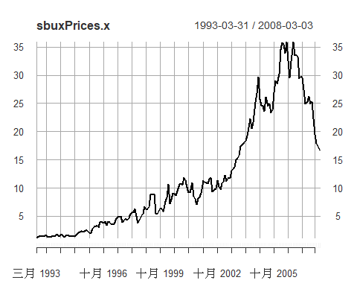

We can also create dynamic graph of prices - a graph will be displayed in Rstudio viewer pane that you can interact with

library(dygraphs)  
dygraph(sbuxPrices.x)

You can interact with the graph. Put your cursor on the graph and see how it iteracts.

# Create dynamic graph for returns

dygraph(sbuxRet.x)