

6CS012
Artificial Intelligence and Machine Learning

Part 2: Vision Task

Student Name : Aaron Shrestha
University ID : 2414190
Group : L6CG12
Module Leader : Mr. Siman Giri
Tutor : Mrs. Jinu Nyachhyon

ABSTRACT :
This project aims to develop a deep learning based image classification for sign language gesture detection. The main objective is classication of hand gesture images into 38 different classes utlilizing Convolution Neural Network (CNN). Different CNN-based methods were explored, to achieve this, including a baseline CNN , deeper CNN with the Batch Normalization and Dropout, optimizer comparison the using Adam and SGD, an ablation study and transfer learning using MobileNetV2. This dataset contained class training images, while the test folder contained three images without separate class folders. Due to this validation split was used to evaluate the model using the performance metrics. All images were resized to the 128 × 128 pixels, then normalized and augmented using techniques like as rotation, zooming, shifting, and shearing. Of all the models , the ablation model without Dropout achieved the best performance, with the validation accuracy of 80.10% and F1-score of 81.53%. The results found shows that CNN-based architectures can learn features from the hand gesture images, but similar gestures with lighting variation, background noise and limited labeled test data remains a challenge.

Table of Contents
Table of Figures 4
1. Introduction: 1
2. Dataset Description: 1
3. Data Preprocessing and Augmentation: 3
4. Methodology 4
4.1 Baseline CNN model 4
5.2 Deeper CNN Model with Regularization: 5
5.3 Optimizer Comparison 6
5.4 Ablation Study 6
5.5 Transfer Learning using MobileNetV2 6
6. Experiments and Results 7
7. Test Set Structure and Prediction 12
8. Challenges and Observations 13
9. Conclusion and Future Work 14

Table of Figures
Figure 1 :Sample images from different sign language gesture classes. 2
Figure 2: Class Distribution Graph 2
Figure 3: Augmented Training Images 3
Figure 4: Model summary of Baseline CNN 4
Figure 5: Deeper CNN model summary 5
Figure 6: Baseline CNN Training Curves 8
Figure 7: Deeper CNN with Adam Training Curves 9
Figure 8: Confusion matrix of the best-performing ablation CNN model. 10
Figure 9: Final Model Comparison Graph 11
Figure 10: Prediction results on the three raw Test folder images using the best-performing model. 12

Introduction:
Sign Language is a crucial form of communication for people with speech and hearing problems. Although, not everyone understand this, which creates communication barriers in daily life, education, and public services. This major gap can be reduced with the help of computer vision and AI by automatically recognizing hand gestures from images.
The project uses deep learning techniques for classification of sign language gesture images. Convolutional Neural Networks (CNNs)are appropriate for the task because they are designed to learn spatial patterns from the images. CNN layers can detect low-level features like as edges and curves and after combine them into a higher-level features such as hand shapes and gesture positions. The aim of the project is to develop image classification models for sign language detection and compare them. The project initiates with baseline CNN model and after that the architecture into a deeper CNN with regularization. Additional experiments were performed for comparing Adam and SGD optimizers, and analyze effect of removing Dropout with Ablation study and then evaluate transfer learning with MobileNetV2. The final goal is identifying which approach give the strongest classification performance but also considering training time and model complexity.

Dataset Description:
The dataset used in the project is the sign language gesture image dataset which contains images representing the different hand gestures and where each class corresponds to unique sign language gesture. The dataset is arranged mainly into the class-wise training directory and small raw Test folder.
The training folder contains 38 class folders. Every folder represent one class label from range 0 to 37. The dataset is balanced and many classes contains around 280 to 300 images. The dataset were split in test and validation sets with the help of keras using ImageDataGenerator in notebook. The total class detected by images was 38. The dataset has variations in hand orientation ,lighting conditions, image background and hand position. The variations make the task more real, because sign language recognition system should able to recognize gestures even when hand appears at the different angles or under different lighting. However, this variations also increases the difficulty of classification.
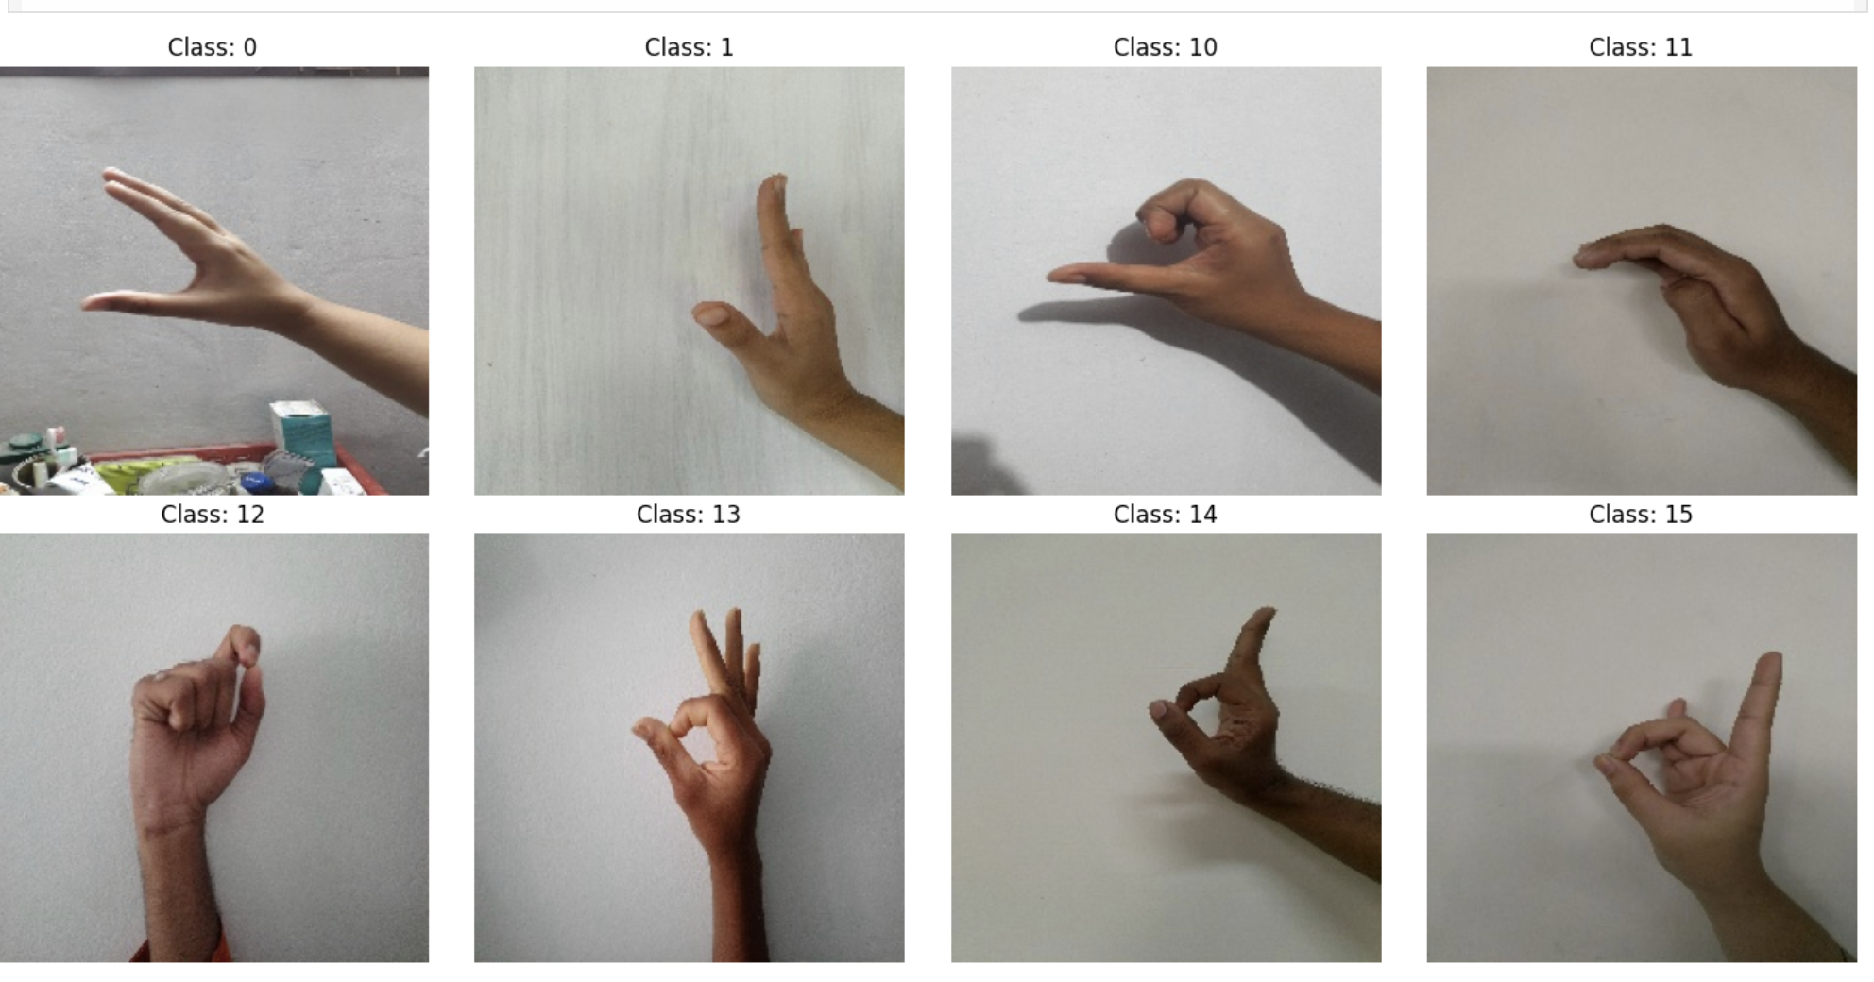
Figure 1 :Sample images from different sign language gesture classes.

The class distribution was also checked for understanding dataset was balanced or imbalanced. Many classes contain a similar number of images, although some classes had fewer samples than the others. This means dataset was generally correct for multi-class image classification but minor imbalance could still affect the performance.
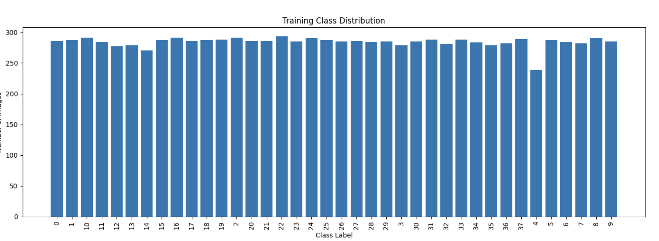
Figure 2: Class Distribution Graph

The test folder contained only three images and did not contain class wise subfolders inside the folder. Due to this it could not be used for metric-based evaluation using Keras flow_from_directory(). Hence, the validation set which was created from training directory was used for the accuracy, precision, F1-score, recall, and confusion matrix evaluation. Three raw Test images was used only for prediction visualization.

Data Preprocessing and Augmentation:
Ahead of training model, the images were preprocessed to make them suitable for deep learning. Initially all the images was resized to 128 × 128 pixels. This is necessary because neural networks require fixed-size inputs. Smaller image size also reduce training time and memory usage by still preserving important hand gesture features.
After that pixel values were normalized by the rescaling from original 0–255 range to 0–1 range. Normalization enhance the model train more smoothly because all the input values are placed on similar scale.
After that data augmentation was applied to the training set. Techniques for augmentation included zooming, rotation, width shifting, shearing, height shifting, and nearest-pixel filling. Due to this modified versions of the original training images is created, which helps the model generalize better by learning the gestures under different angles and positions rather than memorizing exact training images.
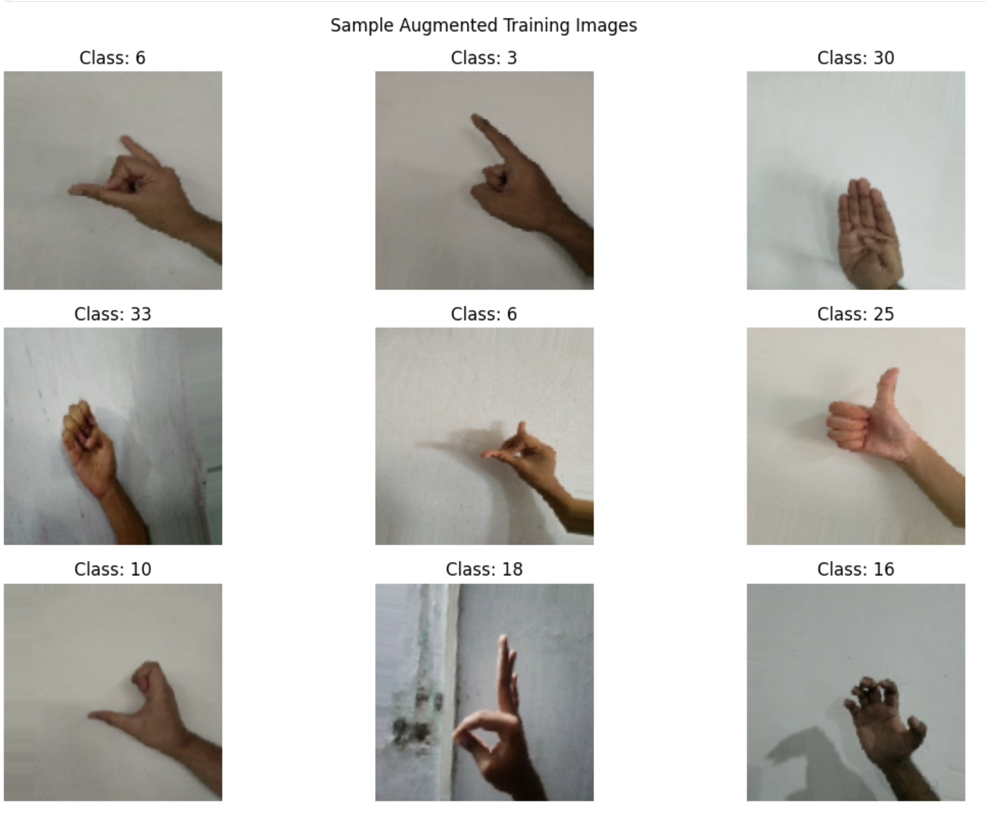
Figure 3: Augmented Training Images

4. Methodology

4.1 Baseline CNN model
The first model was baseline CNN designed from the scratch. It contains three convolutional layers, having each followed by a max-pooling layer. Convolution layers used ReLU activation to learn the non-linear image features. After the convolution and pooling , feature maps were flattened which was then passed into the three fully connected Dense layers. Dropout was applied in dense layers for reducing overfitting. Softmax activation was used in the final output layer because it is a multi-class classification problem with 38 classes.
The baseline model was trained for maximum of 25 epochs using an Adam optimizer and the categorical cross-entropy loss. Early stopping and learning rate reduction were applied for the prevention of unnecessary training and improving convergence.
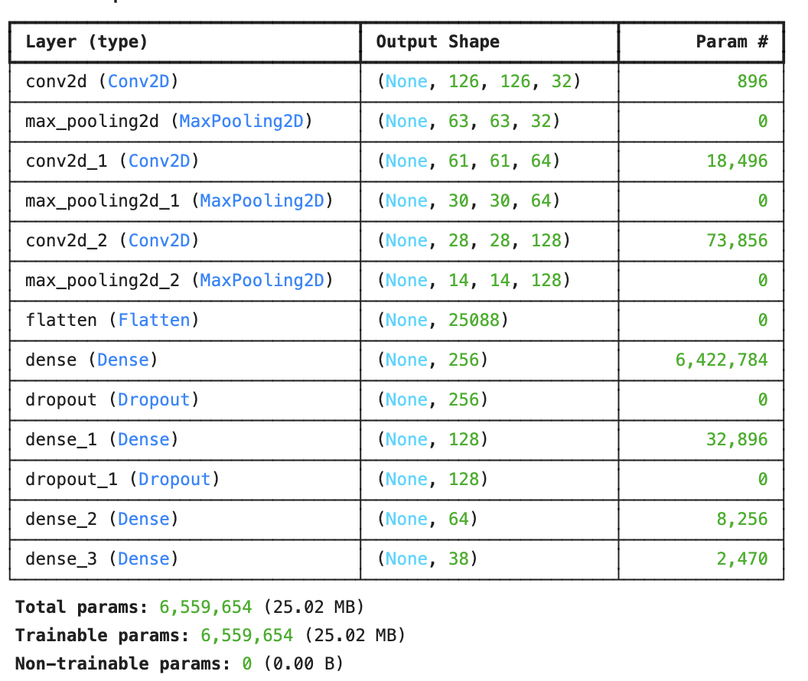
Figure 4: Model summary of Baseline CNN

5.2 Deeper CNN Model with Regularization:
Deeper CNN model was the second architecture. It has included more convolutional layers than a baseline model and has applied the Batch Normalization and Dropout. Batch Normalization was added for the stabilization of training and helps model converge more effectively. Dropout was also included to reduce overfitting by randomly disabling neurons during the training session.
The deeper model was expected for learning the more complex gesture features compared to a baseline model. Although, deeper models requires more training time and computational resources. Hence, its performance was compared with a baseline model to determine whether the added complexity was useful.
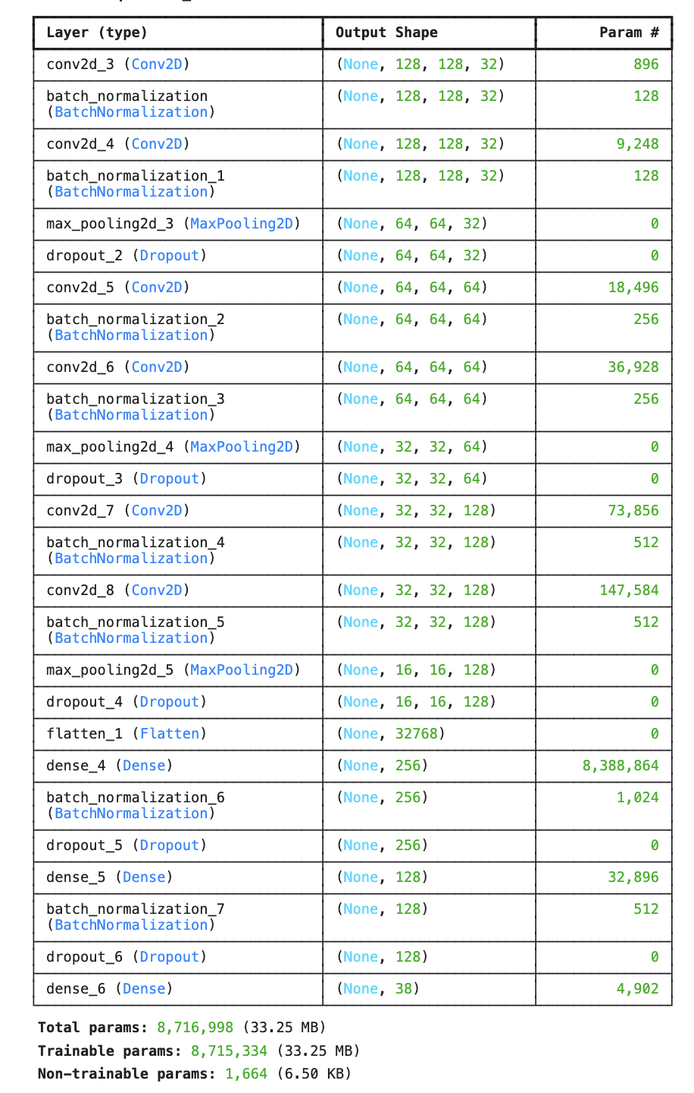
Figure 5: Deeper CNN model summary

5.3 Optimizer Comparison
Deeper CNN model was trained by using two different optimizers which are Adam and SGD.
Adam is the adaptative optimizer which adjusts learning rates during the training and often converges faster. SGD with momentum update weights more gradually and can sometimes generalize well, but may require many careful tuning and longer training. The main purpose of this experiment was analyzing how the optimizer choice affects convergence speed and final classification performance.

5.4 Ablation Study
An ablation study was performed by removing the Dropout from deeper CNN model. This aims to experiment to understand the impact of the Dropout on model performance. Dropout usually is used to reduce overfitting, but removing can sometimes improve its performance if a model is not overfitting severely or if dataset has enough variation.
The ablation model used the deeper CNN structure with the help of Batch Normalization but without Dropout layers. Its performance was also compared against the baseline and the deeper CNN models.

5.5 Transfer Learning using MobileNetV2
The Transfer learning was implemented using the MobileNetV2. MobileNetV2 is lightweight pre-trained CNN model which is trained on the ImageNet. The original classification head were removed and was replaced with a new Dense layers suitable for 38-class sign language dataset.
Two transfer learning strategies were applied . At first, MobileNetV2 was used as feature extractor by freezing a convolutional base and then training only the newly added classifier layers. After that, fine-tuning was performed by unfreezing some of later layers and then training them with the smaller learning rate. Fine-tuning helps the model to adapt pre-trained visual features to a sign language dataset.

6. Experiments and Results
The model has been evaluated by applying the validation set because the Test folder was not class-wise. The evaluation metrics used were accuracy, recall, precision, and F1-score.

Model | Accuracy | Precision | Recall | F1-score | Training Time
Ablation Study – No Dropout | 0.8010 | 0.8438 | 0.8010 | 0.8153 | 824.40 sec
Deeper CNN with Adam | 0.7753 | 0.8010 | 0.7753 | 0.7780 | 1372.64 sec
Fine-Tuned MobileNetV2 | 0.7722 | 0.7833 | 0.7722 | 0.7683 | 549.29 sec
Deeper CNN with SGD | 0.7660 | 0.7962 | 0.7660 | 0.7742 | 1459.64 sec
MobileNetV2 Feature Extraction | 0.7203 | 0.7302 | 0.7203 | 0.7170 | 831.52 sec
Baseline CNN | 0.6884 | 0.6975 | 0.6884 | 0.6870 | 1330.05 sec

The baseline CNN has achieved the accuracy of 68.84% and a F1-score of 68.70%. This shows that even a simple CNN could learn the useful visual patterns from sign language images. However, its performance was lower than deeper models, indicating that the more complex architecture was needed to capture detail gesture features.

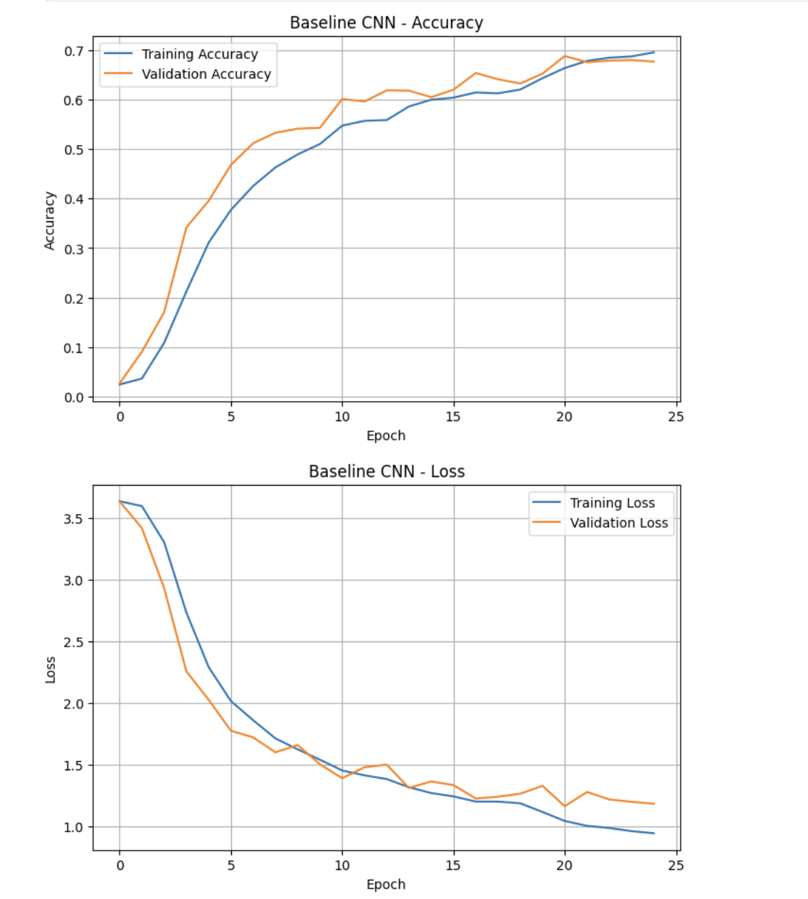
Figure 6: Baseline CNN Training Curves

The deeper CNN with Adam has improved the accuracy to a 77.53% and F1-score to a 77.80%. This has confirm that adding more convolutional layers and regularization helps the model to learn the stronger features. A deeper CNN with SGD achieved a slightly lower accuracy of a 76.60% and the F1-score of 77.42%. Although SGD performed significantly well, Adam also produced slightly better results in this experiment.
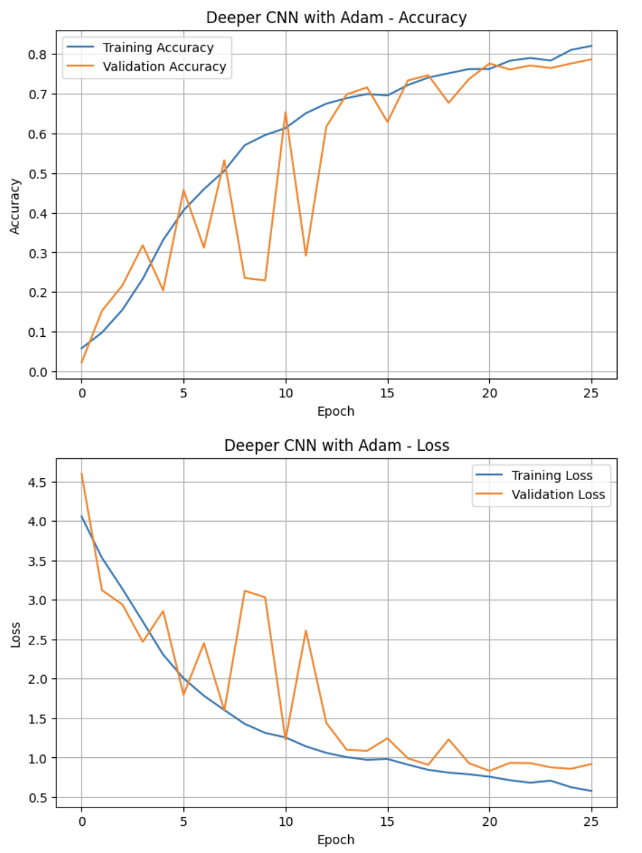
Figure 7: Deeper CNN with Adam Training Curves

The ablation model without Dropout achieved best performance, with the accuracy of 80.10% and the F1-score of 81.53%. This advocates that by removing Dropout allowed the model to learn the stronger class-specific features for the dataset. However, this result should be interpreted carefully because by removing Dropout can increase risk of the overfitting, especially if tested on the larger unseen test set.
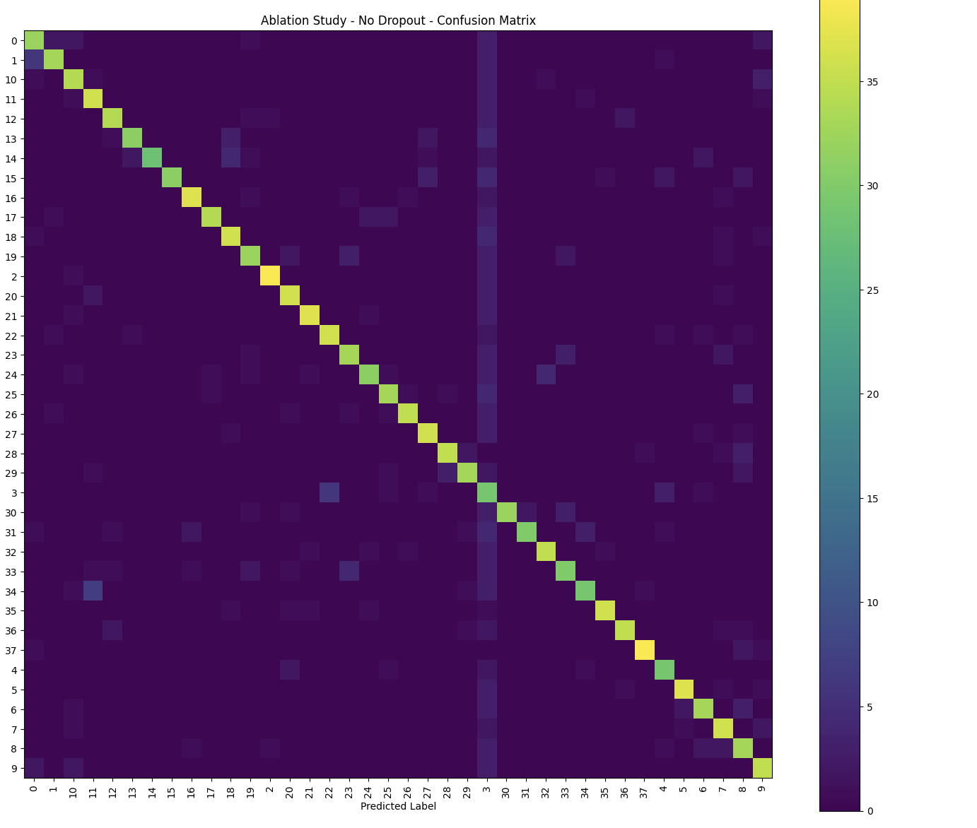
Figure 8: Confusion matrix of the best-performing ablation CNN model.

MobileNetV2 feature extraction has achieved 72.03% accuracy, while fine-tuned MobileNetV2 improved to the 77.22%. Fine-tuning performed nicely because later layers of the MobileNetV2 were allowed to adapt to a sign language gesture dataset. However, the best CNN model trained from the scratch still outperformed MobileNetV2 models in the experiment.
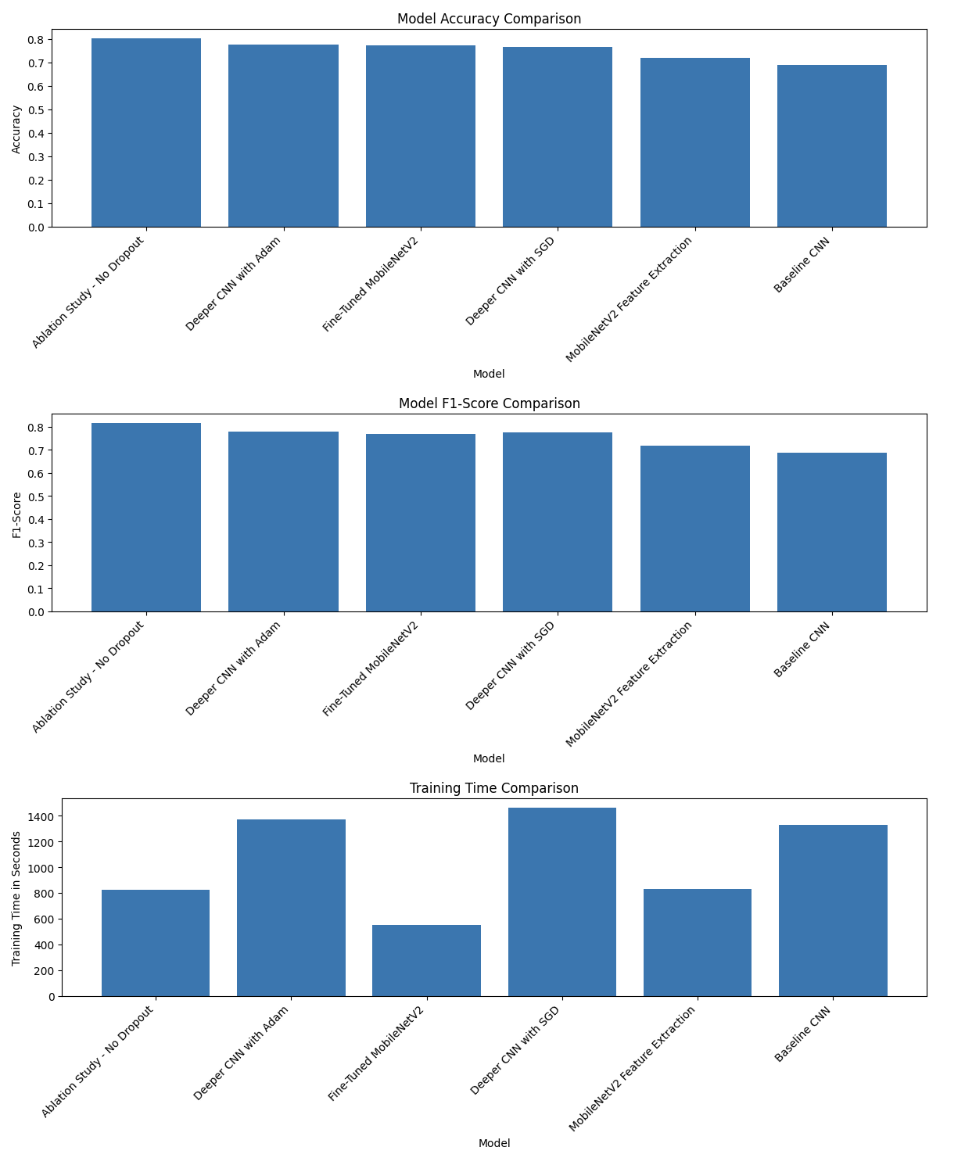
Figure 9: Final Model Comparison Graph

7. Test Set Structure and Prediction
The dataset includes a Test folder, but contained only three raw images which is directly inside folder and doesnot contain class-wise subfolders. Keras “flow_from_directory” method required images to be organize into the class folders to calculate the evaluation metrics. For example, valid test structure would need folders like as Test/0 , Test/1 and so on.
Because Test folder was not arranged in this way, it could not be used to calculate the accuracy, precision, recall, F1-score, or confusion matrix. Hence, the validation set was used for metric-based evaluation. The three raw Test images was still passed through a best trained model for prediction visualization. The model used for the raw Test image prediction was ablation model because it has achieved the best validation performance.
This means that Test images were used for the prediction only, while the validation set was used for supervised evaluation.
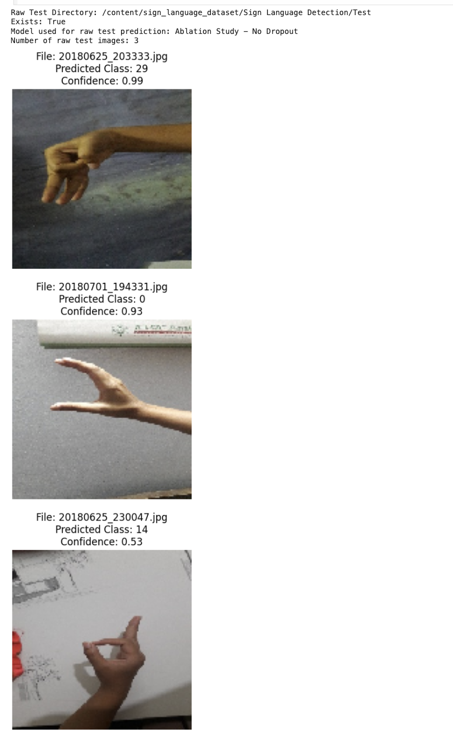
Figure 10: Prediction results on the three raw Test folder images using the best-performing model.

8. Challenges and Observations
Many challenges were observed during this project. At first, some sign language gestures was visually similar, making the classification difficult. Small differences in hand shape or finger position can represent a different classes, so a model must learn fine-grained visual features.
Then Second, the dataset contained variations in the ighting, background, and hand orientation. Although these variations makes dataset more realistic, but they also increase model difficulty. Data augmentation helps address this by exposing model to the different transformed versions of images.
Third, the Test folder was not suitable for a metric-based evaluation because it was not class-wise. This has limited ability to evaluate the model on the separate labeled test set. Instead, the validation split from a training directory was used.
Fourth, model complexity affected training time. The deeper CNN models requires more time to train than the simpler models. A deeper CNN with SGD took the longest training time, while a fine-tuned MobileNetV2 model had the lower training time but did not achieve highest performance.
Finally, ablation study showed that removing Dropout improved performance in this specific run. However, this does not mean Dropout is always unnecessary. More testing with a larger labeled test set would be needed toconfirm whether a ablation model generalizes better.

9. Conclusion and Future Work
This project has successfully implemented and compared the multiple deep learning models for sign language gesture classification. The baseline CNN, deeper CNN models, the ablation model, and MobileNetV2 transfer learning models were trained and then evaluated. The best-performing model was an ablation study model without Dropout, which achieved 80.10% validation accuracy and the F1-score of 81.53%.
The results shows that the CNN-based models are effective for sign language image classification because they can learn the visual patterns like as hand shape, edges, and gesture position. A deeper CNN models performed better than baseline model, showing that the additional convolutional layers can improve feature extraction. Transfer learning using the MobileNetV2 also performed well, especially after a fine-tuning, but it did not outperform best custom CNN model in the experiment.
For future work, this dataset should include the properly labeled class-wise test set so that the model could evaluat on truly unseen data. Better advanced architectures such as EfficientNet or ResNet could be tested. Hyperparameter tuning, background removal, stronger augmentation, and real-time webcam-based prediction can further improve this system. The deployed application could eventually help to translate sign language gestures into the text, making communication more available .

