

6CS012
Artificial Intelligence and Machine Learning
GitHub:

Part 3: Language Task

Student Name : Aaron Shrestha
University ID : 2414190
Group : L6CG12
Module Leader : Mr. Siman Giri
Tutor : Mrs. Jinu Nyachhyon

Abstract
This project focuses on developing a deep learning-based sentiment classification system using the Book Review Dataset. The original dataset contained book ratings from the range of 1 to 5, with review text and summary as well. To arrange the task with sentiment analysis, the ratings are converted into three sentiment classes: Negative, Neutral, and Positive. Ratings 1 and 2 were mapped to Negative, rating 3 was mapped to the Neutral, and ratings 4 and 5 were mapped to the Positive.
The project used the complete Natural Language Processing Pipeline which included Dataset loading, Text cleaning, Tokenization, Sequence padding, Train-validation-Test splitting, Model training, and the evaluation. Four Deep learning models were compared: Simple RNN, LSTM, LSTM with pre-trained embeddings, and Bidirectional LSTM with pre-trained embeddings. Text preprocessing included lowercasing, contraction handling, removal of URLs, numbers, special characters, stopword removal, and lemmatization.
The best-performing model was Bidirectional LSTM with the pre-trained embeddings, which has achieved the test accuracy of 75.28% and the F1-score of 76.06%. The results shows using pre-trained embeddings and the bidirectional sequence learning improvs sentiment classification performance compared to Simple RNN and standard LSTM models. Although, Neutral reviews remained more complex to classify because they usually contain mixed or ambiguous sentiment.

Table of Contents
1. Introduction 1
2. Dataset Description 1
3. Text Preprocessing 3
4. Tokenization and Sequence padding 4
5. Methodology 5
5.1 Simple RNN with Trainable Embedding 5
5.2 LSTM with Trainable Embedding 6
5.3 LSTM with Pre-trained Embeddings 6
5.4 Bidirectional LSTM with Pre-trained Embeddings 6
6. Experiments and Results 7
7. Error Analysis 12
8. Real-Time Prediction Interface 13
9. Conclusion and Future Work 13

Table of Figures:
Figure 1: Rating Distribution Graph 2
Figure 2: Sentiment Class Distribution Graph 2
Figure 3: Top 20 Frequent Words After Cleaning 3
Figure 4: Word Cloud 4
Figure 5: Review Length Distribution 5
Figure 6: Simple RNN Model Summary 5
Figure 7: LSTM Model Summary 6
Figure 8: Bidirectional LSTM Model Summary 7
Figure 9: Simple RNN Accuracy and Loss Curves 8
Figure 10: LSTM Accuracy and Loss Curves 9
Figure 11: Bidirectional LSTM Accuracy and Loss Curves 10
Figure 12: Final model comparison graph 11
Figure 13: Confusion matrix of Best model (Bidirectional LSTM model) 11
Figure 14: Misclassified Examples Table 12
Figure 15: Sample Real-Time Prediction Output 13

Introduction

Text classification is important Natural Language Processing task where the textual data is preassigned to predefined categories. For this project the task is classifying book reviews into sentiment classes based on content of review. Sentiment analysis is frequently used in the real-world applications such as product review analysis, recommendation systems, customer feedback monitoring, and business decision-making.
The Book Review Dataset originally contained ratings from the scale of 1 to 5. However, exact rating prediction can be difficult because difference between nearby ratings, such as 4 and 5, is usually subjective. Therefore, ratings were converted to three sentiment classes: Negative, Neutral, and Positive which makes the problem more suitable for the sentiment analysis and aligns with coursework requirement for text classification using RNN and LSTM models.
Recurrent Neural Networks are good for text classification because they can process sequential data and can learn patterns based on the word order. However, standard RNNs may struggle with the long-term dependencies because of the vanishing gradient problem. LSTM networks report the issue by applying memory cells and gates that control what information should be remembered or deleted. In this project, different RNN-based models were trained and compared for identifying the most effective model for book review sentiment classification.

Dataset Description

The dataset which is used in this project is Book Review Dataset. It was loaded from the CSV file named Book_review.csv. This dataset contains 12,000 records with four columns: The main input features used for this task were reviewText and summary, while the target variable was derived from the rating column.
The summary column provides a short description or title of review, while the review Text contains full review written by user. These two columns were combined into one text input so that model could learn from both short summary and detailed review content.
The original rating values ranged from a scale of 1 to 5. For sentiment classification, ratings were converted as follows:

Rating Value | Sentiment Class | Label
1-2 | Negative | 0
3 | Neutral | 1
4-5 | Positive | 2
After conversion, this dataset contained three sentiment classes. The class distribution was:

Sentiment Class | Number of Reviews
Positive | 6,000
Negative | 4,000
Neutral | 2,000
This shows that this dataset was imbalanced, with Positive reviews being most common and the Neutral reviews being least common. To reduce effect of the class imbalance, class weights were applied during the model training.
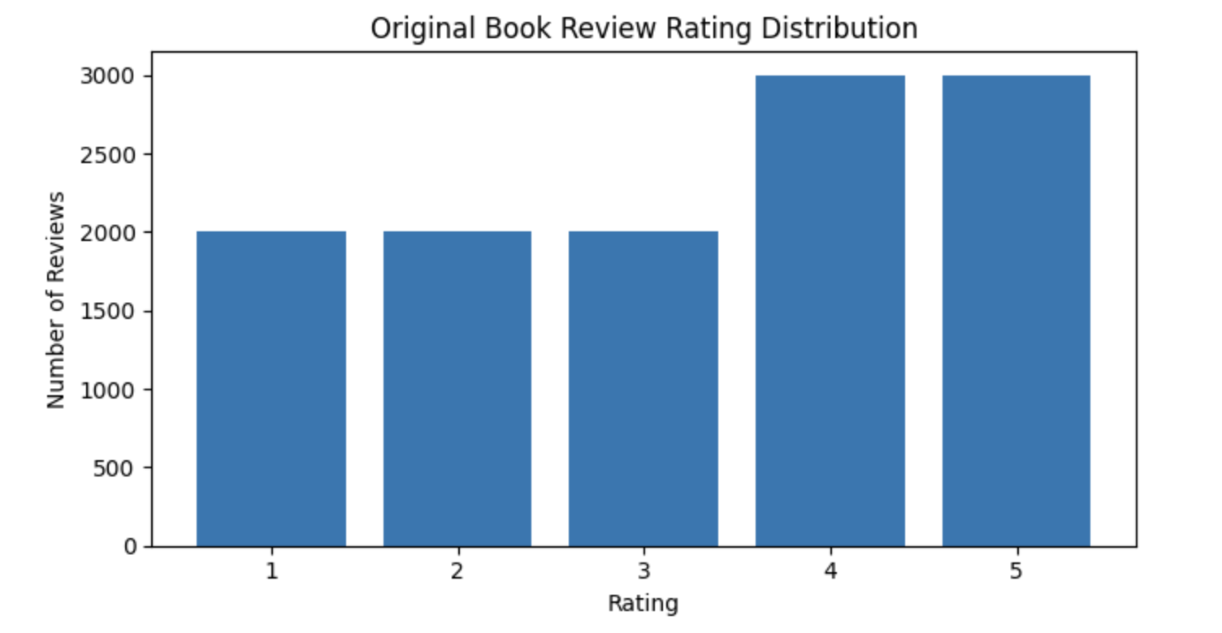
Figure 1: Rating Distribution Graph

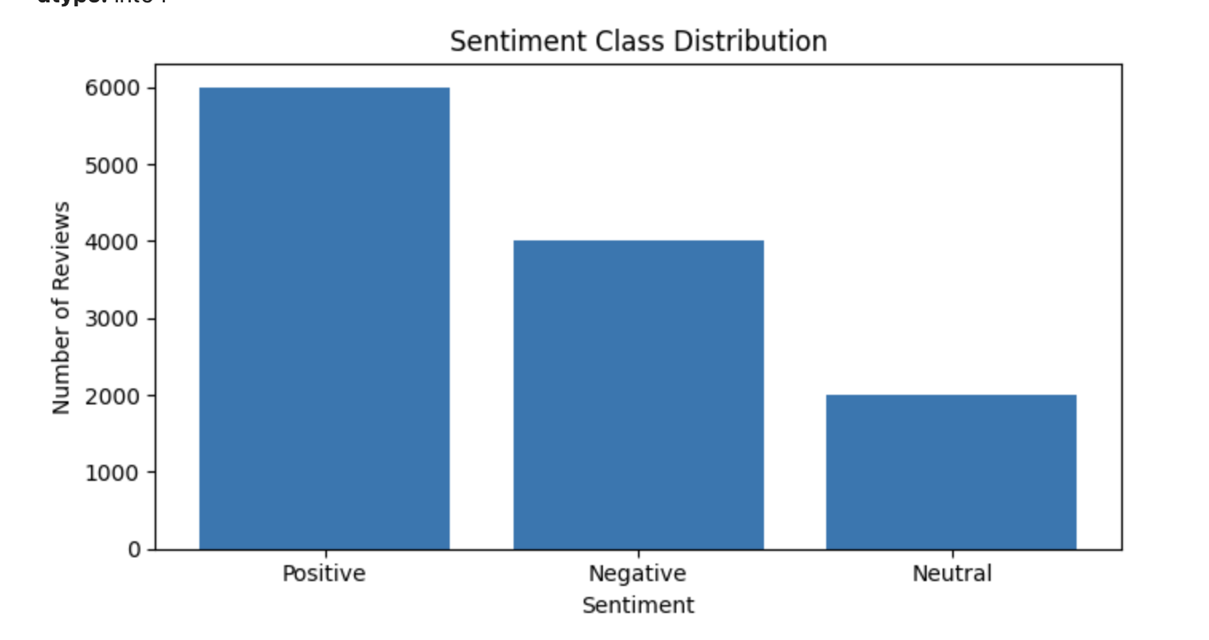
Figure 2: Sentiment Class Distribution Graph

Text Preprocessing
Text preprocessing was performed for cleaning raw review text and make it suitable for the deep learning models. At first, summary and reviewText columns were combined into the single text column. This was done because the summary often contains a short opinion signal, while the review text provides more detailed context.
The text was then converted to the lowercase to ensure its consistency. Contractions are expanded such as changing “don’t” to “do not,” so the model could better understand the negation. URLs, mentions, hashtags, numbers, and special characters were removed because they can add noise to the dataset. Extra spaces were also removed.
Stopword removal was applied to remove the common words that does not contribute much meaning. However, negation words like “not,” “no,” and “nor” were saved because they were important for the sentiment analysis. For example, “not good” has very different meaning from “good.” Lemmatization was applied to the reduce words to their base form, which helps the reduce vocabulary size and the improve consistency.
Text preprocessing is the important because raw text contains noise, spelling variations, symbols, and unnecessary words. Cleaning text helps model focus on the meaningful patterns in review content.
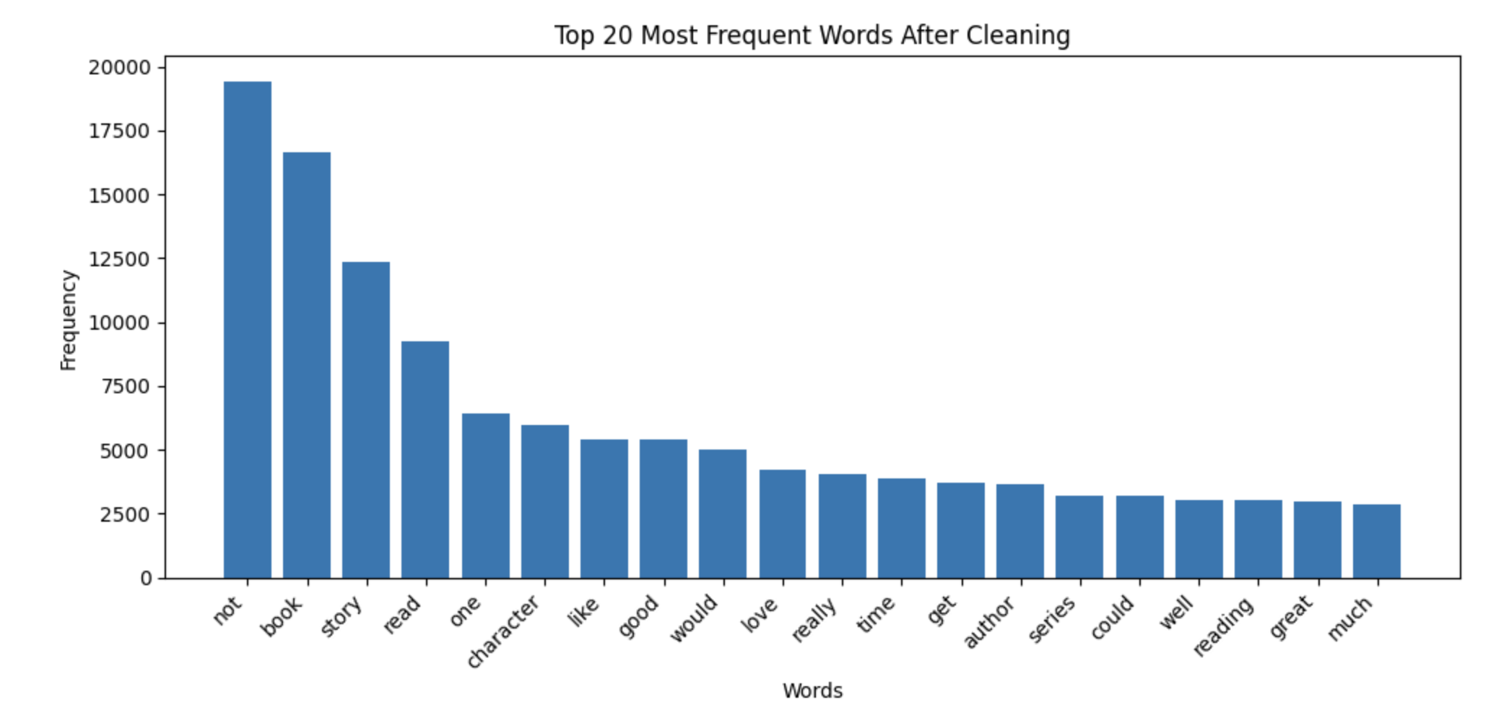
Figure 3: Top 20 Frequent Words After Cleaning

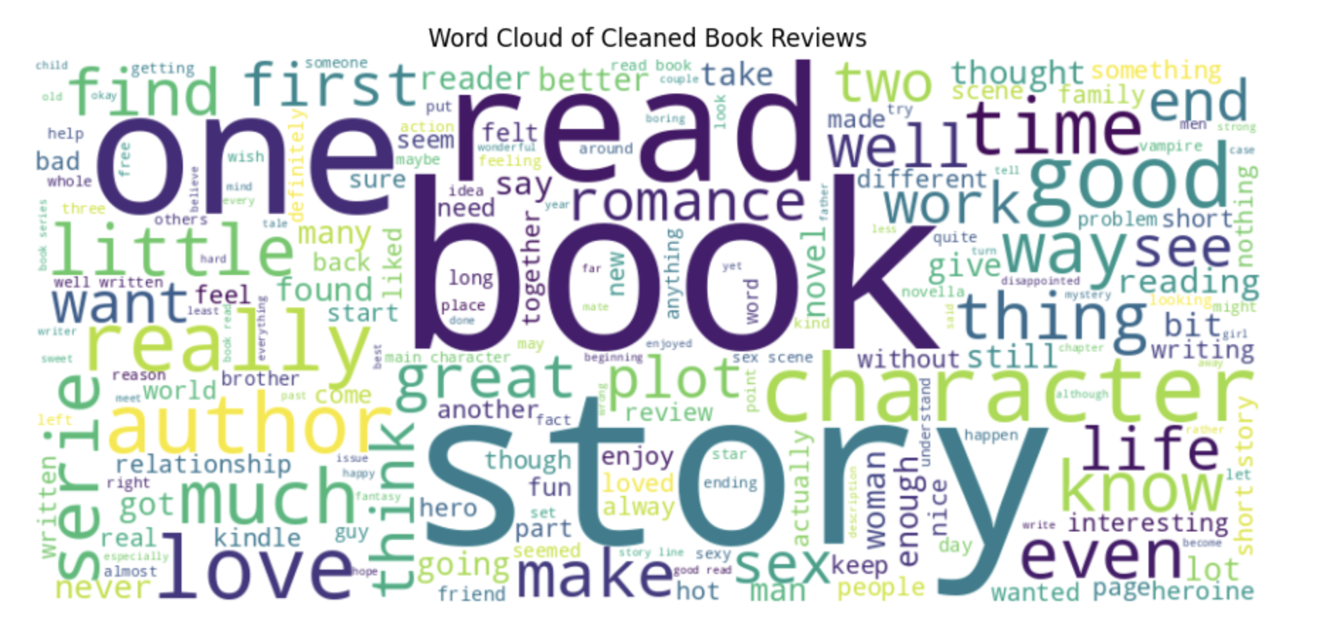
Figure 4: Word Cloud

Tokenization and Sequence padding

After preprocessing part cleaned text was converted into the numerical format using the Keras Tokenizer. Neural networks cannot directly process a raw text. Hence, tokenization converts every word into the integer index. A maximum vocabulary size of the 20,000 words was applied and then out-of-vocabulary token was included to handle the unseen words.
Tokenized reviews had different sequence lengths because some reviews were short while others were long. Since RNN and LSTM models requires the input sequences of an equal length, padding was applied. Percentile-based padding was applied for avoiding making all sequences long as longest review. This help reduce unnecessary computation keeping most useful information.

The dataset was split into the training, validation, and test sets by using ranked sampling. The split was:
Dataset Split | Number of Samples
Training Set | 8,400
Validation Set | 1,800
Test Set | 1,800

The sentiment distribution was preserved across training, validation, and test sets. Class weights were calculated because dataset was imbalanced. The class weights used were:
Class | Sentiment | Weight
0 | Negative | 1.00
1 | Neutral | 2.00
2 | Positive | 0.67
Class weighting helped model pay more attention to smaller Neutral class during training.
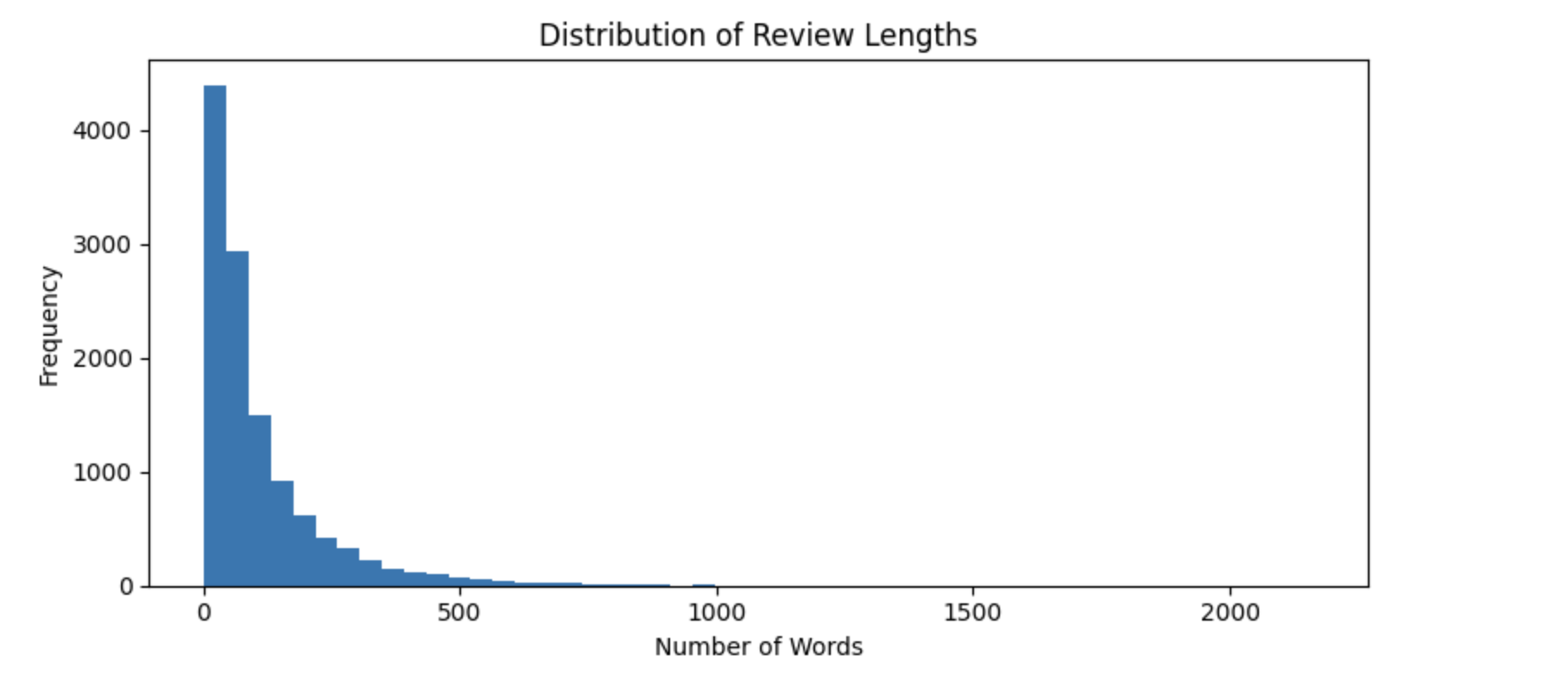
Figure 5: Review Length Distribution

5. Methodology

5.1 Simple RNN with Trainable Embedding
The first model was the Simple RNN with the trainable embedding layer. Embedding layer converted integer word sequences into the dense vector representations. Simple RNN layer then processed sequence data and learned the patterns based on the word order.
Simple RNNs are appropriate for the sequential data, but they can struggle with a long text because earlier information may be lost as sequence becomes longer. This model was used as baseline for comparison.
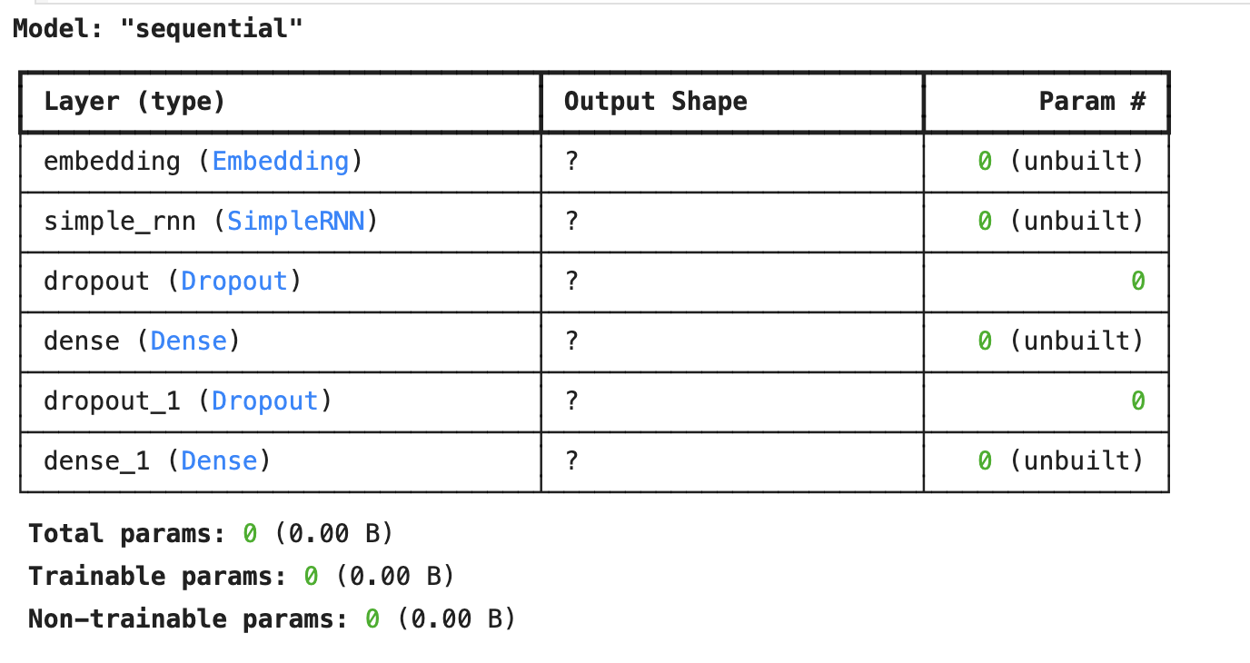
Figure 6: Simple RNN Model Summary

5.2 LSTM with Trainable Embedding
The second model was the LSTM with the trainable embedding layer. LSTM is improved recurrent architecture designed to handle the long -term dependencies more effectively than a Simple RNN. This uses gates for controlling which information should be remembered, forgotten or updated.
The LSTM model used the trainable embedding layer, meaning that a word vectors were learned directly from Book Review Dataset during the training. This allowed model to adapt embeddings to a specific language patterns found in the book reviews.
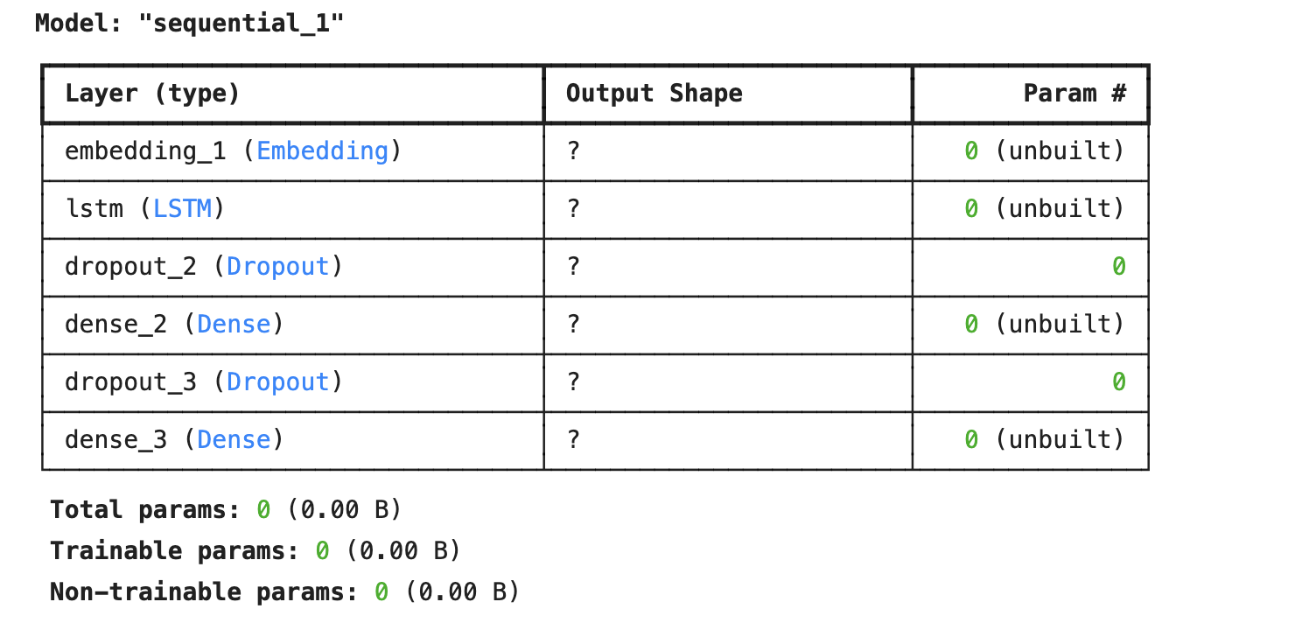
Figure 7: LSTM Model Summary

5.3 LSTM with Pre-trained Embeddings
The third model have used an LSTM with the pre-trained word embeddings. Pre-trained embeddings give word representations learned from the large text corpora. These embeddings can help a model understand the semantic relationships between the words, especially when a training dataset is limited.
For this project, GloVe-style pre-trained embedding model was applied through the gensim.downloader. The embedding matrix was created by matching words from a tokenizer vocabulary with a pre-trained embedding model. Words found in pre-trained model received their corresponding vectors, while missing words were taken care of using zero or random initialization.
This model was included to examine whether the pre-trained word representations has improved classification performance compared to the randomly initialized trainable embeddings.

5.4 Bidirectional LSTM with Pre-trained Embeddings
The fourth model was the Bidirectional LSTM with the pre-trained embeddings. A Bidirectional LSTM processes text in both forward and backward directions. This means a model can learn context from the words that appear before and after the given word. This is useful for sentiment analysis because meaning of a word can depend on the surrounding words.
Pre-trained embedding layer was made trainable in the model, which allows embeddings to adapt to Book Review Dataset during the training. Spatial dropout and dense dropout layers were integrated to reduce the overfitting. The model used Softmax activation in output layer because the task involves three sentiment classes.
This model was expected performing better as it is combined pre-trained semantic knowledge with the bidirectional sequence learning.
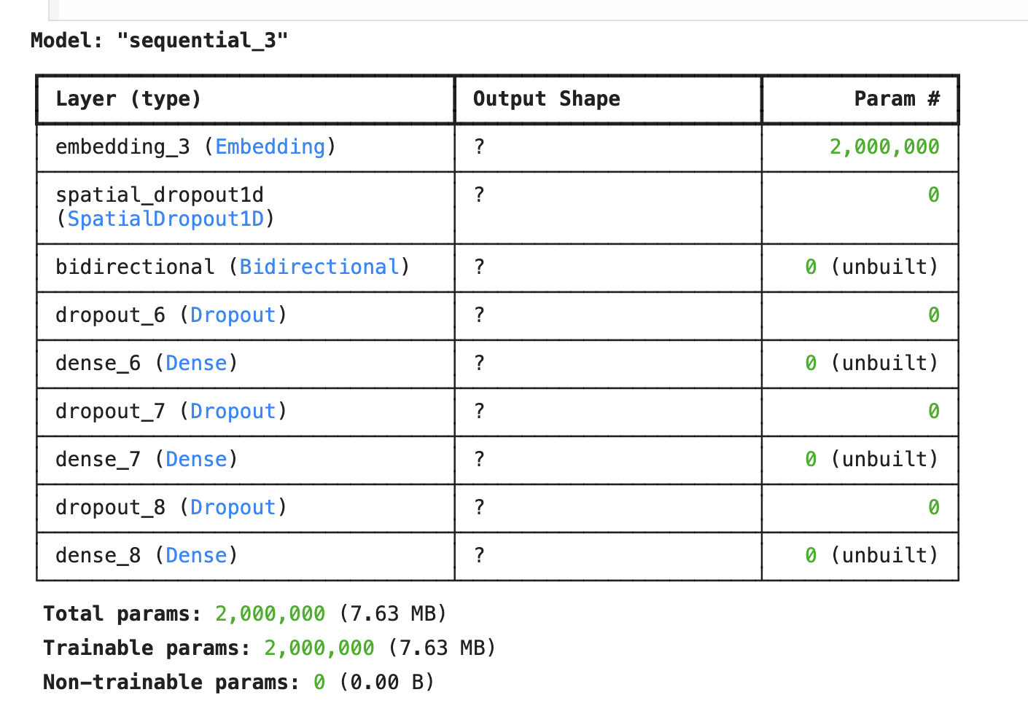
Figure 8: Bidirectional LSTM Model Summary

6. Experiments and Results
All models were trained using training set and validated set using validation set. Final performance was evaluated on a test set. The evaluation metrics applied/used were accuracy, recall, precision, F1-score, confusion matrix and classification report. These metrics provide the broader understanding of the model performance than the accuracy alone, especially when the class imbalance exists.
The results are shown below:
Model | Accuracy | Precision | Recall | F1-score
Bidirectional LSTM with Pre-trained Embeddings | 0.7528 | 0.7724 | 0.7528 | 0.7606
LSTM with Pre-trained Embeddings | 0.4783 | 0.4420 | 0.4783 | 0.3428
Simple RNN | 0.4317 | 0.4092 | 0.4317 | 0.4177
LSTM | 0.3572 | 0.4475 | 0.3572 | 0.2534

The best-performing model was Bidirectional LSTM with the pre-trained embeddings. It has achieved a accuracy of 75.28% and the F1-score of 76.06%. This result shows that by using both pre-trained word embeddings and the bidirectional sequence learning significantly improves sentiment classification performance.
The Simple RNN achieved accuracy of 43.17% and the F1-score of 41.77%. This was expected because Simple RNNs are weaker at capturing the long-term dependencies in the longer review text. Standard LSTM model performed poorly in the run, by achieving the accuracy of 35.72% and an F1-score of 25.34%. This recommends that model may have resisted with the class imbalance or failed to learn a stable sentiment patterns.
The LSTM with pre-trained embeddings achieved the accuracy of 47.83% and an F1-score of 34.28%. Although pre-trained embeddings facilitated slightly compared to standard LSTM, model still performed much worse than the Bidirectional LSTM. The Bidirectional LSTM performed better because it could learn the context from both the directions and fine-tune the embedding layer for the review dataset.

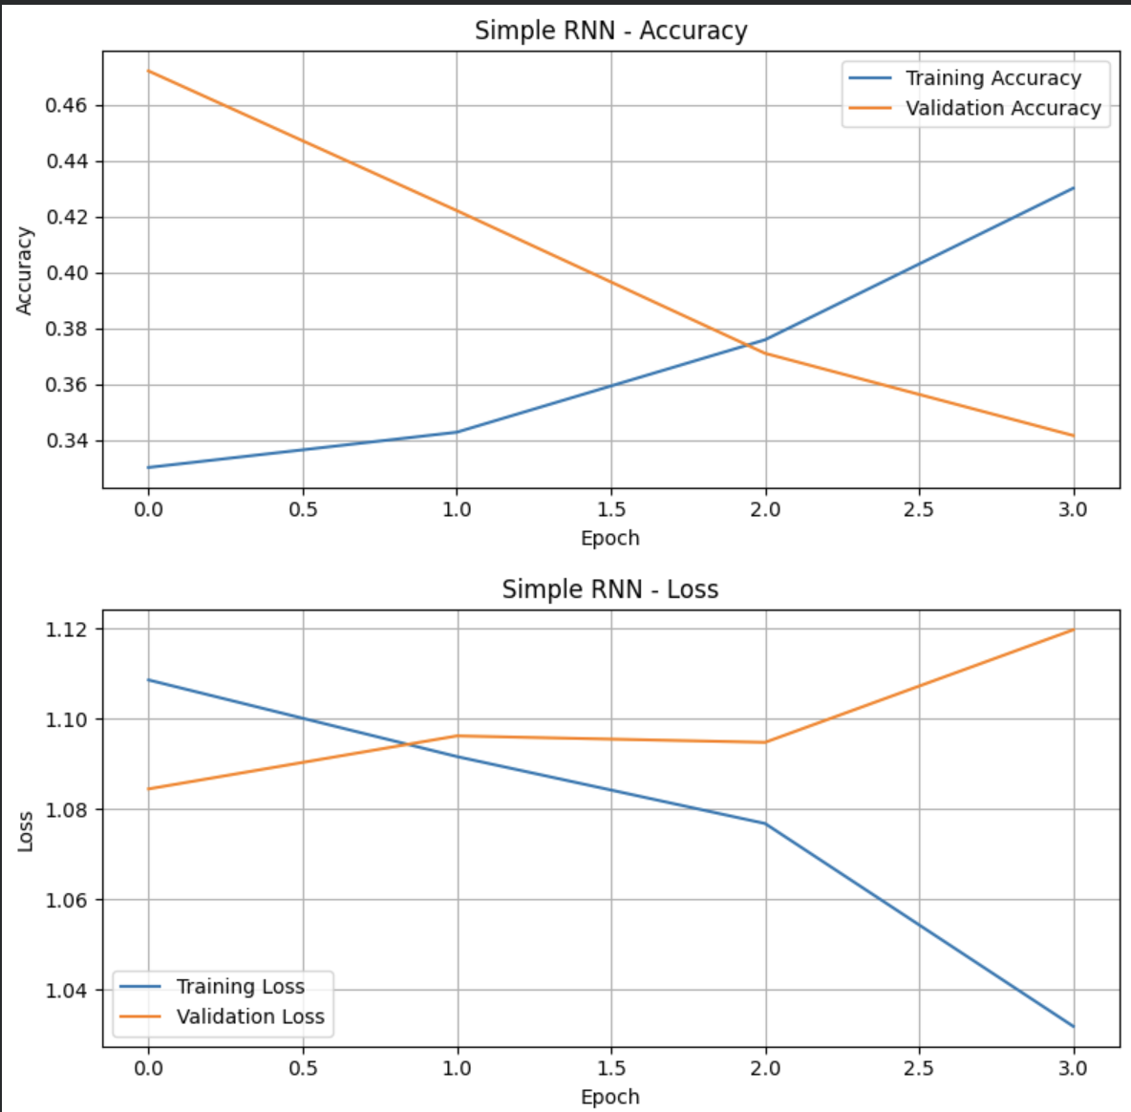
Figure 9: Simple RNN Accuracy and Loss Curves

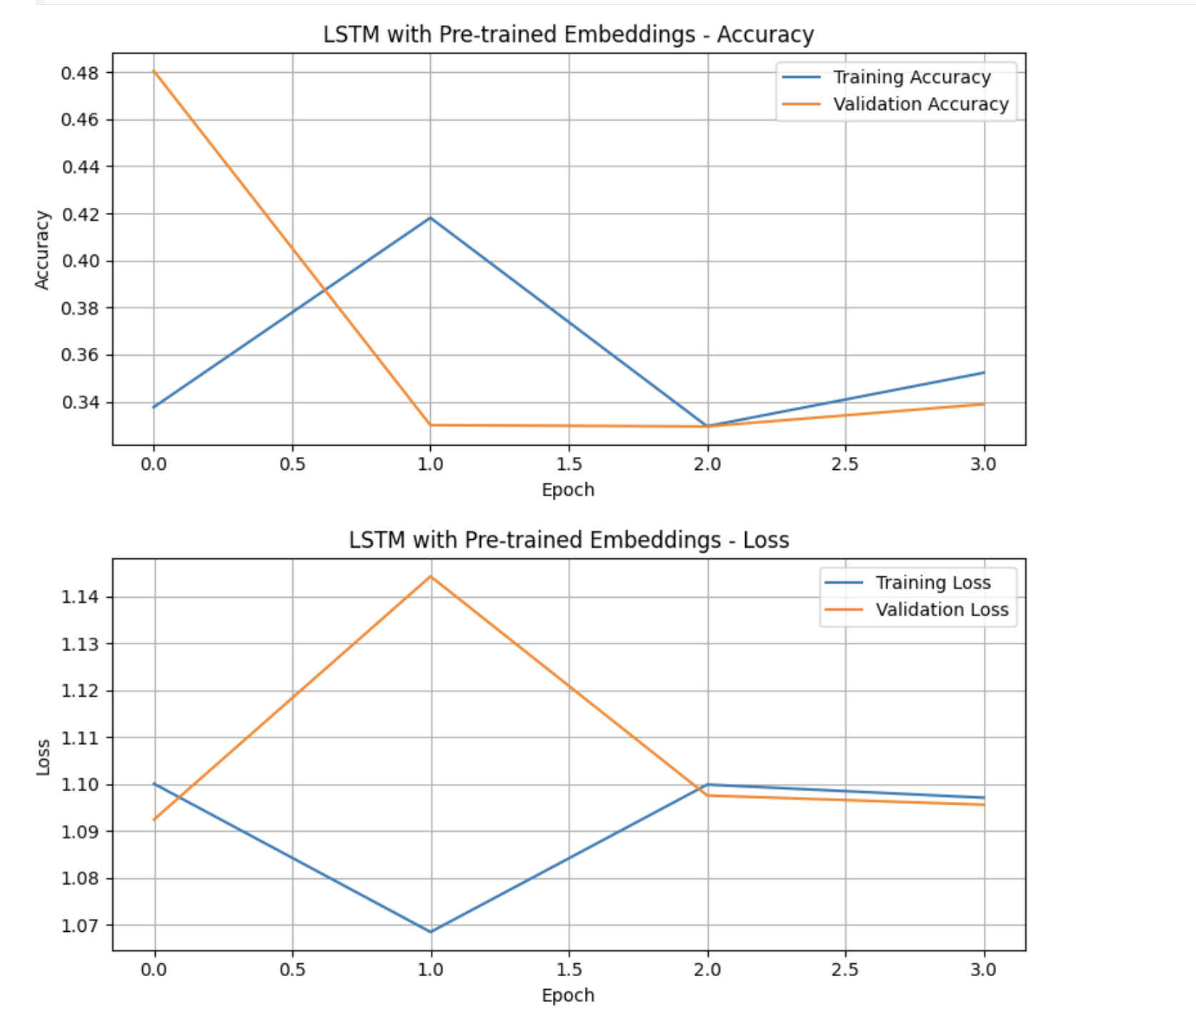
Figure 10: LSTM Accuracy and Loss Curves

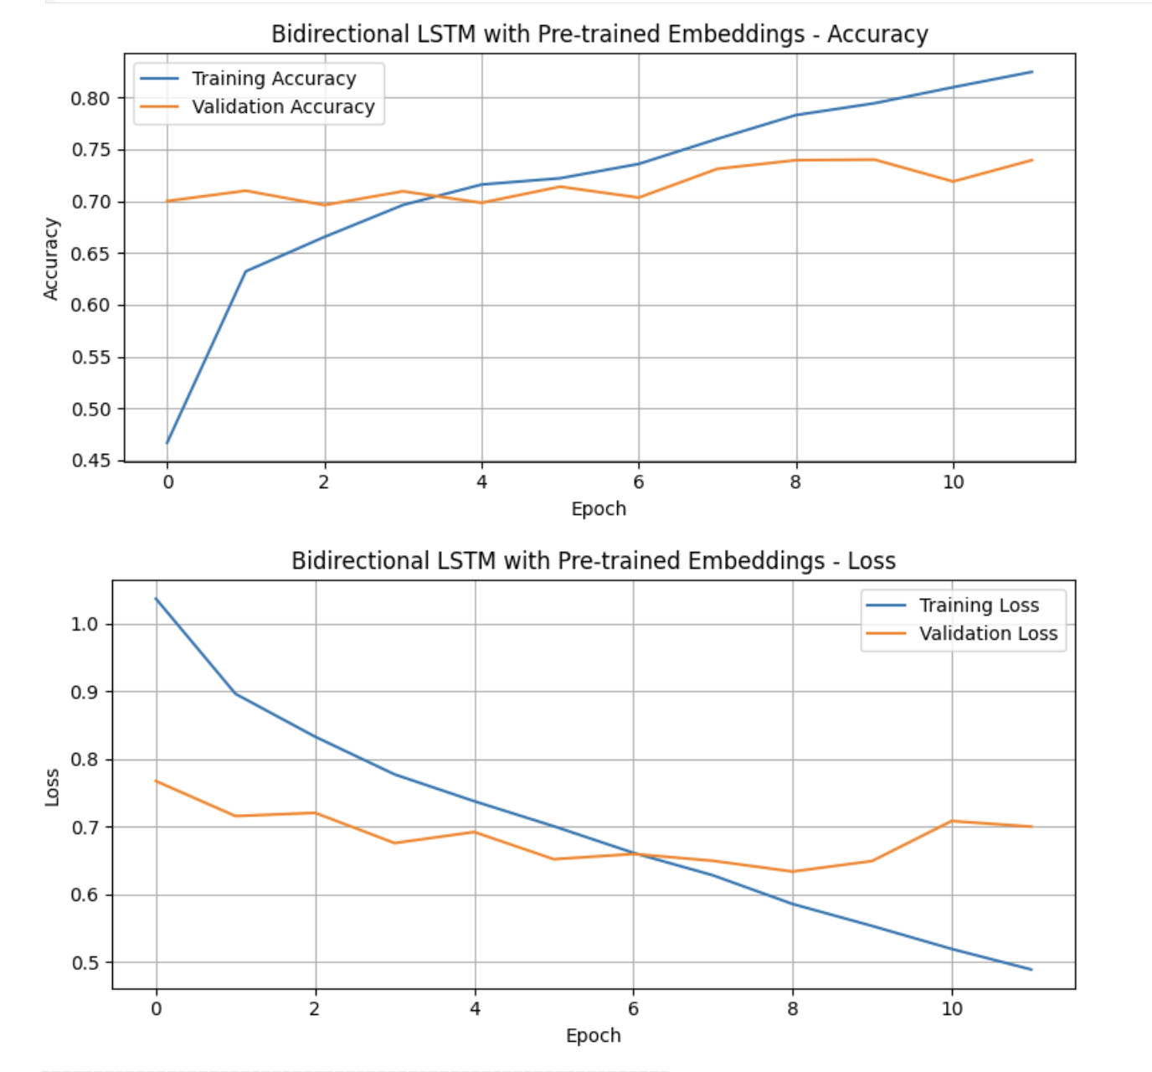
Figure 11: Bidirectional LSTM Accuracy and Loss Curves

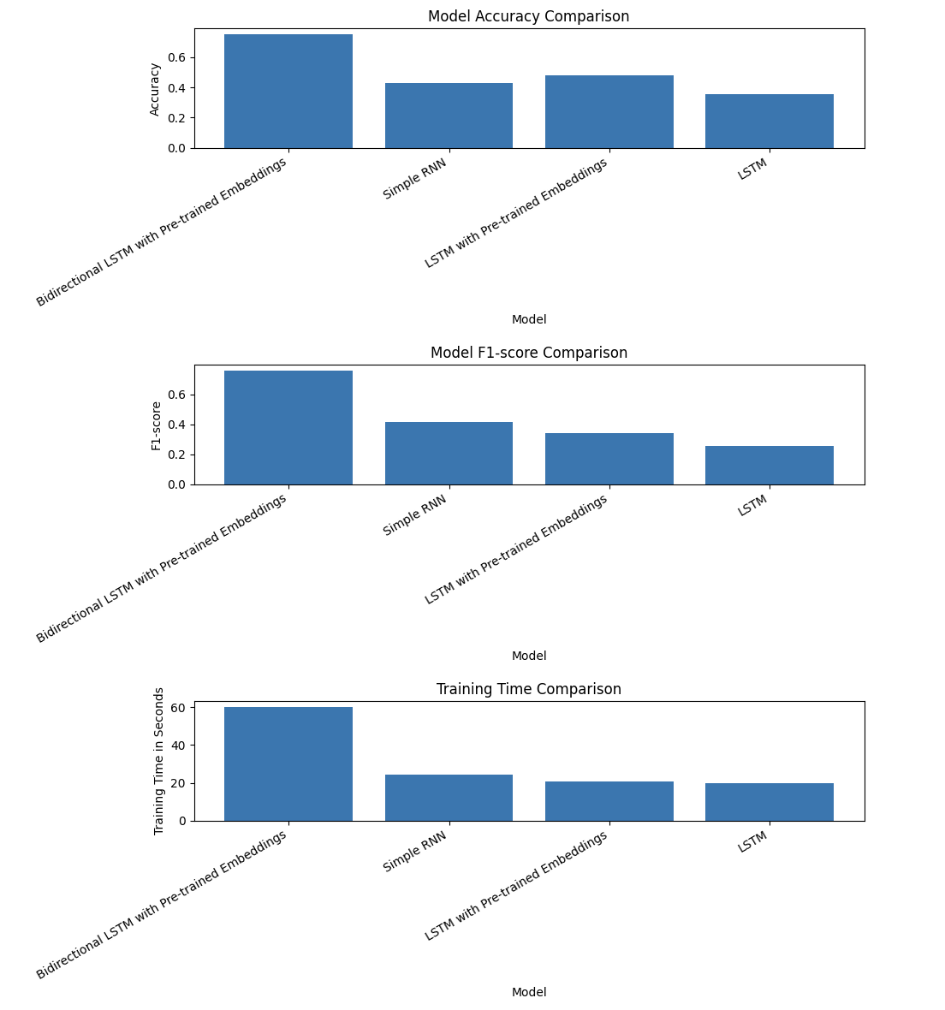
Figure 12: Final model comparison graph

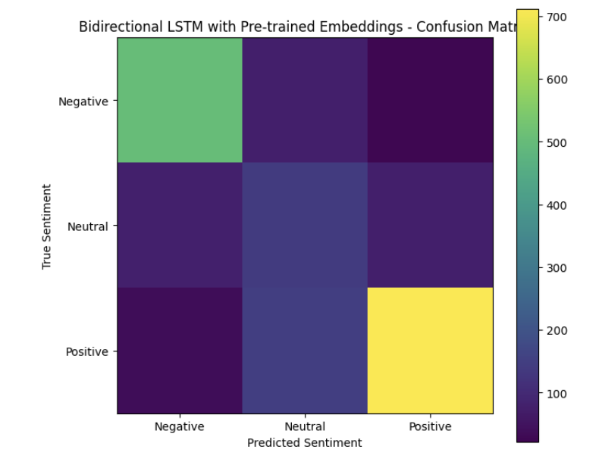
Figure 13: Confusion matrix of Best model (Bidirectional LSTM model)
The classification report of best model showed the strong performance for the Negative and Positive classes. The Negative class achieved F1-score of 0.82, while Positive class achieved the F1-score of 0.83. However, Neutral class achieved the lower F1-score of 0.42. This indicates that the Neutral reviews were harder to classify, like wise because they often have mixed opinions or language that overlaps with both positive and negative reviews.

7. Error Analysis
Error analysis was performed using best-performing model, which was a Bidirectional LSTM with the pre-trained embeddings. The notebook identifies 445 misclassified examples from test set.
Many misclassified reviews was Neutral reviews predicted as the Positive or Negative. This is understandable because the Neutral reviews often contained mixed language. For example, the review may mention both strengths and weaknesses of book, making it difficult for model to determine whether overall sentiment is Neutral. Some reviews also contain strong descriptive words which might sound positive or negative even when a actual rating is Neutral.
One example showed the Neutral review predicted as the Positive with high confidence. Review contained words related to the enjoyment, story, and characters, which may have influenced a model to classify it as the Positive. Another Neutral review was predicted as the Negative because text included criticism about the realism and credibility. These examples shows that the sentiment classification is challenging when the text contains mixed opinions.
The lower performance on the Neutral class suggests that the future improvements should focus on handling ambiguous or mixed-sentiment reviews. Possible solutions include by collecting more Neutral examples, using the more advanced embeddings, increasing model tuning, or using transformer-based models.
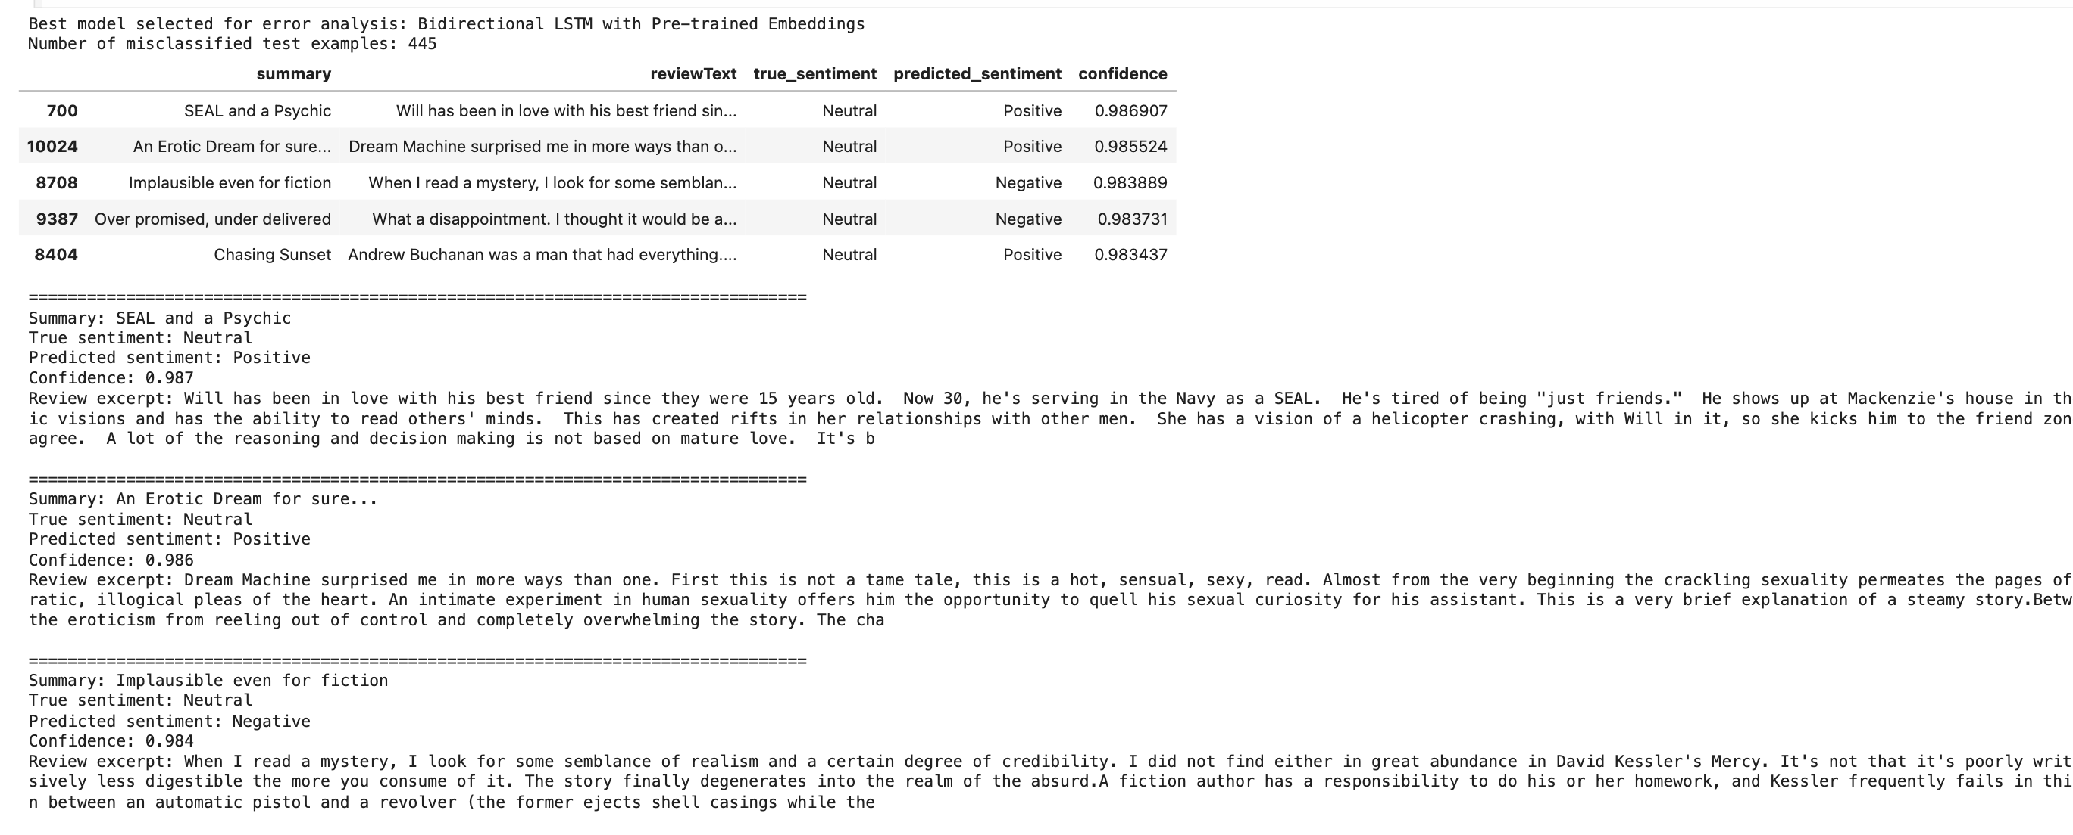
Figure 14: Misclassified Examples Table

8. Real-Time Prediction Interface
A real-time prediction function was implemented allowing the users to enter the book review and receive a predicted sentiment. The input review is first cleaned with the help of the same preprocessing function used during the training. After that it is converted into the sequence using trained tokenizer and padded to a required sequence length. Finally, best-performing model predicts whether a review is Negative, Neutral, or Positive.
Gradio interface was also included in the notebook. The Gradio interface allowed the user to type review into the text box and receive a predicted sentiment and confidence score. By default, Gradio demo was disabled so that running all notebook cells would not get stuck launching the application. It can be enabled manually by setting the RUN_GRADIO_DEMO = True.
The real-time prediction interface demonstrates how trained NLP model could be used in the practical application, such as automatically analyzing customer reviews for the online bookstore.
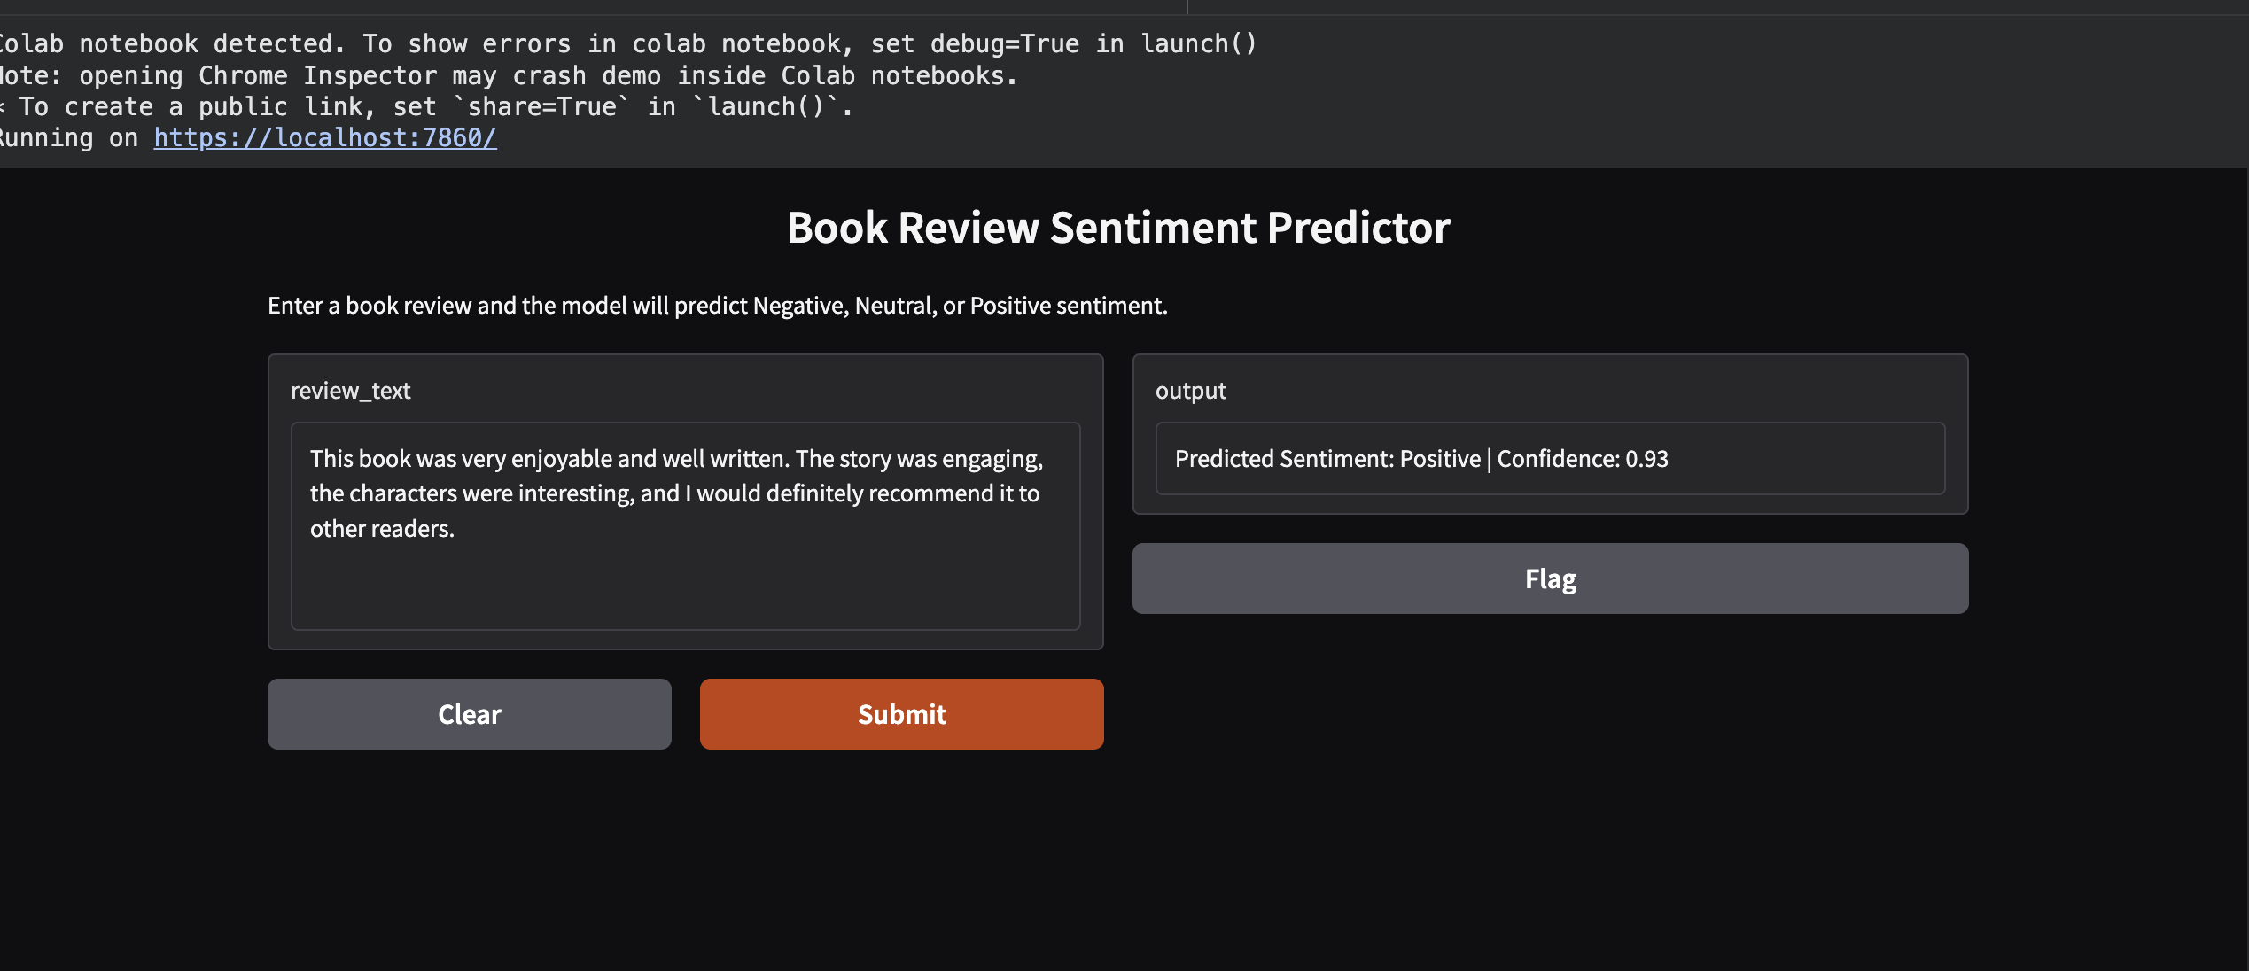
Figure 15: Sample Real-Time Prediction Output

9. Conclusion and Future Work
This project successfully developed the deep learning-based sentiment classification system using Book Review Dataset. The original 1-5 rating labels was converted into the three sentiment classes: Negative, Neutral, and Positive. This made this problem more suitable for the sentiment analysis and improved the interpretability.
The project implemented complete NLP pipeline, including the text preprocessing, tokenization, sequence padding, train-validation-test splitting, model training, evaluation, error analysis, and real-time prediction. Four models were compared: Simple RNN, LSTM, LSTM with the pre-trained embeddings, and an Bidirectional LSTM with the pre-trained embeddings.
The best performing model was Bidirectional LSTM having the pre-trained embeddings and achieving 75.28% accuracy and 76.06% F1-score on test set. This result shows that bidirectional sequence learning and pre-trained embeddings can significantly improve the sentiment classification performance. However, Neutral class remained most difficult to classify because the neutral reviews often contain mixed or an ambiguous sentiment.
For the future work, model could be improved using the larger pre-trained embeddings, more advanced architectures, or the transformer-based models. Additional preprocessing techniques, hyperparameter tuning, and more balanced data could improve performance. Real-time prediction system could be extended into the web application for automatically analyzing book reviews.

