Sharper, Not Safer:
The Direction of Human Deviations from Engine Play
Aaron Sun
San Marino High School
ORCID: 0009-0000-2412-4727
September 2026

Abstract
When a human player departs from a chess engine's preferred move, is the departure noise, or does it have a direction? I analyze 1,970 rated online games by titled players: 50,021 middlegame position-moves; 126,449 engine evaluations in total, comprising 63,429 root and context evaluations for the magnitude analysis, 57,294 successor evaluations for the direction analysis, and 5,726 opponent-reply evaluations for the counterfactual test, all at fixed depth with five principal variations. All evaluations are converted to win probability before differencing. Deviation magnitude behaves as a noise account predicts. It falls with rating, rises with position volatility, and rises under time pressure. The direction of deviation does not. I define a move's riskiness as the steepness of the opponent's punishment curve: the win-probability gap between the opponent's best and fifth-best replies. At equal expected loss, human moves sit on steeper curves than the engine's choice (intercept +1.22 win-probability points, p = 1.6 × 10⁻³⁵; 59.85% of deviations toward the sharper side, sign-test p = 1.8 × 10⁻¹⁷⁰). The effect survives a liquidation control and two pre-specified robustness variants, and it strengthens under time pressure. A risk-averse agent should retreat to recoverable positions; players sharpen instead. A pilot-stage association between deviation direction and a previously measured style dimension collapsed on the full sample, and I report it as unsupported. A pre-registered counterfactual test then asks whether the sharpness is repaid. It is not. Using the difficulty of the position each deviation hands the opponent, measured on the actual branch and on the engine's branch, I separate the opponent's induced error into a part that difficulty explains and a part it does not. The average deviation loses 1.72 win-probability points net of everything it induces. Sharper deviations lose more, not less (−0.48 points per standard deviation of steepness), and the beyond-difficulty component does not rise with steepness (coefficient −0.09). Rerunning the earlier confounded model on the same rows still gives a positive coefficient, so the identification, not the data, reverses the conclusion. My reading is that human play pursues an objective the engine does not share, one that prices the opponent's fallibility, and pays for the pricing without collecting on it. All hypotheses, parameters, and variants were fixed in advance. Three execution faults caught during the study and two post-results diagnostic corrections are disclosed in full.

1. Introduction
Chess engines give behavioral science a domain where every human decision can be scored against a near-optimal benchmark, move by move, in the player's natural environment (Anderson, Kleinberg, & Mullainathan, 2017; McIlroy-Young, Sen, Kleinberg, & Anderson, 2020). When a strong human departs from the engine's preferred move, the standard reading is deficit: the human calculated less deeply and erred. On that reading, deviations are noise around the optimum. Their magnitude should track skill and difficulty, and their direction should carry no signal.
This paper tests the second half of that reading and rejects it. I ask two questions in sequence. First, what predicts how much a titled player deviates from the engine? The answers are the expected ones: skill, position complexity, time pressure. Second, given that a player deviates by a fixed amount, which way does the deviation go? If deviations are noise, moves that cost the same expected value should be exchangeable in every other respect. They are not. At equal expected loss, human choices sit on sharper continuations, meaning positions where the opponent's best reply and fifth-best reply differ more in consequence, and where the opponent must find the precise move or concede. The direction is the opposite of what a risk-management account predicts, and it grows stronger under time pressure, which is where a risk-averse agent would most want a forgiving position.
The question has a history in this project, and that history shaped the design. An earlier pre-registered analysis asked whether engine-suboptimal human moves raise the opponent's subsequent error, which is a direct test of human-AI complementarity. The mechanism coefficient came out positive and the outcome coefficient came out negative, and the design could not separate genuine opponent-directed play from a confound: sharp moments inflate both players' errors at once. Rather than defend an estimate I could not identify, I redesigned the study. Fix the expected loss, then ask about the shape of what the human accepted in exchange. That redesign is this paper, in two steps. Part II fixes the expected loss and asks about the shape of what the player accepted in exchange. Section 4.5 then returns to the complementarity question with an identification the earlier analysis lacked: for every deviation I measure the difficulty of the position the opponent actually received and the difficulty of the position the engine's move would have produced, and I ask whether the opponent's error exceeds what that difficulty explains. The answer is no. The claim of this paper is therefore not that humans deviate profitably, since on average they do not. It is that humans optimize a different objective than the engine, one that prices the opponent's capacity to err, and that in this population the price is paid without being collected.
Three commitments shaped the work. All parameters, hypotheses, bands, and robustness variants were locked in a written specification before execution, with a standing rule that disagreement is reported rather than silently patched. A pilot preceded every full run. And everything that went wrong is disclosed in Section 6: a sign-convention erratum in the specification, an optimizer that silently returned a false null, a shard-naming bug that briefly destroyed a quarter of the data before a coverage check caught it, and a diagnostic in the counterfactual test that was withdrawn by dated amendment as invalid by construction.

2. Data and measures

2.1 Games and positions
The sample is 1,970 rated online games from Chess.com in bullet, blitz, and rapid time controls. Games were drawn by a locked random seed from the male titled-player frame of a companion study (Sun, 2026), and I reuse that study's middlegame boundary function unchanged. Both sides' moves are taken. This yields 50,021 middlegame position-moves by 2,317 distinct players. Titled roster members (578 players) contribute 51.0% of rows, and their opponents span down to club level. Every ply carries clock data, so no game was excluded from time-pressure analyses. Thirty of the originally drawn 2,000 games were unrecoverable because the accounts had been closed, and are reported as attrition.

2.2 Engine benchmark and win-probability loss
Each position was evaluated by Stockfish at fixed depth 15 with five principal variations (MultiPV 5), one thread and 128 MB hash per worker, every position searched independently. The magnitude analysis required 63,429 evaluations for the 50,021 rows: one root evaluation per row; 9,468 further evaluations of post-move positions where the played move fell outside the top-five MultiPV set; and two pre-window context positions per game (3,940) used solely to define evaluation volatility at the window's first two plies. Because that context spans the opening-middlegame boundary, volatility at those two plies is measured across it rather than within the middlegame. Fixed depth guarantees reproducibility; fixed time would not. All centipawn values are converted to win probability by the standard logistic map before any differencing, because centipawns are highly non-linear at the extremes. Mate scores map to ±10,000 cp. The deviation of a played move is WPL: the win probability of the engine's first choice minus the win probability of the move played, from the mover's perspective. WPL is winsorized at the top 1%, with raw values retained for sensitivity. Sign conventions were verified by explicit tests, including a board-mirror identity.

2.3 The direction measure: punishment steepness
For the directional analysis, each of the 28,647 rows where the played move differed from the engine's choice received two further evaluations: the successor position after the played move, and after the engine's choice. A move's punishment steepness is the win-probability gap, from the original mover's perspective, between the opponent's best and fifth-best replies in that successor. A steep successor is one where the opponent must find the precise reply or concede. A flat successor is one where most replies lead to similar outcomes. The directional quantity is ΔRISK: steepness of the move played minus steepness of the engine's choice. Negative means the human chose the flatter continuation; positive means the sharper one. A dispersion-based variant, the standard deviation of the mover's win probability across the opponent's five replies, serves as the single pre-specified sensitivity definition.

3. Part I: What predicts how much humans deviate
I fit a mixed-effects model of WPL with random intercepts for player and game, restricted to titled roster members so that the skill coefficient is a within-titled-population statement. All predictors are standardized. Deviation falls with rating (Elo −0.235, p = 3 × 10⁻¹⁵). It rises with evaluation volatility (+0.485, p = 1 × 10⁻⁶⁷) and with the number of legal moves (+0.311). It falls when the engine's top choices are far apart in value (spread −0.156). It rises as the clock runs down (time pressure −0.429, p = 3 × 10⁻⁵²; the variable is remaining-time fraction, so the negative sign means less time and more error). Stronger titled players deviate less, and harder, sharper, more time-starved positions produce more deviation. None of this is surprising, which is the point: magnitude behaves as a noise account predicts. Elo-by-complexity and Elo-by-time-pressure interactions were not supported at this sample size and are left for larger samples.

4. Part II: Which way humans deviate

4.1 Main result: sharper at equal expected loss
The pre-specified primary test restricts to deviations with WPL in (0, 5]. These are moves that departed from the engine but not catastrophically, the band in which a player genuinely had a choice. It holds 39.7% of rows. A further 42.7% of rows played the engine's first choice exactly, and for those ΔRISK is zero by construction. I fit a mixed model of ΔRISK on standardized WPL, first-choice gap, volatility, and time pressure, with player and game random intercepts. The model's intercept answers one question: holding the size of the sacrifice fixed, is the average deviation toward flatter or sharper ground?
The answer is sharper. The intercept is +1.216 win-probability points (95% CI [+1.02, +1.41], p = 1.6 × 10⁻³⁵). The model-free version agrees: of the 19,836 deviations in the primary band with non-zero ΔRISK (six exact ties excluded), 59.85% moved toward the steeper punishment curve (sign test p = 1.8 × 10⁻¹⁷⁰; median ΔRISK +0.63). Both pre-specified robustness variants preserve the sign. The dispersion definition gives +0.449, and the widened band (0, 10] gives +1.475. This is the paper's central result. Human deviations from the engine are not directionless. At equal cost in expected value, humans buy sharpness.
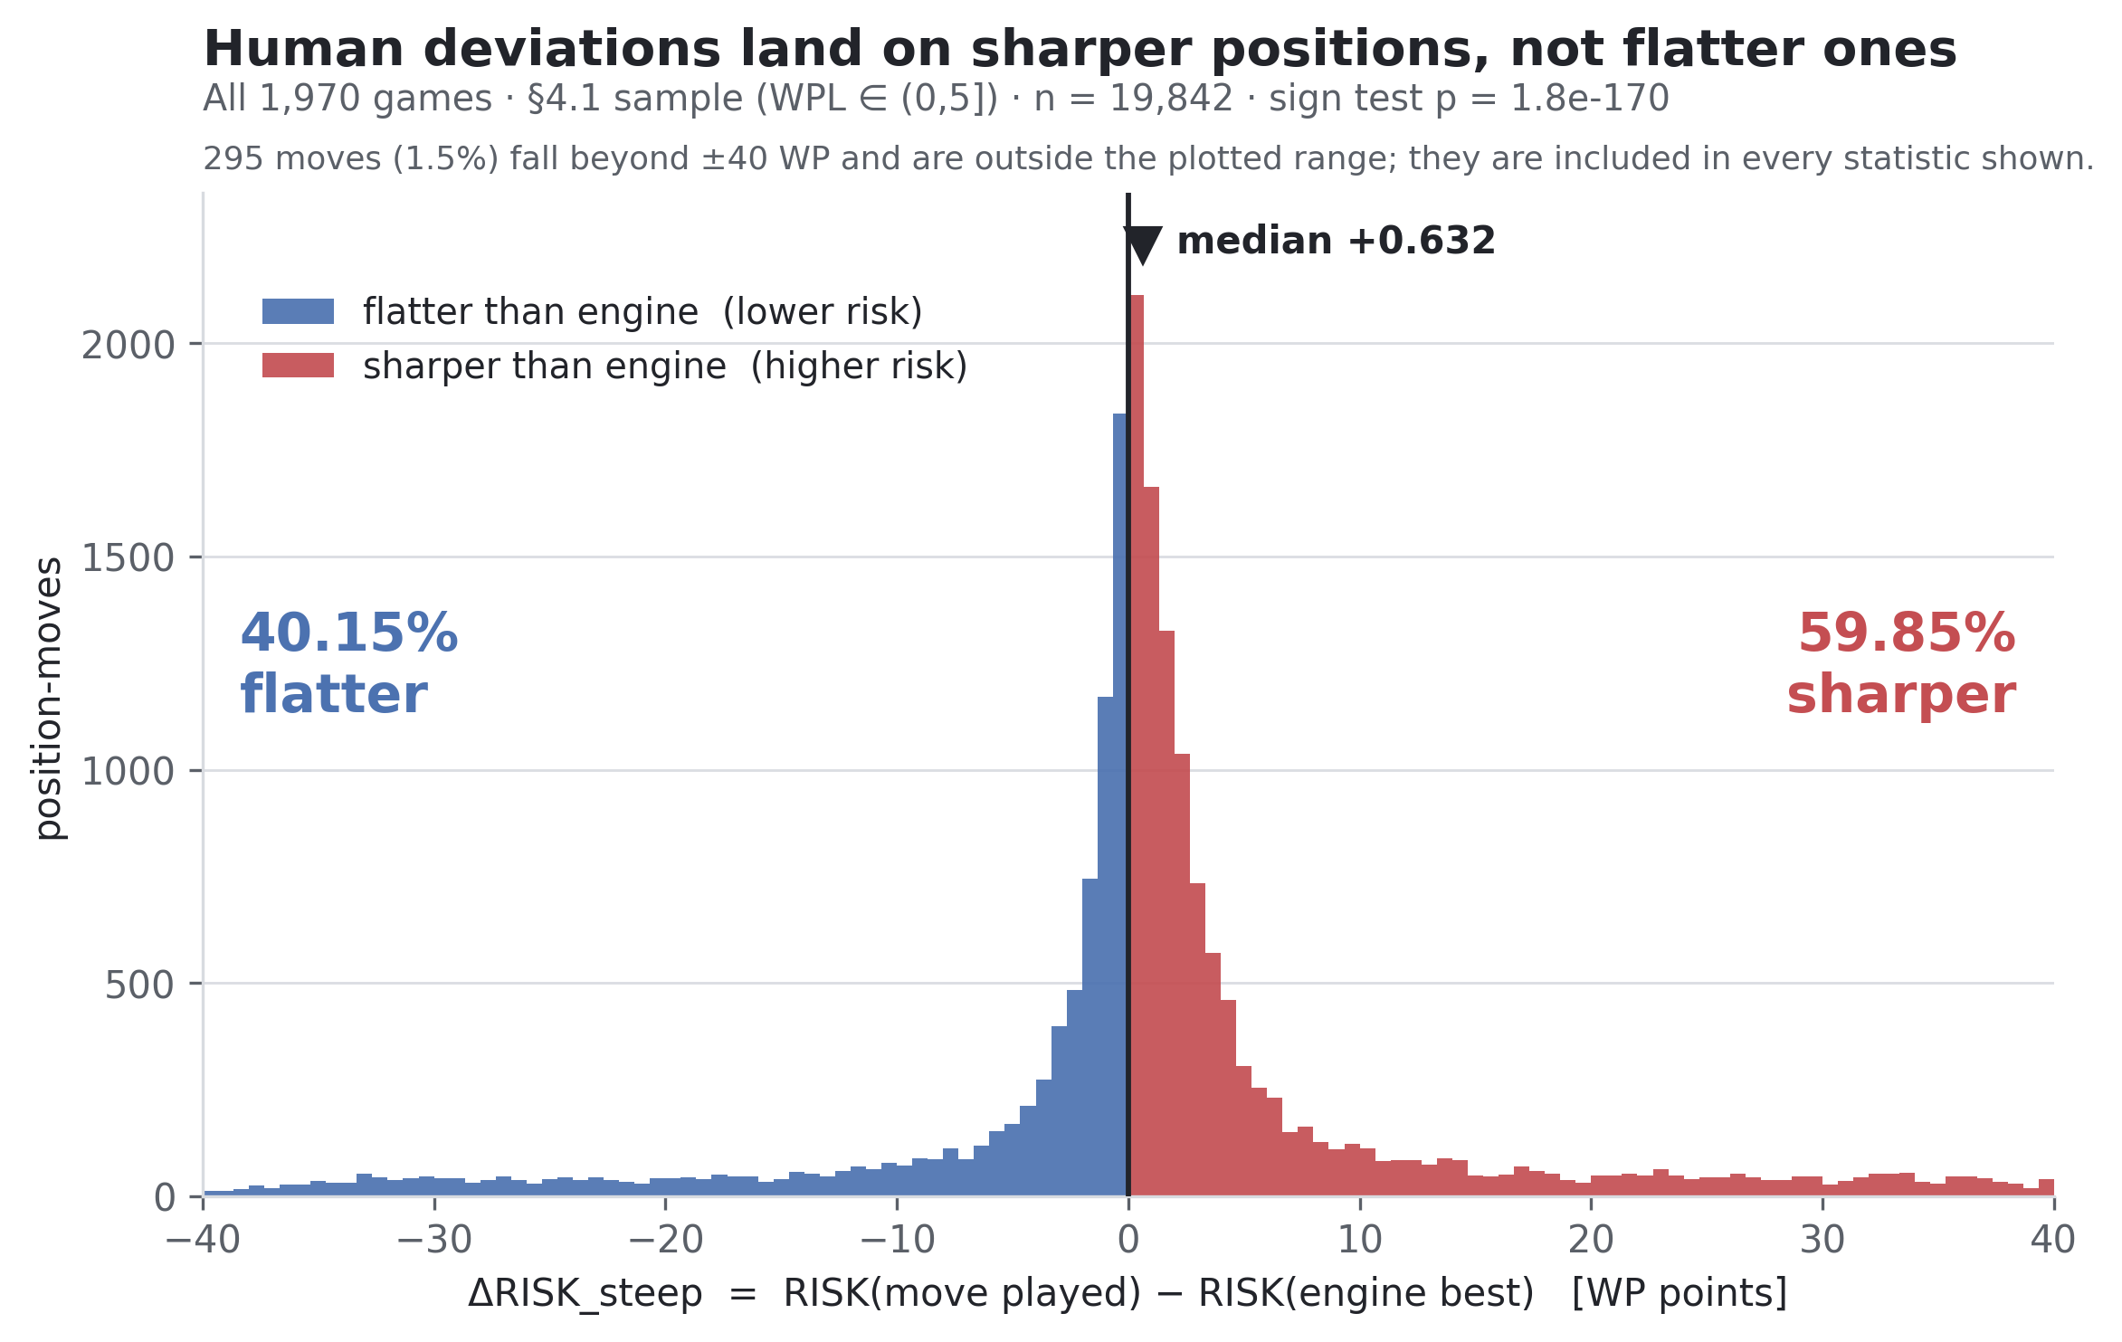
Figure A. Distribution of ΔRISK on the primary band (WPL in (0, 5]; n = 19,842). Positive values mean the played move leads to a steeper punishment curve than the engine's choice. Of the 19,836 deviations with non-zero ΔRISK, 59.85% fall on the sharper side (sign test p = 1.8 × 10⁻¹⁷⁰); median +0.63. 295 moves beyond ±40 WP lie outside the plotted range but are included in every statistic shown.

4.2 The liquidation control
One immediate worry is mechanical. If engine choices simply trade pieces more often, and simplified positions are flatter, then a finding that humans sharpen would only repackage the known human reluctance to exchange. I added two position-level covariates: whether the played move is a capture, and the material change after the played move minus after the engine's choice. The intercept barely moves (+1.215, p = 1.3 × 10⁻⁴⁵ on the full sample, a shift of 0.1%). The diagnostic also overturned the worry's premise. Removing more material predicts a steeper successor, not a flatter one. A capture typically obliges a recapture, and a position with one forced reply and four losing ones has a wide spread across the opponent's top five. Steepness measures the structure of the opponent's reply set, not the amount of material on the board.

4.3 Time pressure amplifies the effect
Time pressure enters the primary model as a main effect on ΔRISK, and its coefficient answers the moderation question directly: −0.334 (95% CI [−0.521, −0.146], p = 4.8 × 10⁻⁴). Less remaining time, sharper deviation. The predicted mean runs from +0.55 at two standard deviations of time comfort to +1.88 at two standard deviations of time trouble, which is a 27% increase per standard deviation toward the clock. A descriptive decile profile is near-monotone: +0.46 in the most comfortable decile, +1.70 in the most starved. The moment a risk-averse agent would most want a recoverable position is when time is short and calculation is impossible, and that is where players sharpen most. Whatever this behavior is, it is not retreat to safety. It reads as a default heuristic under pressure: force the position, narrow both players' choices, and make the opponent solve problems on the same clock.
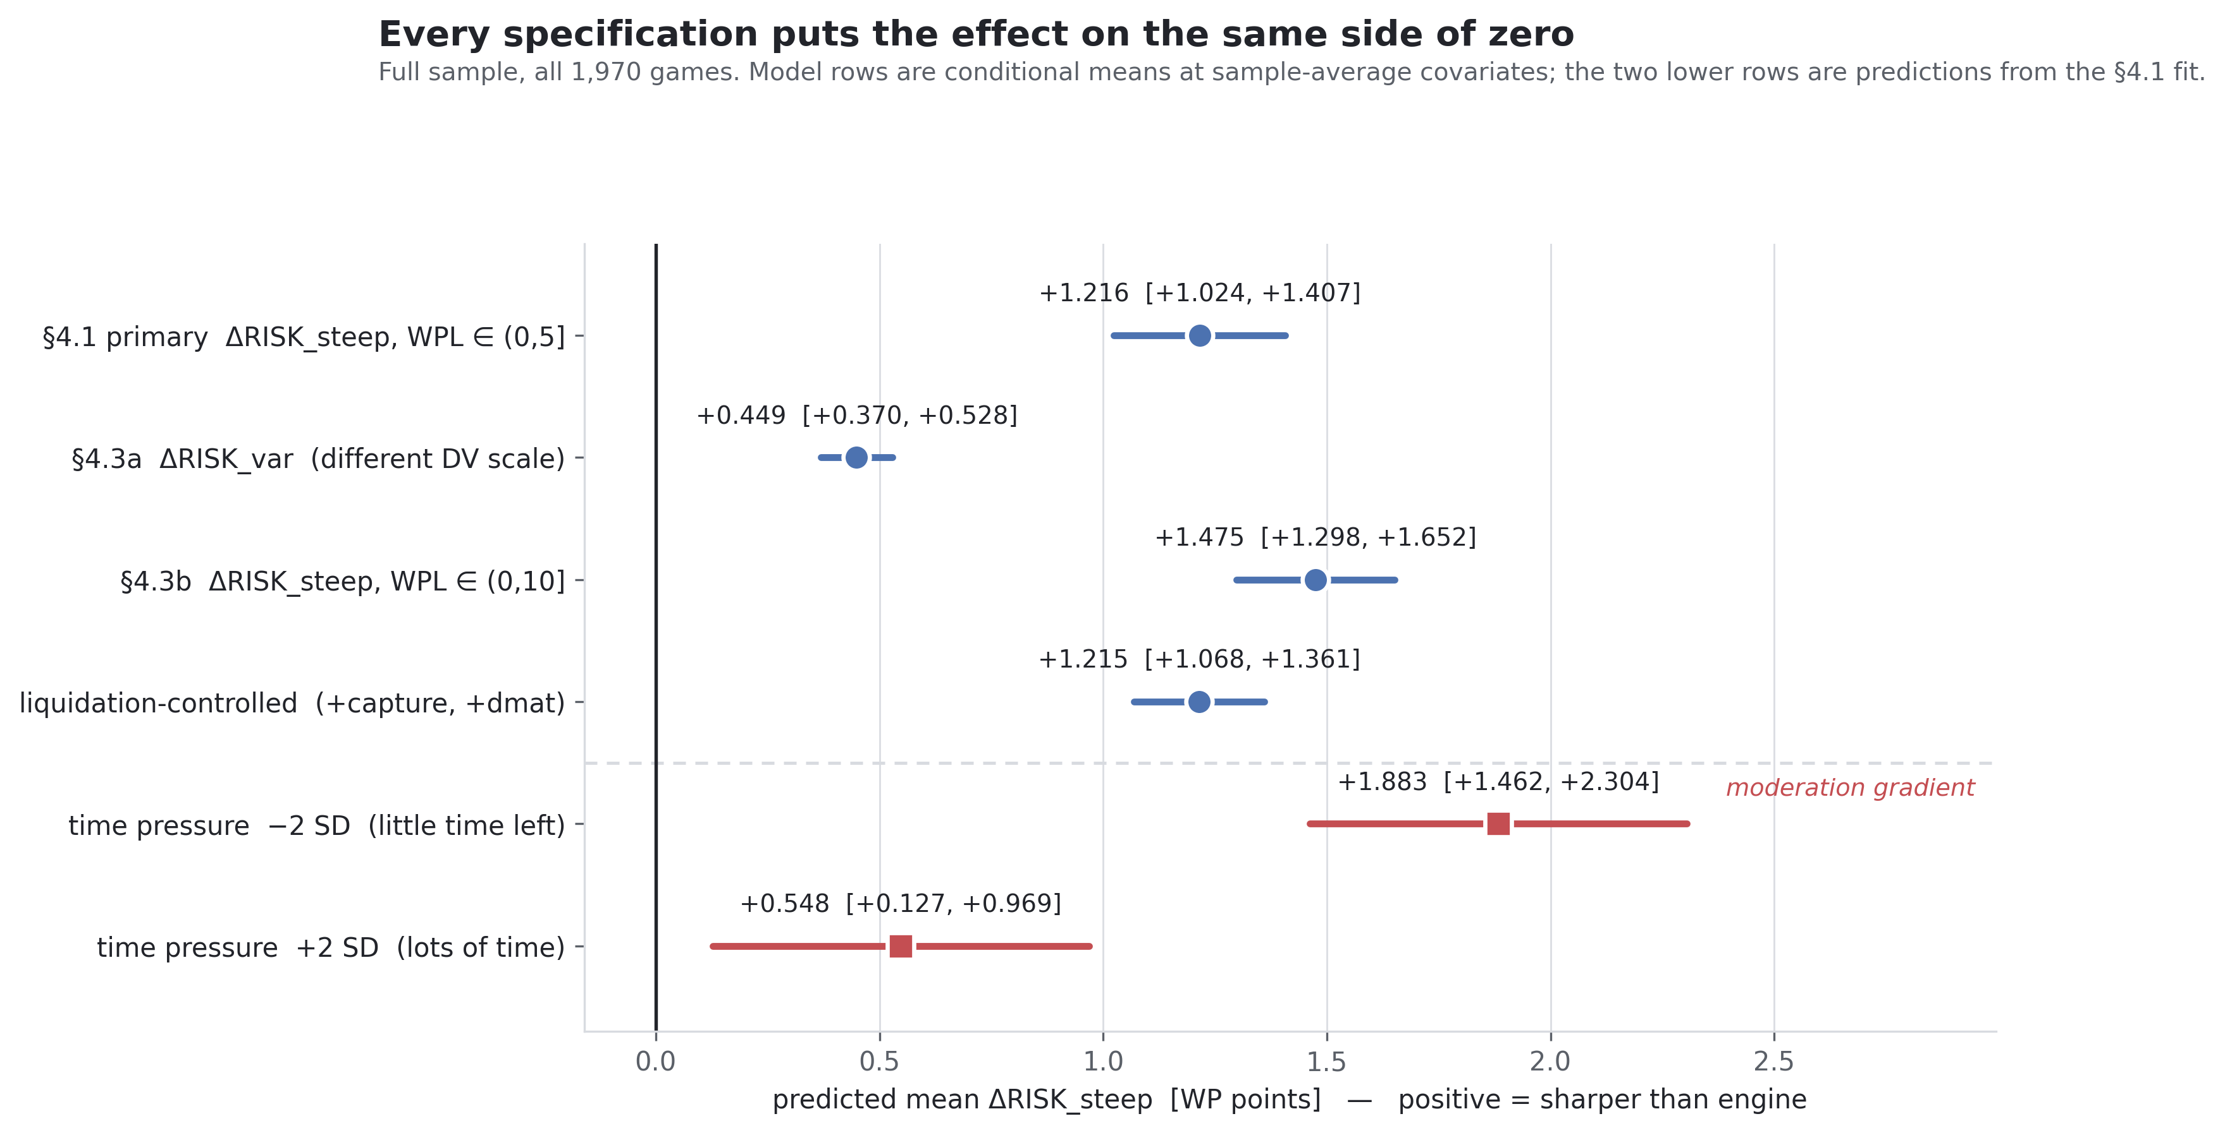
Figure C. Robustness ladder, full sample. Top four rows: conditional mean ΔRISK under the primary specification, the dispersion-based risk definition, the widened loss band, and the liquidation control. Bottom two rows: predicted means at ±2 SD of time pressure from the §4.1 fit. Every specification places the effect on the sharper side of zero.

4.4 A stylistic association that did not survive
The specification pre-registered one bridge to the companion study: players at the positional pole of a previously measured attacking-positional style dimension (Sun, 2026) would sharpen less. On the 500-game pilot the association was significant in the predicted direction (PC1 slope +0.521, p = .0023, n = 348 roster players). On the full sample it collapsed: +0.161, p = .065, n = 578. The point estimate shrank 69% as the player count grew. That is the signature of a small-sample overestimate rather than an effect awaiting power. The sign is unchanged, so I report a weakening rather than a reversal. By the pre-registered standard the association is unsupported, and I do not build on it. I show the pilot-versus-full comparison rather than omitting it (Figure B).
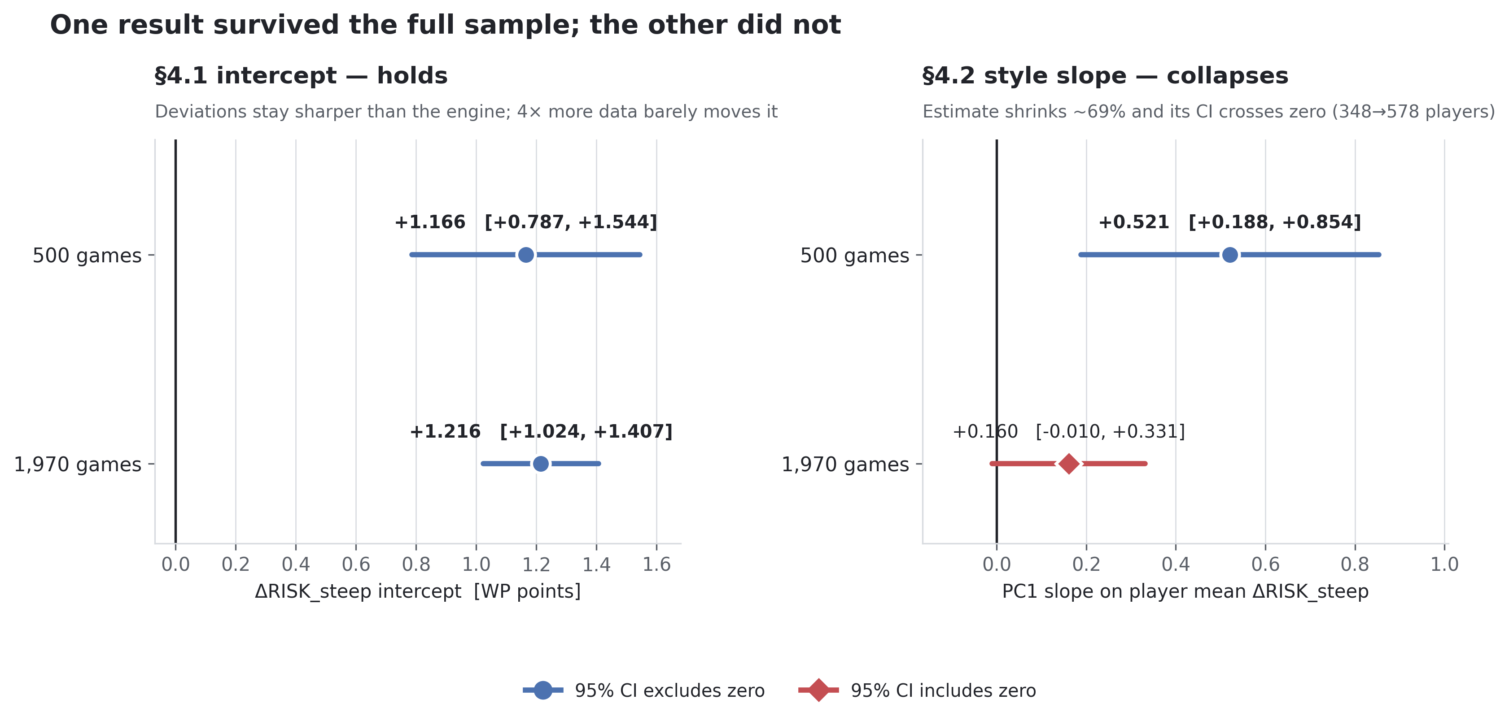
Figure B. Pilot (500 games) versus full sample (1,970 games). Left: the §4.1 intercept holds under a fourfold expansion (+1.166 → +1.216; both CIs exclude zero). Right: the §4.4 style slope collapses (+0.521 → +0.161; the full-sample CI crosses zero). The first effect survives more data; the second does not.

4.5 Is the sharpness repaid? A counterfactual test
The last pre-registered analysis returns to the question Section 1 set aside: does the sharpness buy anything? The obstacle was the shared-difficulty confound. A regression of the opponent's next error on the mover's own error cannot tell whether the player led the opponent into a harder position or both players were already standing in one. The successor evaluations remove the obstacle, because both branches were evaluated. For each deviation I compute the same nine difficulty features on the position the opponent actually faced and on the position the engine's first choice would have produced: evaluation level, the gap between the opponent's best two replies, the spread across five replies, the counts of legal and reasonable moves, evaluation volatility, the opponent's rating, the rating gap, and the opponent's remaining clock. A cross-fitted expected-error model, trained on the 20,387 moves that followed an engine-first choice so that post-deviation rows cannot contaminate the baseline, predicts how much a player of that strength on that clock should err in a position of that difficulty. The difference between the two branches' predictions is the induced error that difficulty explains. The opponent's actual error minus the prediction on the actual branch is the part difficulty does not explain. That part is the direct measure of complementarity, the information about the opponent's fallibility that the engine's objective does not carry. The identifying assumption, stated in the specification, is that conditional on these features the opponent's error does not depend on how the position was reached. Unmeasured factors are addressed in Section 5.2.
Coverage and verification were checked before any model ran. All 57,294 successor positions were re-evaluated under the identical engine configuration and matched the stored values row by row with zero mismatches. Of the 28,647 deviations, 28,603 had an opponent reply; the 44 rows lost to game endings show no association with steepness (p = .98). One fifth of replies fell outside the stored five engine lines and were valued by a fresh search of the resulting position. A direct measurement on 2,000 re-evaluated replies puts the offset between the two valuation routes at +0.22 win-probability points, with no gradient across steepness, so the two-tier rule stands.
Deviating does not pay. On the primary band the average deviation loses 1.722 win-probability points net of everything it induces (95% CI [−1.789, −1.656]), and the pre-specified equivalence test confirms the loss is not practically zero. Sharper deviations lose more: the steepness coefficient on net realized gain is −0.475 per standard deviation (95% CI [−0.527, −0.423], p = 2.9 × 10⁻⁷¹). Neither pre-registered moderator changes this; the interactions with the opponent's clock and with the rating gap are both null. The decomposition locates the reason. In the beyond-difficulty model the steepness coefficient is −0.085 (95% CI [−0.137, −0.034], p = .0012). In the difficulty-explained model it is −0.390 (95% CI [−0.397, −0.383]). Sharper moves do not extract opponent error that difficulty fails to explain, and they reduce rather than raise the difficulty-explained component. All signs hold when the band widens to (0, 10], when the training restriction is dropped, and when the expected-error model is replaced by gradient boosting.
Rerunning the original confounded model on the same rows still returns a positive coefficient for the mover's error on the opponent's next error (+0.209). The data did not change; the identification did. The confound had manufactured the earlier positive mechanism signal. Two further facts complete the picture. Opponents do err slightly more than difficulty predicts after a deviation, about +0.11 points on an exploratory two-way clustered estimate, an order of magnitude below the 1.72-point cost and, in the pre-registered model, slightly lower at higher steepness. And the sharpest deviations force the reply: in the sharpest steepness decile, 99.2% of opponent replies were among the engine's top five lines, against 74.4% in the least sharp. Sharp moves narrow the opponent's task at the same time as they raise its stakes, which is consistent with their failure to harvest error.

5. Discussion

5.1 What the direction means
An engine's objective is expected value against a perfect opponent. The pattern here is a systematic purchase of sharpness at equal expected cost, amplified when time is short. That is what one would observe if human play optimizes a different objective, one in which the opponent can err and in which positions that demand precision from the opponent carry a premium the engine does not price. On this reading, human deviation is not failed imitation of the engine. It is the pursuit of a different target.
The counterfactual test closes the question the earlier analysis could not answer. The same deviations that select steeper punishment curves are net losses on average, the losses grow with steepness, and the opponent's error beyond what difficulty explains does not grow at all. Pursuing a premium on opponent fallibility and collecting it are different things, and in this population the premium is not collected. That average is in line with meta-analytic evidence that combinations of human and algorithmic judgment often perform below the stronger of the two alone (Vaccaro, Almaatouq, & Malone, 2024). One result is consistent with this reading. The difficulty-explained component falls with steepness: a steep position raises the price of the opponent's fifth-best reply, but it also narrows the search, and in the sharpest positions the reply is nearly always among the engine's top lines. The sharpness that players buy makes the opponent's task more dangerous and at the same time more tractable. The picture that fits all the evidence is an agent optimizing a plausible objective with poor calibration. These players pay more in expected value for sharpness than the induced errors return, at least in this population and these time controls. A reasonable target that is mispriced is a familiar pattern in behavioral decision research (Kahneman & Tversky, 1979). The productive question is therefore not whether humans deviate from optimality, but what objective their deviations reveal, and where its calibration fails.

5.2 Limitations
Six limits bound the claims. First, steepness and expected loss are computed from the same evaluation tree, so linear conditioning may leave functional-form residue in the intercept; the (0, 5] band conditions on expected loss rather than matching it. Second, the sample is online fast chess from one platform's titled male frame and their opponents, so classical over-the-board play, other populations, and other platforms are untested. Third, the opponent-objective interpretation is one reading of a behavioral pattern rather than a demonstrated mechanism, and no protocol data speak to what players intended. Fourth, results are cross-sectional across players, and nothing here tracks an individual's development. Fifth, the stylistic bridge to the companion study is unsupported at this scale and should not be cited from the pilot. Sixth, the counterfactual test rests on a stated identifying assumption: conditional on the measured features, the opponent's error does not depend on how the position was reached. Unmeasured factors such as preparation or frustration are not excluded. The magnitude of the beyond-difficulty component also moves with how the expected-error model is trained, so I treat the sign of that coefficient as the finding, not its size.

6. Methods transparency
The study ran under a written specification whose parameters were marked locked. The executing agent's standing instruction was to report disagreement rather than modify. Three faults occurred, and all three are disclosed here. For the counterfactual test, all 57,294 successor evaluations were recomputed under the identical engine configuration before any analysis ran, and every recomputed value matched the stored value with zero mismatches, which verifies the evaluation chain end to end.
Specification erratum. The written formula for punishment steepness stated its operands in an order that contradicted the specification's own note and both downstream sections. The implementer built the orientation the three consistent statements required, flagged the discrepancy rather than resolving it silently, and the erratum was ratified by the designer. Magnitudes are unaffected. Only the printed operand order was wrong.
A silent false null. The default mixed-model optimizer (lbfgs) converged to a degenerate all-zero solution on every directional model. It reported convergence, zero variances, an intercept of exactly zero, and p = 1. Taken at face value, that reads as a clean null result. Four alternative optimizers agreed with each other and with OLS on the true estimate, +1.17 at pilot scale. The fitting helper now tries optimizers in sequence and rejects degenerate optima. The magnitude-model numbers were re-verified byte-identical under the fix.
A shard-overwrite bug. During the full-sample extension, output files were named by a counter that restarted each run, so the second pass overwrote the pilot's shards. Resume logic correctly skipped 7,232 already-evaluated rows, and the same run then destroyed them. A post-run coverage check caught the loss: 25% of rows missing. The check verified games present, rows per game, and key uniqueness. A row count or a completion message would not have caught it. Files now carry per-run unique tokens, the same latent fault was fixed in the magnitude pipeline, and the lost rows were recomputed. Final coverage was verified complete: zero missing, zero duplicates.
I include these because they bear on how far the results can be trusted. Two of the three faults would have produced a publishable-looking wrong result, one a false null and one a silently truncated sample. Both were caught only by verification steps the specification mandated.
The counterfactual extension adds two specification-level corrections, recorded in a dated amendment after the results were read, and both change diagnostics only. A calibration check that binned rows by the steepness of the chosen move was withdrawn as invalid by construction: the expected-error model predicts from position features and never sees the move, so that plot could not have come out flat and its slope proved nothing. A common-support calibration check replaced it and shows no material bias (weighted overall −0.02 points). Separately, the specification predicted that letting post-deviation rows into the training set would shrink the beyond-difficulty coefficient. It grew instead. The prediction itself was wrong under heterogeneous effects, and I report the growth as a limit on that coefficient's magnitude rather than its sign.

7. Conclusion
How much titled players deviate from a chess engine behaves like noise: more when weaker, more when the position is volatile, more when time is short. Which way they deviate does not. At equal expected loss, human moves sit on steeper punishment curves than the engine's choice. The preference survives liquidation and specification controls, and it intensifies under time pressure, which is the opposite of risk management. A pre-registered stylistic moderator did not survive full-sample scrutiny and is reported as unsupported. The deviations are directional, and the direction is toward sharpness. The counterfactual test shows that the pricing does not pay in this domain. Sharper deviations lose more, and the opponent's error beyond what difficulty explains does not rise with sharpness. Against an engine that is strictly stronger, a deviation can reveal a human objective, but it cannot beat the benchmark. The open question is whether the same objective earns a return where the benchmark itself can err, and that question needs a domain the machine does not already dominate.

Figures
Figures A, B, and C are embedded at their points of reference in Sections 4.1, 4.4, and 4.3. Vector PDF versions accompany the preprint deposit.

Data and code availability
Game records were obtained from the public Chess.com API, drawn from the sampling frame of the companion study (Sun, 2026). Raw game-level data are not redistributed, in keeping with the platform's terms of service and to protect individual players. Engine evaluations were computed with Stockfish at fixed depth 15 (MultiPV 5). The locked analysis specifications with their dated amendments, the full pipeline code and analysis reports, and anonymized player-level data are available at https://github.com/aaronsun923/chess-behavioral-lab, archived at https://doi.org/10.5281/zenodo.22285433.

Author note
The author designed the study, wrote and locked the analysis specification, verified the results, and wrote the manuscript. The author declares no conflicts of interest and received no funding for this work.

References
Anderson, A., Kleinberg, J., & Mullainathan, S. (2017). Assessing human error against a benchmark of perfection. ACM Transactions on Knowledge Discovery from Data, 11(4), 1–25. https://doi.org/10.1145/3046947
Kahneman, D., & Tversky, A. (1979). Prospect theory: An analysis of decision under risk. Econometrica, 47(2), 263–291. https://doi.org/10.2307/1914185
McIlroy-Young, R., Sen, S., Kleinberg, J., & Anderson, A. (2020). Aligning superhuman AI with human behavior: Chess as a model system. Proceedings of KDD 2020, 1677–1687. https://doi.org/10.1145/3394486.3403219
Sun, A. (2026). Conditional by design: Sex differences in chess middlegame decision style emerge at the expert tier. Poster, Society for Judgment and Decision Making Annual Conference. Preprint: https://doi.org/10.5281/zenodo.22262168
Vaccaro, M., Almaatouq, A., & Malone, T. W. (2024). When combinations of humans and AI are useful: A systematic review and meta-analysis. Nature Human Behaviour, 8(12), 2293–2303. https://doi.org/10.1038/s41562-024-02024-1

