Where the Benchmark Can Err: Human Deviations from Model Forecasts and Their Return
Aaron Sun
San Marino High School, San Marino, CA
ORCID 0009-0000-2412-4727
October 2026

Abstract
In an earlier chess study, human deviations from a strictly stronger engine went toward sharper positions and were not repaid. This study asks whether deviation from a model earns a return in a domain where the model can err. I use the one ForecastBench round with individual-level human forecasts (July 2024): 40 superforecasters and 500 public forecasters on 578 resolved targets across 162 questions, matched to 34 language-model variants with the same freeze values and no news. The benchmark is the best single model, selected on questions no human forecast. Five hypotheses were locked before analysis. Superforecasters beat the benchmark on average (+3.4 Brier points ×100); public forecasters did not (−7.8). The median forecast of each group carried outcome information the benchmark did not encompass (coefficients 1.79 and 0.97). The humans could search the web and the model could not, so this is information available to the forecasters and not to the model, and the test does not separate the two. A second locked specification varied the benchmark across the 34 variants. Against the median of the other 33, only the superforecasters added information, on an exploratory scale-free measure. Per-forecaster gain over the benchmark has only a small stable component within one round: split-half r by question is 0.22 for public forecasters and 0.27, with an interval including zero, for superforecasters. Beside chess, the two domains agree that the direction of deviation is not simply profitable, and differ on whether the human deviation carries anything beyond a single model.

1. Introduction
Sun (2026), a preprint on Zenodo, compared human middlegame moves with a chess engine's first choice. The engine was strictly stronger. Human deviations from it had a direction: players chose moves that made the position sharper. The direction did not pay. Sharper deviations lost more, and a counterfactual test found that the opponent's extra error beyond what position difficulty explained did not rise with sharpness. The paper closed by saying that complementarity between a person and a machine needs a domain the machine does not dominate, and left that as a question.
Vaccaro, Almaatouq and Malone (2024) found across 106 experiments that human-AI combinations on average did worse than the better of the two alone, and that the sign depended on the task. The chess result was one case on the losing side. This study takes the question to a domain where the machine does not dominate. ForecastBench (Karger et al., 2025) has human forecasters and language models forecast the same questions, and the questions resolve. The best models in 2024 were wrong often. That leaves room for a human forecast to add something, and it leaves room for it to subtract something.
The design mirrors the chess study where it can. The benchmark is one model, chosen as the engine's first choice was the benchmark there. The return to a deviation is the human's score minus the model's on the same target. The direction of deviation is extremization, the forecasting analog of chess sharpness: whether the human is further from 0.5 than the model. Cross-model disagreement plays the part of engine line spread, a measure of how uncertain the benchmark is on that target. Two things are new. The outcome is observed directly, so no counterfactual model is needed. And the same forecasters appear on many targets, so I can ask whether the return is a property of the person.
Five hypotheses were pre-specified and locked in a public repository before any analysis. H1 asks whether humans beat the model on average. H2 asks whether the human forecast carries outcome information the model does not encompass. H3 asks whether the return is larger where the models disagree. H4 asks whether extremizing pays. H5 asks whether the per-forecaster return is stable within the round. The section order below follows that list. A comparison with the chess results follows the results. Section 6 then reports a second locked specification that varies the benchmark across all 34 model variants, and a methods-transparency section records everything that changed after each lock.

2. Data

2.1 Source and round
ForecastBench publishes human forecasts, model forecasts, and resolutions under CC BY-SA 4.0. The human forecasts come from the forecastbench-datasets repository at commit 68932db. The per-model forecasts are not in that repository; they are published as two archives on forecastbench.org, regenerated nightly and unversioned. I fixed one snapshot on 2026-09-06 and recorded its SHA-256 hashes and HTTP ETags in a provenance file. Nothing was re-downloaded during the study.
Only one round, with forecast due date 2024-07-21, contains individual-level human forecasts. It has 40 superforecaster ids (the ForecastBench paper reports 39) and 500 public forecasters on 189 questions. The unit of analysis is one forecaster and one target, where a target is a question at one resolution date. The frame keeps targets with a resolution in {0, 1}: 578 targets across 162 questions, 521 from dataset sources and 57 from prediction markets, matching the expected counts exactly. Superforecasters forecast a median of 87 targets each (range 4 to 578); public forecasters a median of 58 (range 22 to 84). Each target has at least 3 superforecaster forecasts (median 7) and at least 40 public forecasts (median 49).
Targets nest in questions, and outcomes of the same question at different horizons are often identical. The effective number of independent clusters is therefore about 162, not 578 and not 33,334 rows. Every clustered standard error in this paper clusters by question, and every mixed model carries crossed random intercepts for forecaster, question, and target within question.

2.2 Model forecasts and the matched information condition
ForecastBench ran each model in several conditions. The human survey saw the market's freeze value on market questions and no supplied news. The matched model condition is therefore the variant with freeze values and no news, in both prompt scaffolds (zero-shot and scratchpad): 17 base models × 2 scaffolds = 34 variants. Every human target has a forecast from every one of them. ForecastBench fills a model's missing forecasts with 0.5 and flags the row; flagged rows are excluded from ranking, disagreement, and the test set, and a model with more than 5% flagged rows is ineligible as benchmark. One of the 34 variants was ineligible on that rule. Combination questions, which join two base questions by AND or OR, are excluded everywhere; the human survey contains none.

2.3 Choosing the benchmark
Benchmark (a) is the single model with the best mean Brier score on the selection set: the round's resolved single-question targets minus every target any human forecast. That set has 930 targets across 241 questions and shares no target with the test set. Selecting on the complement keeps the choice out of sample. Selecting on the full set would favor, on the human targets, whichever model happened to do well on those very outcomes, and push the human gain down. The winner was Claude-3-5-Sonnet-20240620 in the zero-shot scaffold (selection-set Brier ×100 = 16.16), ahead of the same model's scratchpad variant (16.34). The restriction to single questions mattered: on the unrestricted set, where 86% of targets are combination questions, a different model would have won.
Benchmark (b) is the median forecast across the 34 variants on each target. It appears only as a robustness check.

2.4 Data defects
Two hundred public-forecaster rows (0.6%, from 42 forecasters) carried a forecast outside [0, 1], reaching 5.0 × 10⁸. The public survey asked for a number from 0 to 100 and the published file divides by 100 without cleaning the free-entry field. These rows are not probabilities and are excluded from every analysis. Clipping them to [0, 1] instead moves the public mean gain from −7.81 to −8.09 and is reported as a sensitivity only. Separately, 242 human market rows could not be mapped to a resolution date and 21,596 rows belonged to unresolved targets; both are dropped by the resolution filter.

3. Quantities
All probabilities are for the event resolving to 1. Brier scores (Brier, 1950) are (p − o)² in raw units; tables report values ×100 and say so. Table 1 lists the row-level quantities and the chess quantity each one stands in for.
EXT_a has one limitation. When p_h and p_a lie on opposite sides of 0.5, a positive EXT_a means the human went the other way, not that the human sharpened the model's view. That happens on 29.2% of rows (9,720 of 33,334). The primary H4 pools those rows because the specification did; a sensitivity on non-crossing rows was added after the pilot and is reported beside it.
Three sign tests were locked before execution: G_a must be positive on 20 hand-listed rows where the human is visibly closer to the outcome, negative on 20 where the model is, and EXT_a positive on 10 rows where the human is visibly more extreme. All passed on the full sample.
The distributions of G_a, D_a, EXT_a and DIS by group are shown in Figure 1. The public group's G_a is wider than the superforecasters' (SD 0.288 against 0.164) and its deviations are larger in both directions. The disagreement measure is nearly the same for both groups because it is a property of the target.
Table 1. Row-level quantities and their chess counterparts.
Symbol | Definition | Chess counterpart (Sun, 2026)
p_h | the human's forecast | the move played
p_a | benchmark (a) forecast, single best model | engine first choice
o | outcome, 0 or 1 | game result
G_a | BS(p_a) − BS(p_h); positive = human beat the model on this target | net gain of the deviation in win probability
D_a, absD_a | p_h − p_a and its absolute value | evaluation gap between played and best move
EXT_a | |p_h − 0.5| − |p_a − 0.5|; positive = human more extreme than the model | sharpness (punishment-curve steepness) of the played move
DIS | cross-model disagreement: mean of two within-scaffold SDs across the 17 base models | engine line spread
CONF_a | |p_a − 0.5|, the model's own confidence | engine evaluation margin
HZ, MKT, SRC | horizon in days (log), market indicator, question source | time control, phase
GRP | S (superforecaster) or P (public) | Elo band

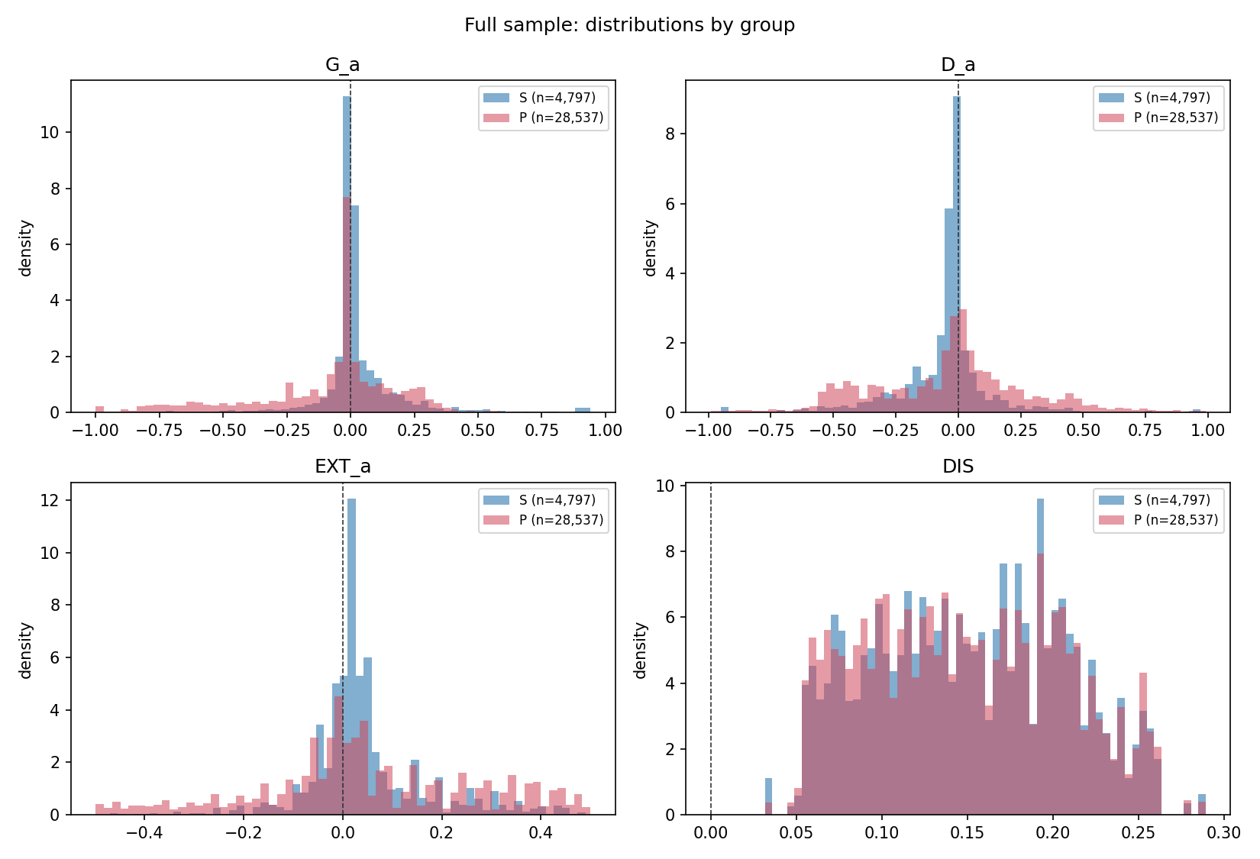
Figure 1. Distributions of net gain G_a, signed deviation D_a, extremization EXT_a, and cross-model disagreement DIS, by group. Brier quantities in raw units.

4. Results
Table 2 collects the core pre-registered quantities. Each is discussed in turn.

4.1 H1: does the human beat the model on average?
Superforecasters beat benchmark (a) by 3.38 Brier points ×100 (question-clustered 95% CI 1.36 to 5.41). Public forecasters lost to it by 7.81 (−9.69 to −5.92). The mixed model with crossed random intercepts gives the same picture: an intercept of −0.072 for the public group and a superforecaster difference of +0.099. This restates the published leaderboard and is the background fact, not the contribution. Against benchmark (b), the cross-model median, the numbers are +4.55 and −5.86.
Two facts qualify the superforecaster figure. Superforecasters were run as a nine-day tournament with a group stage in which they saw one another's forecasts and rationales and could revise. The models forecast once, alone. And both human groups could browse the open web at forecast time; the matched model variants had no retrieval. A positive gain for superforecasters is therefore a statement about a deliberating, searching group against a single-pass model, not about judgment alone. The public group did not deliberate, which is part of why its gain is negative, and the gap between the groups should not be read as pure skill.
Table 2. Core quantities. 33,334 rows, 578 targets, 162 questions, 540 forecasters. Predictors in the H3 and H4 mixed models are standardized; outcomes are in raw units, stated per row. Intervals are question-clustered or bootstrap as specified in each section. The two 1,000-split rows give the median and the 2.5th to 97.5th percentiles across splits, not a confidence interval. The two as-locked H5 rows are the pre-registered split by target, superseded by Amendment 4 (Section 9).
Hypothesis | Quantity | Estimate [95% CI]
H1 | mean G_a, superforecasters (Brier points ×100) | 3.38 [1.36, 5.41]
H1 | mean G_a, public (Brier points ×100) | −7.81 [−9.69, −5.92]
H2 | encompassing coefficient, superforecaster median (log-odds per unit of logit(p_h) − logit(p_a)) | 1.79 [1.04, 2.53]
H2 | encompassing coefficient, public median (log-odds per unit) | 0.97 [0.24, 1.70]
H3 | DIS_z on G_a (raw Brier units per SD of DIS) | 0.001 [−0.023, 0.025]
H4 | EXT_a_z on G_a, all rows (raw Brier units per SD of EXT_a; 0.028 = 2.8 points ×100) | 0.028 [0.025, 0.031]
H4 | EXT_a_z on G_a, non-crossing rows (raw Brier units per SD) | 0.022 [0.020, 0.024]
H4 | EXT_a_z on G_log (raw log-score units per SD) | −0.022 [−0.033, −0.011]
H4 | EXT_a_z × DIS_z on G_a, all rows (raw Brier units per SD × SD) | −0.021 [−0.024, −0.018]
H5 | split-half r by question, superforecasters (Pearson, n = 39) | 0.27 [−0.10, 0.52]
H5 | split-half r by question, public (Pearson, n = 500) | 0.22 [0.13, 0.30]
H5 (1,000 splits) | split-half r by question across 1,000 random splits, superforecasters (median; 2.5th to 97.5th percentile of splits) | 0.38 [−0.45, 0.78]
H5 (1,000 splits) | split-half r by question across 1,000 random splits, public (median; 2.5th to 97.5th percentile of splits) | 0.23 [0.16, 0.29]
H5 (as locked) | split-half r by target, superforecasters (Pearson, n = 40); inflated by shared outcomes across horizons | 0.78 [0.61, 0.90]
H5 (as locked) | split-half r by target, public (Pearson, n = 500); inflated by shared outcomes across horizons | 0.64 [0.59, 0.69]

4.2 H2: does the human forecast carry information the model lacks?
The outcome is fixed within a target, so I aggregate humans first: the median forecast among superforecasters on the target, and separately among public forecasters. The test is the forecast-encompassing regression of Chong and Hendry (1986): a logistic model of the outcome on logit(p_a) and on the difference logit(p_h) − logit(p_a), with question-clustered standard errors. A positive coefficient on the difference means the human aggregate carries outcome information the model does not encompass. Probabilities are clipped to [0.01, 0.99] before the logit.
The coefficient is 1.79 (95% CI 1.04 to 2.53) for the superforecaster median and 0.97 (0.24 to 1.70) for the public median. Both intervals lie above zero. I give more weight to the public result. Public forecasters did not deliberate. They still had web access the model did not, so the comparison is not perfectly clean, but it is the closer approximation to a crowd of independent individual judgments against a model's. The superforecaster coefficient mixes individual judgment with the group stage.
The superforecaster median hit the clip bound on 160 of 578 targets (28%); the public median hit it on none. With bounds of [0.001, 0.999] the superforecaster coefficient is 1.77 (0.99 to 2.54) and the public coefficient 0.97 (0.24 to 1.70). The result does not depend on the clip.
The test cannot say where the information came from. Both human groups could search the web at forecast time. The matched model variants had freeze values and no news, and the benchmark's training data end months before the forecast date. A human median that carries outcome information the model lacks may therefore reflect better judgment, access to news the model never saw, or both. This paper refers to it as information available to the forecasters and not to the model, and makes no claim about judgment as such.
Here the forecasting result differs from the chess result. In chess, the human deviation carried nothing the engine lacked: the opponent's error beyond difficulty did not rise with the deviation's character, and the deviation cost on average. Here a public forecaster who lost to the model on average still contributed, in aggregate, something the model did not have. Losing on average and carrying information are compatible. The public forecasts are noisier than the model's and the noise costs Brier points, but the signal inside them is not already in the model. Section 6 asks the harder question of whether that signal is already in the other models.

4.3 H3: is the return larger where the models disagree?
The chess paper's closing conjecture predicts that the human's return rises where the benchmark is least certain. The mixed model regresses G_a on standardized DIS, with the model's own confidence, log horizon, the market indicator and group as controls, and crossed random intercepts. The DIS coefficient is 0.001 (95% CI −0.023 to 0.025). It is 0.002 under the pre-amendment 34-variant disagreement measure and 0.011 (−0.017 to 0.039) on dataset questions only. Under the log score it is 0.002 (−0.071 to 0.076). The return does not rise with cross-model disagreement, on any version of the test that keeps benchmark (a).
With benchmark (b), the median of 34 models, the coefficient is 0.036 (0.021 to 0.052). This is a robustness item, not a second primary result. It shows that the H3 result depends on which benchmark is used. Against a single strong model the return is flat in disagreement; against the crowd of models it rises. One reading is that the median of 34 models is itself worse where the models disagree, so a human forecast has more to beat there, while the best single model is not hurt by the others' disagreement in the same way. I do not test that reading.
The question-level moderators in H3 and H4 rest on about 162 independent clusters. The DIS interval above spans roughly ±0.024 standardized units, which is the resolution this design has for a question-level effect. It should be read as a null at that resolution, not as evidence the effect is exactly zero.

4.4 H4: does the direction of deviation pay?
The mixed model adds standardized EXT_a and absD_a to the H3 predictors, plus the one locked interaction EXT_a × DIS. Because EXT_a equals |p_h − 0.5| minus the model's confidence by construction, its coefficient is the effect of the human's extremity at fixed model confidence and fixed deviation size. The direction was pre-registered as two-sided and only the sign is interpreted. Extremizing an aggregate is a known correction for the underconfidence that averaging produces (Baron et al., 2014); the question here is different, whether one person's extremity relative to one model pays.
Under the Brier score the coefficient is +0.028 (95% CI 0.025 to 0.031). It has the same sign in the pilot (+0.041), on non-crossing rows (+0.022), on dataset questions only (+0.034), and against benchmark (b) (+0.066). In chess the corresponding coefficient, sharpness on net gain, was negative. Under the Brier score, then, a human who is more extreme than the model at a given distance from it does better, which is the opposite of the chess result.
Under the log score the coefficient is −0.022 (−0.033 to −0.011). The two intervals do not overlap and neither contains zero. Whether extremizing relative to the model pays therefore depends on the scoring rule, and the claim cannot be stated without that qualifier. Both are proper scoring rules. Neither is correct in general. Which one to use depends on what the forecast is for, and in particular on whether one confident error can cost without limit. The Brier score is bounded and treats a confident wrong forecast as costing at most 1. The log score is unbounded below and treats it as costing without limit, subject to the clip. A pattern in which extremization is usually in the right direction and occasionally far wrong will look profitable under one rule and costly under the other.
A post-hoc diagnostic, specified after these results were seen and carrying no inferential claim, shows where the two rules disagree (Section 7). It does not decide between them. The primary H4 remains the Brier fit because the specification named it, and I report the log-score sign beside it as a limitation on the finding rather than as a second finding.
The locked interaction EXT_a × DIS is −0.021 (−0.024 to −0.018) on all rows, +0.016 (0.014 to 0.019) on non-crossing rows, and +0.016 in the pilot. All three intervals exclude zero, and the sign is not the same in all three. The crossing rows carry the negative sign in the primary fit. I do not interpret this coefficient. It is disclosed as a pre-registered quantity that reversed between a 30% subsample and the full sample, which is a fact about how thinly a question-level interaction is identified on 162 clusters.

4.5 H5: is the return a stable property of the forecaster?
For each row I subtract from G_a the mean of G_a across all other forecasters on that target, leaving the forecaster's own row out. This removes the target's difficulty, which would otherwise leak into a forecaster's average through the non-random set of targets they chose to answer. The 162 questions were then split in half by one random assignment (seed 20260906), with every target of a question in the same half and the same split for every forecaster, and each forecaster's mean demeaned gain was computed in each half. The split is by question rather than by target because targets of one question at different horizons often share an outcome and the same judgment; a split by target would place that judgment in both halves and inflate the correlation. The specification as locked split by target. The change is Amendment 4, recorded in Section 9. The target-level result is reported there and in Table 2.
The correlation across forecasters between the two half-means is 0.27 for superforecasters (bootstrap 95% CI −0.10 to 0.52; 39 forecasters, one excluded for having no target in one half) and 0.22 for public forecasters (0.13 to 0.30, 500 forecasters). Spearman correlations are 0.23 and 0.22. Each half holds 81 questions, so these are reliabilities of a half-length measure; the Spearman-Brown values for the full set are 0.43 and 0.35. Across 1,000 random question-level splits the median r is 0.38 for superforecasters (2.5th to 97.5th percentile −0.45 to 0.78) and 0.23 for public forecasters (0.16 to 0.29). Figure 2 shows the two scatters. For public forecasters a stable per-forecaster component exists and is small. For superforecasters the sample of 39 does not resolve it: the interval includes zero and the estimate moves with the split.
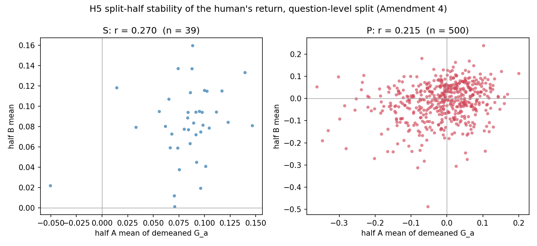
Figure 2. Split-half stability of per-forecaster gain over benchmark (a), after leave-one-out target demeaning, with the 162 questions split in half (Amendment 4). Left: 39 superforecasters. Right: 500 public forecasters. Each point is one forecaster's mean demeaned gain in the two halves.
The forecaster random intercept in the H3 model accounts for 4.1% of the variance of G_a; question and target together account for 28%, and the residual for 68%. A small variance share and a low split-half correlation are consistent. Most of the variation in gain is about the target, and 81 questions per half are not enough to average it out.
This is what the individual-difference line can take from this round. The quantity can be computed, and a small stable part of it is detectable in a sample of 500. Whether it is a property of the person, and what it is made of, needs more than one round: a test across time, not across a split of one round.

4.6 Robustness
Three robustness items were locked. Benchmark (b) in place of (a) changes the H3 disagreement coefficient from null to positive, as reported in 4.3, and leaves the H4 extremization sign unchanged (+0.066). The log score in place of Brier reverses the H4 extremization sign, as reported in 4.4, and leaves H3 null. Dropping the 57 market targets leaves H3 null (0.011) and H4 positive under Brier (+0.034). Of the three, only the scoring-rule item changes a sign on a main effect, and only the benchmark item changes a sign on a moderator.

5. Two domains side by side
Table 3 sets the forecasting results beside the chess results of Sun (2026). The chess entries come from the counterfactual redesign in that paper's Section 4.5 and from its main direction analysis.
Table 3. The same five questions in the two domains.
Question | Chess (benchmark strictly stronger) | Forecasting (benchmark fallible)
Does the human beat the benchmark on average? | No. Deviating cost 1.72 WP on average. | Superforecasters yes (+3.4); public no (−7.8).
Does the human deviation carry something beyond the benchmark? (note a) | No. The opponent's error beyond difficulty did not rise with sharpness (RES −0.085 per SD). | Yes. Both group medians carry outcome information the model does not encompass (1.79, 0.97). Humans had web access; the model did not.
Is the return located where the benchmark is least certain? | Untested. The chess study interacted the deviation with clock and Elo, not with engine line spread. | No. Return flat in cross-model disagreement (0.001); positive only against the median-of-models benchmark.
Does the direction of deviation pay? | No. Sharper deviations lost more (−0.48 per SD). | Depends on the scoring rule. Positive under Brier (+0.028), negative under log score (−0.022).
Is the return a stable property of the person? | Untested. | Small for public forecasters (r = 0.22 by question); not resolved for superforecasters (0.27, interval includes zero).

Note a. The two cells in the second row are different operationalizations. In chess the quantity is the opponent's realized error beyond what a cross-fitted difficulty model predicts, tested against the deviation's sharpness. In forecasting it is the coefficient on the human-minus-model term in an encompassing regression of the outcome. Both ask whether the deviation brings something the benchmark did not already have, but they are not the same test and the row should not be read as if they were.
The two domains agree on more than I expected. The direction of deviation is not simply profitable in either. In chess it costs. In forecasting it pays or costs depending on how confident errors are priced. The return is not located where the benchmark is least certain in forecasting, against the single strong model; in chess the question was not asked, and Table 3 says so. The conjecture that closed the chess paper, that complementarity should appear where the machine is most uncertain, is not supported here on its most direct test.
The two domains differ on one thing. In chess the human and the engine saw the same board. In forecasting the humans could look up news the model did not have. So the difference is consistent with the benchmark's fallibility deciding it, and equally with a difference in information access, and this design cannot separate the two. In chess the human deviation carried no information the engine lacked. In forecasting it did, relative to the single best model, for both groups, including the group that lost to the model on average. Section 6 narrows that: relative to an ensemble of the other models, only the superforecasters add something on a scale-free measure. The forecasting result that survives is relative to a single model; the chess study had no ensemble counterpart, so the two-case comparison is between single benchmarks. Whether the human has anything to add is consistent with being set by the benchmark's fallibility or by the information gap. Where it adds, and in which direction, is not settled by that, and the forecasting results give no simple answer to either. The two domains differ in more than the benchmark's fallibility, including what information each side had, so this is a pattern across two cases, not a test of what produces it.

6. Varying the benchmark
Sections 4 and 5 fix the benchmark at one model. The round has 34 model variants in the matched information condition, spanning a range of quality, and each can serve as the benchmark in turn. A second specification (SPEC v2) was locked and pushed to the same repository on 2026-09-08, before any of its analysis ran, to ask how the information the human median carries beyond a model changes with that model's quality. This section was added to the paper after the first version was published; the first version and its specification are unchanged in the repository.

6.1 Design
For each variant m, Q_m is its mean Brier score on the v1 selection set, the single-question targets that no human forecast, so quality is measured out of sample relative to the test set. Q spans 0.1616 to 0.3974, but unevenly: 32 of 34 variants lie between 0.1616 and 0.2642 and the top two sit apart at 0.2841 and 0.3974. Two quantities are computed per variant and per group with the v1 code paths: β_m, the encompassing coefficient of Section 4.2 with variant m as the model, and ε_m, the extremization coefficient of Section 4.4 with variant m as the model. The mean gain over variant m is also tabulated but not plotted, because it is close to an identity: it is the variant's Brier score minus the group's, and the second term does not vary with m.
Three hypotheses were locked. H6: the slope of β on Q, expected positive because a worse model leaves more for the human to add, two-sided. H7: the slope of ε on Q, no direction. H8, descriptive: whether the human median disagrees with all models in the same places. The 34 points are not independent observations. Every β and ε rests on the same 578 targets, the same human medians, and the same outcomes, so outcome noise is shared across all 34, and clustering on the 17 base models cannot remove that sharing. The primary interval is therefore a question-level cluster bootstrap: resample the 162 questions, recompute every β for all 34 variants, refit the slope, 2,000 draws. The analytic interval clustered by base model is reported beside it and is much narrower. A leverage rule (leverage above 2p/n or Cook's distance above 4/n) was fixed after the pilot and before the full run, with a co-primary refit on unflagged points; an H6 or H7 conclusion stands only if the slope keeps its sign without the flagged points. Two robustness items address the scale of β: a scale-free version of H6 replaces β with the out-of-sample improvement in mean log score from adding the human term, cross-fitted in five folds by question, and H7 is rerun under the log score.

6.2 Pre-registered results
β is positive on every variant for both groups: 1.49 to 1.94 for the superforecaster median and 0.71 to 1.78 for the public median. The fitted line does not reach zero anywhere in the observed range of Q for either group, and 100% of bootstrap draws put the crossing outside the range, so no extrapolation is made. Since β is positive at the best model (Section 4.2) and the slope is not negative, this is the expected consequence of those two facts and not a separate finding. What it says is that within this generation of models, the information the human median adds shows no sign of vanishing as the model improves.
The H6 slope for the superforecaster median is +0.47 (bootstrap 95% CI −0.57 to 1.50) on all points and −0.62 with four flagged points removed. The sign does not survive, so under the locked rule no directional claim is made. For the public median the slope is +3.13 (2.06 to 4.54) on all points and +4.48 (2.78 to 6.47) with two flagged points removed, so the sign survives. On the scale-free measure the slope is +1.10 (0.82 to 1.42) for superforecasters and +1.01 (0.71 to 1.32) for the public, both agreeing in sign with the β slope. The single highest-Q variant, GPT-3.5-Turbo zero-shot, carries leverage of 0.56 to 0.75 in every fit and a Cook's distance of 4.09 in the public β fit; the slopes are largely a contrast between a dense cluster and that point.
H7 is descriptive only. The fast inner-loop estimator required for a valid bootstrap (question-clustered OLS with forecaster fixed effects) differed from the mixed-model point estimates by up to 0.059, against an across-variant spread of ε of 0.023, and the amendment that introduced it had ruled that a discrepancy of that size demotes H7 to a figure without an interval. The descriptive slopes are +0.02 (superforecasters) and −0.17 (public), the first not surviving the leverage refit. H8 gives a mean pairwise correlation across variants of the human-minus-model term of 0.77 for the superforecaster median and 0.34 for the public median, against a reference correlation of 0.56 among the model forecasts themselves. The two groups straddle the reference in opposite directions, which is what a shared-component artifact looks like, and no conclusion is drawn from it.

6.3 A reference curve
The H6 slope has a problem that the pre-registered design did not address. Any predictor that is not pure noise improves more on a worse model, so a positive slope is close to mechanical and does not by itself show that the human adds anything a second model would not. A post-results amendment (SPEC v2 Amendment 2) added a reference curve: for each variant m, the human median is replaced by the median of the other 33 variants on that target, and both y quantities are recomputed with the same folds, seed, clipping, and target sets. The reading was locked in advance: the claim that the human carries information the models do not is supported only where the human curve lies above the reference curve. The difference is computed inside each bootstrap draw so the interval is paired. This is a diagnostic added after the results were seen; it refit no pre-registered estimate.
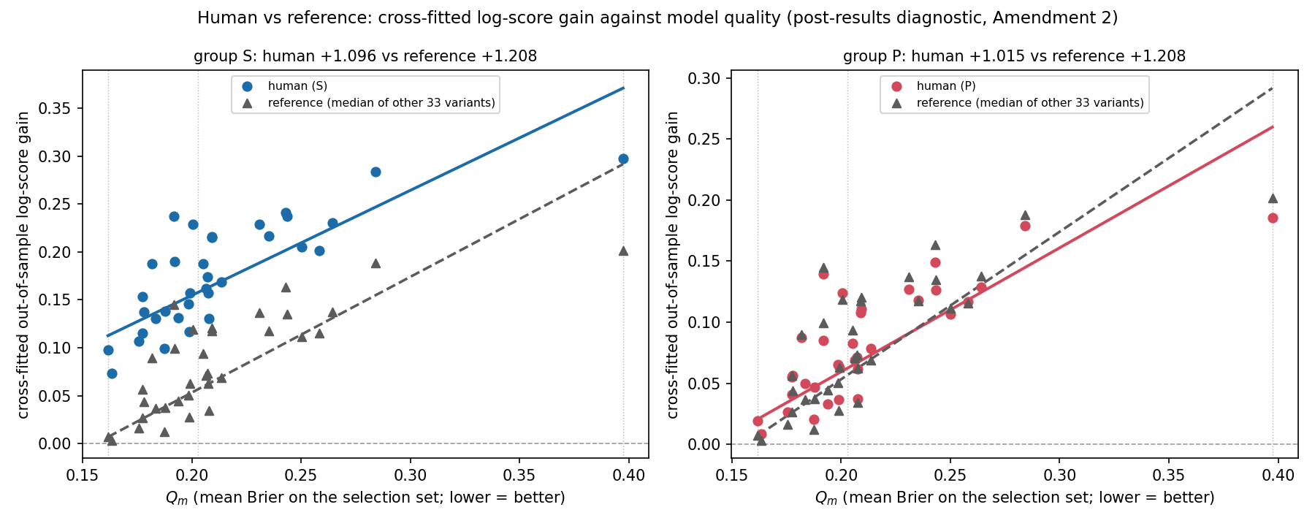
Figure 3. Cross-fitted out-of-sample log-score gain from adding the human median (circles, solid line) or the median of the other 33 model variants (triangles, dashed line) to each of 34 benchmark models, against the benchmark's quality Q. Left: superforecaster median. Right: public median. Vertical dotted lines mark the minimum, median, and maximum Q at which the paired differences in Table 4 are evaluated.
Table 4. Human minus reference, evaluated at three points on Q. Paired question-level bootstrap, 2,000 draws, 95% intervals. Positive = the human median adds more than the median of the other 33 models.
Quantity | Group | At min Q (0.16) | At median Q (0.20) | At max Q (0.40)
β (encompassing) | S | −0.68 [−1.70, 0.37] | −0.88 [−1.86, 0.14] | −1.81 [−2.77, −0.87]
β (encompassing) | P | −1.08 [−2.17, −0.23] | −1.16 [−2.23, −0.35] | −1.59 [−2.62, −0.80]
Log-score gain | S | +0.106 [0.064, 0.150] | +0.101 [0.061, 0.146] | +0.079 [0.041, 0.140]
Log-score gain | P | +0.014 [−0.016, 0.055] | +0.006 [−0.031, 0.049] | −0.032 [−0.114, 0.037]

The reference curve is steeper than the human curve on both quantities (β slope +5.29 against +0.47 and +3.13; log-score gain slope +1.21 against +1.10 and +1.01). On β the human median is below the reference at every evaluation point for the public group and at the highest Q for superforecasters, and not distinguishable from it elsewhere. On the scale-free measure the superforecaster median is above the reference at all three points, and the public median is not distinguishable from it at any of them. Figure 3 shows the two log-score curves; the β figure is in the repository report.

6.4 Reading
One claim survives. On the out-of-sample log-score measure, the superforecaster median adds information that the median of the other 33 models does not, across the whole observed range of model quality. Everything else in this section is either not distinguishable from what another model-like source contributes or, for the public median on β, below it. The public H6 slope, which was the one pre-registered result to survive the leverage rule, does not survive the reference comparison on either quantity.
This narrows Section 4.2. Relative to the best single model, both human medians carried information the model did not encompass, and that result stands. Relative to an ensemble of the other models, most of that information is available from the ensemble, and only the superforecasters add something beyond it. This reference is not the baseline (b) of Section 4.3; that was a benchmark the human was scored against, and this is a comparator for what the human contributes. The surviving claim rests on a robustness quantity tested by a post-results diagnostic, so it is exploratory. Two things qualify the comparison in the other direction. The reference is a 34-model ensemble, which was not a system anyone was running in July 2024; the single-model comparison of Section 4 is the deployable case. And the median of 33 forecasts is less noisy than the median of about 7 superforecasters or 49 public forecasters on a target, so a human curve below the reference mixes two things this design cannot separate: whether the human's information is distinct, and whether the human median is noisier than the ensemble.

7. A post-hoc diagnostic of the scoring-rule reversal
This section was specified after the results were seen. It refits no pre-registered model, changes no estimate, and tests no hypothesis. It exists to show where in the data the two scoring rules disagree.
I split the 33,334 primary rows into quartiles of EXT_a (cut points −0.050, 0.020, 0.180). Under the Brier score the most-extremizing quartile Q4 has a mean G_a of −0.095, better than the least-extremizing Q1 at −0.102. Under the log score the order flips: Q4 has a mean G_log of −0.465, far worse than Q1 at −0.271. The middle quartiles are the best two under both rules. The fitted coefficients' reversal is this single swap at the extremes.
The mechanism is a thin tail of confident errors. I count a row as confidently wrong when the forecast is at or beyond 0.9 on the wrong side of the outcome. The human share rises across quartiles from 0.88% to 3.14% to 3.64% to 23.5% in Q4. Benchmark (a) on the same rows goes from 1.98% to 0.00%, which is by construction: Q4 is where the human is far more extreme than a model that was not extreme. Figure 4 shows both series.
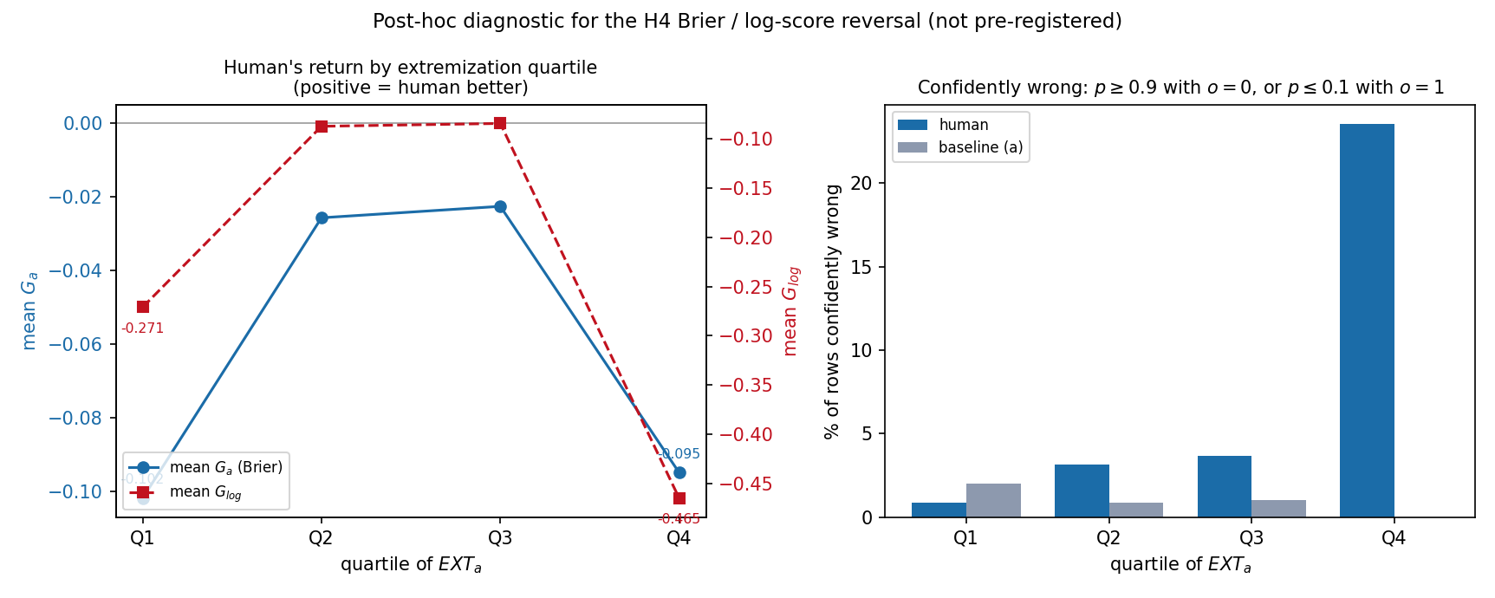
Figure 4. Post-hoc diagnostic. Mean gain by EXT_a quartile under the Brier score and under the log score, and the share of confidently wrong forecasts (at or beyond 0.9 on the wrong side) for the human and for benchmark (a) in each quartile.
The two groups behave oppositely. Superforecasters are confidently wrong on 1.04% of their rows, against 2.04% for the model on those same rows. Public forecasters are confidently wrong on 8.88% of theirs, against 0.81% for the model, about eleven times the model's rate. The log-score penalty falls almost entirely on the public group.
One reading of this, offered as an interpretation and not a result, is that extremization relative to the model is usually in the right direction and, for public forecasters, occasionally very wrong. Superforecasters extremize too (their mean EXT_a is 0.045, close to the public 0.050) and do so with a tail cleaner than the model's. That would make the scoring-rule dependence in H4 a fact about who is extremizing rather than about extremization as such. Testing it would need a pre-registered group-by-extremization model, which this study did not specify and does not fit. It is the first hypothesis for a follow-up.

8. Limitations
One round. Everything here is from the forecast due date 2024-07-21, the only round with individual-level human forecasts. Nothing can be checked for replication across rounds, forecaster skill cannot be separated from round-specific luck, and the H5 stability is stability across a split of one round's questions, not across time.
About 162 independent clusters. The rows are 33,334 but the questions are 162, and the question-level moderators in H3 and H4 (DIS, CONF_a, HZ, MKT) are estimated on a sample of that size. Their intervals are correspondingly wide, and the interaction that reversed between pilot and full sample shows what that width means in practice. The row-level predictors EXT_a and absD_a vary within a target across 540 forecasters and are much better identified; that asymmetry is real and is not a sign that the question-level effects are precisely zero.
The superforecaster comparison is not clean. Superforecasters deliberated in a group stage and could revise; both human groups could search the web; the matched models did none of that. The public median is the cleaner H2 comparison for that reason, and the superforecaster H1 gain is the gain of a process, not a person.
Judgment and information are not separated. The humans could search; the models could not. Every result here that says the human adds something the model lacks is about information available to the forecasters, whatever its source. A comparison against news-augmented variants of the same model would separate part of this, and is left for a follow-up.
Benchmark dependence. The H3 disagreement result changes sign when the single best model is swapped for the median of 34. Such a result tells as much about the benchmark as about the forecasters. I chose the single model as primary before seeing any data because it mirrors the chess design, and I report the other because the specification required it.
Scoring-rule dependence. The H4 extremization sign reverses between Brier and log score. Both are proper. The paper does not choose between them, and any statement that extremizing pays or costs in this data has to name the rule.
The extremization measure. On 29.2% of rows the human and the model sit on opposite sides of 0.5, and on those rows EXT_a measures crossing rather than sharpening. The non-crossing sensitivity agrees with the primary fit on the main effect and disagrees on the interaction.
Nothing here is causal. DIS, CONF_a and EXT_a are properties of forecasts, not manipulations. A forecaster who extremizes on hard questions differs from one who does not in ways this data cannot observe.

9. Methods transparency
The specification (SPEC v1) was locked on 2026-09-06 and pushed as the root commit of the public repository forecast-complementarity before any analysis. Everything that changed afterward is listed here in order.
Amendment 1, after the lock and before execution, recorded the rulings from a feasibility audit of the data: the selection set restricted to single questions; imputed model rows excluded and a 5% eligibility rule; the matched information condition identified as freeze values without news, both scaffolds; the disagreement measure redefined as the mean of two within-scaffold SDs; the pilot drawn by question rather than by target, with H5 excluded from the pilot; fallback and reading notes for the mixed models; and known join hazards. No hypothesis or estimand changed. The single-question restriction did change the benchmark: on the unrestricted set a different model would have won.
The pilot ran on 30% of questions (49 questions, 171 targets, 9,886 rows). All sign tests passed and all mixed models converged. It surfaced the 200 out-of-range human forecasts and the 29% crossing share.
Amendment 2, after the pilot and before the full run, excluded the out-of-range rows as a locked rule with clipping as a sensitivity, added the non-crossing H4 sensitivity, and added the tighter-clip H2 sensitivity. No primary quantity changed.
The full run kept every sign of the pilot's H1 means and H4 main effect. The locked EXT_a × DIS interaction reversed sign from +0.016 in the pilot to −0.021 in the full sample, both intervals excluding zero. It is reported and not adjudicated.
Amendment 3, after the results, added the diagnostic in Section 7. It refit no model and changed no estimate.
Amendment 4, after the results and after a review, changed the H5 split from targets to questions, for the reason given in Section 4.5. It was pushed before the new split was computed, with the rule that the paper leads with the question-level estimate whatever its value. The locked target-level split gave r = 0.78 for superforecasters and 0.64 for public forecasters; the question-level split gives 0.27 and 0.22. The difference is the inflation described in Section 4.5, not a change in the data.
All mixed models converged. Every fit printed the statsmodels warning that the maximum-likelihood estimate may be on the boundary of the parameter space. To check this, every reported mixed model was refitted (159 fits, each reproducing its published fixed effects) and the variance components read off. Under a rule of a variance below 10⁻⁶ or below 0.1% of the residual variance, no forecaster, question, or target component is at the boundary in any fit; the smallest is a forecaster variance at 0.9% of the residual. The warning does not correspond to a component estimated at zero. The per-fit values are in the repository (docs/boundary_components.csv). The coefficient estimates and their intervals are reported as fitted. The mixed models were fitted in statsmodels 0.14.6; R and lme4 were not used. The pilot was refitted after the full run with the final model code to confirm that its numbers were unchanged (1,741 numeric tokens identical).
SPEC v2 was locked and pushed on 2026-09-08 before its analysis ran. The first push contained a stale draft, corrected the same day by the commit the report names as governing. Its Amendment 1, after the pilot and before the full run, fixed the leverage rule and the co-primary unflagged refit, replaced an invalid stage-2 bootstrap for H7 with a validated inner-loop estimator and a demotion rule if the validation failed (it did), and required a per-variant boundary-warning column. Its Amendment 2, after the results, added the reference curve of Section 6.3 as a diagnostic with the reading fixed in advance; no pre-registered estimate was refit, and the human quantities recomputed inside the paired loop reproduced the stored bootstrap draws exactly. Of the 136 mixed-model ε fits in SPEC v2, 92 raised the boundary warning and 10 fell back to clustered OLS; the per-variant record is in the repository report.
The chess study to which this one is compared was published in the same way: a locked specification, disclosed faults, and a public repository. Both repositories carry the specification with all amendments in place, the code, and the reports the numbers in this paper are drawn from.

10. Conclusion
In a domain where the benchmark can err, human deviation from it carries information that was available to the forecasters and not to the best single model. This design cannot say whether that information came from judgment or from what the forecasters could look up. That was true for the median of superforecasters who beat the model and for the median of a crowd of independent public forecasters who did not. Against an ensemble of the other models, an exploratory comparison found that only the superforecasters add information, and within this generation of models the human's addition does not fall as the model improves. Whether the deviation pays depends on the direction and on how confident errors are priced, and where it pays is not where the models disagree. The return a forecaster earns over the model has a stable component within the round, but a small one, and one round cannot say more about it. Beside the chess result, where a strictly stronger benchmark left the human deviation with nothing to add, the pattern across the two cases is consistent with the fallibility of the benchmark, or the information the human has beyond it, deciding whether the human has anything to contribute, while leaving open where and in which direction. The next step in this line is a second round of individual-level data, so that the per-forecaster return can be tested across time rather than across a split of one round.

Data and code availability
The two specifications with all their amendments, the analysis code, the pilot and full-run reports, and the figures are in the public repository github.com/aaronsun923/forecast-complementarity, archived at https://doi.org/10.5281/zenodo.22600832. The ForecastBench data are published under CC BY-SA 4.0 by the ForecastBench project; the snapshot used here is identified by the hashes and commit recorded in the repository's provenance file. The chess study and its repository are cited below.

Author note
The author designed the study, wrote and locked both specifications, verified the results, and wrote the manuscript. The author thanks the ForecastBench team for publishing the individual-level forecasts this study depends on. The author declares no conflicts of interest and received no funding for this work.

References
Baron, J., Mellers, B. A., Tetlock, P. E., Stone, E., & Ungar, L. H. (2014). Two reasons to make aggregated probability forecasts more extreme. Decision Analysis, 11(2), 133–145.
Brier, G. W. (1950). Verification of forecasts expressed in terms of probability. Monthly Weather Review, 78(1), 1–3.
Chong, Y. Y., & Hendry, D. F. (1986). Econometric evaluation of linear macro-economic models. Review of Economic Studies, 53(4), 671–690.
Karger, E., Bastani, H., Yueh-Han, C., Jacobs, Z., Halawi, D., Zhang, F., & Tetlock, P. E. (2025). ForecastBench: A dynamic benchmark of AI forecasting capabilities. International Conference on Learning Representations (ICLR 2025).
Sun, A. (2026). Sharper, not safer: The direction of human deviations from engine play [Preprint]. Zenodo. https://doi.org/10.5281/zenodo.22267000
Vaccaro, M., Almaatouq, A., & Malone, T. (2024). When combinations of humans and AI are useful: A systematic review and meta-analysis. Nature Human Behaviour, 8(12), 2293–2303. https://doi.org/10.1038/s41562-024-02024-1

