Reliance on a classifier at three accuracy levels: the Tejeda et al. (2022) sequential data
Aaron Sun, ORCID 0009-0000-2412-4727. October 2026. Specification (SPEC v2, locked before computation), code and full report: github.com/aaronsun923/hai-reference.
The overreliance indicators in Liu, Zhou, Shen, Liu, Wu and Chen (CHI 2026) are read from interaction logs. The public Tejeda et al. (2022) data have no logs, so none of them can be computed there. What the data do have is, for every trial, the participant's answer before and after seeing the classifier, and whether each answer was right. This note reports what that allows.
Data
Tejeda et al. (2022), sequential paradigm: 72 participants after the exclusions used in my earlier reanalysis (OSF data, used with Mark Steyvers' permission), 24 per classifier level, 192 trials each, 13,824 initial/final pairs. Each trial: the participant classifies a noisy ImageNet image into one of 16 classes and rates confidence (low, medium, high), sees a VGG-19 classifier's output, then answers again. Between participants, the classifier is one of three fine-tuned versions. On these trials the classifiers' accuracy is 45% (A), 63% (B) and 68% (C). The participants' own first-answer accuracy, before seeing the classifier, is 50%, 50% and 49% in the three groups, so A is 5 points below the participants, B is 13 points above, and C is 19 points above. All rates below are on disagreement trials, where the initial answer differs from the classifier's class (56% of trials). Intervals are 95% participant-cluster bootstrap, 2,000 draws.
Result
On the trials where the participant's first answer was right and the classifier's was wrong, the share who replaced their answer with the classifier's was 7% [5, 10] with the classifier 5 points below their own accuracy and 21% [15, 27] with it 13 points above. Five points higher still it was 22% [17, 27]; the B to C difference is +0.01 [-0.07, +0.08]. The other rates in the table move the same way: every one of them between A and B, with intervals excluding zero, and none between B and C.
This is a different behavior from the hesitation in the CHI paper. There, the person pauses over the model's output and then accepts it. Here, the person has already given a correct answer, is shown a wrong one, and replaces it; the data record the two answers and nothing in between.
Measure (disagreement trials) | A (45%) | B (63%) | C (68%)
Switch rate: final answer = classifier | 0.28 [0.23, 0.33] | 0.50 [0.42, 0.57] | 0.53 [0.44, 0.61]
RAIR: initial wrong, classifier right, switched | 0.49 [0.43, 0.56] | 0.62 [0.55, 0.69] | 0.64 [0.51, 0.78]
RSR: initial right, classifier wrong, kept own | 0.88 [0.84, 0.92] | 0.69 [0.62, 0.75] | 0.67 [0.60, 0.75]
Overreliance: initial right, classifier wrong, switched | 0.07 [0.05, 0.10] | 0.21 [0.15, 0.27] | 0.22 [0.17, 0.27]
Underreliance: initial wrong, classifier right, not switched | 0.51 [0.44, 0.57] | 0.38 [0.31, 0.45] | 0.36 [0.22, 0.49]
With 16 classes, a participant whose first answer was right can switch to a third class, so RSR and overreliance do not sum to 1 within a level (0.95 under A, 0.90 under B, 0.89 under C); the remainder is the third-class share. Underreliance is 1 minus RAIR.
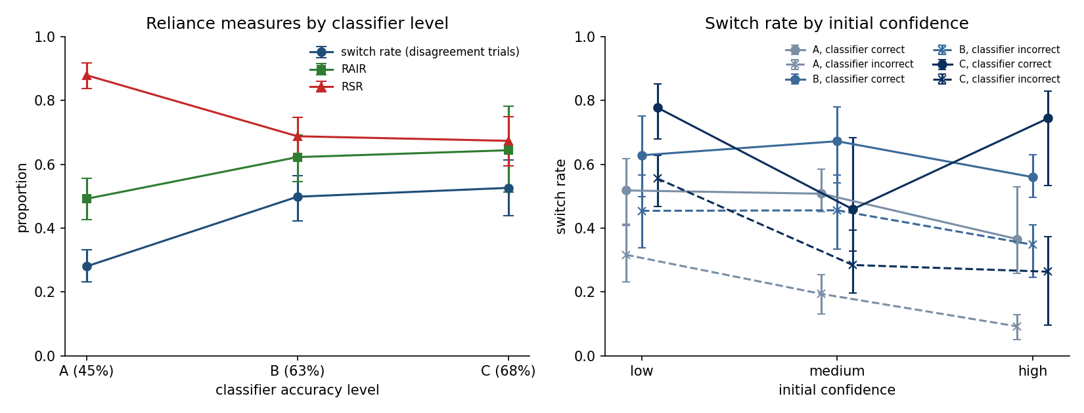
Figure. Left: switch rate, RAIR and RSR by classifier level, 95% participant-cluster bootstrap intervals. Right: switch rate by the participant's initial confidence; solid, classifier correct; dashed, classifier incorrect.
Limits
One task, one participant pool, three classifier levels spanning 45% to 68%. Levels are between participants, so the step could partly reflect who was assigned to A. Accuracies are on this note's trials, not the figures reported by Tejeda et al. Rates pool trials across participants within a level.

