Data Preprocessing

Aaron Tellez

Online Campus, Southern New Hampshire University

CS-570: Machine Learning

Instructor: Mahmoud Al-Khasawneh

May 24, 2026

Data Preprocessing
In The data preprocessing process starts by exploring and summarizing the features in the dataset. The program shows that the file has six independent predictive features and one target class column, with a total of 1,728 data records. Looking at the features before cleaning shows that the values are categorical and ordinal. For example, Feature 1 and Feature 2 describe price levels with the labels high, medium, low, and very high. Feature 3 describes structural characteristics with the values two, three, four, and five-or-more. Feature 4 shows capacity using two, four, and more. Feature 5 measures space with small, medium, and big, while Feature 6 shows safety ratings with low, medium, and high. The target classification variable sorts results into four groups: unacceptable, acceptable, good, and very good.
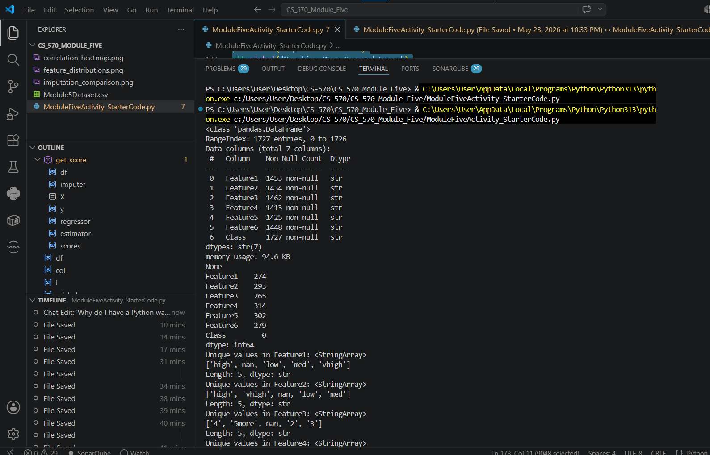

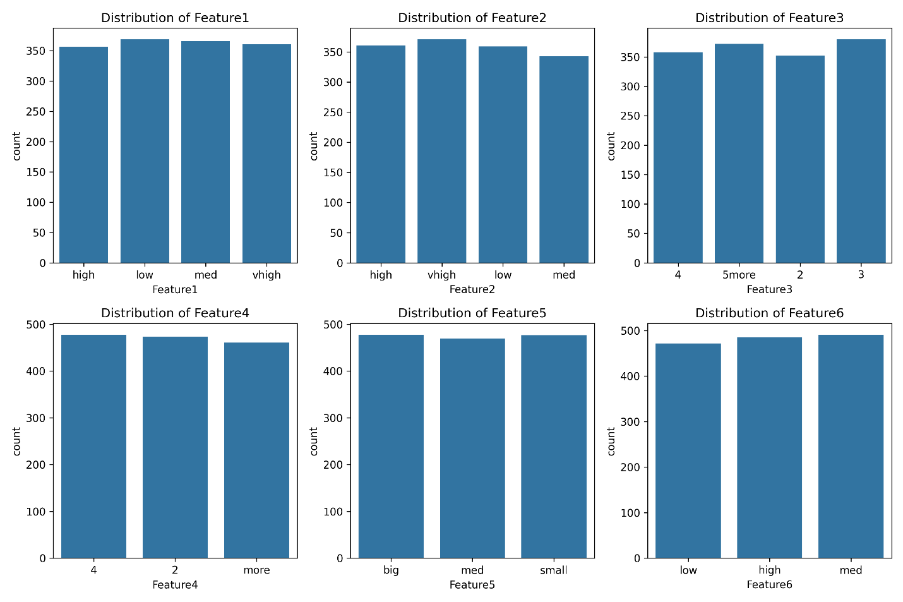
Preparing this dataset for a scikit-learn linear regression model requires several changes because the algorithm can only work with numerical data. Linear regression needs data in the form of integers or floating-point values so it can calculate algebraic dot products and adjust gradient weights. It also cannot handle missing values, since incomplete data would cause calculation errors and make the program crash. To fix this, an ordinal transformation was done by manually changing text labels into sequential integers. This manual dictionary mapping was chosen instead of automatic encoders because it changes text values while keeping missing value markers unchanged for later cleaning. This method works well because linear regression depends on mathematical patterns, and the categories already have a natural order.

Before filling in missing values, testing a baseline model showed that running linear regression on the raw dataset was impossible because of the text values and missing fields. This caused an immediate execution error. A valid correlation matrix could only be created after changing all values into numbers, since correlation calculations need numerical data to measure covariance. The visual output saved as correlation_heatmap.png shows the linear relationships between features and how strongly the encoded variables connect to each other. This step confirms that the important predictive patterns were kept during the transformation process.

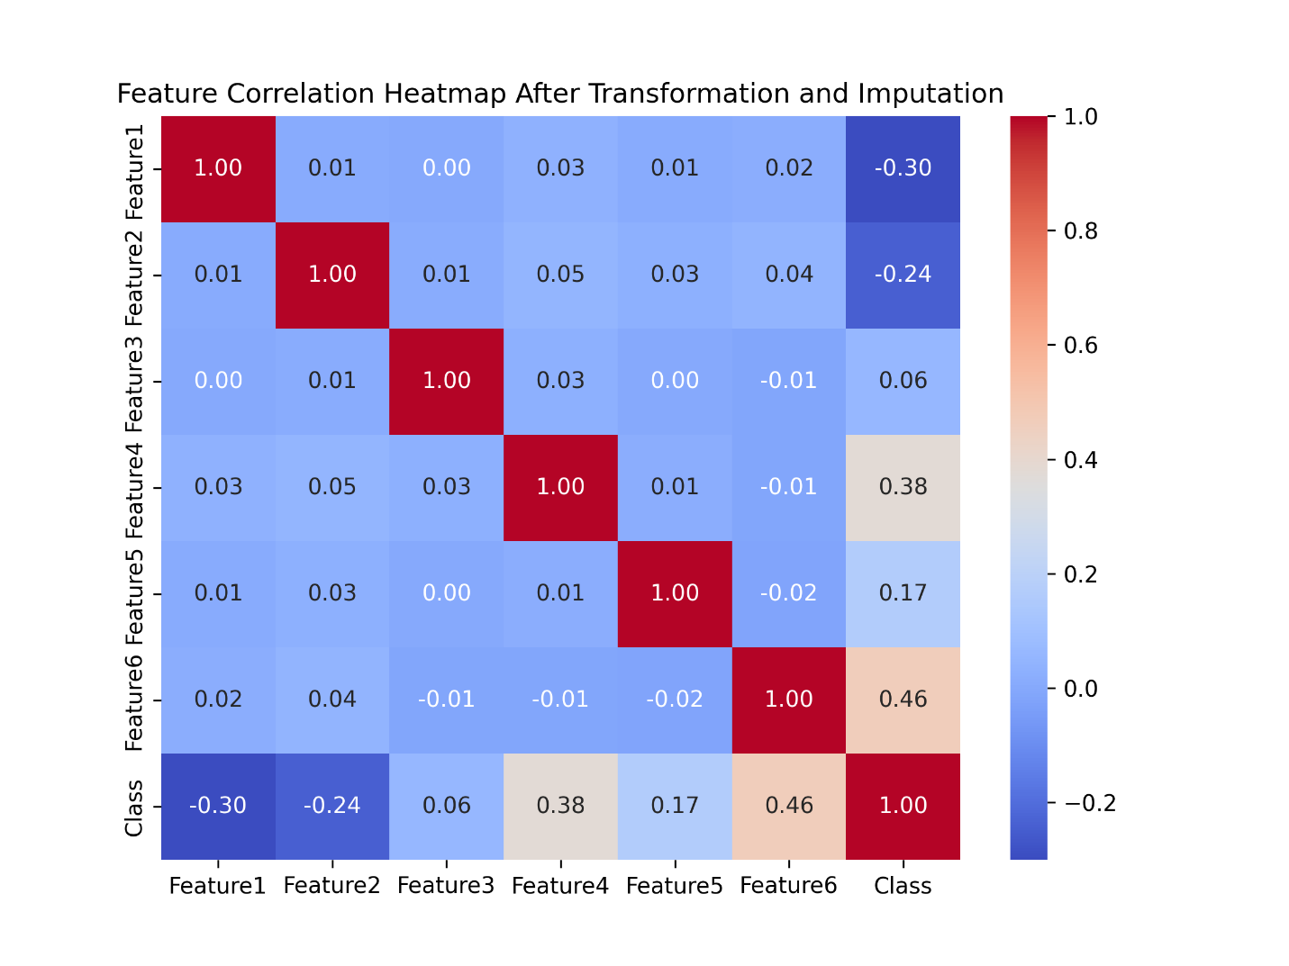
Testing different imputation techniques makes it possible to compare how each method changes the final model accuracy, as shown in the chart saved as imputation_comparison.png. The results show clear differences between the methods. The constant zero imputer performed poorly because replacing missing values with zero changes the natural data distribution and weakens the regression line. The simple mean imputer performed slightly better by filling empty spaces with column averages. The best accuracy scores, which are closest to zero on the negative mean squared error scale, came from the K-Nearest Neighbors imputer and the Iterative Imputer. These advanced methods work better because they look at nearby data patterns and use surrounding feature relationships to predict and restore missing values more accurately.

