Project: Building an NLP Chatbot

Aaron Tellez

Online Campus, Southern New Hampshire University

CS-620: Natural Language Processing

Instructor: Francis Manning

September 6, 2026

Project: Building an NLP Chatbot
The main dataset contains 1,022 text documents focused on mineralogy and geology. An initial analysis was used to organize the raw text and identify useful language components, including chemical formulas, mineral names, Mohs hardness ratings, crystal structures, and geological groups such as silicates, carbonates, oxides, and sulfides. The process included tokenizing the text, removing HTML and common stop words, and finding frequently used words and word combinations. The analysis showed that geological records often follow similar patterns when describing physical properties, chemical compositions, and classifications.
Mineralogy was selected because its data contains both clear patterns and specialized technical language. The dataset was evaluated based on entity density, context clarity, vocabulary consistency, and usefulness for automated knowledge retrieval. This made mineralogy a good choice for testing a hybrid chatbot that can use fixed rules for exact questions and NLP models for open-ended questions.
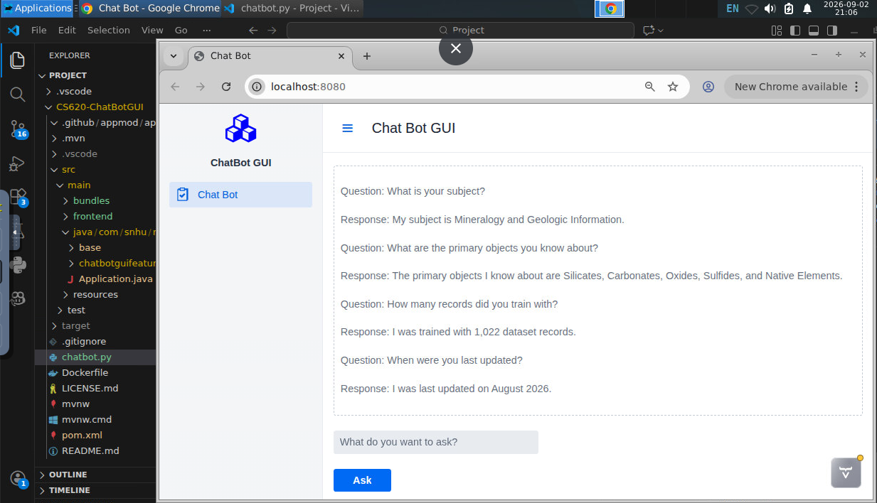

Tools, Libraries, and Corpus Preparation
The corpus was prepared using spaCy, scikit-learn, and pandas. Regex patterns and custom cleaning functions were used to handle chemical formulas and measurement units. SpaCy was used for tokenization and custom Named Entity Recognition, while scikit-learn was used for data transformations, term frequency-inverse document frequency encoding, and dataset splitting.
The 1,022 records were divided into 70% training, 15% validation, and 15% testing data. The training set updated the NLP model, the validation set was used to adjust training settings and prevent overfitting, and the test set was kept separate for the final evaluation. This helped measure accuracy and how well the model worked with new questions.
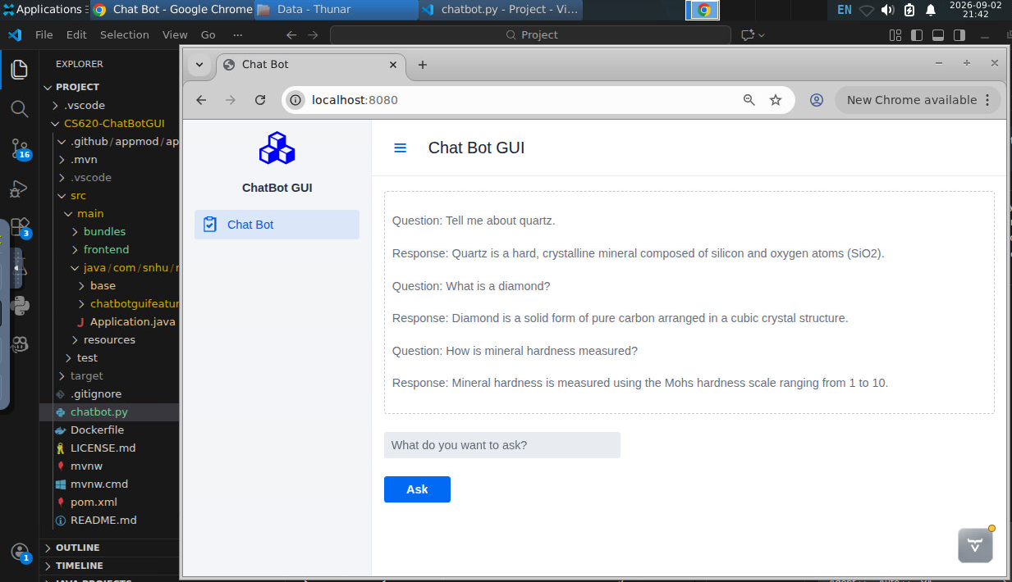

Ethical, Regulatory, and Data Management Considerations
The dataset came from open-access Wikipedia articles under the Creative Commons Attribution-ShareAlike license, allowing it to be used for academic and software development purposes. Even with public data, the system must avoid misinformation, copyright problems, and incorrect AI-generated information. In mineralogy and geology, incorrect information about chemical toxicity, reactions, or safety could cause harm if used in technical or industrial settings.
The chatbot also needs clear rules for automated responses, data handling, and security. API endpoints and data connections must be protected from attacks and unauthorized changes. In this system, communication between the Spring Boot interface and Python processing engine was limited to isolated local ports. Input sanitization and deterministic fallback responses were also used to improve safety and reliability.
Application Architecture and Response Generation Process
The hybrid chatbot combines a Java Spring Boot graphical interface with a custom Python processing engine chatbot.py. The two systems communicate through a RESTful API. The HTTP GET endpoint /api/v1/getQuestion provides user questions, while the HTTP POST endpoint /api/v1/replytoQuestion sends responses back to the interface. The Python script continuously checks for new questions, processes them, and returns answers.
Each question first goes through text cleaning, lowercasing, and whitespace removal. It is then sent to an Intent Router. If the question matches a predefined rule, the system immediately provides a fixed answer. If there is no rule match, the question is sent to the fine-tuned spaCy model. The model identifies entities, searches the JSON knowledge graph, and creates a relevant domain answer.
Rule-Based Engine Design and Intent Routing
The rule-based system handles important system questions with high accuracy, no hallucinations, and fast response times. It uses exact string matching and regular expressions to recognize different versions of the same question. It handles questions about the system subject, recognized objects, training records, and update date. The router checks these rules before using the statistical model. The handle_rule_based() function runs first and immediately returns the fixed answer when a match is found. This saves computing resources because the model does not need to process simple questions. If no rule matches, the function returns a null signal and sends the question to the statistical model.
Problem-Specific Terminology and Feature Engineering
Mineralogy contains specialized terms that can be difficult for standard NLP systems. Examples include chemical formulas such as SiO2 and Fe2O3, Mohs hardness scores, classification terms, and crystal systems such as isometric, tetragonal, and monoclinic. Standard tokenizers may incorrectly split chemical formulas or treat hyphens in mineral names as sentence breaks.
Custom tokenization and feature engineering were used to solve these problems. The tokenizer was configured to preserve chemical formulas and hyphens in mineral names. Custom labels such as MINERAL, CHEMICAL_CLASS, and HARDNESS_SCALE helped the model identify different types of information. A knowledge graph was also created from the 1,022 records and stored as a JSON dataset. It connects domain terms to their definitions and properties, allowing the system to verify entities and retrieve information.
Evaluating Model Suitability for Chatbot Applications
The NLP model was selected by considering processing speed, computer resources, training data requirements, and accuracy. Large general-purpose language models can require more resources and may produce incorrect information without reliable context. For this project, a fine-tuned statistical NLP pipeline with structured entity matching provided faster and more reliable results.
The fine-tuned spaCy pipeline was well suited for mineralogy because many questions require identifying a mineral and finding information such as its hardness or chemical formula. A lightweight entity recognition and slot-filling system can provide consistent results while using fewer resources. Running locally, the spaCy pipeline processes questions with sub-millisecond inference times, allowing it to work smoothly with the Spring Boot system.
Toolkit Use, Training, Fine-Tuning, and Model Performance
The chatbot was developed using spaCy and scikit-learn. The original spaCy model handled general English and common entities such as dates and locations but struggled with specialized geological terms. It often classified mineral names as regular nouns or locations. The model was therefore fine-tuned using the 70/15/15 dataset split. The training data was labeled with MINERAL, CHEMICAL_CLASS, and HARDNESS_SCALE entities. The model was trained over multiple epochs, adjusting its weights based on incorrect predictions. Batch size and dropout rates were tested using the validation set to help prevent overfitting.
The fine-tuned model performed much better on the test dataset. Entity recognition precision reached approximately 88%, recall reached 85%, and the overall F1-score was ~86.5%. Rule-based questions reached 100% accuracy because they used fixed keyword matching. Model-based responses correctly identified domain entities and retrieved the correct information in over 85% of test cases. Fine-tuning also reduced errors with major mineral groups and created a stronger foundation for automated mineralogy knowledge retrieval.

