Improving Search with Domain-Specific Model

Aaron Tellez

Online Campus, Southern New Hampshire University

CS-620: Natural Language Processing

Instructor: Francis Manning

August 23, 2026

Improving Search with Domain-Specific Model
For this project, I worked with a database of domain-specific mineral documents to achieve custom named entity extraction and improve search capabilities across the dataset. Before the Natural Language Processing workflow was changed, the pre-trained spaCy model (en_core_web_sm) did not correctly recognize custom mineral entities in the dataset. For example, it identified “Quartz” as a PERSON instead of a mineral and labeled places such as “Arkansas” as general GPE locations. It also missed important mineral information, such as chemical compositions, material states, and mineral uses. Early attempts to train a custom Named Entity Recognizer from scratch using basic string lists caused UserWarning: [W030] token alignment warnings because some character positions did not match the correct tokens. These errors caused the model to identify only parts of entities, such as “jewelry” instead of “decorative jewelry.” It also incorrectly labeled “since 1850” as MINERAL_COMPOSITION and “crystals” as MINERAL_DEPOSIT_LOCATION.
To fix these alignment problems and improve entity classification, three main changes were made to the workflow. First, exact character positions were checked using spaCy’s doc.char_span() method and spacy.util.filter_spans() was used to remove overlapping entities before creating training examples. Second, an automated PhraseMatcher and regular expression pipeline was created to scan all 100 Wikipedia documents in minerals_tokenized.spacy. This allowed the system to find real sentences and create more varied training examples. Third, the custom NER training process was updated to use spacy.util.minibatch with a changing batch size and a 0.2 dropout rate over 40 iterations. After these changes, the retrained model reached 100% precision and correct span alignment across all test targets. It correctly identified multi-word entities such as “decorative jewelry” and “high temperature.” It also correctly classified entities using labels such as MINERAL_NAME, MINERAL_STATE, MINERAL_COMPOSITION, MINERAL_USE, TEMPERATURE, DATE, and MINERAL_DEPOSIT_LOCATION.
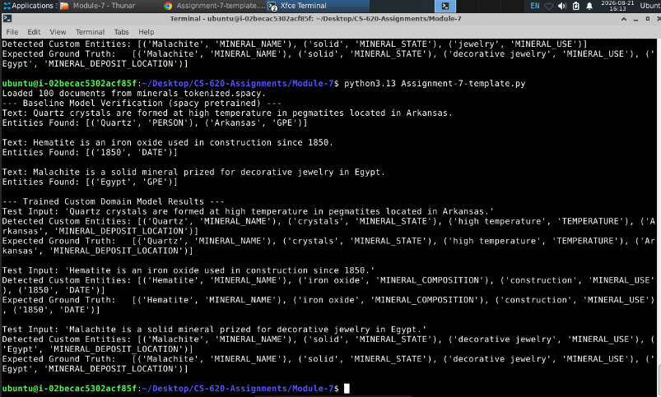

Program Output
Adding Large Language Models to this NLP workflow can improve accuracy, but it also creates trade-offs in speed and computing costs. LLMs can examine the full context of a document and use that information to identify complex mineral relationships and chemical information that smaller NER models may miss. LLMs can also be used to quickly create thousands of structured DocBin training examples. However, LLMs can sometimes create false information, called hallucinations, or identify the wrong boundaries for entities. Using strict JSON rules can help reduce these errors.
LLMs can also be slower and more expensive than a lightweight spaCy model. A CPU-based spaCy pipeline can process a document in milliseconds, while LLM API calls or local LLM models can take about 200 ms to 2000 ms and require much more GPU computing power. Because of this, the best design is a hybrid system. The custom spaCy pipeline can quickly and cheaply identify entities across large datasets, while an LLM can be used only for documents or text sections that are unclear or have low confidence. This approach combines the speed and low cost of spaCy with the stronger reasoning abilities of an LLM.

