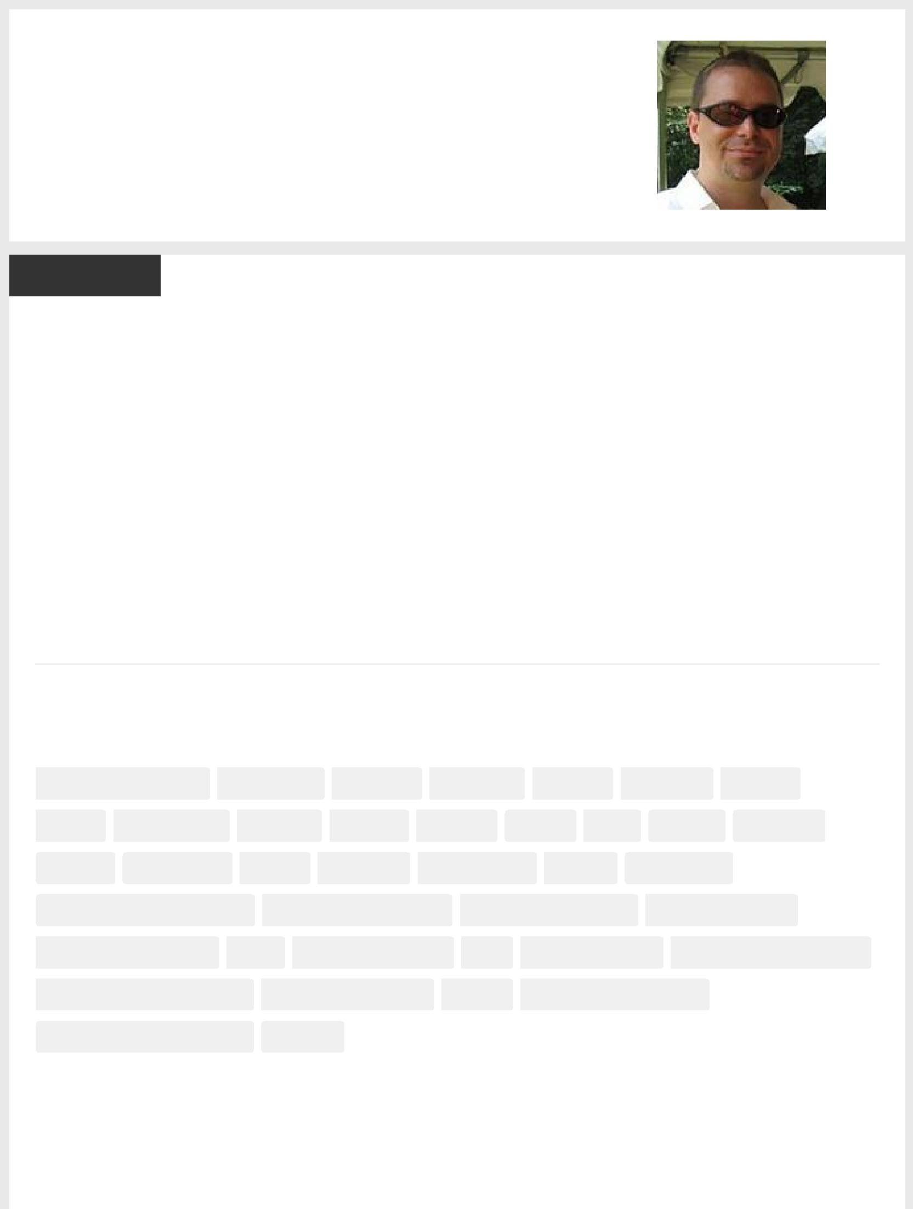Aaron T. Grogg

Senior Developer at Netbiscuits

Email aarontgrogg@gmail.com

Twitter aarontgrogg

Websites aarontgrogg.com

LinkedIn https://www.linkedin.com/in/aarontgrogg

Background

Summary

Hi, I’m Aaron. I love working with web technologies.

I carefully hand­craft HTML, CSS and JavaScript, including jQuery, JSON and Ajax. I also like to play with PHP and MySQL, usually for WordPress. Lately I’ve been digging into SVG, Node, Git, Grunt, Bootstrap, and Angular.

I like learning new stuff and my passion is making things better. Have a look below, and let me know what you think.

Bye for now,

Atg

Skills

|  |  |  |  |  |  |  |  |  |  |  |  |  |  |  |  |  |  |  |  |  |  |  |  |  |  |  |  |  |  |  |  |  |  |  |  |  |  |  |  |  |  |  |  |  |  |  |  |  |  |  |  |  |  |  |  |  |
| --- | --- | --- | --- | --- | --- | --- | --- | --- | --- | --- | --- | --- | --- | --- | --- | --- | --- | --- | --- | --- | --- | --- | --- | --- | --- | --- | --- | --- | --- | --- | --- | --- | --- | --- | --- | --- | --- | --- | --- | --- | --- | --- | --- | --- | --- | --- | --- | --- | --- | --- | --- | --- | --- | --- | --- | --- |
| Web Development | | | |  |  | Front­end | | | | | | |  |  |  |  | HTML5 | | |  |  |  |  | HTML 5 | | | | | | | |  |  | HTML | | | |  |  |  |  | XHTML | | | | | |  |  |  | CSS3 | |  |  |  |  |
|  |  |  |  |  |  |  |  |  |  |  |  |  |  |  |  |  |  |  |  |  |  |  |  | |  |  |  |  |  |  |  |  |  |  |  |  |  |  |  |  |  |  |  |  |  |  |  |  |  |  |  |  |  |  |  |  |
|  |  |  |  | |  |  |  |  |  |  |  |  |  |  |  |  |  |  |  |  |  |  |  | |  |  |  |  |  |  |  |  | |  |  |  |  |  |  | |  |  |  |  |  |  |  | |  |  |  |  | |  |  |  |
| CSS |  |  | JavaScript | |  |  |  |  | jQuery | | | |  |  |  |  | AJAX |  |  |  |  |  | JSON | | | | |  |  |  |  | SVG | | | |  |  | Git | | |  |  |  |  | Grunt | | | |  |  | Node.js | | |  |  |  |
|  |  |  |  | |  |  |  |  |  |  |  |  |  |  |  |  |  |  |  |  |  |  |  | |  |  |  |  |  |  |  |  |  |  |  |  |  |  |  |  |  |  |  |  |  |  |  | |  |  |  |  |  |  |  |  |
|  |  |  |  | |  |  |  |  |  |  |  |  |  |  |  |  |  |  | |  |  |  |  | |  |  |  | | |  |  |  |  |  |  | | |  |  |  |  |  |  | |  |  |  | |  |  |  |  |  |  |  |  |
| LESS |  |  | GruntIcon | |  |  |  |  | PHP | | | |  |  |  | MySQL | |  | |  |  |  | WordPress | | | | | | | | |  |  |  | CMS | | |  |  |  |  | Bootstrap | | | | | | |  |  |  |  |  |  |  |  |
|  | |  |  | |  |  |  |  |  |  |  |  |  |  | | |  |  | | |  | |  |  |  |  |  | | |  |  | | |  |  | | | |  | |  |  |  |  |  |  |  | | | |  |  | | |  |  |
| Optimizing Performance | | | | | | |  |  |  | Mobile Development | | | | | | | | | | | | | |  |  |  | Mobile Technology | | | | | | | | | | | | | |  |  |  |  | Mobile Devices | | | | | | |  | | |  |  |
|  |  |  |  |  |  |  |  |  |  |  |  | |  |  |
|  | | | | |  |  |  | |  |  |  |  |  | | | |  | | | | | |  |  |  |  |  | | |  |  |  |  |  | | | | | | | |  |  |  |  |  |  | | | | |  |  | |  |  |
|  | | | | |  |  |  | |  |  |  |  |  | | | |  | | | | | |  |  |  |  |  | | |  |  |  |  |  | | | | | | | | | |  |  |  |  | | | | | | | |  |  |
| Mobile Applications | | | | |  |  | UX | | | |  |  | User Experience | | | | | | | | | | |  |  |  | UI | | | |  |  |  | User Interface | | | | | | | | | |  |  | User Interface Design | | | | | | | | |  |  |
|  | | | | |  |  |  |  |  |  |  |  | | | | |  | | |  |  |  |  |  |  | |  | | |  |  |  |  |  | | | | | | | | | | |  |  |  | |  |  |  |  |  |  |  |  |
| Information Architecture | | | | | | |  |  |  | Interaction Design | | | | | | | | | |  |  |  |  |  | SEO | | | | |  | |  |  | Agile Methodologies | | | | | | | | | | | | |  | |  |  |  |  |  |  |  |  |
|  |  |  |  |  |  |  |  |  |  |  |  |  | |  |  |  |  |  |  |  |  |
|  | | | | | | |  |  |  |  | | | | | | |  | | |  |  |  |  |  |  |  |  |  |  |  |  |  |  |  |  |  |  |  |  |  |  |  |  |  |  |  |  |  |  |  |  |  |  |  |  |  |
| Agile Web Development | | | | | | |  |  |  | Skype | | | | | | |  | | |  |  |  |  |  |  |  |  |  |  |  |  |  |  |  |  |  |  |  |  |  |  |  |  |  |  |  |  |  |  |  |  |  |  |  |  |  |
|  |  |  |  | | |  |  |  |  |  |  |  |  |  |  |  |  |  |  |  |  |  |  |  |  |  |  |  |  |  |  |  |  |  |  |  |  |  |  |  |  |  |
|  | | | | | | | | |  |  | | | | | | |  | | | | | | | | | | | | | | | | | | | | | | | | | | | | | | | | | | | | | | |  |
|  | | | | | | | | | | | | | | | | | | | | | | | | | | | | | | | | | | | | | | | | | | | | | | | | | | | | | | | |  |

Experience

Senior Developer

Netbiscuits

March 2012 – Present (3 years 5 months) | Kaiserslautern, Germany

With a lab of 1000s of manually­tested devices, Netbiscuits is the global leader in software solutions for adaptive mobile web experiences, providing hand­curated device detection results and unparalleled analytics information.

* Member of international, Agile team
* Hand­code standards­based, mobile­first, responsive & adaptive HTML, CSS and JavaScript
* Lead front­end developer for Analytics Dashboard, utilizing Bootstrap, jQuery, jQuery DatePicker, Highcharts, Highstock, and dynamic SVG charts
* Lead front­end developer for customer Account Management system, utilizing Thymeleaf framework, Bootstrap, jQuery, and jQuery Validate
* Lead developer for company website, built using WordPress, integrating server­side adaptive design and client­side responsive design via a custom theme, third­party plugins and in­house plugins
* Aggressively focus on cross­device performance, including file minification, concatenation & caching, custom builds, and device­specific mark­up
* Utilize Node, Grunt, Grunticon, and LESS for cross­device builds and continuous integration & deployment
* Coordinate code repos via Git
* Support legacy proprietary BiscuitML & Tactile frameworks
* Investigate & resolve cross­device issues
* Research, test and propose new technologies where applicable  
  1 recommendation 

Co­Founder / Director of Technology

UX Test Kitchen

April 2008 – Present (7 years 4 months) | New York, NY

UXTK was formed to help support the nonprofit community by providing high­end, agency­quality services. For free.

* Hand­code HTML, CSS and JavaScript, including jQuery, integrate code into WordPress
* Determine client needs, define project scope, and find the ultimate solution
* Guide team on all aspects of the project, including technologies used, best practices, and implementation guidelines
* Hand­code site into WordPress
* Implement cutting­edge HTML, apply SEO, progressive CSS and JavaScript, as needed
* Conduct client staff training and guidance on new site

10 honors and awards 

Freelance Web Developer

Aaron T. Grogg

November 2011 – February 2012 (4 months) | Kaiserslautern, Germany

During transition from NYC to Germany, continued working for Time, Inc. as a freelancer.

* Hand­code HTML, CSS and JavaScript, including jQuery & JSON
* Establish and restrict project scope
* Estimate project time frames, requirements, and costs
* Issue proposals, write contracts, and invoices
* Communicate via Skype, email, phone
* Deliver product on time

7 projects 

* recommendation 

Tech Lead, People.com

Time Inc.

June 2007 – November 2011 (4 years 6 months) | New York, NY

As Time, Inc.’s most­visited website (up to 40 million uniques some months), People.com constantly challenged performance.

* Developed tablet­optimized, responsive design version of website, including dynamic data retrieval, use of in­browser data storage, and swipability
* Created second­screen project for 2011 Academy Awards, adding in­synch branded interactivity to the night's events
* Spear­headed site­wide optimization projects including:
* studying and recommending server­ and client­side performance optimizations
* cleansing of all site CSS files, reducing home page load by 23 objects, 52kb, and 1.3 seconds; these same techniques were then applied site­wide, with consistent, cascading results
* rewrite of site JS files, improving speed, reliability and portability
* introducing jQuery to global JS, rewriting functionality when file size or function performance could be improved
* integration of HTML5 Boilerplate techniques, including customized version of Modernizr and use of CSS3 techniques when possible (and adding reliable fallbacks when not)

• Numerous HTML, CSS, JS projects, often concurrently, in various stages of completion

• Numerous JS projects, many of which have been used cross­brand, including:

* Google Map implementations with custom markers and overlays, driven by multiple JSON feeds
* Ajax galleries using JSON/P
* Hot­spot tagging tool
* Gallery stitching
* Custom Twitter module
* More carousels than I care to remember...
* Converted above Ajax photo gallery JS into iPad in­app browser hot spot, bringing currency to date­specific magazine app
* Served as departmental mentor & team leader

3 recommendations 

Web Developer

Bank of America

June 2005 – June 2007 (2 years 1 month) | New York, NY

Working for the Prime Brokerage team, providing design, development, hosting, and maintenance for hedge fund clients.

* Developed conference registration website for Capital Introduction team, improving data tracking and customer relations
* Developed, maintained, and hosted client websites, including secure sections and fund­specific data
* Automated monthly performance page updates, saving up to 10 man­hours per month and ensuring data import accuracy
* Developed dynamic investor statement pages, improving customer client relations
* Implemented advanced CSS and JavaScript techniques, migrating client sites from table­based to CSS­ based layouts and introducing progressive enhancement techniques to the team, improving page load times and reducing site maintenance time
* Integrated server­side variables to dictate user­based access levels and to trigger page­specific CSS for look and layout control, improving customer client relations

1 recommendation 

Education

Pace University

BS, Computer Studies

2006 – 2007

Acquired in three semesters with a 3.98 GPA while working full­time.

Activities and Societies: Graduated with Distinction

* recommendation 

Montgomery College

Two Associates degrees, Information Systems, Web Technologies

2002 – 2004

Acquired two degrees simultaneously with 3.84 and 3.89 GPAs, respectively, while also working part­time.

Activities and Societies: Phi Theta Kappa

Volunteer Experience & Causes

Co­Founder / Director of Technology

UX Test Kitchen

April 2008 – Present (7 years 4 months) | Science and Technology



Publications

Aaron T. Grogg | Thoughts, Findings, and Rants…

http://aarontgrogg.com/

What started as a personal blog has evolved into a collection of posts regarding interesting and cutting­edge technology that I feel is worth tracking and sharing with the tech community.

In addition to my Today's Readings series, I also publish tips & tricks I encounter or discover, as well as updates to my various personal projects.

Moving Beyond the Responsive Web to the Adaptive Web

SitePoint

July 15, 2014

Responsive web design is a core skill today, but it isn't everything. Here I explain the advantages of an adaptive web approach.

Projects

Responsive Test Environment

Starting February 2013

A site I developed to help test multiple screen­sizes in one browser window with only one refresh; you choose the URL to test, you choose the breakpoints, make a change, click one refresh button, see the results in all your breakpoints at once.

Practical CSS3

Starting August 2011

A site I developed that shows you how to create several of the most commonly requested design effects using nothing but CSS (well, almost nothing but CSS), including fallback methods to make it all work cross­ browser.

WordPress Theme: HTML5 Boilerplate

Starting August 2010

A WordPress Theme I developed based on HTML5 Boilerplate and the Starkers WP Theme; a great Parent Theme for any new Child Theme!

WordPress Plugin: HTML5 Boilerplate

Starting April 2011

A WordPress Plugin I developed based on HTML5 Boilerplate; add H5BP upgrades to any existing Theme, but only the parts you want.

WordPress Plugin: Navigation Menu IDs & Classes

Starting September 2011

A WordPress Plugin I developed to reduce extraneous classes and add unique IDs to navigation menus.

WordPress Plugin: Add Custom Post Type Slugs to Admin Body Class

Starting February 2012

A WordPress Plugin I developed to add a class to the Edit Post/Page body element that reflects the type of the Post/Page being edited, in slugified­form.

WordPress Plugin: Add URL Slugs as Body Classes

Starting February 2012

A WordPress Plugin I developed to add classes to the body element that reflects the current page’s URL, in slugified­form.

Languages

English Native or bilingual proficiency

Spanish Elementary proficiency

Honors & Awards

2010 W3 Award, Nonprofit category, Silver

UX Test Kitchen, for the complete rebranding and launch of the Orphaned Starfish website: http://www.orphanedstarfish.org/

2010 W3 Award, Photography category, Silver

UX Test Kitchen, for the complete rebranding and launch of the Orphaned Starfish website: http://www.orphanedstarfish.org/

2010 Communicator Award, Nonprofit category, Gold

UX Test Kitchen, for the complete rebranding and launch of the Orphaned Starfish website: http://www.orphanedstarfish.org/

2010 Communicator Award, Nonprofit category, Gold

UX Test Kitchen: http://uxtestkitchen.com/

2010 Communicator Award, Structure & Navigation category, Gold

UX Test Kitchen, for the navigation and structure of the UXTK website:

http://uxtestkitchen.com/

2010 Communicator Award, Websites ­ Charitable Organizations / Non­Profit, Silver

UX Test Kitchen, for the complete rebranding and launch of the Orphaned Starfish website: http://www.orphanedstarfish.org/

2010 Communicator Award, Websites ­ Charitable Organizations / Non­Profit, Silver

UX Test Kitchen, for the complete rebranding and launch of the Rise website:

http://rise­community­services.org/

2009 Davey Award, Navigation category, Silver

UX Test Kitchen, for the navigation and structure of the UXTK website:

http://uxtestkitchen.com/

2009 W3 Awards, Navigation/Structure category, Silver

UX Test Kitchen, for the navigation and structure of the UXTK website:

http://uxtestkitchen.com/

2009 W3 Awards, Nonprofit category, Silver

UX Test Kitchen, for the complete rebranding and launch of the Rise website: http://rise­community­services.org/

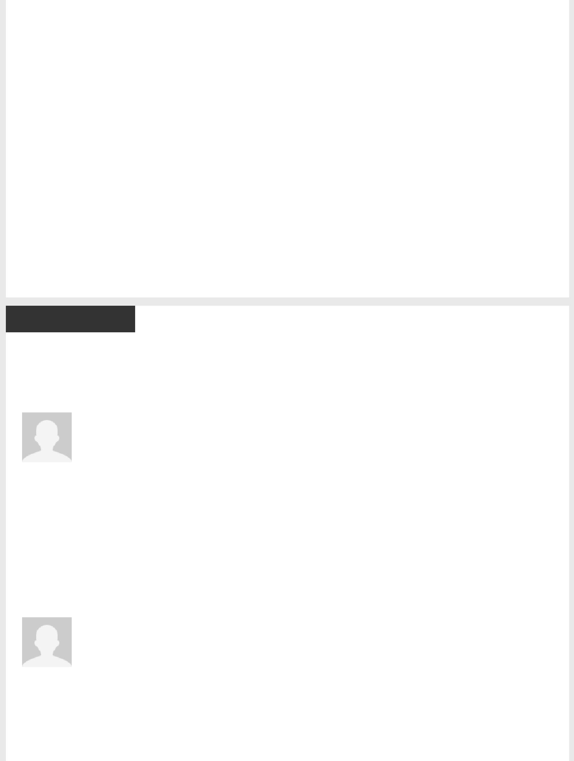Additional Info

 Interests

Reading, writing, hiking, biking, camping, photography, traveling, drumming, learning, and of course, tinkering

around the web...

 Advice for Contacting Aaron

I am currently employed full­time, and residing, in southwestern Germany.

But if you have anything for which you think I could be helpful, please feel free to reach out to me.

Contact me via LinkedIn and I will get back to you as soon as possible.

Thanks,

Atg

Recommendations

Senior Developer

Netbiscuits

Jan Bugata

Product Manager / Mobile Front­end Consultant

“Aaron is an extremely talented developer, with a huge knowledge of front­end and back­ end development, focused on adaptive web design, responsive web design and mobile­first approach. He can easily work on any technology and development environment and his pragmatic approach, along with a strong understanding of usability, would make him a great asset for any organization.

January 30, 2015, Jan worked directly with Aaron T. at Netbiscuits

Freelance Web Developer

Aaron T. Grogg

Joe Smith

Business Manager

“"Aaron did freelance web site design and update for North Shore Plastic Surgery. He was very patient, helpful, and instructive. He guided me through options for the web site and taught me how to complete routine site changes. His work is excellent and cost effective."

March 30, 2012, Joe was Aaron T.'s client

Tech Lead, People.com

Time Inc.



Dawn Bovasso

VP/Group Director, Content Strategy at Digitas

“Aaron and I have worked together for more than six years and across multiple projects and clients. He has become the standard by which I measure all other developers.

From the first day we worked together, Aaron's attitude was clear: no matter what the interaction or design ­ no matter how blue sky ­ Aaron would say, "I'll figure out a way to make it work." And he would. He'd go away, think about it, do some testing, and then come back with a creative and brilliant solution.

His strong understanding of UX and the creative process saves limitless time and money: when he reviews wireframes or designs, he has a knack for suggesting a small tweak (often unnoticeable) that saves hours of development time without compromising the intended experience. He is observant, quick to respond, and relentless in finding answers.

Because of his skills and approach, Aaron and I partnered to form a nonprofit interactive agency that provides custom, high­end sites to other nonprofits. Together we run the entire process, from choosing clients to managing other staff. Aaron has shown a complete understanding of all phases of webdev; he doesn't have tunnel vision just for code (despite being obsessed with providing the most innovative and up­to­date best practices). He contributes countless hours to making our projects successful, and I know I can rely on him without question.

I cannot recommend Aaron enough, from his skills to his leadership to his contributions to work culture.

September 14, 2013, Dawn worked with Aaron T. at Time Inc.

Joshua Hoeltzel

Development Manager at The New York Times

“For the past 4 years Aaron has been a dependable, hard­working developer, a creative problem solver, a constant learner and a strong team player and resource. I've depended on Aaron to not only take on our most complex and ambitious projects but to also make smart, reasonable decisions in the day­to­day maintenance and growth of our sites. I very strongly recommend Aaron.

October 21, 2011, Joshua managed Aaron T. at Time Inc.

Alla Gringaus

Lead UX, Front­end, Performance, SEO

“Like many managers in any kind of organization, I always cared to see valuable qualities in the workplace, to make my work and my colleagues' work more interesting. Aaron is one of those rare people who's willing to work very creatively, long hours, or, under pressure, when values matter to him and his company. It's quite easy to measure Aaron's success ­ he focuses on task completion, not time spent, and always delivers the project on its promise. In shared­responsibility environment, Aaron never isolates himself from the project processes. He's the developer who can be brought in to answer specific requirement questions, and then you can rely on him until what needs to be done is delivered. In other words, he's not a small part of a bigger picture ­ he's the leader and the active doer. I often ask Aaron for input. He's so remarkably good at IA and UX, that whatever he builds, he always aims it to be as solid and usable application as it can only get. If you need a

feedback, Aaron will provide a useful one that will not only heighten motivation, but will actually help creating the best web product.

On development side, Aaron's one of those highly talented front­end engineers with valuable qualities necessary to build usable web: Dom scripting, unobtrusive JavaScript, semantic markup, microformats, accessible web, cross­browser compatibility and knowledge of server side languages all complete a picture of a true developer I've been privileged to work with. Much to learn from, too much to lose.

May 27, 2009, Alla managed Aaron T. indirectly at Time Inc.

Web Developer

Bank of America

Richard Hradek

Chief Technology Officer at Ovis Technologies

“I worked with Aaron for about 3 years while at Bank of America. Aaron’s attitude towards his work and his pride in his job performance makes him a very dependable asset. Aaron also has the analytical skills to diagnose problems and devise viable solutions. Aaron is well organized which allows him to stay focused during frenzied periods which in turn proves his ability to work well under pressure.

Aaron’s interpersonal and communication skills allowed him to develop productive working relationships with both clients and staff.

Aaron is a great addition to any team. Not only would I recommend Aaron for employment without reservation, I have since hired Aaron as a consultant.

October 21, 2011, Richard managed Aaron T. at Bank of America

BS

Pace University

Darren Hayes

Assistant Professor & Director of Cybersecurity at Pace University

“Aaron T. Grogg was a model student, who provided tremendous expertise in the area of Web design and Web technologies. His greatest strength, in my opinion, is his willingness to help others. This is especially true of his aid to non­profit organizations. He looks for no reward for all of the many hours that he spends working on Websites for charitable organizations. He's excited about technology and I can always rely on him for information about the latest technologies on the market to help out one of our clients. Aaron got his grade some time ago but I know that I can call upon him at any time to speak at one of our events or to help out someone in need.

He's a reliable friend!

June 1, 2009, Darren taught Aaron T. at Pace University