TABLE OF CONTENTS

1 Purpose 2
2 Scope 2
3 References 2
4 Standard 3
4.1 Prototype: Optional 4
4.2 Draft System Specification Documentation 4
4.3 Enterprise Architecture Coaching Session 8
4.4 Review Draft System Specification 8
4.5 System Specification Approval 8
4.6 Update Traceability Matrix 9
5 Definitions 10
6 Roles and Responsibilities 10
7 Standard Ownership, Authorization, and Revision History 11
7.1 Owner: Senta Taylor, Global Manager, Customer Compliance Lean 11
7.2 Authorization 11
7.3 Revision History 11
8 Appendices 12
A.1 Appendix 1: Supporting Documents 12

Purpose
This document defines the minimum requirements, associated process, and guidelines for defining a System Specification.

Scope
This procedure pertains to all GEHC personnel engaged in the system specification phase of the system development life cycle. For iterative development, wherein the system development lifecycle is divided into increments and the delivery of user requirements may span one or more production releases, this procedure applies to the system specification phase of each production release in the lifecycle.
This document defines standard work activities to be completed by Global IT employees and contractors. For regulatory requirements relating to IT work activities (e.g., Software Validation), refer to GEHC QMS Procedures.

References
- GEHC Global IT Glossary of terms and definitions (DOC0297142)
- GEHC Global IT Document Control (DOC0282266)
- GEHC Global IT System Specification of computerised systems (DOC0078823)
- GEHC Global IT Application Security Review (DOC0391298)
- GEHC Global IT Risk Management (DOC0307869)
- GEHC Global IT Data Migration Plan Template (DOC0059963)
- GEHC Global IT System Requirement Specification Template (DOC0297131)
- GEHC Global IT User Requirements (DOC0297103)
- GE Healthcare Person Data Request Process Document (DOC0047774)
- Integration Requirements Specification (IRS) Template (DOC0245583)
- Siebel High Level Design Template (DOC0280117)
- Siebel Report Design Template (DOC0280118)
- MD63 Template (DOC0065032)
- Global IT PROD System Requirements Specification (DOC0301731)
- Global IT PROD ERP Upgrade Program System Requirements (DOC0282072)
- MD60 Template (DOC 0059453)
- CV60 Template (DOC0065034)

Standard
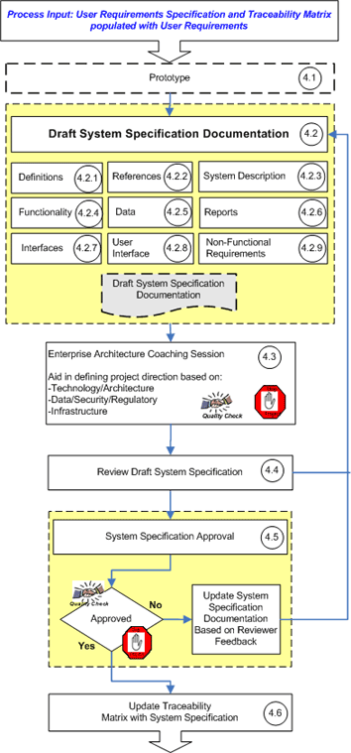

Prototype: Optional
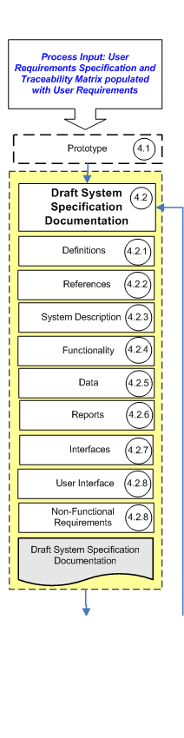
Certain systems will require the development of prototypes to identify technology constraints. Prototyping can be conducted at any time in the System Specification process.

Draft System Specification Documentation
The System Specification documentation can be authored by a combination of the Systems Analysts, or Architects who are the technical owners of the document. The Project Manager is ultimately responsible for ensuring this documentation is completed.
In general, definition of the System Specification should be an iterative process that accounts for discovery of new details throughout the process. A System Specification can consist of one or a set of several documents depending on the activity’s specific scope. At a minimum the System Specification documentation shall address the content outlined below. If a particular topic is not applicable to the activity it should be noted as Not Applicable with an explanation of the rationale.
The System Requirement Specification Template document contains sections for all of these items. See Appendix A.1 for additional documents that support this process.

In iterative development, the system development lifecycle is divided into increments. Each increment develops a subset of the user requirements, and one or more increments may be bundled together for release to production. As a result, in iterative development, delivery of the user requirements may span one or more production releases. For each release, the System Specification shall contain the functional specification of the subset of the user requirements being released to production in that release.

Definitions
Define any terms that may be unfamiliar to the readership of the document.

References
List any documents that are referenced within the System Specification content or documents that were used to create the contents of the System Specification. All references should be traceable by the reader and should contain the MyWorkshop location. The activity’s User Requirements Specification is an example of this.

System Description
A high level statement of required functionality and a breakdown into the main sub-systems shall be provided, including the logical and physical architecture, and interfaces to other systems. Anything specifically out of scope should be noted here.
- System Usage: Define the type of users, number of total users, number of concurrent users and their respective locations. An example of type of user is Mobile Sales Force or Back Office Data Entry Operator.

Functionality
Take the high level description and break it down into individual features or functions. The following aspects shall be addressed if applicable. If a particular topic is not applicable it should be noted as Not Applicable with an explanation of the rationale.
- Objectives and Detailed Descriptions: The objective of the feature or function and the details of its use, including interface with other parts of the system. Critical business rules and system logic should be highlighted. Indicate whether or not this feature is GxP relevant and also consider any safety aspects or global requirements such as multiple languages.
- Configurations: Features or functions which are configurable and any constraints within which the configuration can take place.
- Performance: Any applicable requirements regarding performance response times, accuracy, and transaction volume. These should be stated in a quantitative manner whenever possible such as noting screen response time in seconds
- Error Handling: Define how the system will handle errors or conflicts if it is possible for these scenarios to occur
- Security: Define any specific information security functionality that will be required. This may include authorization and authentication requirements such as password and SSO handling, data recovery, data confidentiality, data integrity, system and data availability. Reference the General Electric Information Security Policy for more information.

Data
Define the data on which the system is to work. The following aspects should be addressed if applicable. If a particular topic is not applicable it should be noted as Not Applicable with an explanation of the rationale.
- Description: Describe the data to be used by the system. Critical parameters should be highlighted. A data diagram is required. (e.g. logical data model, entity relationship diagram, data flow diagram).
- Access: Define which sub-systems need read or write access to each data item, access method, speed and update timing.
- Security: The sensitivity of the data shall be understood and appropriate controls put in place in order to protect GE Healthcare's data. The Project Manager is responsible for ensuring that each discrete data element used by the system has a data classification level associated with it: either Public, GE Internal, GE Confidential, or GE Restricted. Since each individual data element has a classification level an application may have multiple classification levels associated with it. Each classification level has a set of controls that should be applied to uniformly protect data elements of the same classification level. The set of controls as well as how to classify data elements are detailed within the data classification guidelines and the process for determining data classifications is outlined in the GEHC Global IT Application Security Review process.
- Storage: Describe details around the required data capacity and address any data retention requirements.
- Data Migration: If data migration is required detail the requirements. The Global IT Data Migration Plan template is the recommended document for this topic.
- Regulatory: Include any requirements for legal, compliance or data privacy. For example if the system is associated with the preparation or submission of information to healthcare regulatory bodies or in any way associated with clinical testing, clinical data or clinical trials detail those requirements here. Other examples include:
  - GxP systems shall be compliant with FDA 21 CFR Part 11 for electronic records and electronic signatures
  - Sarbanes Oxley (SOX) compliance
- Person Data: List the system requirements for employee and/or contractor data. If HR data is required the Project Manager shall initiate the HR Data request process. This process is initiated by accessing the GE Healthcare Person Data Request Process document.

Reports
If the User Requirements state that reporting is required the Project Manager should meet with a Business Intelligence COE Architect and go through the Business Reporting Decision Tree. This discussion will help the Project Manager to determine which technology is most appropriate to meet the reporting needs. If a particular topic is not applicable it should be noted as Not Applicable with an explanation of the rationale.
- Objective: The objective of the report or reports and the details of their use and distribution. Also indicate whether or not this report is GxP relevant.
- Data Elements: Identify the required data elements for the reports including properties and source.
- Timing: Define how often the data in the report will be updated e.g. once/day, once/hour, on demand, other.

Interfaces
If changes to existing interface or new interfaces are required detail the requirements. The EAI IRS Template (IRS) is the recommended document for this topic. In addition it is recommended an AIM diagram be created to represent the Interface. If a particular topic is not applicable it should be noted as Not Applicable with an explanation of the rationale.

User Interface
If the application has a user interface this should be clearly addressed. Configurable systems may only require a textual description of the intended user interface. For customizations it is recommended that screen shots or mockups be used to document the desired user interface.

Non-Functional Requirements
- Availability: As identified through the GEHC Application Classification Guideline identify whether the system is:
  - Platinum - Global Application (Available 24 x 7), Make/Buy/Sell Functionality, Mission critical, Operates in high availability environment – (Clustered / Load Balanced), requires 24 x 7 x 365 Support
  - Gold - Pole Specific Application, Make/Buy/Sell Functionality, Critical to close, Operates in high availability environment, requires 24 x 7 x 365 Support
  - Silver - Non-Make/ Buy/Sell Functionality, Operates in a high availability environment, requires 24 x 7 x 365 Support
  - Bronze - All Other Applications, Supported during business working hours
  - Include any additional details that may be required around reliability and redundancy.
- Infrastructure Requirements: If changes to existing infrastructure or new infrastructure are required detail any known requirements at this time. The following items should be considered:
  - GxP requirements such as qualified data centers
  - Servers (number of, specific brands or versions, operating systems, etc.)
  - Database requirements
  - WebServices requirements
  - Telecom requirements
  - Common Applications requirements (SSO enablement, Active Directory, Thin Client…)
  - Network requirements
  - Operating system requirements
  - Desktop: Any new thick client application introduced into the business should undergo Desktop Certification Testing performed by the Desktop Team.
    - A Thick Client is any application that installs client on a user’s PC.
    - Desktop Certification Testing is testing that ensures that the application is compatible with the GEHC core image.
    - If applicable, review the Desktop Guidelines for Application Development document on the Support Central Community at the following URL:
http://supportcentral.ge.com/products/sup_products.asp?prod_id=18706

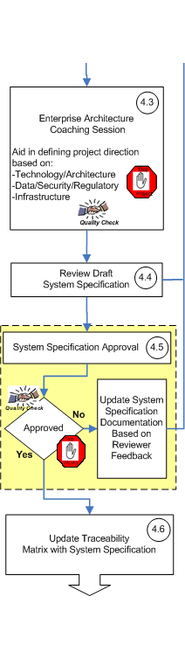
Enterprise Architecture Coaching Session
The Project Manager also continues to work through the Enterprise Architecture Coaching Session process that was initiated during Project Definition. This process aids in defining project direction based on technology, architecture, data, security, and infrastructure requirements. The Enterprise Architecture Coaching Session is a single, coordinated stop for Architecture and Design Guidance that has proven success if initiated as early as possible in the Software Development Lifecycle. Those sessions are attended by three different groups:
- CTO Team for architecture and conformance to overall design principles, ensure alignment to Technology Roadmap and 1-5 years roadmap and coordination of program reviews
- COE Team for Technology Specific roadmap and ownership, detailed design reviews and standard ownership
- Technology Services team as a single gateway to all infrastructure components
The System Specification documentation does not need to be entirely complete to leverage this process and the intent is for programs to engage early in the process to avoid potential redesign or rework. The aim of the Enterprise Architecture Coaching Session is to increase the quality of the project by contributing to the System Specification content and it should not be used to merely review finalized documentation.

Review Draft System Specification
The team is ready to proceed beyond the System Specification when, to the best of their ability, the authors determine the documentation to be both:
- Complete: Every significant requirement concerning system function, performance, attributes, interfaces and design constraints are included and the System Specification has accurately and correctly addressed the criteria defined in section 4.2.
- Attainable: Technically feasible.
If the documentation is determined not to be complete and attainable by the authors the content shall be revised. In general, definition of the System Specification should be an iterative process that accounts for discovery of new details throughout the process. If deemed necessary by the Project Manager – Business Solutions previous process steps should be revisited to ensure that it is both complete and attainable. For more on the quality of content refer to the Standard for the specification and definition of computerized systems.

System Specification Approval
The System Specification shall be submitted for formal review and approval. For iterative development, wherein the system development lifecycle is divided into increments and the delivery of user requirements may span one or more production releases, this shall be done for each production release. Refer to the Document Control Standard to understand how to go through document review and approval process.
For validated systems, system specifications shall be approved by a QA Representative.

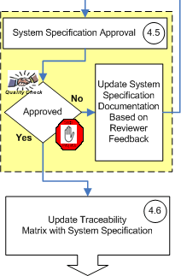
Update Traceability Matrix
The Project Manager shall ensure that Traceability Matrix is updated by the System Analysts or Architect once the System Specification is approved to ensure a clear, traceable line from user requirements to the appropriate system specification element. The origin of each requirement shall be clear, and traceable to a test identified at a later date, which proves its delivery. For iterative development, wherein the system development lifecycle is divided into increments and the delivery of user requirements may span one or more production releases, the Traceability Matrix shall be updated for each production release. For each release, the Traceability Matrix shall trace from the user requirements being released to production in that release to the appropriate system specification element. User requirements not being released to production in a given release shall be marked “For future iteration” in the “System Specification MWS Document Link” field of the Traceability Matrix. By the time all increments are completed, every user requirement shall trace to the appropriate system specification element. However, if the project is stopped prior to completing all increments, the Traceability Matrix, and for validated systems, the Validation Plan, shall be updated with the rationale for requirements not met.

Definitions
This section defines the abbreviations, acronyms, terms and definitions that are specific to this document.
Description | Definition
AIM diagram | Application Interaction Model Diagram
GUI | Graphical User Interface
IRS | Interface Requirements Specification
Iterative Development | A software development approach wherein the system development lifecycle is divided into increments. After the specification of user requirements, a subset of the requirements is developed in each increment, following the usual lifecycle steps of design, development and testing. One or more increments may be bundled together for release to production, following the usual production deployment procedures. As a result, in iterative development, delivery of the user requirements may span one or more production releases.

Roles and Responsibilities
Personnel | Responsibilities
Project Manager (PM) | - Assignment of tasks to project team  - Ensures completion of all minimum required documentation  - Coordinates required activities, reviews and approvals  - Responsible for ensuring the documentation is complete
Systems Analyst and  Architect | - Technical Lead personnel that provides technical process subject matter expertise on requirements.  - Is the ultimate owner of the System Specification Document.  - Develops and documents the System Specification.  - Dependent on activity specifics such as what technology is being used and size of project any combination of these resources can complete the definition and documentation of System Specification
Quality Assurance (QA) Representative | - Ensures quality in requirements to comply with relevant regulations.  - Approves system specification requirements.
Anyone involved in the process | - Responsible for stopping projects and/or work activity if the criteria laid out in the process is not met  - Responsible for working with the project managers to log a risk in the project's risk management system anytime projects are stopped.

Standard Ownership, Authorization, and Revision History

Owner: Senta Taylor, Global Manager, Customer Compliance Lean

Authorization
See MyWorkshop for approval signatures.

Revision History
Revision | Version | Effective Date/ Site | Reason for Change / Change Reference | Author
1 | 1 | As in MyWorkshop/Global IT | New WI | Greg Juedes
2 | 1 | As in MyWorkshop/Global IT | Updated Security References; Section 3 & 8  Updated Security description; Section 4.2.4 & 4.2.5  Removed Technical Architecture Plans from Template Usage; Section A.1.2  Updated approval description; Section 4.5, 6  Updated traceability description; Section 4.6  Updated Enterprise Architecture Coaching description; Section 4.3  Added User Interface; Section 4.2.8  Removed Optional Design Direction section | Greg Juedes
2 | 2 | As in MyWorkshop/Global IT | Revised for Spell Checking Error | Greg Juedes
3 | 1 | As in  MyWorkshop/Global IT | Update Reference section;  Add to section 4.5 QA as approver;  Change in section 4.6 in updating the Traceability Matrix;  Add QA to roles table  Section 3 – Updated references | Julio Razo  Sandra Gaus
4 | 1 | As in MyWorkshop/Global IT | Added updates to accommodate iterative development in Sections 2, 4.2, 4.5 and 4.6  Replaced must with shall throughout document  Removed “milestone” word from section 4.3  Add to section 5 Definition of iterative development | Cindy Behmke,  Raja Ramnarayan
5 | 1 | As in My Workshop / Global IT | Converting to STD | Julio Razo

Appendices
  - Appendix 1: Supporting Documents
    - GE Healthcare Person Data Request Process Document
DOC0047774
    - Supporting Documents
Criteria for Document Usage | Recommendation | Location
Recommended primary document for all System Specifications unless noted differently below. | GEHC Global IT System Requirement Specification Template (ITQ_TPLT_DOC0297131_SRS) | DOC0297131
New interface or a change to an existing interface (Middleware) | In addition to the SRS complete a new EAI IRS Template or update existing documentation if already created. | DOC0245583
 | Complete new Application Interaction Model (AIM) Diagram or update existing documentation if already created. Reference the guidance document to aid in creation of an AIM diagram at the following URL. | http://libraries.ge.com/download?fileid=14698001101&entity_id=2228972101&sid=101
If Data Migration is needed | In addition to the SRS complete new Global IT Data Migration Plan Template | DOC0059963
New application or changes to a Siebel instance (BA COE)  New reports or changes to existing Siebel reports (BA COE) | Siebel HLD, this may be used in place of the SRS | DOC0280117
 | Siebel Report HLD | DOC0280118
New BI reporting application or a change to an existing BI reporting application (BI COE) | Complete a new MD63 for each individual report. These should be referenced in the SRS | DOC0065032
New Oracle application or a change to an existing Oracle application (BA COE) | Update System Level Oracle SRS if one is created or use the standard template from above | GLPROD - DOC0301731  PRODERP - DOC0282072
 | Create new MD60's for customizations or update existing documentation if already created | DOC0059453
 | Create new MD63's for reports or update existing documentation if already created | DOC0065032
 | Complete new Capacity Planning Template or update existing documentation if already created. Refer to the following URL for a guidance document. | http://data.supportcentral.ge.com/upload/40484/doc_1251046.xls
 | Complete CV60 if data conversions are required | DOC0065034
If Reporting is needed | Walkthrough GEHC Global IT Business Reporting Decision Tree at the following URL. | http://data.supportcentral.ge.com/upload/44311/doc_1503549.ppt
Review the GE Data Classification standards at the following URL | Review the GE Data Classification document at the following URL to classify the data | http://sc.ge.com/*dataclassification
Review the General Electric Information Security Policy at the following URL | General Electric Information Security Policy | http://sc.ge.com/*infosecpolicy

