**Assessment 1 – report**

**Task 1 - Examination of the data types.**

The dataset was examined using the pandas info() method to obtain information about the variable datatypes. There are two types of data mismatch. First, pandas imports string data, and mixed data types as the Object Dtype. Second, where some of the mixed data types comprise numerical and string value.

In the first mismatched, a function was written to convert all Object Dtypes to the string type.In the second mismatched Dtpyes, the number_outpatient, number_inpatient, number_emergency variables were loaded as string types due to the presence of a ‘?’ character to denote missing/unknown values.

The ‘?’ character was replaced, using the pandas replace method, with the numpy nan. This is a floating-point representation of ‘Not a Number’. The floating-point variable was subsequently converted to the Int64 data type because the data represented by the variable are discrete quantitative. Results of the correction are shown in Figure 2.

The DataFrame of the corrected mismatches is shown in Figure 3.

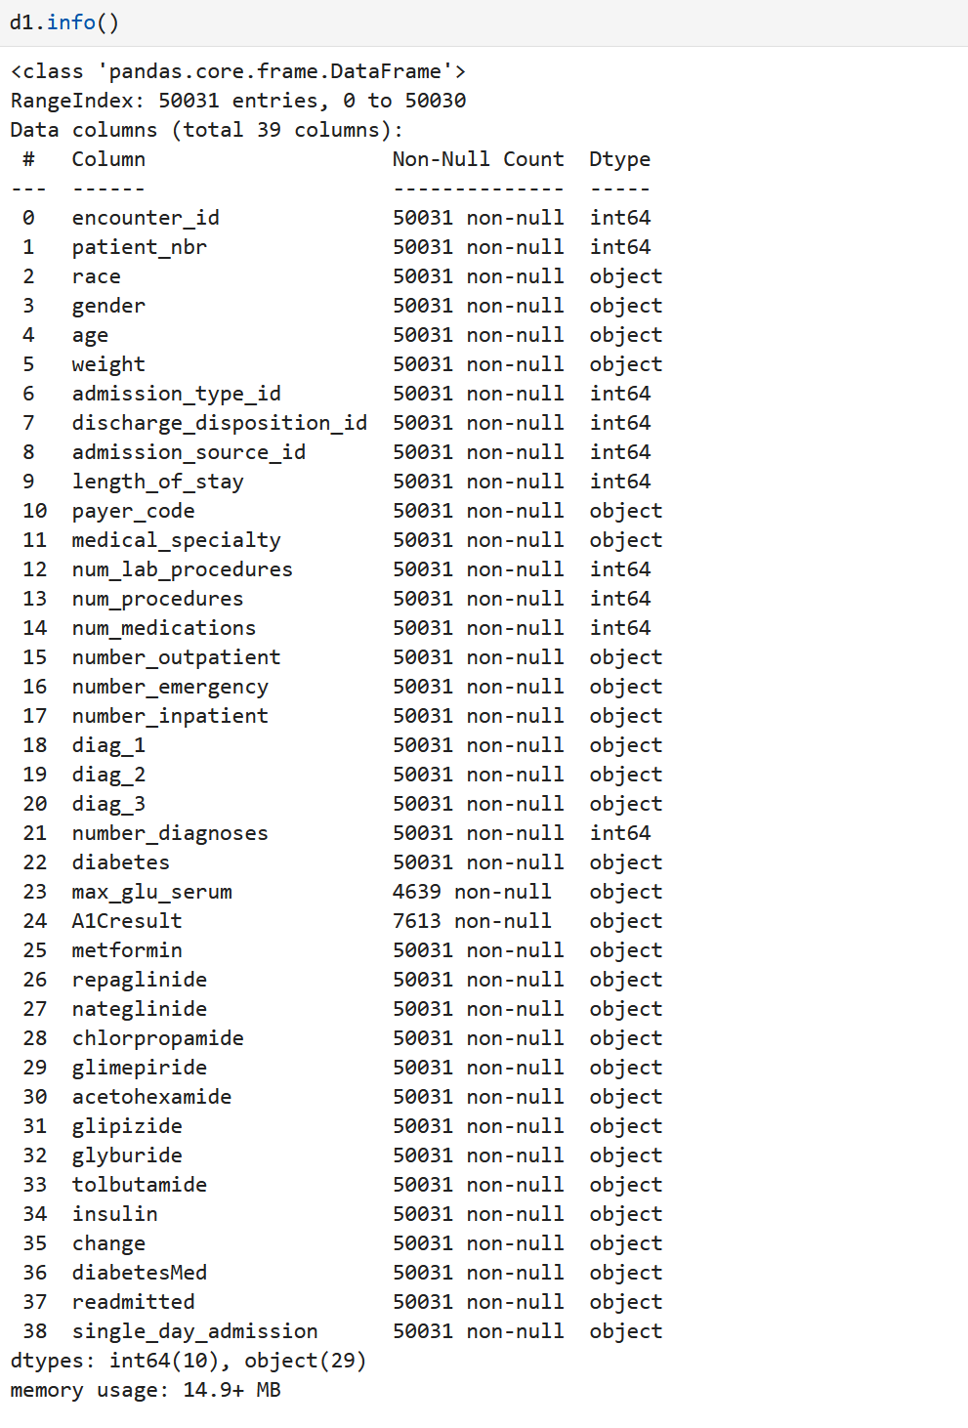

Figure 1 - Output of the pandas info() method on the imported dataset

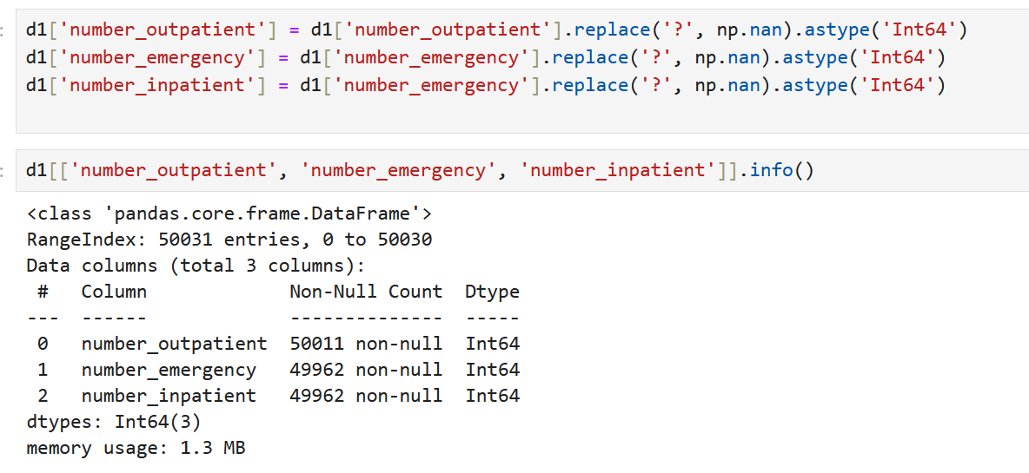

Figure 2 – Code to perform the correction of mismatched data types

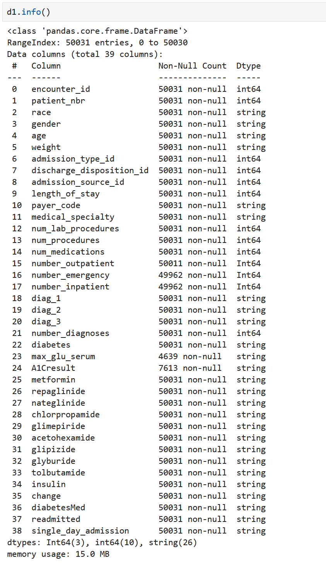

Figure 3 - Output of pandas info() after correction of mismatched data types

**Task 2 – Data exploration of the diabetes dataset.**

Using suitable statistical measures and functions, and visualisation plots as well to

* Identify and report the skewness present in the variables.
* Identify missing values, outliers, or errors in the data.
* List the variables with the identified problems.

**Skewness and outliers**

Skewness is a statistical measure that describes the asymmetry of the distribution of quantitative numerical values in a dataset. In our dataset, this can be measured on the meaningful integer values. Those variables are length_of_stay, num_lab_procedures, num_procedures, num_medications, number_outpatient, number_emergency, number_inpatient, and number_diagnoses. The encounter_id is an identifier variable and not required for analysis. The admission_type_id, discharge_disposition_id, and admission_source_id integervalues were not analysed for skewness as these represent references to categorial values.

A note about the patient_nbr variable. This was not included at this stage for skewness as it can be excluded as an identifier variable. However, a small number of patients have multiple encounters that has its own frequency distribution. The impact of multiple encounters per patient_nbr will be revisited at the modelling stage, to consider whether repeated patient encounters are independent of each other and whether they should be removed.

**Frequency distribution of the quantitative variables.**

The skewness was determined by visual inspection of the frequency distribution of the quantitative variables and using the pandas skew method.

The quantitative variables very separated into three distinct groups to reflect different characteristics of the patients, their medical history, and encounters.

|  |  |
| --- | --- |
| Group | Variables include |
| Relating to prior healthcare exposure | Number_inpatient, number_outpatient, number_emergency |
| Relating to procedures/medications during the encounters | Num_procedures, num_lab_procedures, num_medications |
| Relating to comorbidity and time in hospital | Num_diagnoses, length_of_stay |

The dataset was analysed for outliers, or errors in the data, and to detect skewness. using frequency distributions of the variables using histograms and boxplots using the code in Figure 4.

Figure - Code to produce box plots and frequency distributions

Figure - Histograms and boxplots showing distributions of prior inpatient, outpatient, and emergency department visits

The histograms in Figure 5 show that the number of inpatient, outpatient, and emergency visits are right-skewed, with most patients having few visits. The boxplots show that there are many outliers in each of the variables. This is expected given the right-skewed distribution of the data.

This can be confirmed by calculating the skewness of the variables.

Table - Skewness of inpatients, outpatients, and emergency visits variables.

The skewness values are positive, confirming that the data are right skewed which is consistent with the histograms and boxplots.

The following code shows the zero-inflated nature of these group1 numerical data types.

Figure - Code block to produce the table of the percentage of encounters with number of visits per visit type

Table - Percent of values for the inpatients, outpatients, and emergency visits (top 5 results only)

The table shows that for each visit type, most patients had no prior visits to inpatient, outpatient, or emergency departments in the preceding year. This means that many records for these three variables are outliers.

We tested this using the interquartile range (IQR) method to calculate the number and percentage of outliers for each variable. This method reported the number of values that either less than the 25th percentile multiplied by 1.5 times the IQR, or more than the 75th percentile times 1.5 times the IQR.

A function was written which incorporated the pandas describe() to calculate the number of outliers and percentage outliers in columns.

Figure - Code to detect outliers

Table - Percent of outliers in inpatient, outpatient, and emergency visits

These outliers are a result of the data being strongly zero-inflated therefore the IQR and outlier upper bound are low values. The same process was repeated for the second group of variables representing number of procedures, lab tests, and medications.

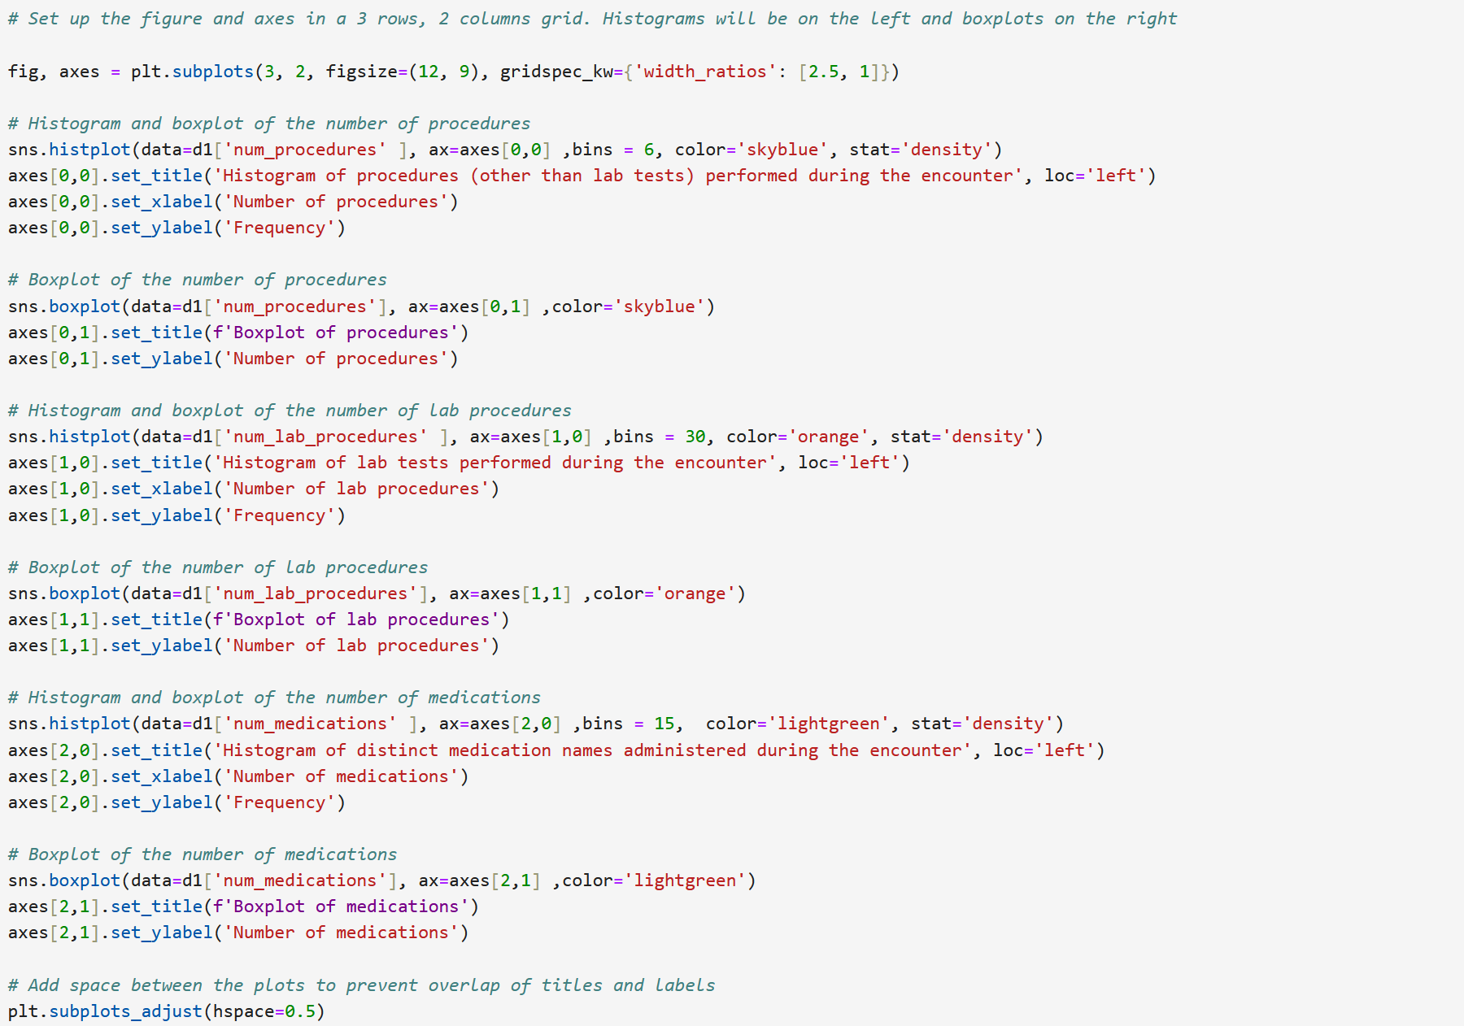

Figure - Code to produce box plots and frequency distributions

Figure – Histograms and boxplots of num_procedures, num_lab_procedures, and num_medications

Figure - Proportions of outliers in number procedures, number lab procedures, and number medications variables

The histograms show that the number of procedures and medications are positively skewed. With a smaller number of patients having large numbers of procedures and medications.

The number of lab procedures is more evenly interesting because it shows what appears to be a long tail, in the presence of several zero values. The skewness variable indicates that this variable is in fact slightly negatively skewed.

Figure - Skewness of number procedures, number lab procedures, and number medications variables

The boxplots show that there are many outliers in each of the variables. This needs to be interpreted in the context of the data. For example, the number of procedures and medications, while exceeding the IQR, may not be considered outliers in a medical context.

Also, the number of outliers in the lab procedures is comparatively low, but this is due to the large number of zero values in the data. This is likely because not all patients require lab procedures during their encounter. These outliers should be considered differently than the outliers from patient visits. For example, while the number procedures show 6 as a statistical outlier based on the IQR, it would not substantively be considered an outlier because it is the range of a small number of discrete procedures variable.

The distributions of the procedures and number of medications variables are all positively skewed with long tails, and as such, the handling of outliers for this group of variable will require careful consideration for handling the values in the long tails.

Figure - Code to produce histograms and boxplots o fthe number of diagnoses and lengths of stay

Figure - Histograms and boxplots for number of diagnoses and lengths of stay

The histograms show that the number of diagnoses are negatively skewed whereas the length of stay is positively skewed. The boxplots show that there are no outliers for the number of diagnoses, but there are many outliers for the length of stay.

Figure - Proportions of outlers in number of diagnoses and lengths of stay

These are corroborated by the skewness values which are negative for the number of diagnoses and positive for the length of stay.

Figure - Skewness of number of diagnoses and lengths of stay

**Missing data and errors**

There are three types of missing or erroneous values in the dataset:

1. Missing data represented by a ‘?’ character
2. Missing integer values which have been converted from ‘?’ to a NaN value
3. Unknown, not available, or not mapped values in the reference admission_type_id, discharge_disposition_id, and admission_source_id columns, and in the gender column.

The following code detects each type of missing or erroneous data and presents the details in Table 4.

Table - List of missing/erroneous values in the dataset

**Task 3 – Data preparation**

The problems associated with the data, with the proposed corrections, are presented in Table X.

List of values with identified problems:

**Table 5 - Issues identified with the data set and the respective corrective actions.**

|  |  |  |
| --- | --- | --- |
| Variable | Problem | Proposed correction |
| encounter_id | None | Drop – not required for data mining |
| patient_nbr | Multiple records | Drop |
| race | Missing values | Impute by random value imputation |
| gender | 1 missing value | Impute by mode imputation |
| age | Numerous unnecessary bins | Recode to reduce number of bins |
| weight | 96% missing | Drop – majority of values are missing |
| admission_type_id | Too many levels for encoding | Identify and correct missing values.  Recode variable to reduce the number of features. |
| discharge_disposition_id | Too many levels for encoding | Identify and correct missing values.  Recode variable to reduce the number of features. |
| admission_source_id | Too many levels for encoding | Identify and correct missing values.  Recode variable to reduce the number of features. |
| length_of_stay | None | Normalise with z-scores |
| payer_code | 65% Missing | Drop – too many missing values. |
| medical_specialty | Too many levels for encoding | Recode to higher level categories. |
| num_lab_procedures | None | Normalise with z-scores |
| num_procedures | None | Normalise with z-scores |
| num_medications | None | Normalise with z-scores |
| number_outpatient | The variables have a small number of missing values.  The variables are strongly zero inflated. | Replace NaN values with median value to limit bias.  Normalise with z-scores |
| number_emergency |
| number_inpatient |
| diag_1 | Too many levels for encoding | Recode to top level ICD9 categories |
| diag_2 | Too many levels for encoding  Limited value in addition to diag_1 | Drop |
| diag_3 | Limited value in addition to diag_1 and diag_2 | Drop |
| number_diagnoses | Qualitative | Convert to numeric |
| diabetes | Qualitative | Convert to numeric |
| max_glu_serum | Many missing values | Drop |
| A1Cresult | Many missing values | Drop |
| metformin | Too many values to encode  Presence of zero-variance fields  1 missing value | Drop the zero variance acetohexamide and tolbutamide  Chlorpropamide has a missing value that will be imputed.  Derive a new variable to reflect diabetes medication changes |
| repaglinide |
| nateglinide |
| chlorpropamide |
| glimepiride |
| acetohexamide |
| glipizide |
| glyburide |
| tolbutamide |
| insulin |
| change | Qualitative/Redundant | Drop – correlates strongly with new diabetes medication change variable |
| diabetesMed | Qualitative/Redundant | Drop – correlates strongly with diabetes variable |
| readmitted | Qualitative | Convert to numeric |
| single_day_admission | Qualitative | Convert to numeric |

The diagnosis categories (diag_1, diag_2, and diag_3) represent ICD9 codes of primary, secondary, a tertiary diagnoses of cases. The variables each have more than 600 unique values. This would be impractical for a machine learning model so these will require grouping.

Similarly, medical speciality has 68 unique values and 35% of values are missing. This variable will be recoded into higher level specialities e.g. internal medicine, surgery, general practice, oncology, paediatric etc.

The variables admission_type_id, discharge_disposition_id, and admission_source_id can be recategorized to reduce the number of values.

The admission_type_id can be condensed to fewer categories as follows:

* Emergency, urgent, and trauma center can be combined into the Emergency category based on their acuity
* Not Available, NULL, and Not Mapped can be combined into the Not available category based on the lack of mapping, or unavailability
* Newborn can be left as a separate category

The discharge_disposition_id can be condensed to four distinct categories that capture the concepts of discharged home; transferred for ongoing care; deceased; and unknown.

* Discharged to home can be categorised as 'Discharged home'
* Examples of discharged/transferred include another short-term hospital, SNF, ICF etc can be categorised as 'Ongong care'. This is because they are all forms of additional care in the current facility or through another facility.
* Any variable with Expired will be recoded to 'Deceased'
* All ‘Not mapped’, NULL, and Unknown will all be recoded to 'Unknown'

The admission_source_id can be condensed to fewer categories as follows:

* Referral from another provider e.g. a physician or clinic.
* Transferred in from another facility or health agency.
* Emergency room admission.
* Not Available

On inspection of the variables, there were a small number that were related to childbirth/newborns and some that were court order. Given the small number (less than 10) these were considered as a referral.

**Task 4 - Selection of data mining task and feature selection**

* Identify correlation between variables (use a correlation matrix)
* Examine relationship between diabetes and diabetesMed – this will be strong. DiabetesMed will be redundant.
* Exclude pointless variables e.g. weight, payercode, max_glu_serum, AC!result etc…
* Identify mining task – this will likely be a classification algorithm using supervised machine learning. For example,
  + are there characteristics of the patient encounters that can be used to predict hospital length of stay. Or,
  + are there characteristics of the patient encounters that can be used to predict mortality as an outcome?
* What variables should be included and why?