User Documentation

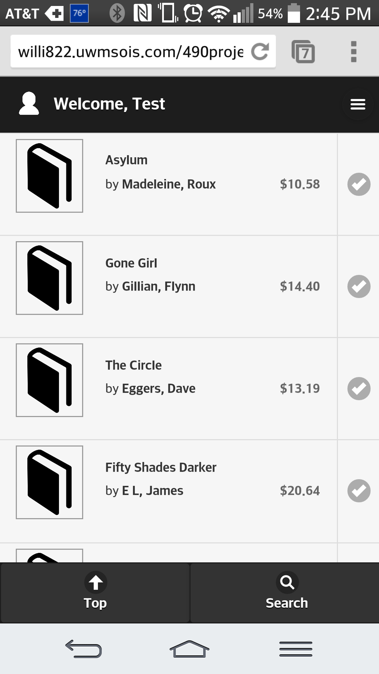

After Logging in, the user will be brought to their home page.

The Home Page will display all the books in the stores database and has four buttons to trigger the mobile app functions

Menu Button- Upper Right corner that will trigger side navigation will no display four new option

* Search (which is also located at the bottom of the homepage)
* My account (Display a page of all information about the user, Name, Address, etc. as well as any books they have on there reserve list)
* Reserved books (takes user to My Account page)
* Logout (Will log the user out from the system)

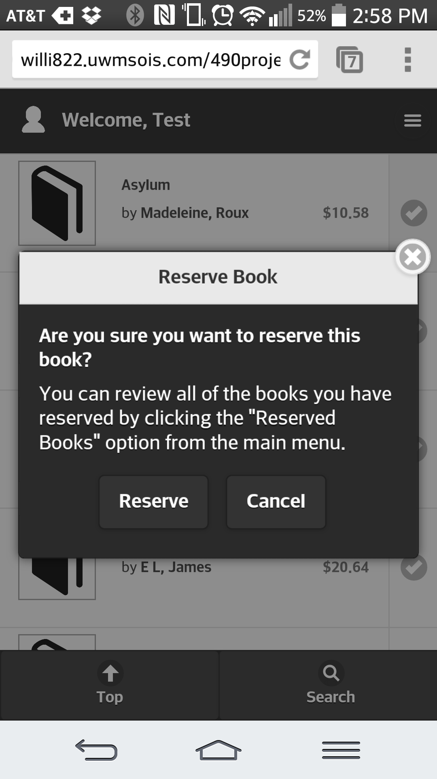Check mark book reserve - display a pop up box that gives the users option to reserve this book or cancel.

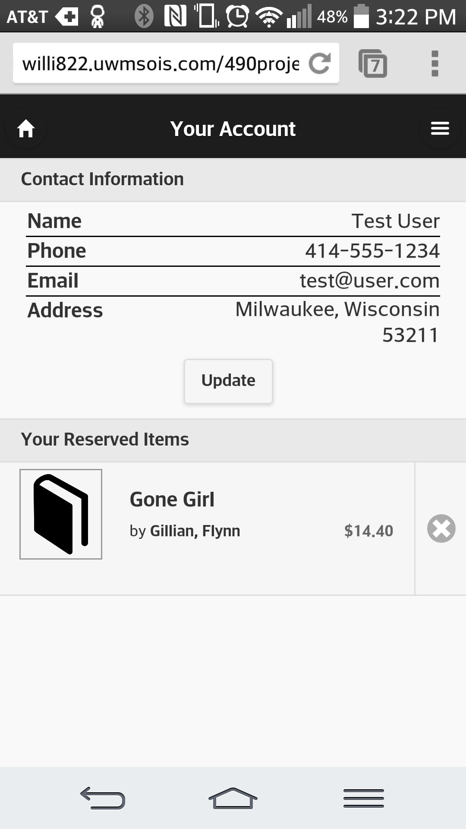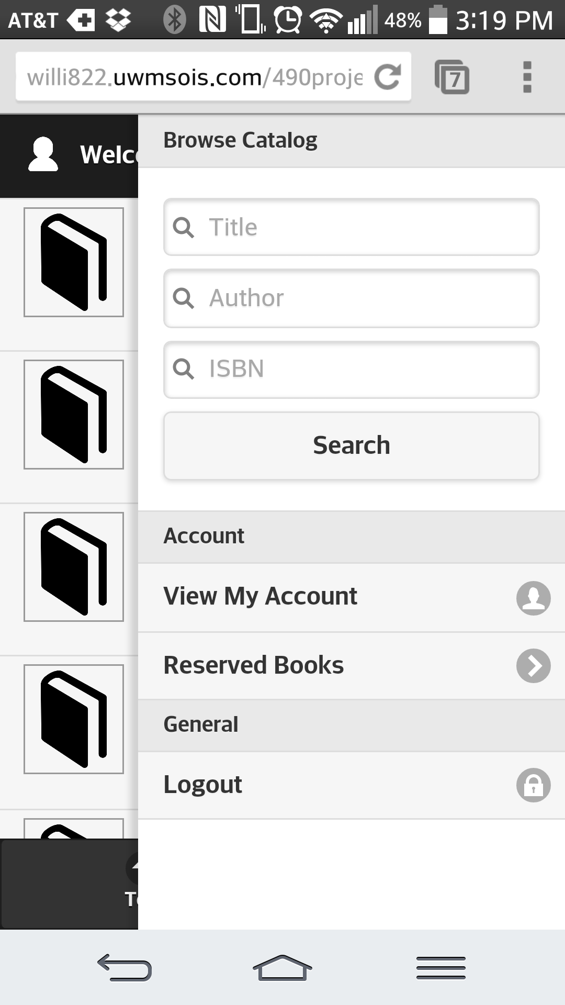

Menu User Account

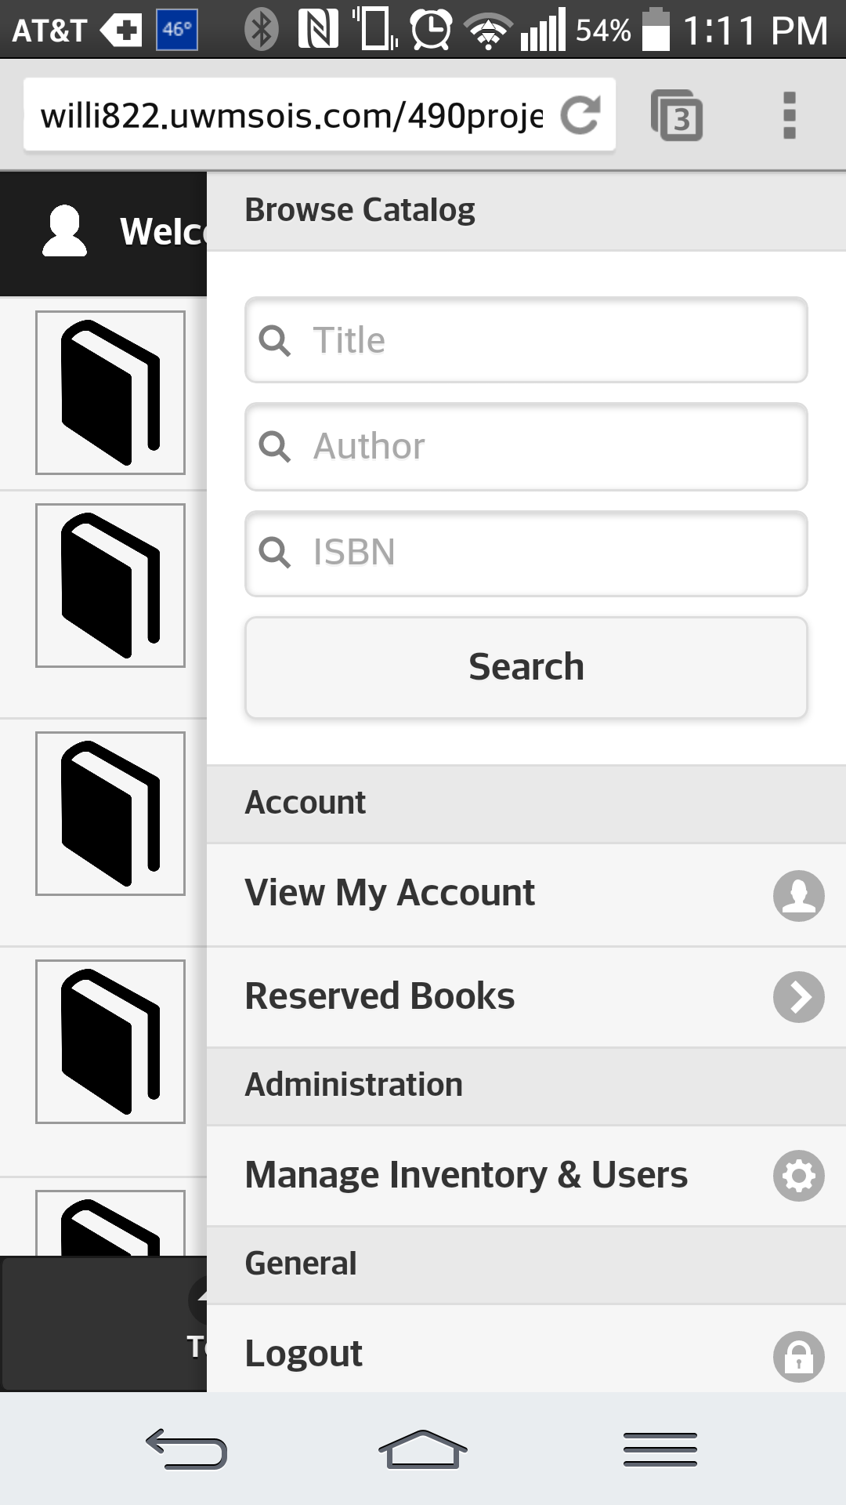Administrator Documentation

Default administrative login:

username: admin@admin.com

password: apple32

The Home Page will display all the books in the stores database and has four buttons to trigger the mobile app functions, this page looks identical to the user’s home page, except for the inventory and book management menu link

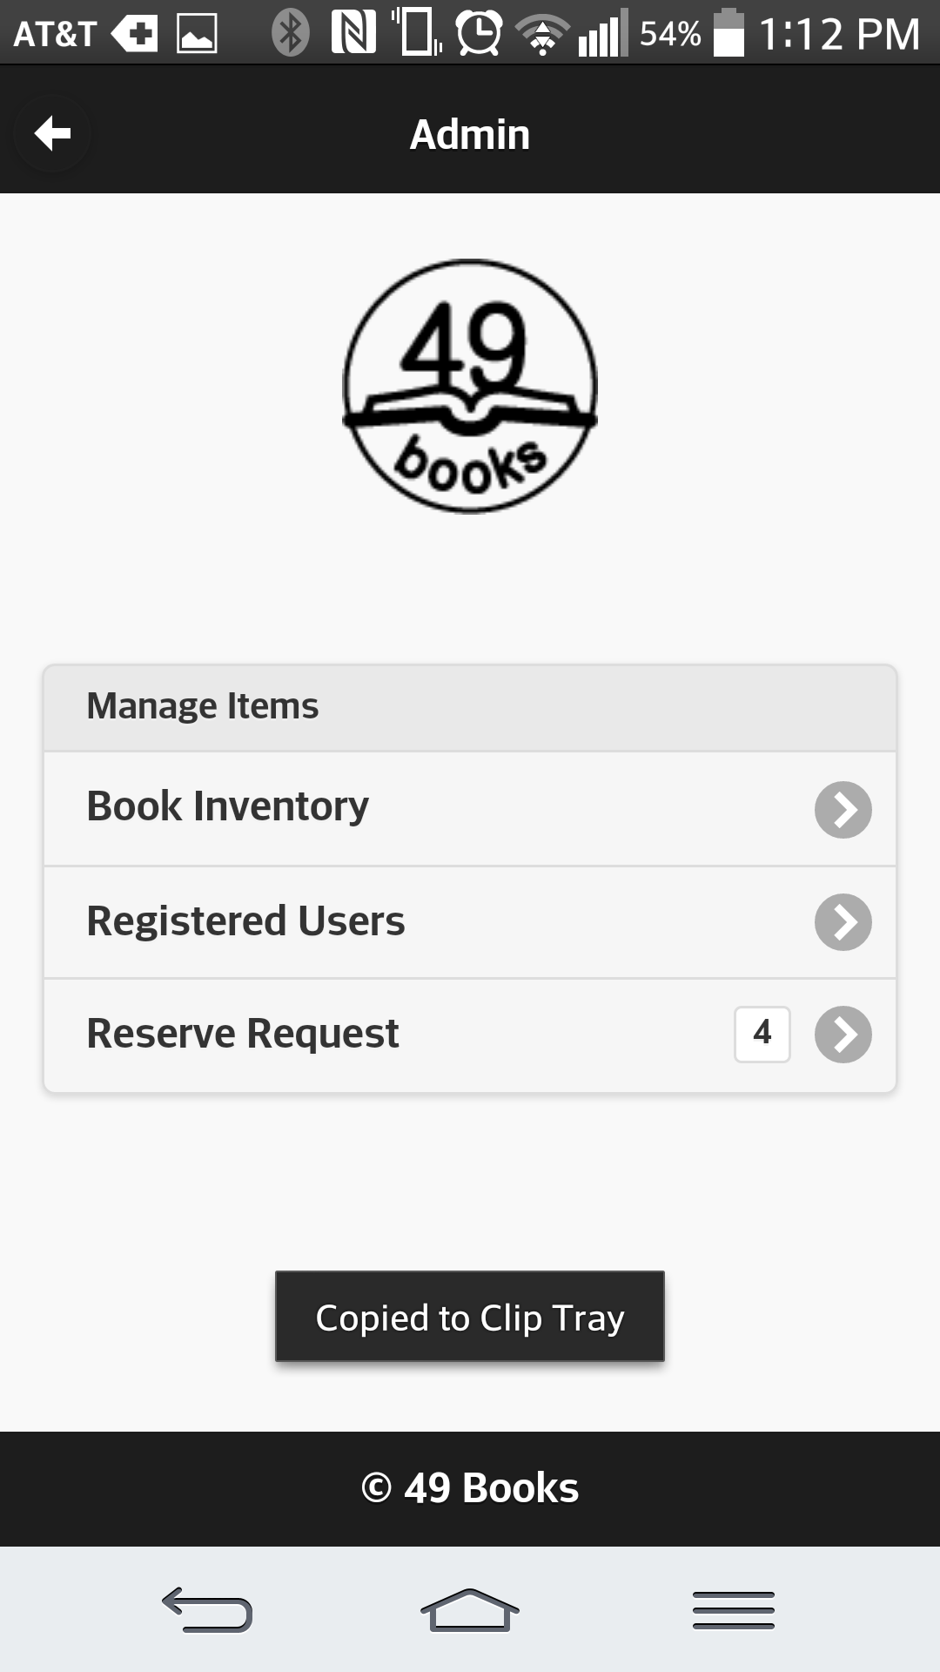

Upon entering the inventory management page,

The administrator can add, delete or update book inventory by clicking the appropriate buttons on the ‘Book Inventory’ page

Registered users can be added, deleted, and updated from the labeled buttons on the ‘Registered Users’ page

‘Reserve Request’ will allow management of pending book reservations

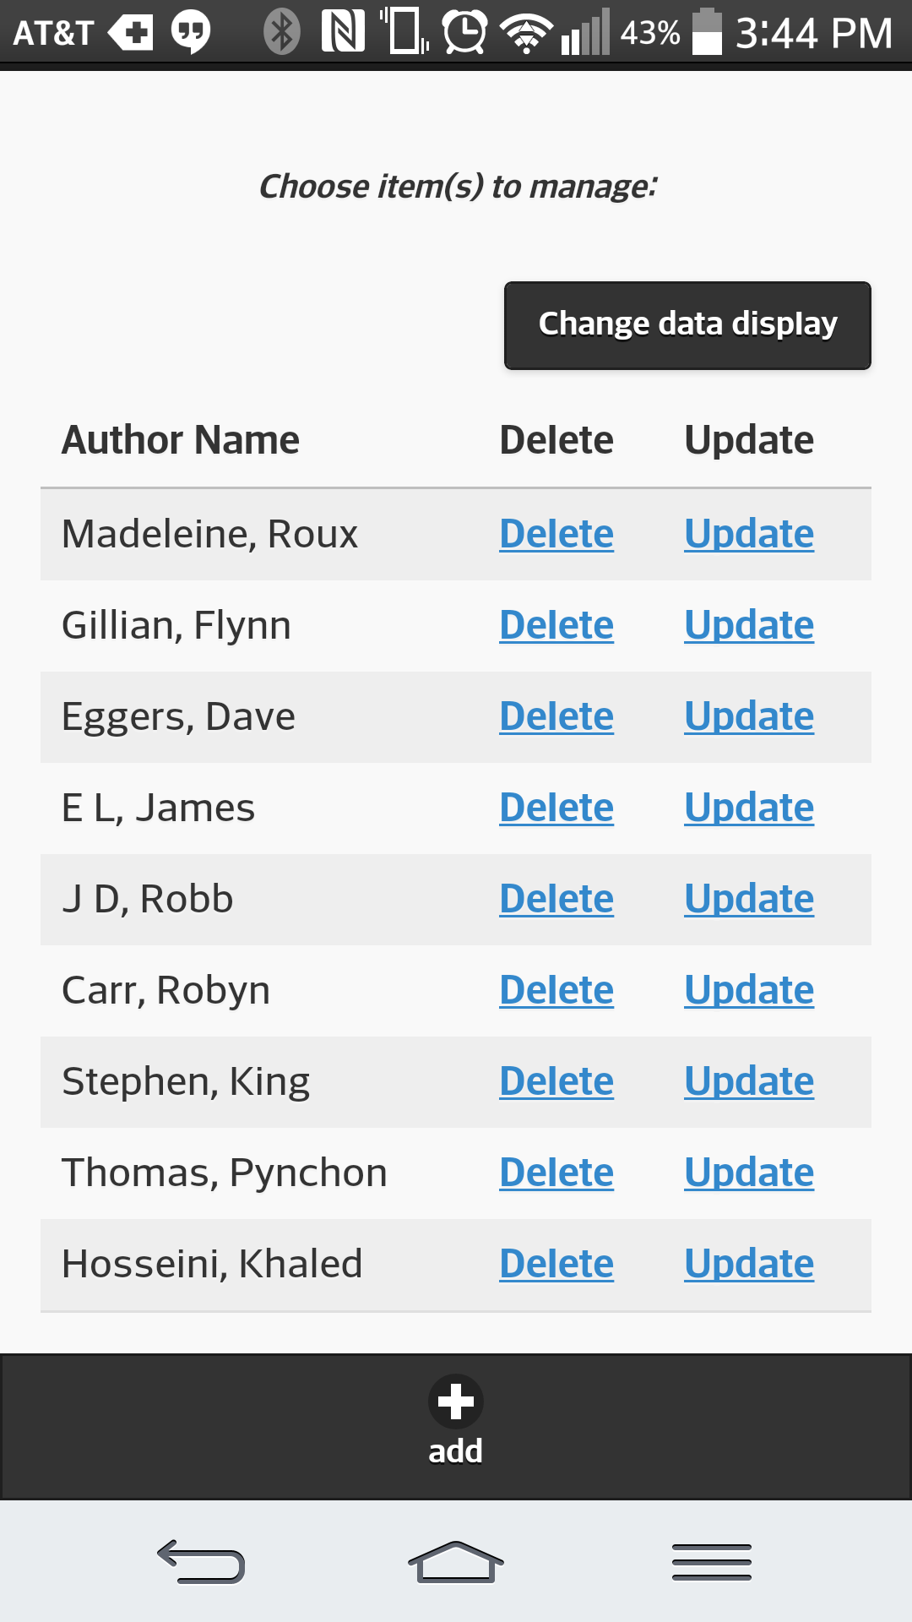**Book Inventory**

-clicking ‘change data display’ will allow the admin to choose which book attributes to see on their screen

-each book has a delete and update button

All book attributes except ISBN can be changed

-the add button allows for a new book entry

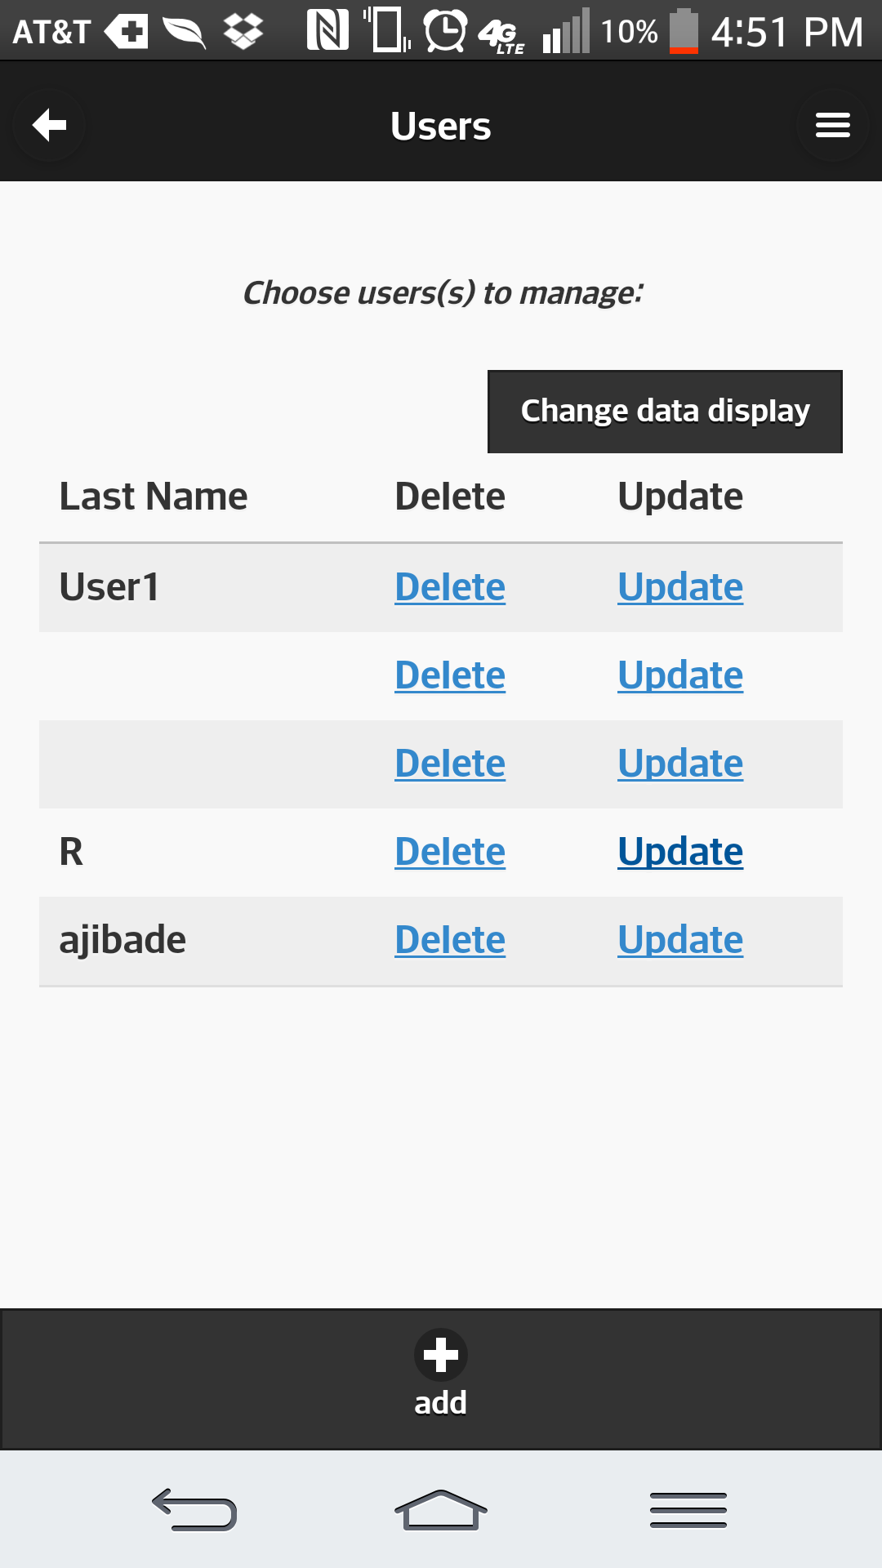

**Registered Users**

-very similar to book management

-each user has a delete and update button

-display can be customized to show specific user attributes under ‘change data display’

-new users can be added with the add button



**Reserve Request**

-Book reservations can be marked as:

*Filled (deleted from inventory) or

*Cancelled (placed back in inventory and user’s reservation removed) from the ‘Reserve Request’ page