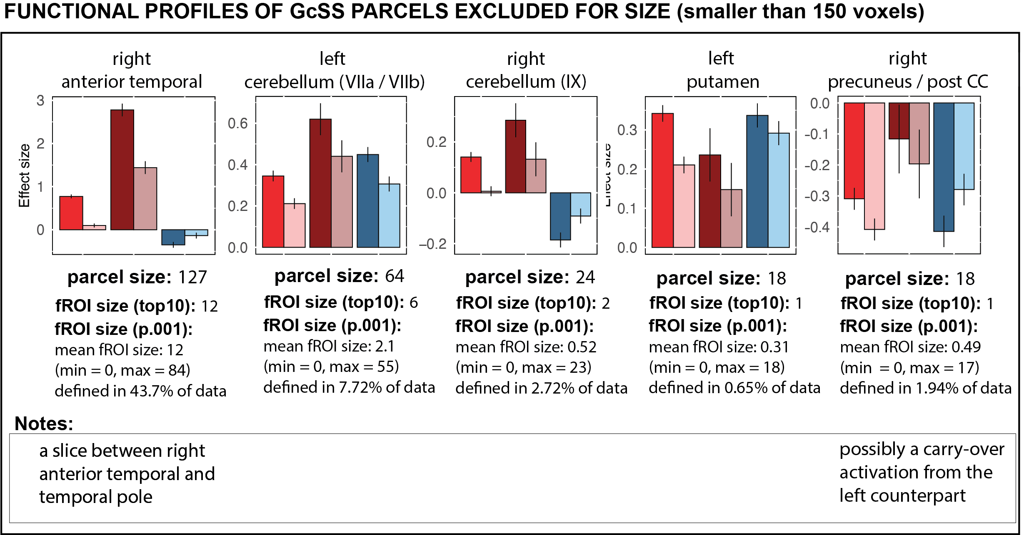
Figure O4. Functional profiles of parcels identified by the GSS parcellation but excluded from the main analyses due to small size (>150 voxels). The figure presents functional profiles of these parcels (note that the scales differ between ROIs) and gives the size of the parcel, fROI’s defined using top 10% of most active voxels, and size statistics of fROI’s defined using a statistical threshold – p < .001 (uncorrected), including the mean size, minimal and maximal size as well as the proportion of data in which this parcel was successfully defined in our sample (i.e., localizer mask was larger than 0)

