Quantitative Methods, Hill
SPSS Lab 1

Practice dataset: states.sav
Download from Blackboard course site in “Resources”

Opening a Data File (*.sav)
File > Open > Data
Navigate to file states.sav and click Open.
*Do not open SPSS data files by double clicking the icon.

Creating a New Syntax File (*.sps)
File > New > Syntax

Opening an Existing Syntax File (*.sps)
File > Open > Syntax

Descriptive Statistics: Frequency Tables
Frequency tables are appropriate for nominal or ordinal variables with only a few values. Creating frequency tables for interval-ratio variables will render large useless tables. First, let’s look at the breakdown of states by region:

SYNTAX:
FREQUENCIES VARIABLES=region
/ORDER=ANALYSIS.

Output:
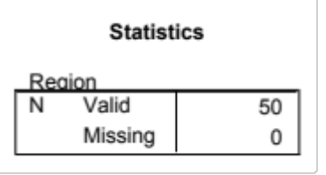
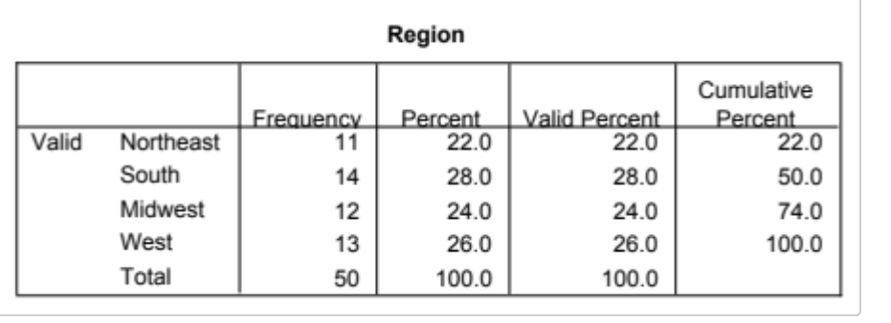

Descriptive Statistics: Explore
For interval-ratio measured variables, the Explore function summarizes central tendency, dispersion, and other useful information. In this example, let’s look at the variation in the rate of population per square mile.

SYNTAX:
EXAMINE VARIABLES=density
/PLOT NONE
/PERCENTILES(5,10,25,50,75,90,95) HAVERAGE
/STATISTICS DESCRIPTIVES
/CINTERVAL 95
/MISSING LISTWISE
/NOTOTAL.

Output:
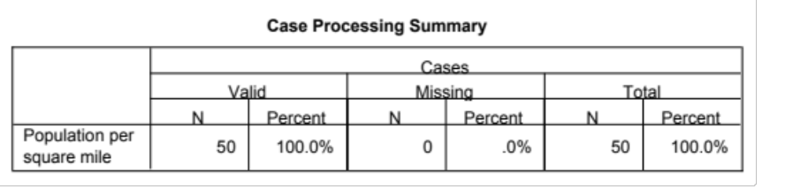
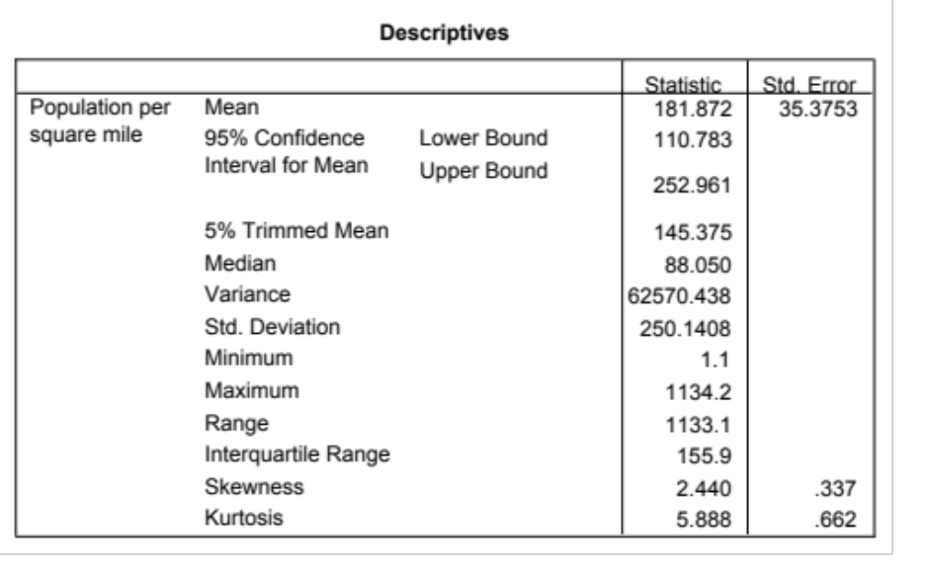

Quantitative Methods, Hill
SPSS Assignment 1

Dataset: country.sav
Download from Blackboard course site in “Resources”

Submission instructions:
- Your work should be completed in a word processing application.
  - To copy and paste SPSS output into the word processing application:
    - In SPSS output, Right-Click the object to be pasted, and Copy
    - If the output is a table: Paste
    - If the output is a graph: In the word processing application, go to Paste > Paste Special > As: Picture(JPEG)
- Save your document as a PDF file. It should include answers to the questions, your SPSS syntax, and appropriate supporting output, tables, and/or graphs, not to exceed two pages.
- Upload the file to PDF file to the Blackboard course site in “Assignments,” by the assigned due date.

Assignment

- List the level of measurement for each of the following variables:

  - case
  - country
  - hdirank
  - hdicat
  - pop2004
  - URBAN
  - physicians
  - mort2004
  - tele2004
  - cell2003
  - internet03
  - gdp
  - inequality
  - educ04
  - milit2004
  - debt04
  - cde2003
  - lifef
  - lifem

- What is the average infant mortality rate (per 1,000 births) in 2004?
- What is the maximum infant mortality rate (per 1,000 births) in 2004?
- What is the median for cell phones per 1,000 people in 2003?
- What is the 95th percentile for cell phones per 1,000 people in 2003?
- Compare the median and 95th percentile for cell phones per 1,000 people in 2003. What does this comparison tell you about the distribution of this variable?
- Describe hdicat
- Describe hdirank
- Did you describe hdicat and hdirank differently? Why or why not? What does each description tell you? How do these variables relate to each other?
- Why is it important to use Frequency Tables for nominal and ordinal variables and Explore for interval- ratio variables?

