Quantitative Methods, Hill
SPSS Lab 5

Dataset: states.sav
Download from Blackboard course site in “Resources”

ANOVA
Test whether the poverty rate differs across regions of the U.S.
Dependent variable: poverty
Independent variable: region

Level of measurement:
- The dependent variable must be interval-ratio.
- The independent variable must be nominal or ordinal, with more than two categories to be tested.

SYNTAX:
General structure:
oneway [DEPENDENT VARIABLE] by [INDEPENDENT VARIABLE]
/statistics descriptives
/missing analysis.

For this example:
oneway poverty by region
/statistics descriptives
/missing analysis.

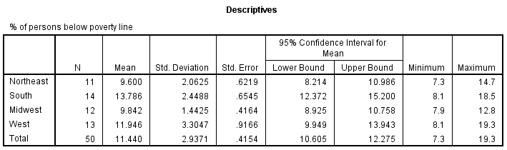
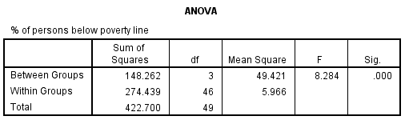

How to interpret the tables on Output:
F-obtained is now calculated and shown on the ANOVA table on Output. Does it fall in the critical region? If the value of Sig. is smaller than alpha (typically 0.05), we will reject the null hypothesis that there is no difference among the three populations represented by the three groups. If the value of Sig. is greater than 0.05, we will fail to reject the null hypothesis.

Technically reporting ANOVA:
We examined poverty by region. There was a significant main effect of region F(3,46) = 8.284, p < 0.001.
Quantitative Methods, Hill
SPSS Assignment 5

Dataset: drugtreatment.sav
Download from Blackboard course site in “Resources”

Assignment

- Conduct the appropriate hypothesis test to determine if there is a difference in depression based on history of drug use.
  - Use variables at the appropriate level of measurement.
  - Show SPSS syntax.
  - Show results tables.
  - Report technical results.
  - In one paragraph, comment on the implications of the result of the test. Speculate. What might be a consequence of drug use? Is this relationship cause and effect; why or why not?

- If you wanted to conduct an ANOVA hypothesis test, but both of your variables were interval-ratio, which of the following tasks would you need to complete in order to be able to conduct the test? Select only one answer:
  - Recode the dependent variable into a nominal or ordinal variable.
  - Recode the independent variable into a nominal or ordinal variable.
  - Recode both the dependent and independent variables into nominal or ordinal variables.
  - Conduct the test with the two interval-ratio level variables.
  - Abandon the analysis.

