Quantitative Methods, Hill
SPSS Lab 6

Dataset: states.sav
Download from Blackboard course site in “Resources”

Chi Square

Does poverty vary by region? In this example, we are going to use the Chi-Square test for statistical significance.
Dependent variable: poverty2 (recoded to ordinal)
Independent variable: region

Level of measurement:
- The dependent variable must be nominal or ordinal.
- The independent variable must be nominal or ordinal.

SPSS Syntax:
General structure:
CROSSTABS
/TABLES=[dependent variable] BY [independent variable]
/FORMAT=AVALUE TABLES
/STATISTICS=CHISQ
/CELLS=COUNT COLUMN
/COUNT ROUND CELL.

For this example:
*recode I/R level variable poverty into ordinal variable poverty2.

RECODE poverty (0 thru 10.5=1) (10.5 thru HIGHEST=2) INTO poverty2.
VARIABLE LABELS poverty2 '% of persons below poverty line (ordinal)'.
EXECUTE.

VALUE LABELS
poverty2
1 'Low (10.5 or less)'
2 'High (10.6 or greater)'.
EXECUTE.

*run chi square statistic.

CROSSTABS
/TABLES=poverty2 BY region
/FORMAT=AVALUE TABLES
/STATISTICS=CHISQ
/CELLS=COUNT COLUMN
/COUNT ROUND CELL.

SPSS Output:
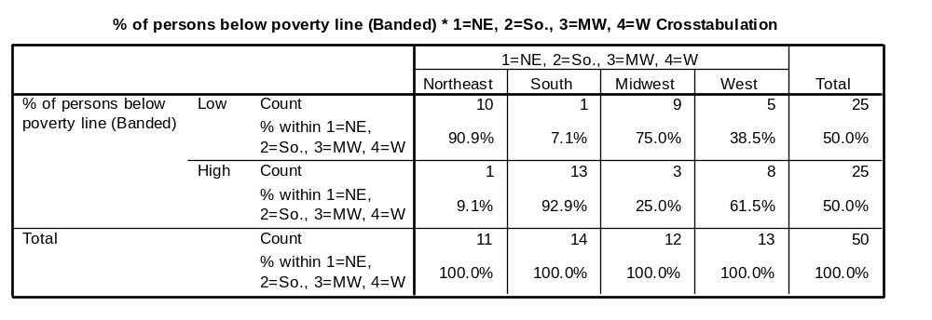
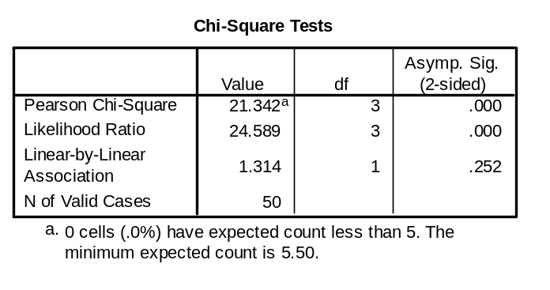
How to interpret the tables on Output:
Check whether the Sig. value of ‘Pearson Chi-square’ on the Chi-Square Tests table is less than 0.05. If it is less than 0.05, it means that there is a statistically significant difference between two variables.

Technically reporting Chi-Square:
The percentage of persons below the poverty line varied by region. X² (3, N = 50) = 21.3, p < .001.

Quantitative Methods, Hill
SPSS Assignment 6

Dataset: lowbwt.sav
Download from Blackboard course site in “Resources”

Assignment

- Conduct the appropriate hypothesis test to determine if there is a difference in the rate of those who smoke while pregnant, by race.
  - Use variables at the appropriate level of measurement.
  - Show SPSS syntax.
  - Show results tables.
  - Report technical results.
  - In one paragraph, comment on the implications of the result of the test. Make observations. Speculate.

- If you wanted to conduct a Chi-Square hypothesis test, but both of your variables were interval-ratio, which of the following tasks would you need to complete in order to be able to conduct the test? Select only one answer:
  - Recode the dependent variable into a nominal or ordinal variable.
  - Recode the independent variable into a nominal or ordinal variable.
  - Recode both the dependent and independent variables into nominal or ordinal variables.
  - Conduct the test with the two interval-ratio level variables.
  - Abandon the analysis.

