ICU Mashup

This is a web application that displays six KPIs from three different apps, which are linked together through department groups and month year. The three apps are ICU Metrics, Respiratory Therapy, and Central Lines. The two filter dropdowns apply the selections across the six KPIs and the number of selections are displayed in the nav bar. The selections are cleared upon refreshing the site, along with pressing the clear button.

Installing

Software/Programs to Install:

* IDE (i.e. [Visual Studio Code](https://code.visualstudio.com/))
* [Node.js](https://nodejs.org/en/) (to run the local server for testing)
* [Git](https://git-scm.com/) (Version control and storage on GitHub, not totally necessary)

Getting Started

If you are reading this, you are in the informatics share drive and found the source folder (ICU_Mashup). Copy the folder locally to your computer and open it in your favorite IDE. (Visual Studio Code is good) Once you have the project open, use [Ctrl + `] to bring the terminal up, and type in the terminal “node server.js”.



This creates a local server found at <http://localhost:3000> that displays the mashup. The mashup has also been imported as an extension onto the Qlik dev server and can be located at <https://qlikdev.jefferson.edu/adfsd/extensions/ICUDashboard/index.html#/dashboard> .

Additional Notes

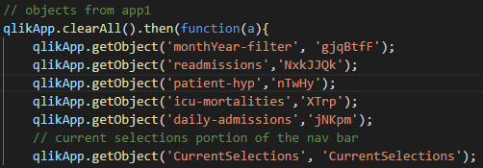

This is a screenshot of the objects taken from app1 in dashboard.component.js. The most important part of each getObject line is the object id, i.e. ‘gjqBtfF’.

The object IDs of the apps can be found easily with a Qlik created bookmark.

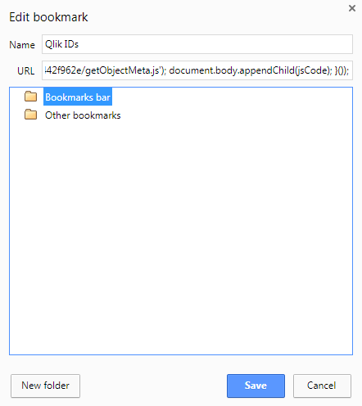

Create a bookmark with any arbitrary name, but for the URL paste:

javascript: (function () { var jsCode = document.createElement('script'); jsCode.setAttribute('src', 'https://cdn.rawgit.com/tboland/f504a892556adda47dea85adb733dfbe/raw/cd7336228ceee21139d398be6c41db13442f962e/getObjectMeta.js'); document.body.appendChild(jsCode); }());

When this bookmark is used on a Qlik sheet, each individual object will have a “Show Meta” tag.

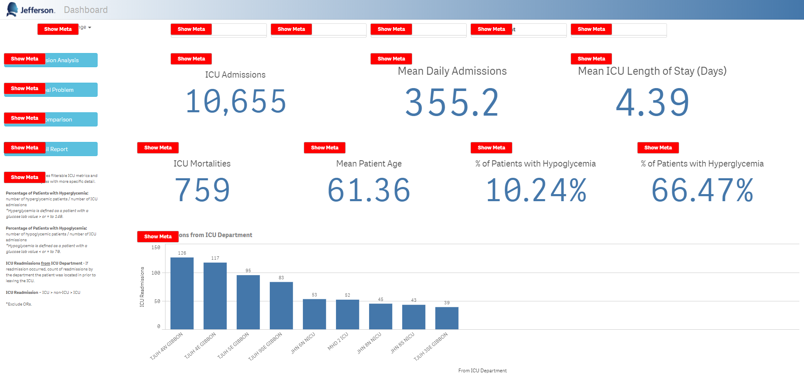

The object IDs can be found in the hypercube with the key ‘qID’.

Additional functionality of the mashup will be conditional color formatting for each KPI determined by a specific threshold.