Based on the observation, temperatures of the observed cities that are located in the northern hemisphere are relatively colder comparing to cities that are located in southern hemisphere in Jan. of 2019.

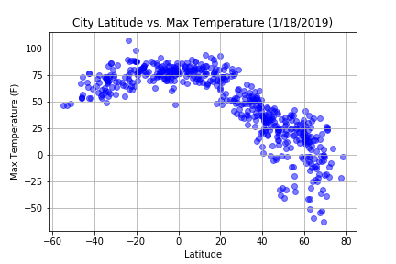

Based on the observation from below plotting, there is no significant difference can be observed and proved there is a significant difference in humidity between northern and southern hemisphere. The differences of humidity of each observed data appears to be determined by longitude of the observed data.

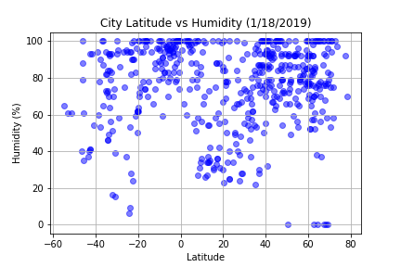

#Based on the plotting from below, cloudiness of each city does appear to be affected by latitude of the observed city, possibly affect by the longitude of the observed data.

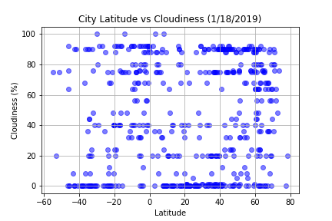

This time of year, wind speed does not appear to have a significant correlation with latitude with majority of observed cities are located around 0-10 mph zone.

