I am using a Macbook Pro 2015 15-inch running Ubuntu 21.10 with Xfce 4.16.

I am using Geany as my editor:
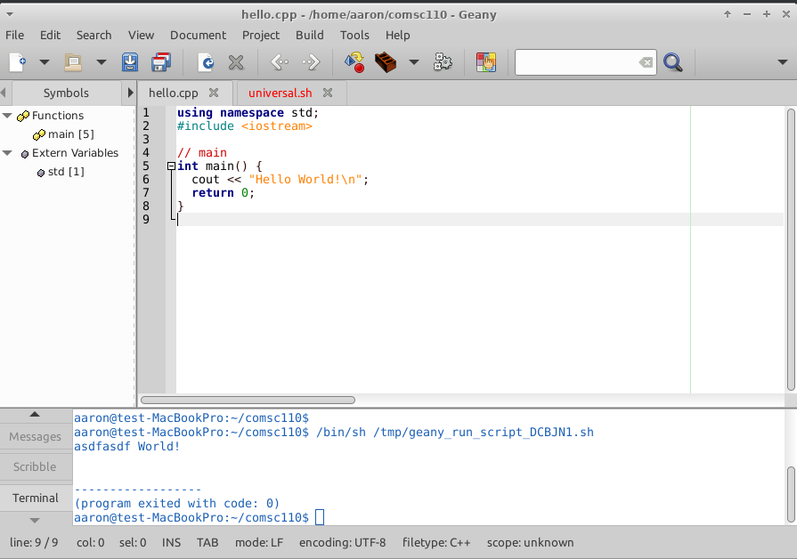

I am using g++ or gcc, the compiler that shipped with my Ubuntu install. The terminal I am using is Hyper, using a custom command prompt style I made myself:

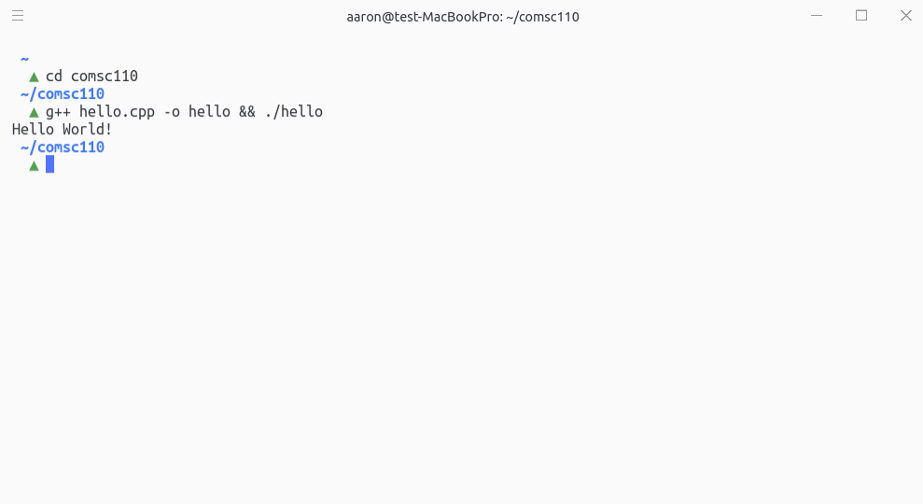

The working folder I am using is called comsc110:
