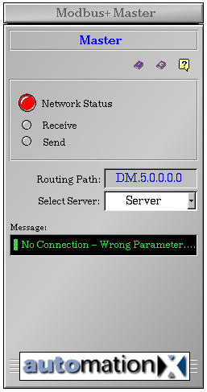
Communication
Status
Instance name
Technical documentation and troubleshooting
Routing path
Active server selection
Connection status and runtime messages

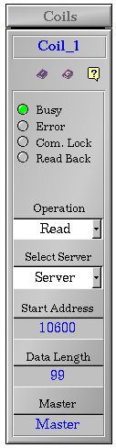
Communication status
Instance name
Technical documentation and Troubleshooting
Operation and Server selection
Addressing
Connection to Modbus_SA85 Master class

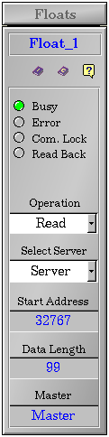
Communication status
Instance name
Technical documentation and Troubleshooting
Operation and Server selection
Addressing
Connection to Modbus_SA85 Master class

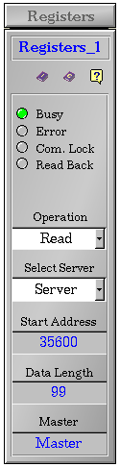
Communication status
Instance name
Technical documentation and Troubleshooting
Operation and Server selection
Addressing
Connection to Modbus_SA85 Master class

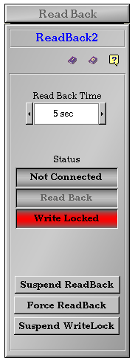
Read Back Time
Instance Name
Technical Documentation and Troubleshooting
Network, Read Back and Write Lock status
Control Buttons

