**For Teamwork Evaluation**

**Group 4**

(Aaro Tukia, Sami Narvanmaa, Tommi Laakso, Petri Jouppi)

**Repository link:**

https://github.com/aarotukia/expense-tracker-react-G4

Our version of the Car Fuel Expenses” application fulfills 30 out of the 30 maximum points.

**Requirements implemented:**

* The application fills all requirements that are related to totaling over all cars **(2 points)**

**(all the required calculations are done for all cars)**

- The application fulfills are requirement that are related to totaling over each car separately **(6 points)**

**(all the required calculations are done for all cars also by name, so that the car that you have entered most recently is always shown as counted alone.)**

* The application is divided into components in a justified way **(2 points)**

**(the application uses a subfolder which holds multiple components)**

* The components are functional components **(2 points)**

**(the components provide the functionality for the page)**

* React hooks are used **(3 points)**

**(hooks are used in the project ( for example useState is a big part of the app)**

* Context API is used to manage state **(2 points)**

**(useContext and GlobalContext is used)**

* The application functions without exceptions **(2 points)**

**(the app works without errors)**

* The application is styled with css and looks good and specific **(3 points)**

**(the application has a large css file and to us, looks good)**

* Git is used by the group **(2 points)**

**(git is used and the github repository link is:**

[**https://github.com/aarotukia/expense-tracker-react-G4**](https://github.com/aarotukia/expense-tracker-react-G4)**)**

* create_react_app is used **(1 point)**

**(create react app was utilized to initialize the project, as can be seen in the github readme.md file)**

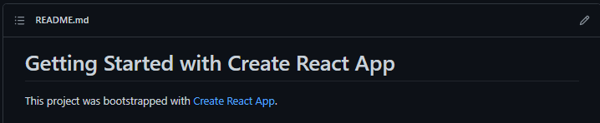

* + - Extend the application so that it can also handle nicely the expenses related to the electric cars (it should possible to calculate expenses to both electric and other cars at the same time) **(5 points)**

**(the application counts and lists the vehicle as an electric car if the fuel amount field is left empty, and calculates the fields (total cost etc.) properly)**

As you can see from the GitHub repository and commits, our project was coded by Aaro Tukia and Sami Narvanmaa, the other members of the project did not participate or contact us.   
Aaro made the framework for that program and then we worked on the code together, solving problems. At the end, we will investigate small functional problems separately. We made together the electric car specifier. Sami made the one that counts cars by name separately. Aaro added comments to the code.