Name: Aaron Harabedian
Date: 7-30-18
15.07 Picture Lab Worksheet
Directions: Make note of your responses to the following questions as you work through the activities and exercise in the lesson.
Activity 5 Questions
Question | Yes | No
- Is the method getPixels2D in the Picture.java class? |  | No
- Is the method getPixels2D in the SimplePicture.java class? | yes
- Will the following code compile?  DigitalPicture p = new DigitalPicture(); |  | no
- Assuming a no-argument constructor exists for SimplePicture, will the following code compile?  DigitalPicture p = new SimplePicture(); | Yes
- Assuming a no-argument constructor exists for Picture, will the following code compile?  DigitalPicture p = new Picture(); | Yes
- Assuming a no-argument constructor exists for Picture, will the following code compile?  SimplePicture p = new Picture(); | Yes
- Assuming a no-argument constructor exists for SimplePicture, will the following code compile?  Picture p = new SimplePicture(); |  | No

Activity 5 Exercise Results

- Describe your method for keepOnly red, blue, or green.
My keepOnlyRed method loops through each pixel in the 2D array of pixels with a nested for-each loop. It then sets the blue and green values of each pixel to 0.
- For the negate method, paste your code related to calculating and setting the values for red, blue, and green.
public void negate()
{
Pixel[][] pixels = this.getPixels2D();
for (Pixel[] rowArray : pixels)
{
for (Pixel pixelObj : rowArray)
{
pixelObj.setRed(255 - pixelObj.getRed());
pixelObj.setGreen(255 - pixelObj.getGreen());
pixelObj.setBlue(255 - pixelObj.getBlue());
}
}
}
- Paste a copy of the image that is the result of calling the grayscale.
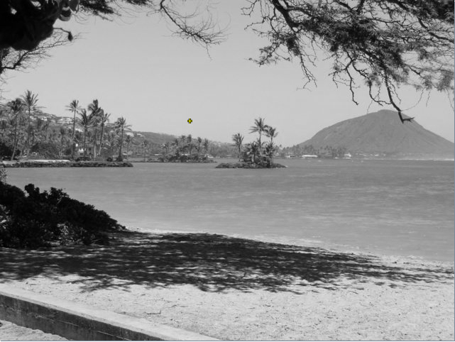
- For the method fixUnderwater, describe the algorithm you'd propose to accomplish the task.
I would check each pixel and make the blue pixels more blue and less green. The fish are a blue color so this should help to highlight the fish and negate some of the green color from the water.

Activity 6 Exercise Results
- Paste the image that is the result of calling the method mirrorVerticalRightToLeft.
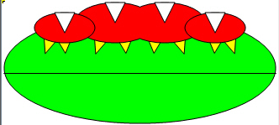
- Describe the algorithm for the method mirrorHorizontal works.
  - Gets 2D array of pixels
  - Loops through each row of pixels until it gets half way through.
  - Each loop sets the bottom row of pixels to the top row of pixels.
  - Each loop lowers the “top row” by one and raises the “bottom row” by one
  - When setting the bottom row equal to the top row, the algorithm loops through each pixel in the bottom row and sets it equal to the corresponding pixel in the top row.
- Paste the image that is the result of calling the method mirrorHorizontalBotToTop.
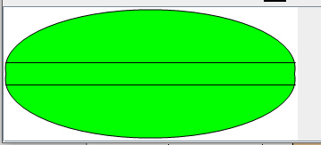

Activity 7 Questions
  - How many times would the body of this nested for loop execute? 90
for(int row = 7; row < 17; row++)
for(int col = 6; col < 15; col++)
  - How many times would the body of this nested for loop execute? 112
for(int row = 5; row <= 11; row++)
for(int col = 3; col <= 18; col++)

Activity 7 Exercise Results

- What value is displayed for count after the nested loop ends in the mirrorTemple method? 18410
- Paste the image that is the result of calling the method mirrorArms.
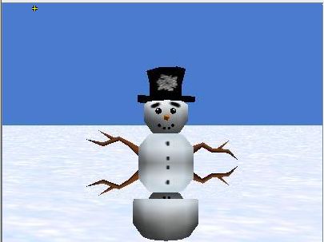
- Paste the image that is the result of calling the method mirrorGull.
