Name: Aaron H
Date: 8-3-18
16.06 Picture Lab Worksheet
Directions: Make note of your responses to the following questions as you work through the activities and exercise in the lesson.

Activity 8 Exercise Results

- Paste the image that is the result of calling the second copy method that adds parameters to allow you to copy just part of the fromPic.
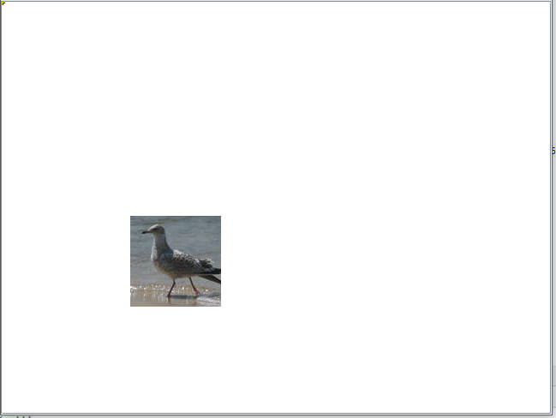
- Paste the image that is the result of calling the myCollage method.
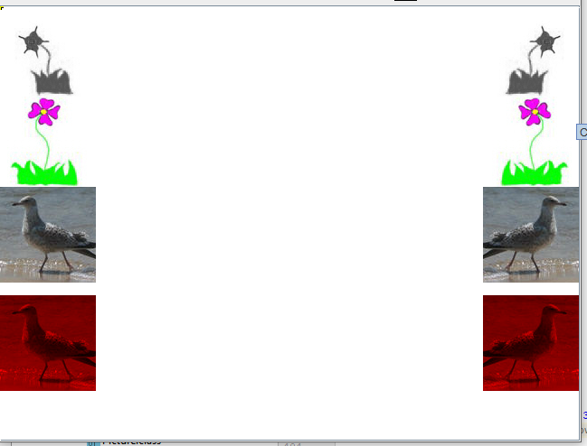
Activity 9 Exercise Results
- Paste the image that is the result of calling the edgeDetection2 method.
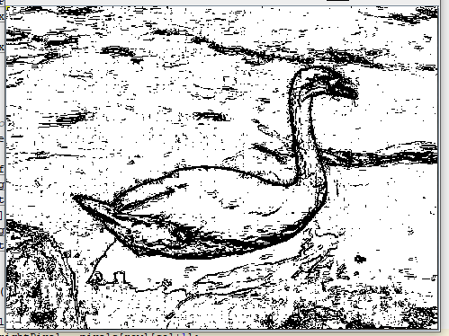
- Think about and propose another algorithm for edge detection.
You could create a similar algorithm but instead of setting each pixel to black, you could set the pixels to a grayscale color that is proportional to the color distance. This would give a grayscale image of the edge detection and give more insight into how “hard” of an edge there is instead of a black/white (edge/no edge) representation.
