Sample Problem 1: School Results Application
Class Diagram
The class diagram represents the structure of a school results application where students have subjects, and their scores are calculated for grades.
Diagram Description:
- Classes: Student, Subject, GradeCalculator
- Relationships:
  - A Student has multiple Subject entries (Aggregation).
  - GradeCalculator computes the results for a Student.
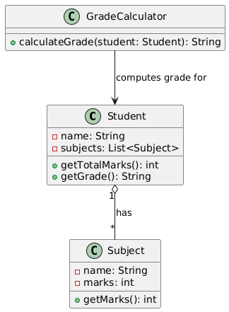
→ Class Diagram:

Object Diagram
An object diagram provides a snapshot of the Student and their Subject objects at a particular point.
Example:
- Student: John
- Subjects: Maths, Science
- Marks: 90, 85
→ Object Diagram:
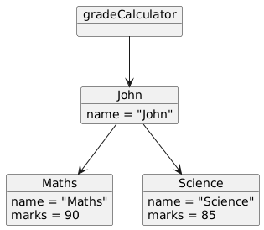

Sequence Diagram
The sequence diagram shows how objects interact to calculate grades.
Scenario: A student requests their grade based on marks in subjects.
Actors:
- Student
- GradeCalculator
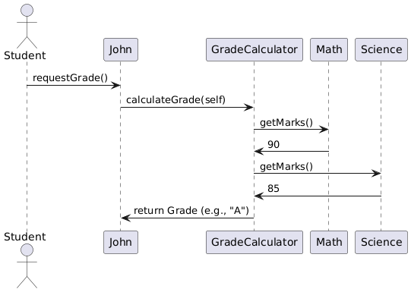
→ Sequence Diagram:

Sample Problem 2: Grocery Store Bill Generation Application
Class Diagram
The class diagram models the system where a customer buys products, and the bill is generated.
Diagram Description:
- Classes: Customer, Product, BillGenerator
- Relationships:
  - A Customer can purchase multiple Product items (Composition).
  - BillGenerator computes the total for the Customer.
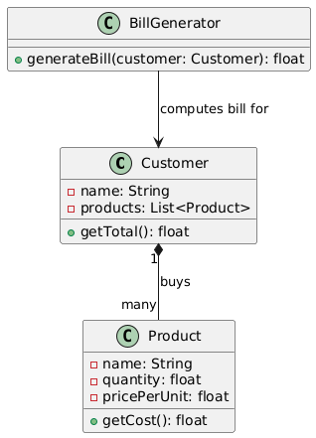
→ Class Diagram:

Object Diagram
An object diagram shows the details of a Customer and the Product objects they have purchased.
Example:
- Customer: Alice
- Products:
  - Apples (2 kg at $3 per kg)
  - Milk (1 liter at $2 per liter)
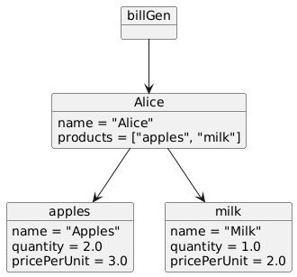
→ Object Diagram:

Sequence Diagram
The sequence diagram shows the process of bill generation for a customer.
Scenario: A customer checks out at the grocery store, and the total bill is generated.
Actors:
- Customer
- BillGenerator
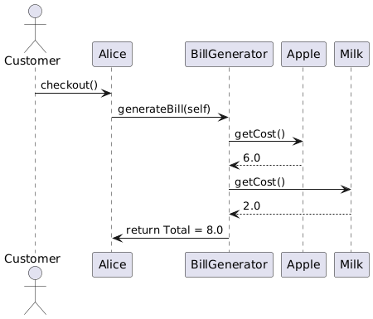
→ Sequence Diagram

