Humana AKS POC

**Azure Pipeline Configuration**

Prolifics

6 May 2020

**REVISION HISTORY**

Show New Borrower Grid

|  |  |  |  |
| --- | --- | --- | --- |
| Doc Ver. # | Date | Author(s) | Description |
| 1.0 | 05/06/2020 | Prolifics | Draft version |
|  |  |  |  |
|  |  |  |  |
|  |  |  |  |
|  |  |  |  |
|  |  |  |  |
|  |  |  |  |
|  |  |  |  |

Table of Contents

1 Introduction 4

2 Purpose & Audience 4

2.1 Purpose 4

2.2 Audience 4

3 Azure ADO Pipeline configuration 5

3.1 First step - defining Tasks/Variables/Triggers 5

3.2 Defining Agent pool 7

3.3 Select source to checkout application code 7

3.4 Agent specification 8

3.5 Task to pull docker build conductor image from artifactory 8

3.6 Task to build ACE commonLibs bar 9

3.7 Task to build ACE LETTER_TRIGGER bar 10

3.8 Task to build ACE AGGR_AL bar 11

3.9 Task to build ACE AGGR_ME2883 bar 12

3.10 Task to build ACE LETTER_PROCESS bar 13

3.11 Create custom ACE docker image to add barfiles 14

3.12 Task to install helm 15

3.13 helm update to patch custom ACE image 16

4 Pipeline build run 16

4.1 Screen showing Pipeline run 16

4.2 Steps executed during Pipeline run 17

# Introduction

This document provides details to setup Azure CI/CD pipeline for deploying ACE applications.

# Purpose & Audience

## Purpose

The purpose of this document is to provide pipeline configuration details to deploy ACE applications to AKS.

## Audience

This document is intended for operations team who manage CI/CD of application deployment.

# Azure ADO Pipeline configuration

## First step - defining Tasks/Variables/Triggers

Tasks

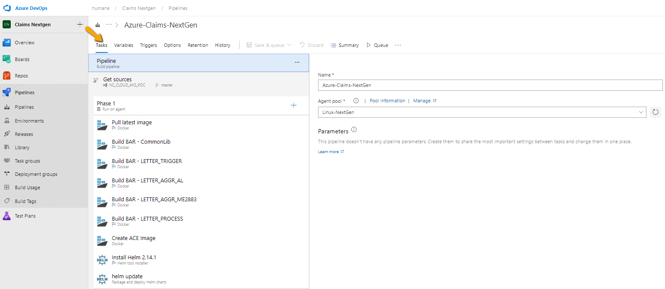

Variables

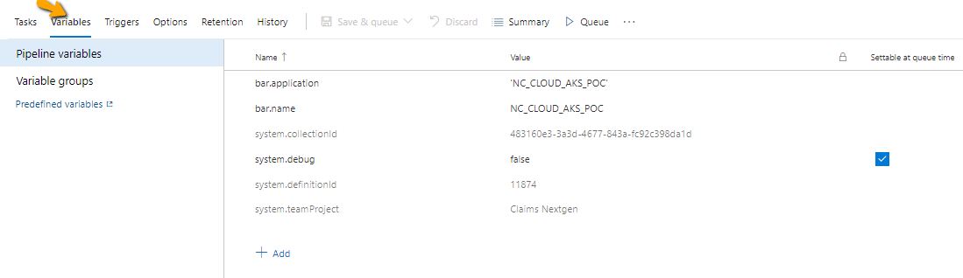

Triggers

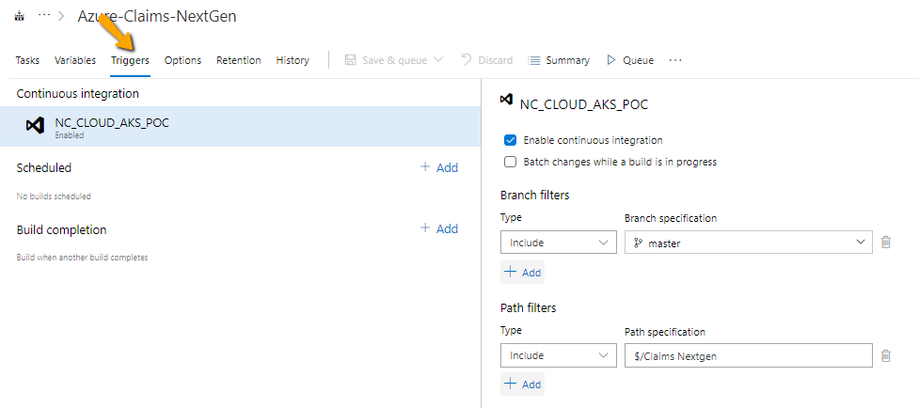

Options

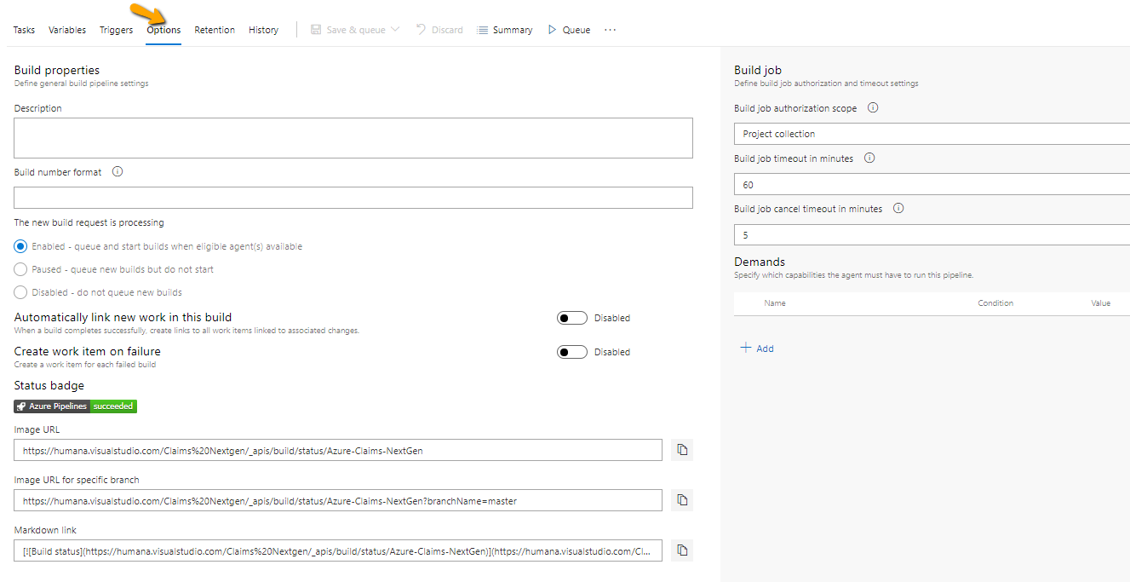

## Defining Agent pool

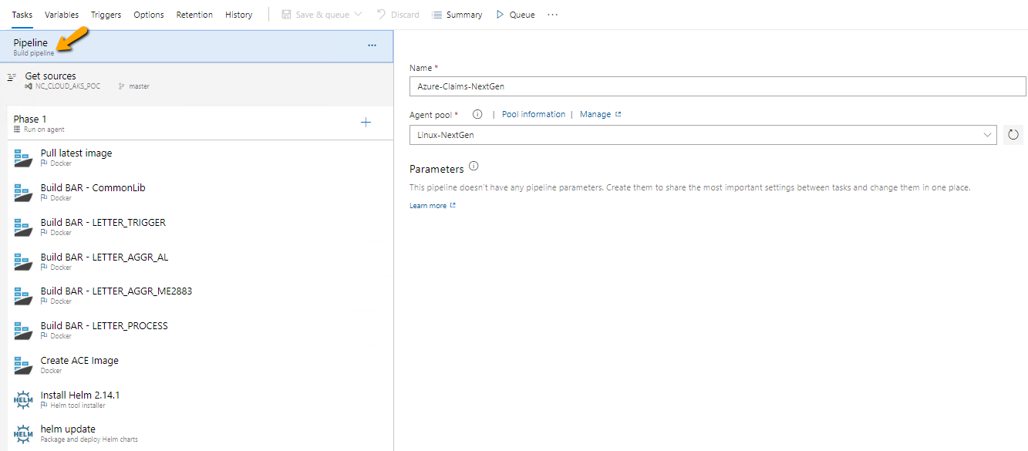

## Select source to checkout application code

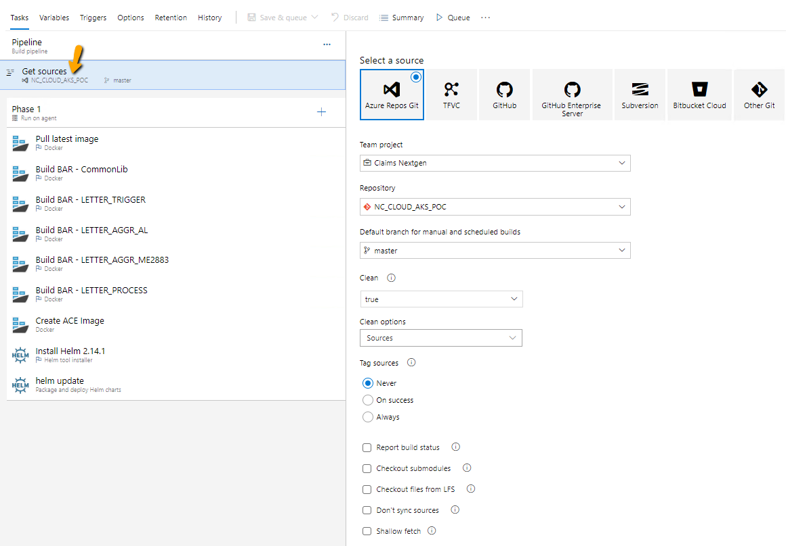

## Agent specification

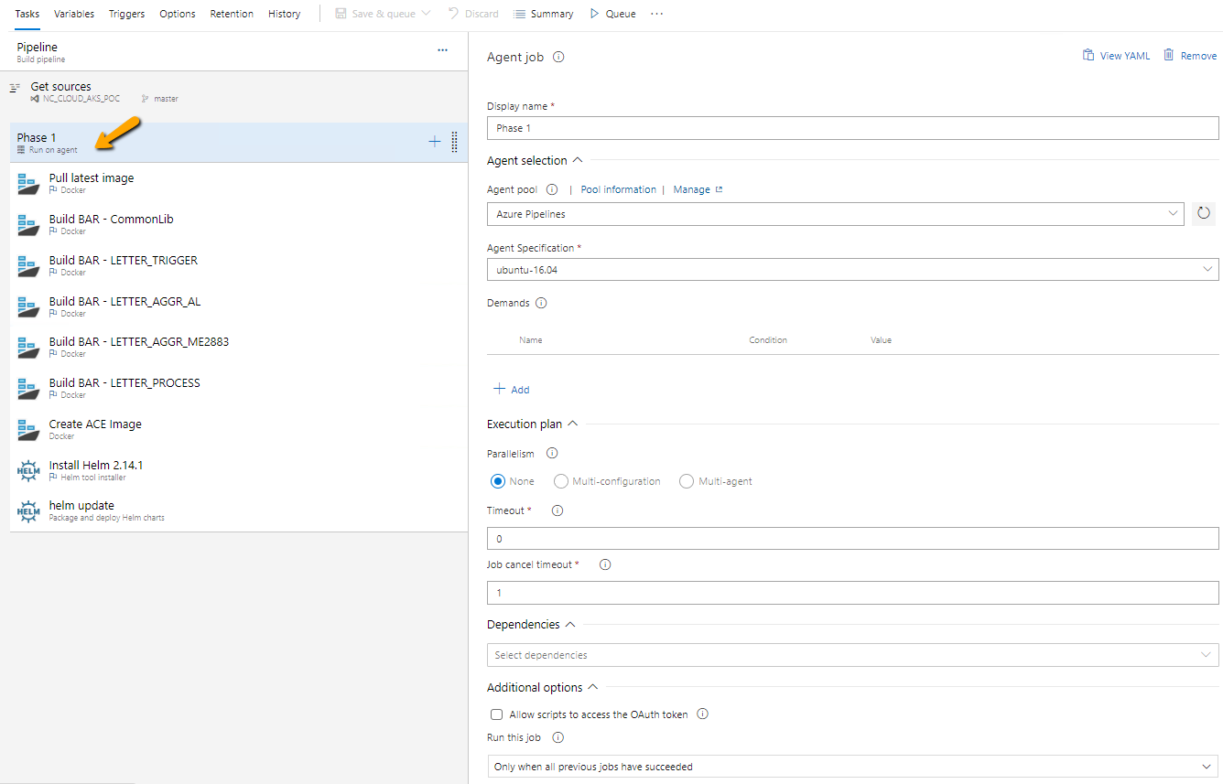

## Task to pull docker build conductor image from artifactory

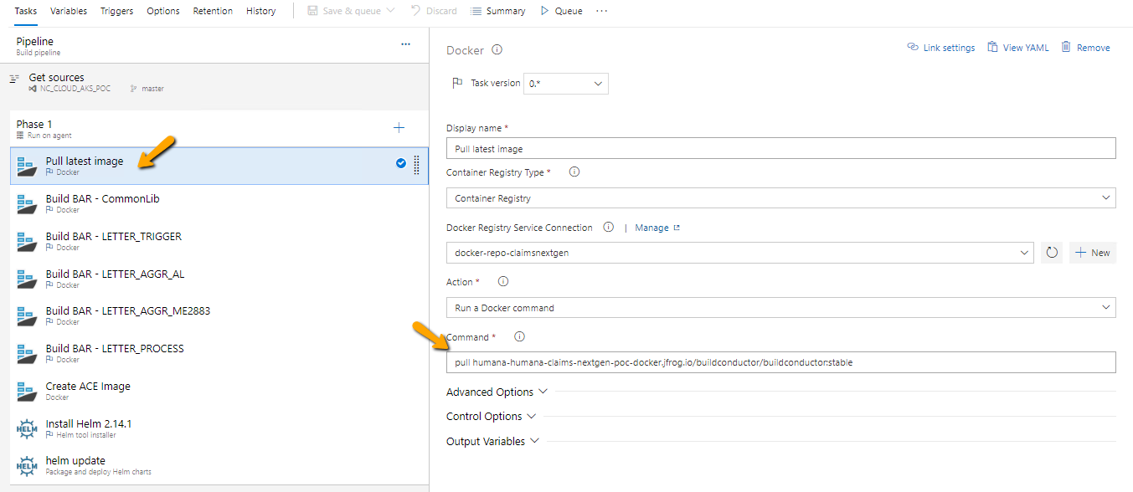

## Task to build ACE commonLibs bar

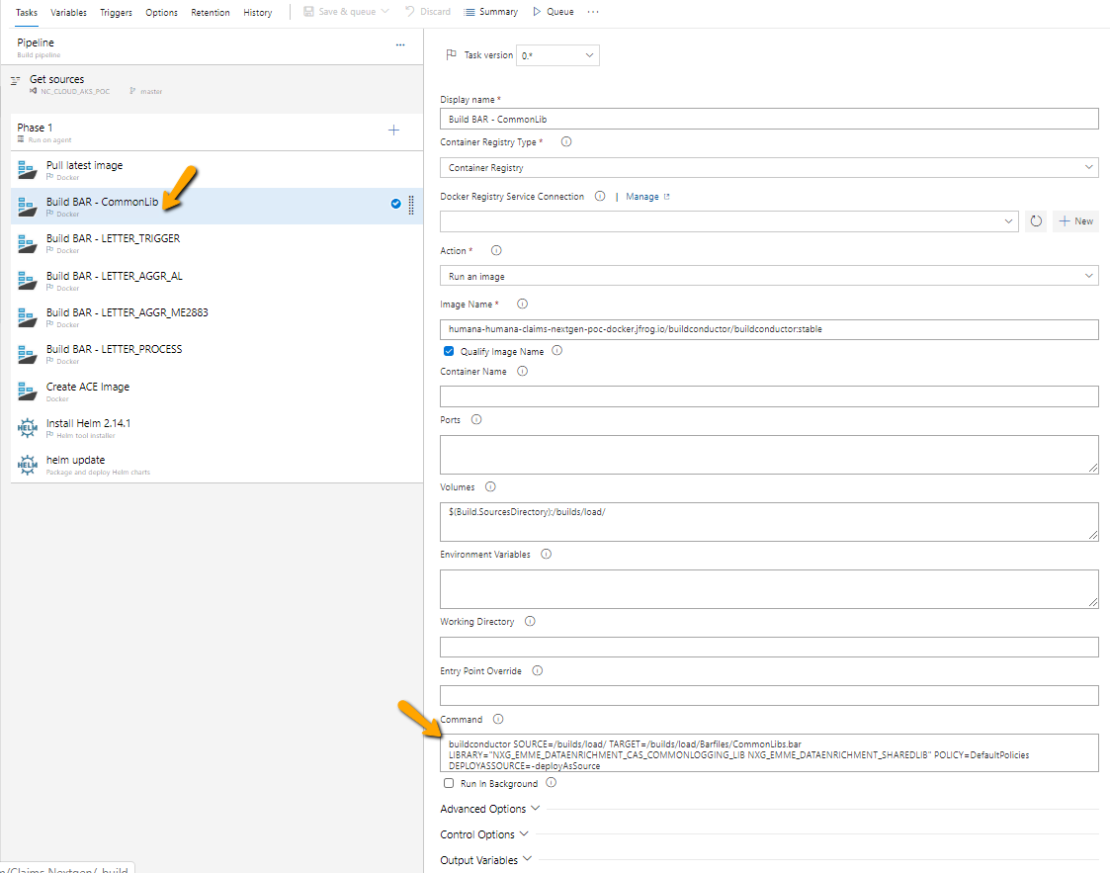

## Task to build ACE LETTER_TRIGGER bar

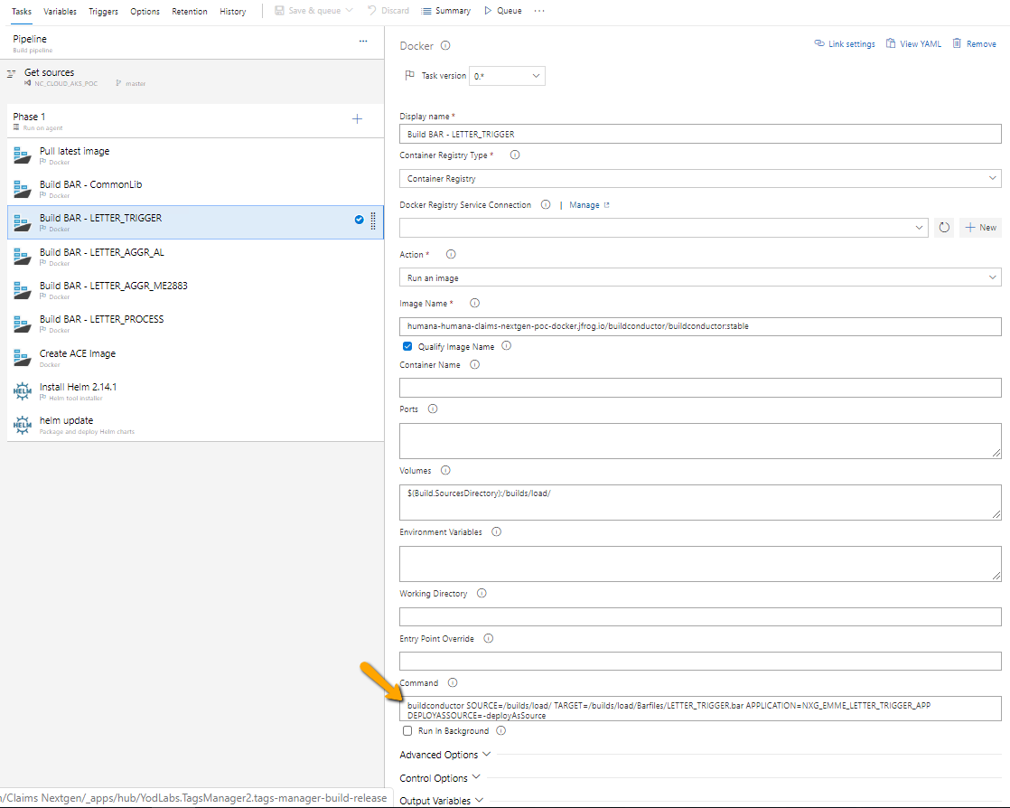

## Task to build ACE AGGR_AL bar

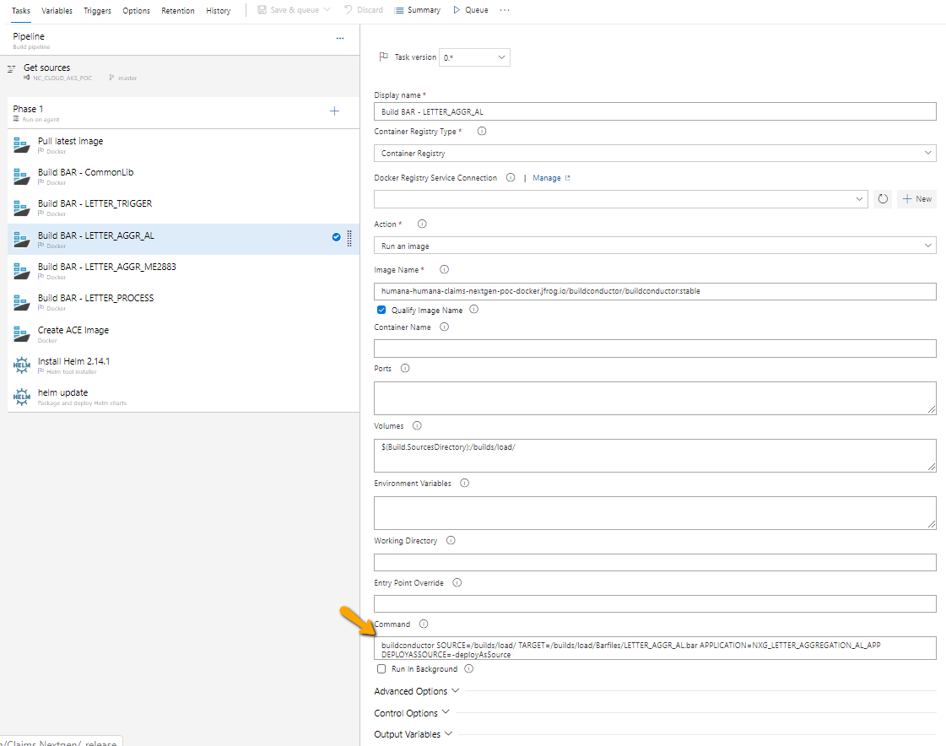

## Task to build ACE AGGR_ME2883 bar

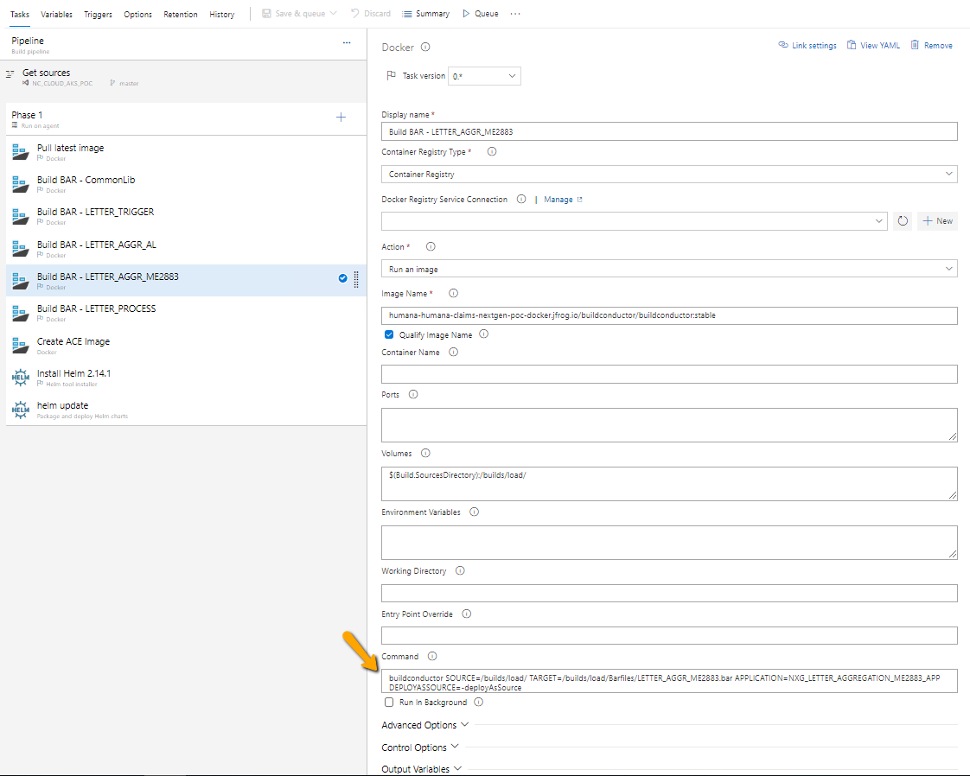

## Task to build ACE LETTER_PROCESS bar

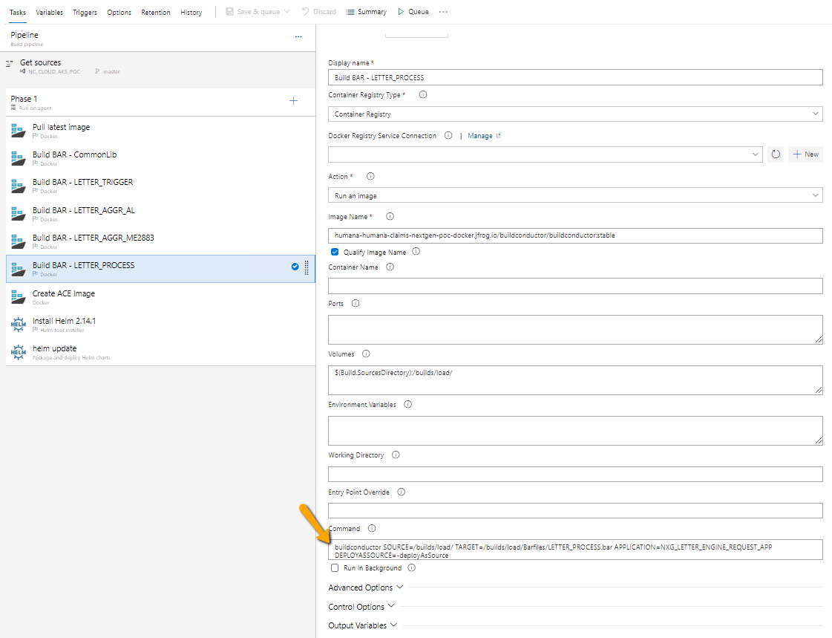

## Create custom ACE docker image to add barfiles

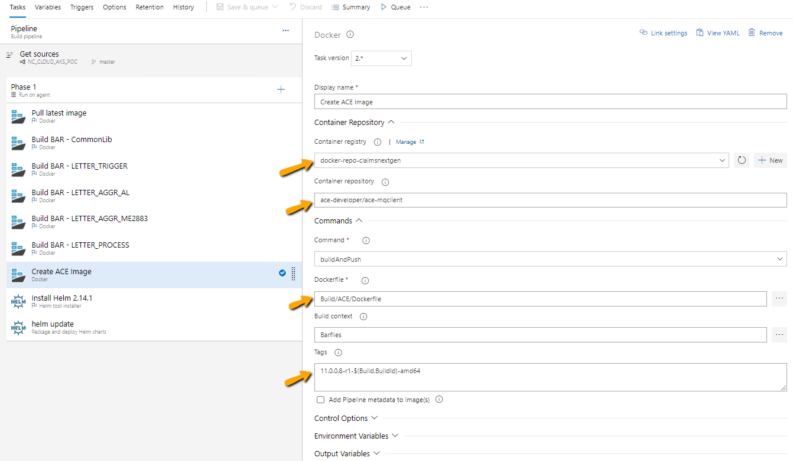

## Task to install helm

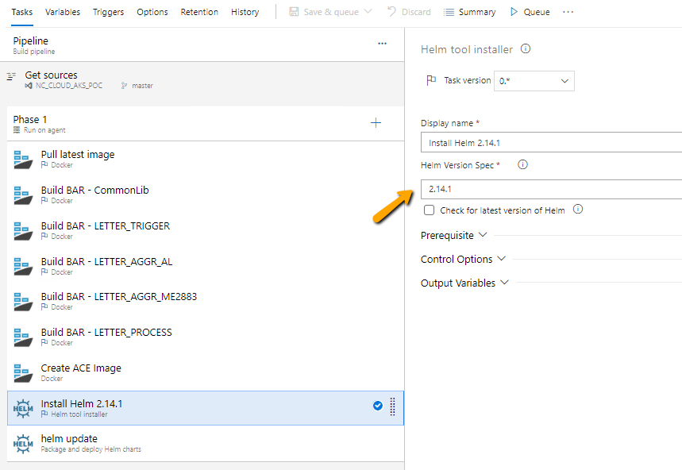

## helm update to patch custom ACE image

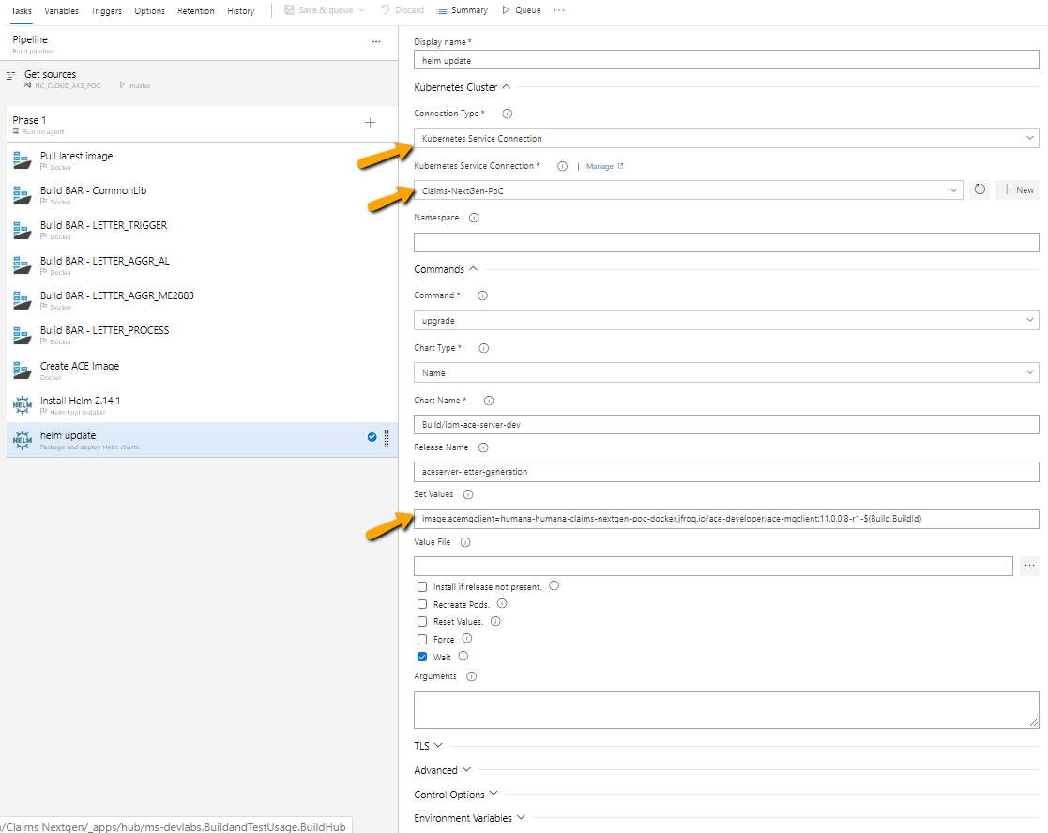

# Pipeline build run

## List of pipelines

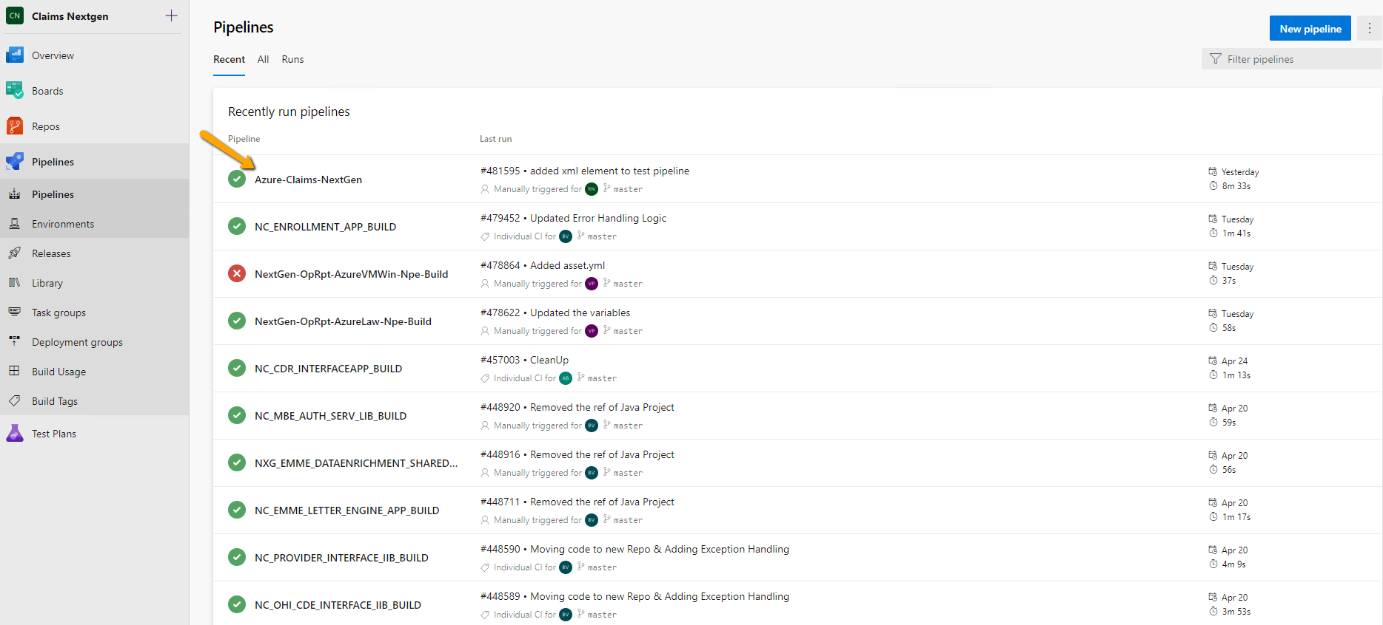

## Start the Pipeline run

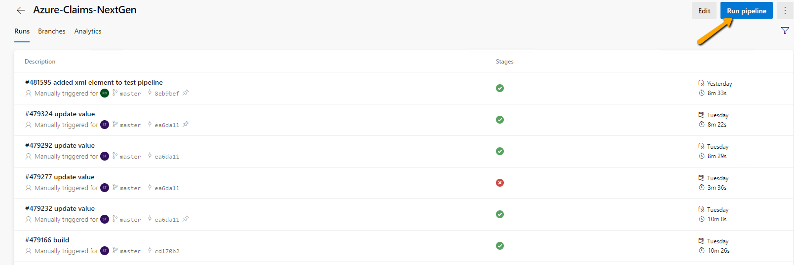

## Screen showing Pipeline run

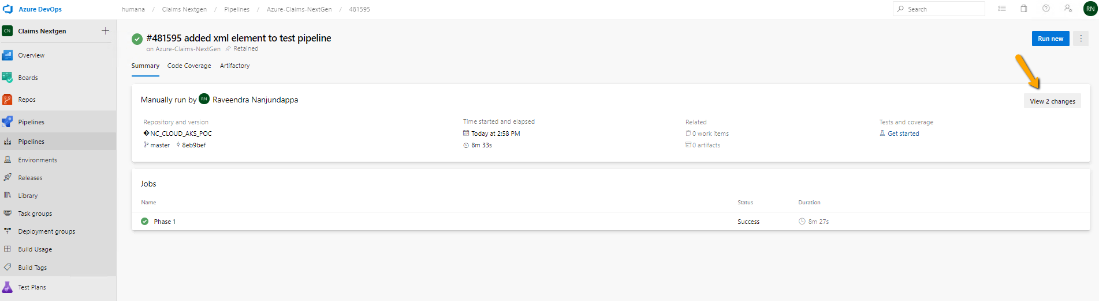

## Steps executed during Pipeline run

