Name: Aarshi Italiya  
Semester:7 Division:A

Assignment:1

Roll no:27

Github assignment link: <https://github.com/aarshiitaliya/27_AarshiItaliya_701_A2.git>

1)  
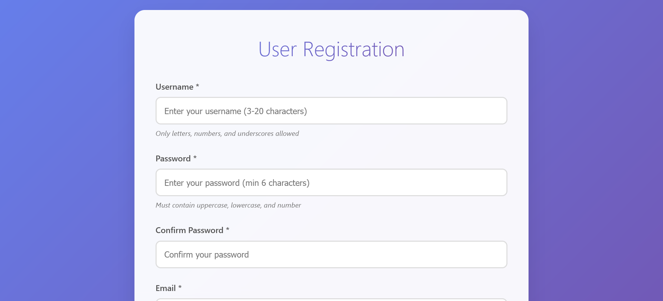

2)

3)

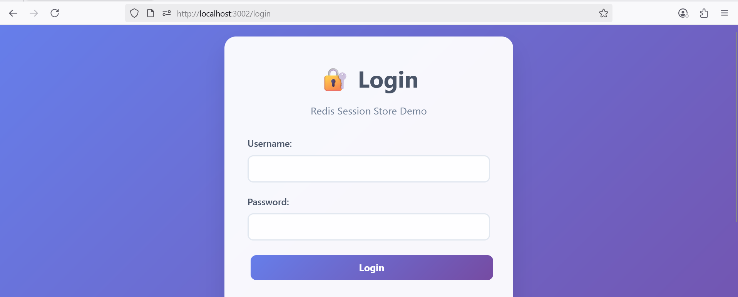

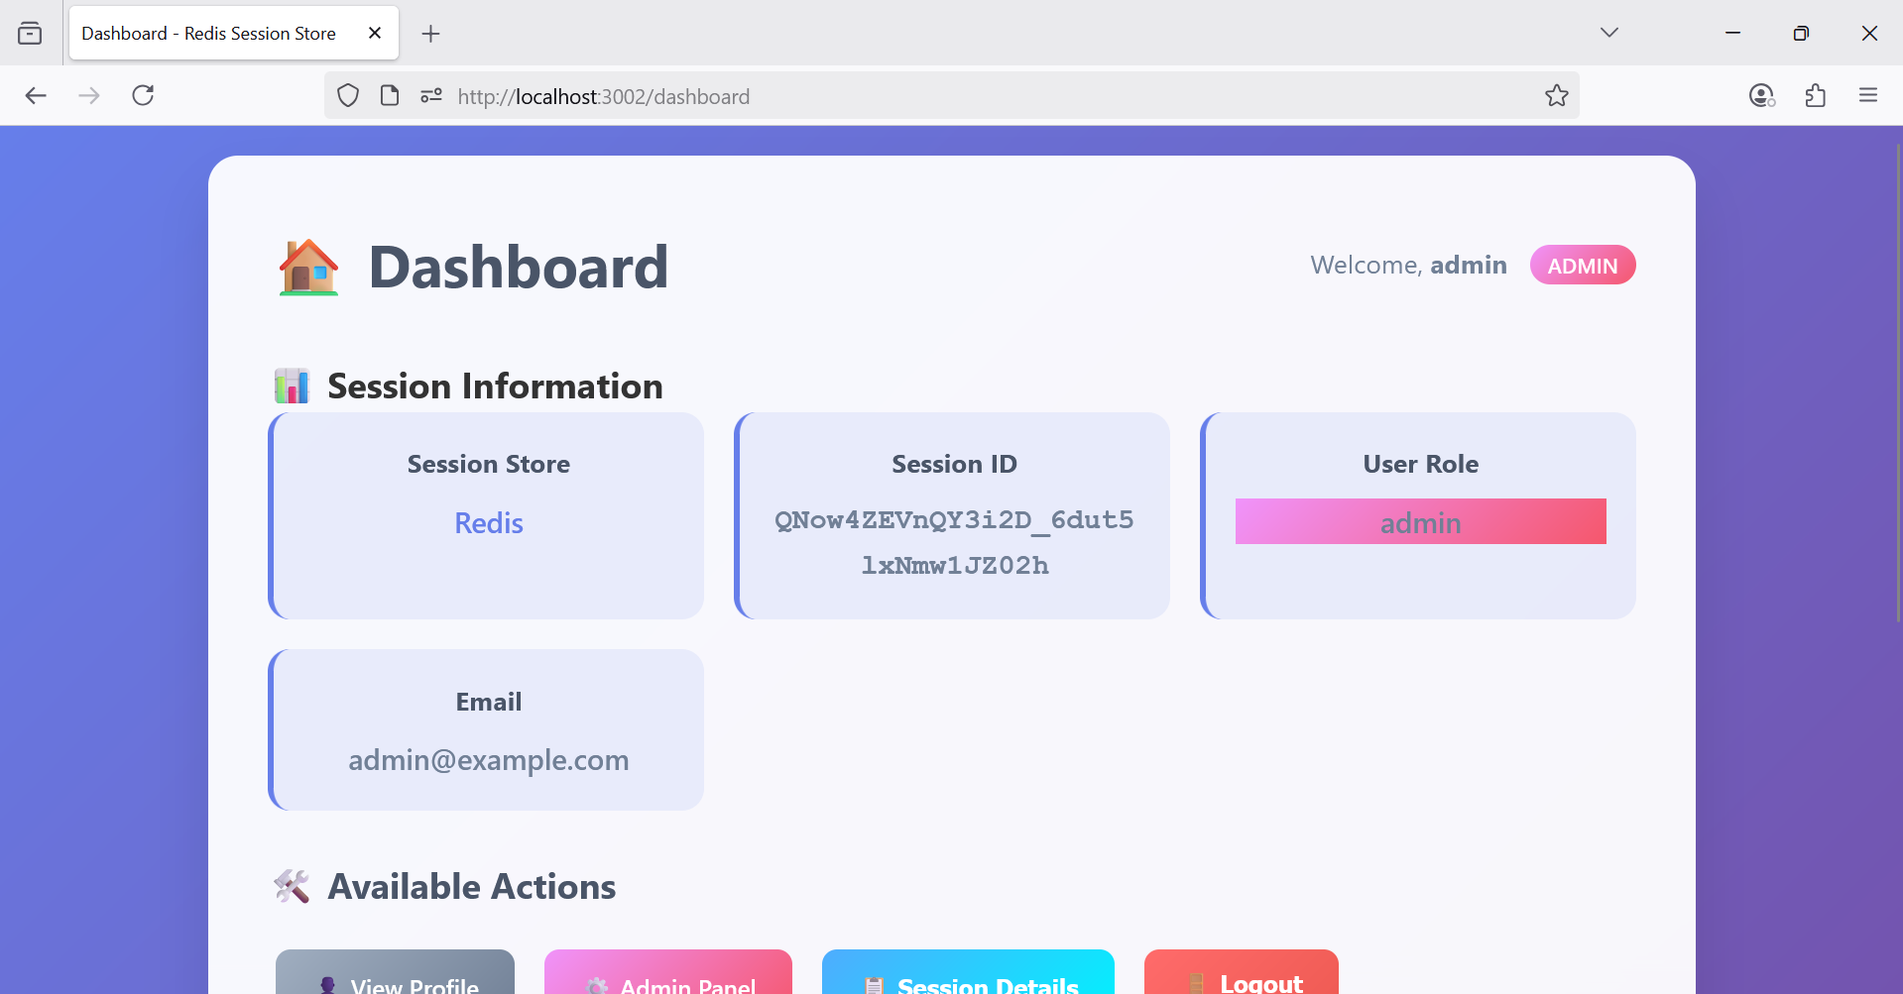

**4)  
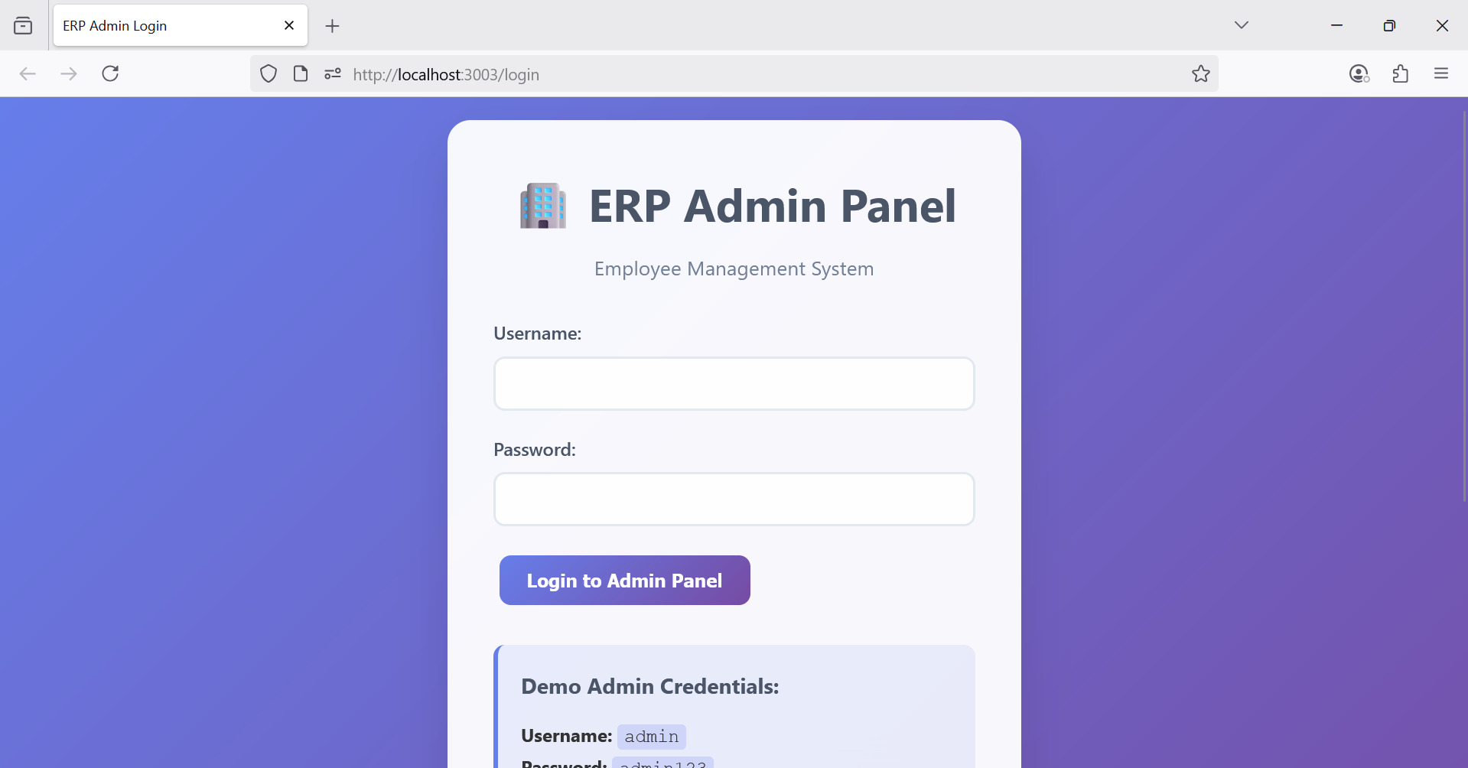**

**5)**

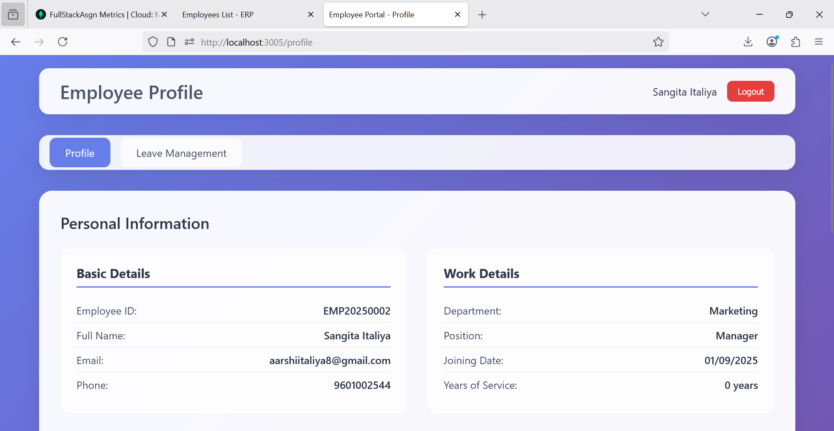

**6)**

