**Are women empowered to be joining the labour force?**

Addressing the importance of women in the labour force of a country



Course: EPA1315 – Data Analytics and Visualization

Masters Program: Engineering and Policy Analysis

University: Technical University of Delft

Authors: Aarthi Meenakshi Sundaram (4995813), Madhumita Naik (5043646)

Code: <https://github.com/aarsundaram/dav_final/blob/master/DavFinalProjMD.Rmd>

**Summary**

Gender equality has come a long way over the past few centuries. With the inclusion of gender equality as one of the sustainable development goals, more countries are paying attention to this goal. However, despite several international and national policies implemented to bolster gender equality, women are still a long way away from achieving complete equality in all areas – for example, political participation, labour force participation, property rights, etc.

In this report, we consider the matter of the working woman – why is it important that more woman join the work force of a country, and what are the factors that influence a woman to find profitable employment? It would be apt to include the inspiration behind this report - a quote by Annabel Crabb from her book “The Wife Drought”, at this point:

*“The obligation for working mothers is a precise one: the feeling that one ought to work as if one did not have children, while raising one's children as if one did not have a job.”*

Since we are considering the country-wise participation of women in the economic arena, the report focuses on the interaction of the female labour force participation rate (FLFPR) with Gross Domestic Product (GDP), among other indicators. Childbirth and child-rearing are important determining factor for a woman to work, hence fertility is also considered. The level of education will also be considered (since common sense dictates that an educated woman is more likely to take up an earning role) – this will be considered through gross enrolment ratio (GER) in secondary and tertiary schools. We will also be considering the proportion of seats held by women in the parliament – as a higher number of women in a position to influence policy implies that there would be more policies to support the inclusion of women in the workforce.

We have carried out the above analysis dividing countries over national income (high-income vs low-income). This division is required as high-income countries are mostly western, while low-income countries are developing countries from the east. This division highlights the cultural and economic differences that have developed in these countries throughout history. For example, the suffrage movement started in western countries in the late-19th century, while low-income countries are going through slow but steady cultural changes moving towards gender equality starting from just a few decades ago.

With the help of the collider model, we have tested the hypothesis that the labour force participation rate for women over the age of 15 is determined by GDP, fertility, GER_Secondary, GER_Tertiary, and proportion of women holding parliamentary seats.

The collider used

1. For high-income countries - 4 betas and 4 sigma’s
2. For low-income countries – 5 betas and 4 sigma’s

which had a prior of a normal distribution between 0 and 0.01 for the different betas, and a uniform distribution between 0.01 and 0.99 for the variances, which when squared gave the sigma's.

From this model it became clear that correlation between different variables exists, but not a linear relation. The model is only designed to identify correlations between different variables, but this also means that a definitive conclusion cannot be reached on the exact influencing factors for FLFPS. Further research could focus on developing a model to check possible second-degree correlation between the aforementioned variables.

# **1. Introduction**

According to data from the World Bank, FLFPR over the world has declined over the past two decades:

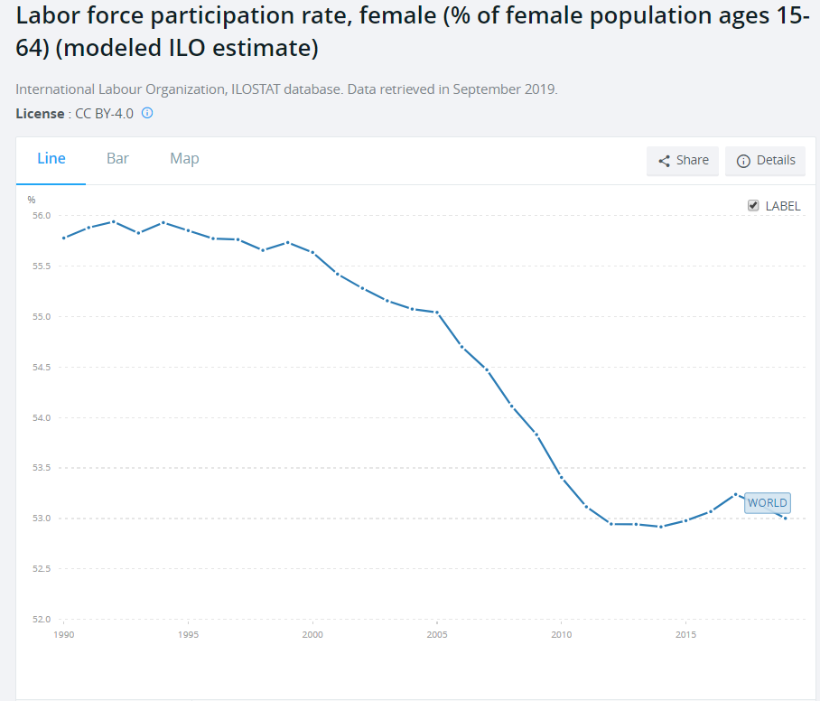

*Fig. 1. Female Labor Force Participation Rate over time  
Picture Credit:* [*https://data.worldbank.org/indicator/sl.tlf.acti.fe.zs?end=2019&start=1990&view=chart*](https://data.worldbank.org/indicator/sl.tlf.acti.fe.zs?end=2019&start=1990&view=chart)

However, carrying out our own analysis over high-income and low-income countries, this is how the change in FLFPR differs between the two (with respect to GDP):

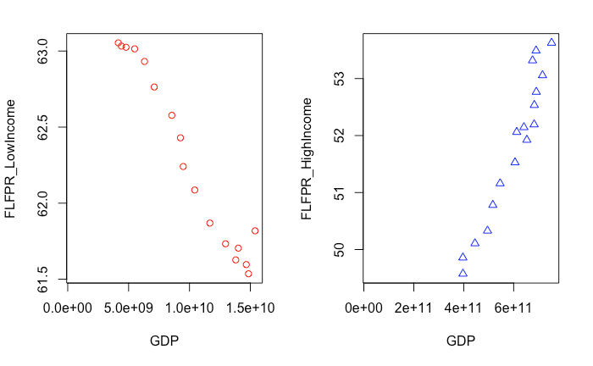  
*Fig.2 FLFPR vs GDP in low-income and high-income countries*

As per the outline for classification of countries by the UN, countries are classified by their level of development, into high-income, upper-middle income, lower-middle income and low-income on the basis of per capita gross national income (GNI). Low income countries are those with GNI < $1,035 and high-income countries are those with GNI > $12,615.

This evidence merits an analysis into factors that govern the change of FLFPR in a different manner in high-income vs low-income countries. The above graphic shows that analysis of FLFPR on a global scale hides nuances of governing factors over countries, and paints an incorrect picture that fewer women all over the world are joining the workforce.

To further this question, we used data from UN Gender Stats and World Bank Open Data sources. The World Bank has freely available data over a wide range of indicators. The choice of different indicators that influence FLFPR has been discussed in a later chapter.

The research question guiding this paper is

“*What factors influence the participation of women in the labour force of a country?”*

The report follows the CRISP-DM process. The report starts with a Business Understanding section in chapter 2. Following this are the Data Collection, Data Exploration, and Data Quality sections in chapter 3,4 and 5 respectively. Chapter 6 is devoted to Data Exploration, followed by Data Preparation in chapter 7. The rest of the chapters deal with the model created – Test Design (Chapter 8), Model Options (Chapter 9), Parameter Setting (Chapter 10) and Final Model Description (Chapter 11). Chapter 12 outlines an overall assessment of the report.

# **2. Business Understanding**

As per the International Labour Organization, the labour force participation rate is calculated as the proportion of country’s working-age population that engages actively in the labour market, either by working or by looking for work. This provides an indicator to the size of the labour supply available to engage in economic activities such as production of goods and services.

The breakdown of this indicator by age and sex gives a more detailed profile of the distribution of the labour force of a country.

The female labour force participation rate, hence, describes the proportion of a country’s working-age population, that is female, and above the age of 15, that is actively engaged in the labour market.

## **2.1 Issues**

Until now, gender statistics have been region-neutral – they show LFPR (Labour Force Participation Rate), wage gaps, etc. country-wise or region-wise. There is little attention paid to causal relationships behind these trends.

If there is a huge difference in the manner in which fertility rates and labor force participation rates are related in the Sub-Saharan Africa, little effort is spent in understanding the reason for the same. Exploring causal relationships, if any, into how women belonging to different regions are responding to country-wide policies that affect economic growth, maternity leave, etc. can offer insights on how to improve labor force participation rates by region.

## **2.2 Limitations**

Labour force data is usually obtained from population censuses that are based on a limited set of questions. The scope is limited and offers little opportunity for probing. Hence this data might not be consistent with surveys specific to labour force data. Consequently, this data will vary over countries depending on the number and type of questions asked in surveys that generate the data. Many times, this data also leaves out people that are employed in small businesses or in the informal economy.

There are also differences between countries on what constitutes the labour force – for example, inclusion or exclusion of military conscripts, workers that are part of the family, and unemployed people who are looking for work.

Even the limits of age for the working force differ between countries – where some opt a non-standard upper age limit for employed people. As an extension of this, there will always be a certain portion of the population beyond the upper age limit that is still working too.

## **2.3 Trends**

Below is the analysis of the change of the various indicators used with respect to FLFPR. The time frame chosen is 2000-present, because this time frame has the most consistent set of data for all the concerned variables, over 110 countries (84 high-income countries, and 36 low-income countries). This also overlaps with the worldwide drop of FLFPR.

### **a. FLFPR over the last two decades**

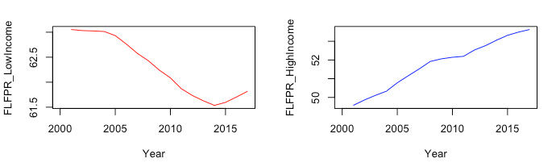  
 *Fig.3 FLFPR changes over time in low-income and high-income countries*

Over the last two decades, FLFPR has consistently dropped in low income countries, while it has increased consistently in high income countries.

### **b. FLFPR vs Gross Domestic Product**

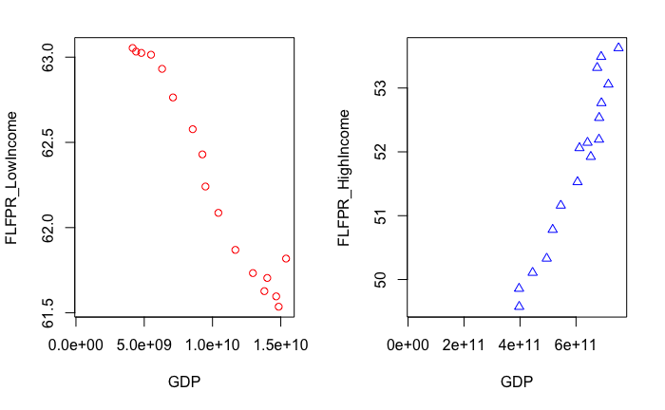

*Fig. 4 FLFPR vs GDP in low-income and high-income countries*

Mapping the change of FLFPR with the average GDP of low-income and high-income countries shows that

1. while GDP has increased in low-income countries, FLFPR has decreased
2. while GDP has increased in high-income countries, FLFPR has increased

### **c. FLFPR vs Female Seat Proportion in the National Government**

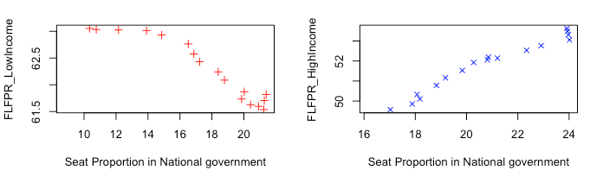

*Fig.5 FLFPR vs Female Seat Proportion in the National Government for low-income and high-income countries*

From the above graphic, it is evident that while the number of seats allotted in the national government has increased in both low-income and high-income countries, this rise has been accompanied by a drop in FLFPR in low-income countries but an increase in FLFPR for high-income countries.

### **d. FLFPR vs Gross Enrolment Ratio in Secondary Schools**

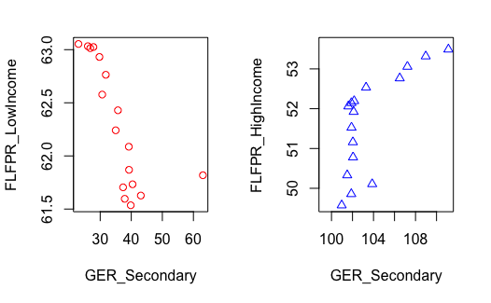

*Fig.6 FLFPR vs Gross Enrolment Ratio in Secondary schools for low-income and high-income countries*

The above graphic highlights the below:

1. While Gross Enrolment Ratio in secondary schools has increased in low-income countries, FLFPR has decreased in the same time frame
2. While Gross Enrolment Ratio in secondary schools has increased in high-income countries, FLFPR has decreased in the same time frame

### **e. FLFPR vs GER_Tertiary**

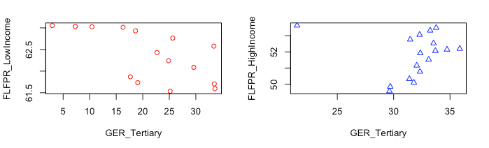

*Fig.7 FLFPR vs Gross Enrolment Ratio in Tertiary Schools for low-income and high-income countries*

The above graphic highlights the below:

1. While Gross Enrolment Ratio in tertiary schools has increased in low-income countries, FLFPR has decreased in the same time frame
2. While Gross Enrolment Ratio in tertiary schools has increased in high-income countries, FLFPR has decreased in the same time frame

Overall, it is evident that while all the contributing factors to labour force participation rate have increased (i.e GDP, GER_Tertiary, GER_Secondary, Female Seat Proportion in National Government), FLFPR has consistently decreased in low-income countries, and consistently increased in high-income countries.

## **2.4 Relevance for Organization for Economic Co-operation and Development (OECD)**

This subject is of importance to the strategic counsellor of the OECD as direct consequence of Sustainability Development Goal #5. SDG #5 aims to achieve gender equality and empower all women and girls. This is in direct consequence to the above goal.

It is especially relevant to address the topic of gender equality over countries with differing incomes, as we can see drastically different trends between low-income and high-income countries in the change of FLFPR over the last two decades.

This also counts as a step closer to SDG #8 – full and productive employment and decent work for all, SDG #1 – ending poverty, SDG #2 – food security and SDG #10 – reducing inequalities.

According to UN Women, increasing employment rates of women in just the OECD countries to match that of Sweden, would increase the worldwide GDP by over 6 trillion USD, which is directly relevant to the core interest of OECD – economic development.

If we can identify the contributing factors to the above trends, the OECD can better target the root cause of these patterns and improve gender equality with the FLFPR indicator.

# **3. Data Collection**

For the research behind this project, open data was collected from UN Gender Stats and the World Bank open database.

# **Citations:**

International Labour Organization, Labour Force Participation Rate  
<https://www.ilo.org/ilostat-files/Documents/description_LFPR_EN.pdf>

UN Women, Facts and Figures: Economic Empowerment  
<https://www.unwomen.org/en/what-we-do/economic-empowerment/facts-and-figures#notes>

United Nations, World Economic Situation and Prospects (2014), Country Classification, p.144  
<https://www.un.org/en/development/desa/policy/wesp/wesp_current/2014wesp_country_classification.pdf>