Latvian boards are single side mounted components
code IK 4R7 resistor code IK

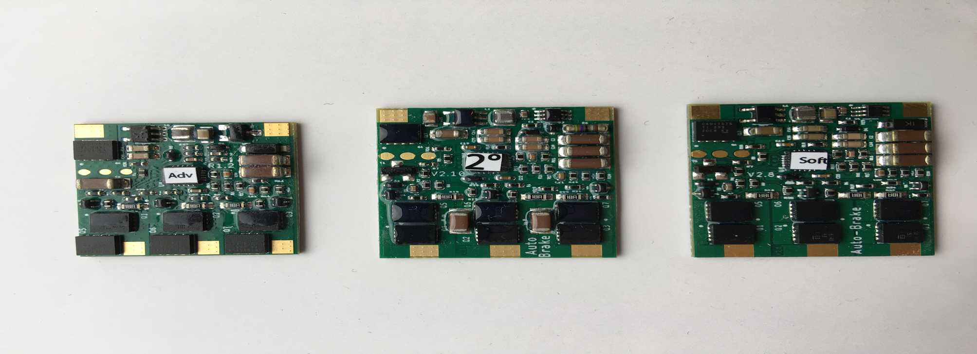
Raivis Edition V1.2 A Latvian Slot Production V2.10 Latvian Slot Production V2.8
Raivis Edition looks like V2.8 without auto brake bits.

Ruilon SMAJ TVS diode code UV

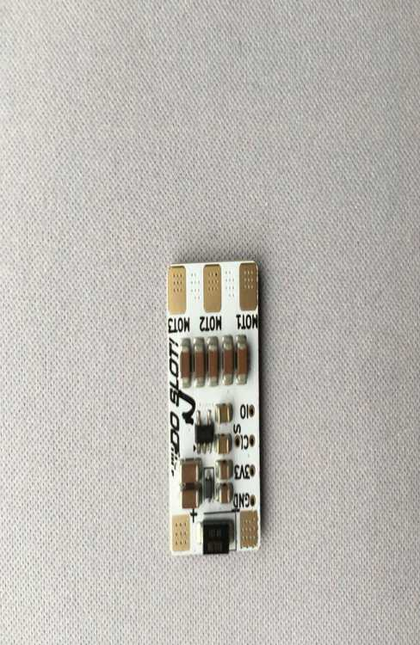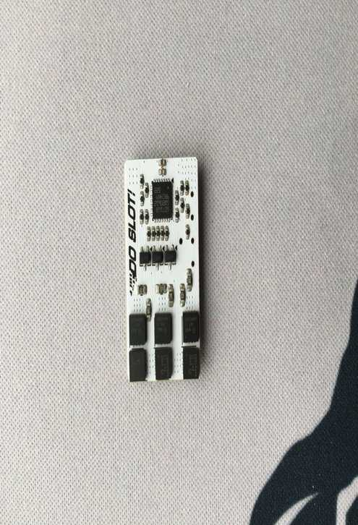

board | Remora1 | Raivis Edition A | Latvian V2.10 | Latvian V2.8 | Do Slot
weight g | 1.45 | 1.90 | 2.35 | 2.31 | 2.00
pcb dimensions mm, area mm² | 23.21 ×16.39×0.79  380 | 23.33×18.74×1.01  437 | 26.33×20.19×1.04  532 | 26.29×20.12×1.03  529 | 24.72×15.95×1.01  394
overall thickness mm | 3.09 | 2.99 | 2.87 | 2.95 | 3.92
smallest pad sizes mm | 3.4×1.8 | 2.2×1.8 | 2×2 | 2.5×2 | 3×3
reverse polarity protection | control & power circuits | control & power circuits | control & power circuits | control & power circuits | control only
auto brake | no | no | yes | yes | no
output mosfets  (note thin lead-wire 24AWG is 0.84mΩ/cm) | L0302A (1.2mΩ)  Remora1.2 | CSD17575 (2.5mΩ)  CSD25404 (40mΩ to 5.5mΩ) | CSD16340 (4.2mΩ)  CSD25404 (40mΩ to 5.5mΩ) | CSD16340(4.2mΩ)  CSD25404 (40mΩ to 5.5mΩ) | CSD16340 (6.1mΩ to 5mΩ)  CSD25404 (40mΩ to 5.5mΩ)
reverse polarity mosfet | 1R603 (1.2mΩ) | CSD17575 (2.5mΩ) | CSD17575 (2.5mΩ) | CSD17575 (2.5mΩ) | na
start V | 1.350 | 2.348 | 2.193 | 1.978 | 1.957
stop V | 1.499 | 2.02 | 1.95 | 1.657 | 1.955
F at 10.00V 3000Kv motor  see graph | T=1, 3.0303kHz  T=11, 3.1250kHz  T=18, 3.2258kHz  T=25, 3.3670kHz  T=31, 3.4722kHz | 3.4602kHz | 3.4247kHz | 3.1056kHz | 3.4130kHz
no load current mA  see graph | T=1, 220  T=11, 241  T=18, 278  T=25, 345  T=31, 421 | 457 | 430 | 284 | 380
DC bus discharge time with 12R, µs | 800 | 640 | 810 | 660 | 1140
calc capacitance µF | 67 | 53 | 68 | 55 | 95
cap size × nos. | 0805 × 10 | 1207 × 3 (fat 1206) | 1206 × 5 | 1207 × 3 (fat 1206) | 1206 × 7

Remora with unloaded 3000Kv motor, rotation frequency & current vs timing

Start table and waveforms
3000Kv motor with flywheel

board | Remora1 | Raivis Edition A | Latvian V2.10 | Latvian V2.8 | Do Slot
initial delay ms | 6 | 23 | 23 | 23 | 5
proper rotation at ms | 30 | 75 | 68 | 68 | would not start
peak current | 14 | 20 | 20 | 20 | 11  about 14A if start at very low voltage initially

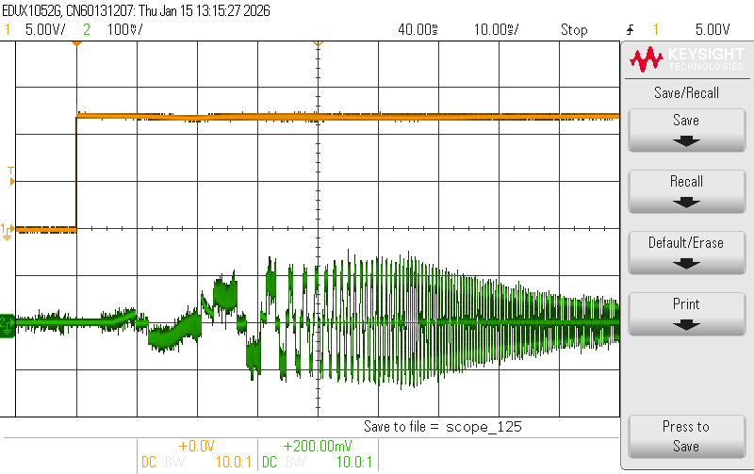
Remora with default settings, yellow = supply 5V/div, green = motor current 10A/div, time base 10ms/div.
Initial delay ≈ 6ms, proper rotation ≈ 30ms, peak current ≈ 14A,

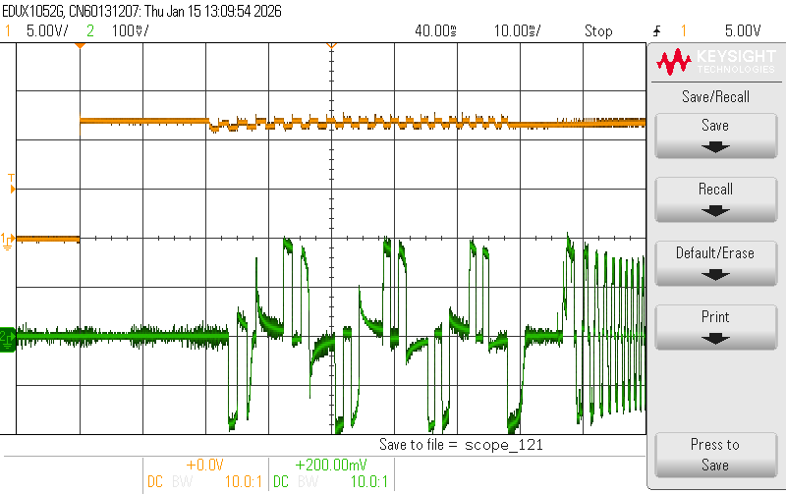
Raivis Edition A, yellow = supply 5V/div, green = motor current 10A/div, time base 10ms/div.
Initial delay ≈ 23ms, proper rotation ≈ 75ms, peak current ≈ 20A,
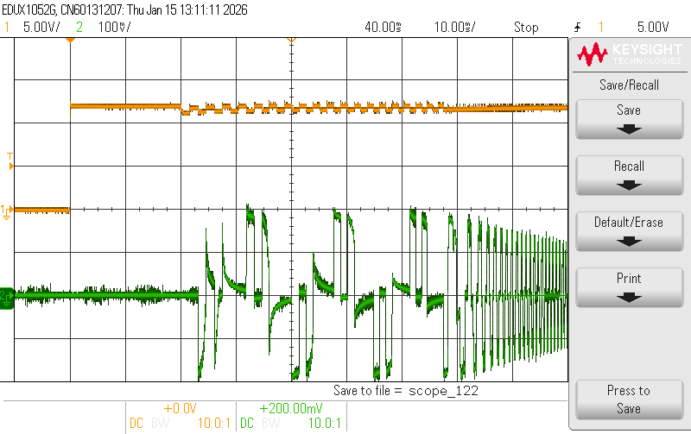
Latvian V2.10, yellow = supply 5V/div, green = motor current 10A/div, time base 10ms/div.
Initial delay ≈ 23ms, proper rotation ≈ 68ms, peak current ≈ 20A,

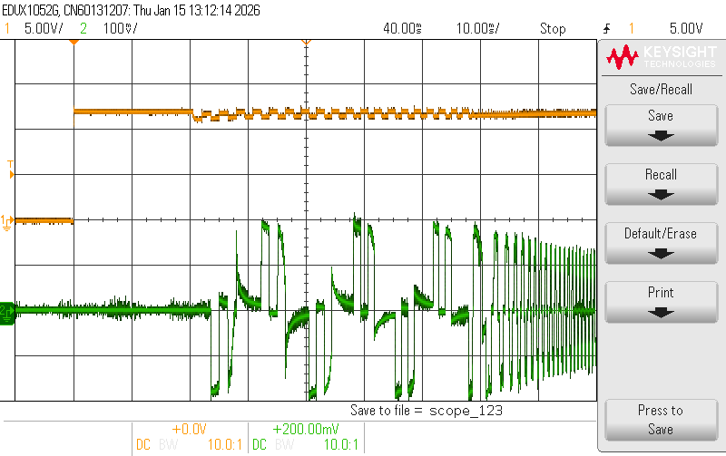
Latvian V2.8, yellow = supply 5V/div, green = motor current 10A/div, time base 10ms/div.
Initial delay ≈ 23ms, proper rotation ≈ 68ms, peak current ≈ 20A,

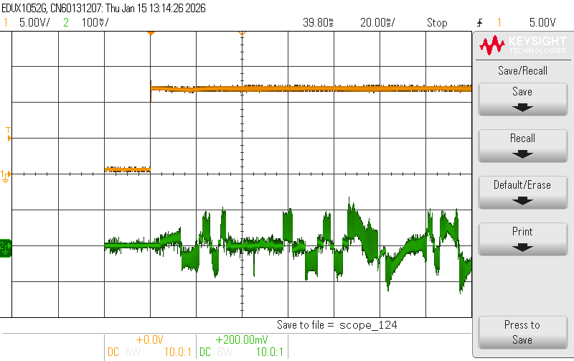
Do Slot, yellow = supply 5V/div, green = motor current 10A/div, time base 20ms/div.
Initial delay ≈ 5ms, proper rotation would NOT start, peak current ≈ 11A,

