ANGULAR HANDS-ON 1 [Beginner]
Task 1: Scaffold and Explore the Angular Project
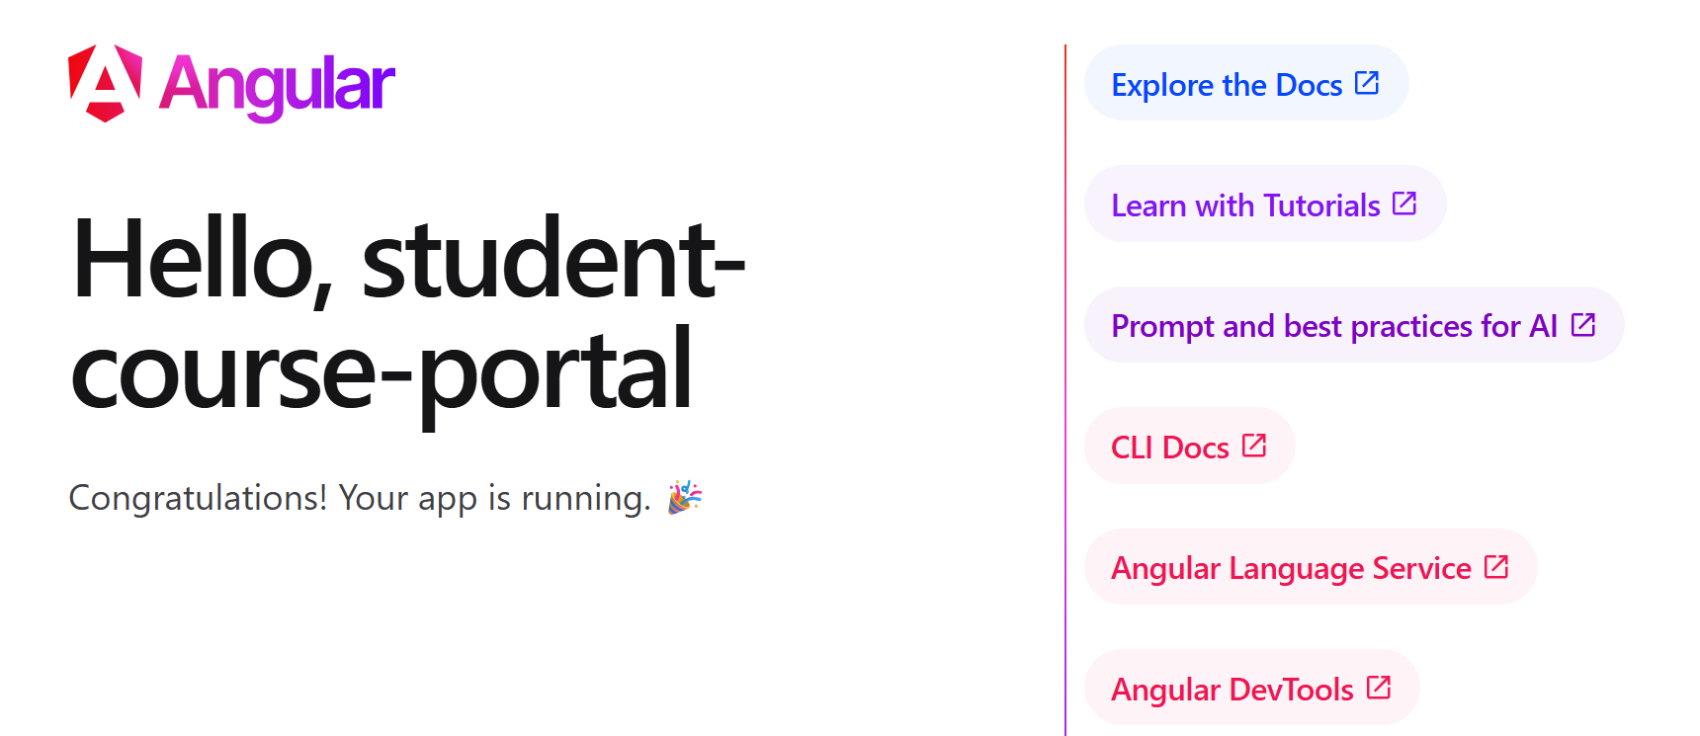
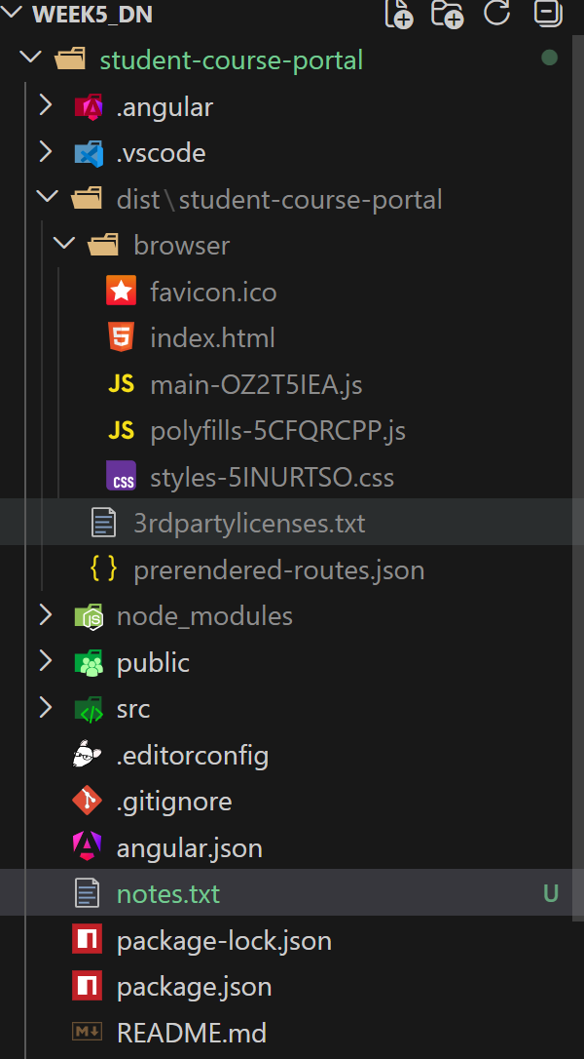

Task 2 : Create and Organise Components
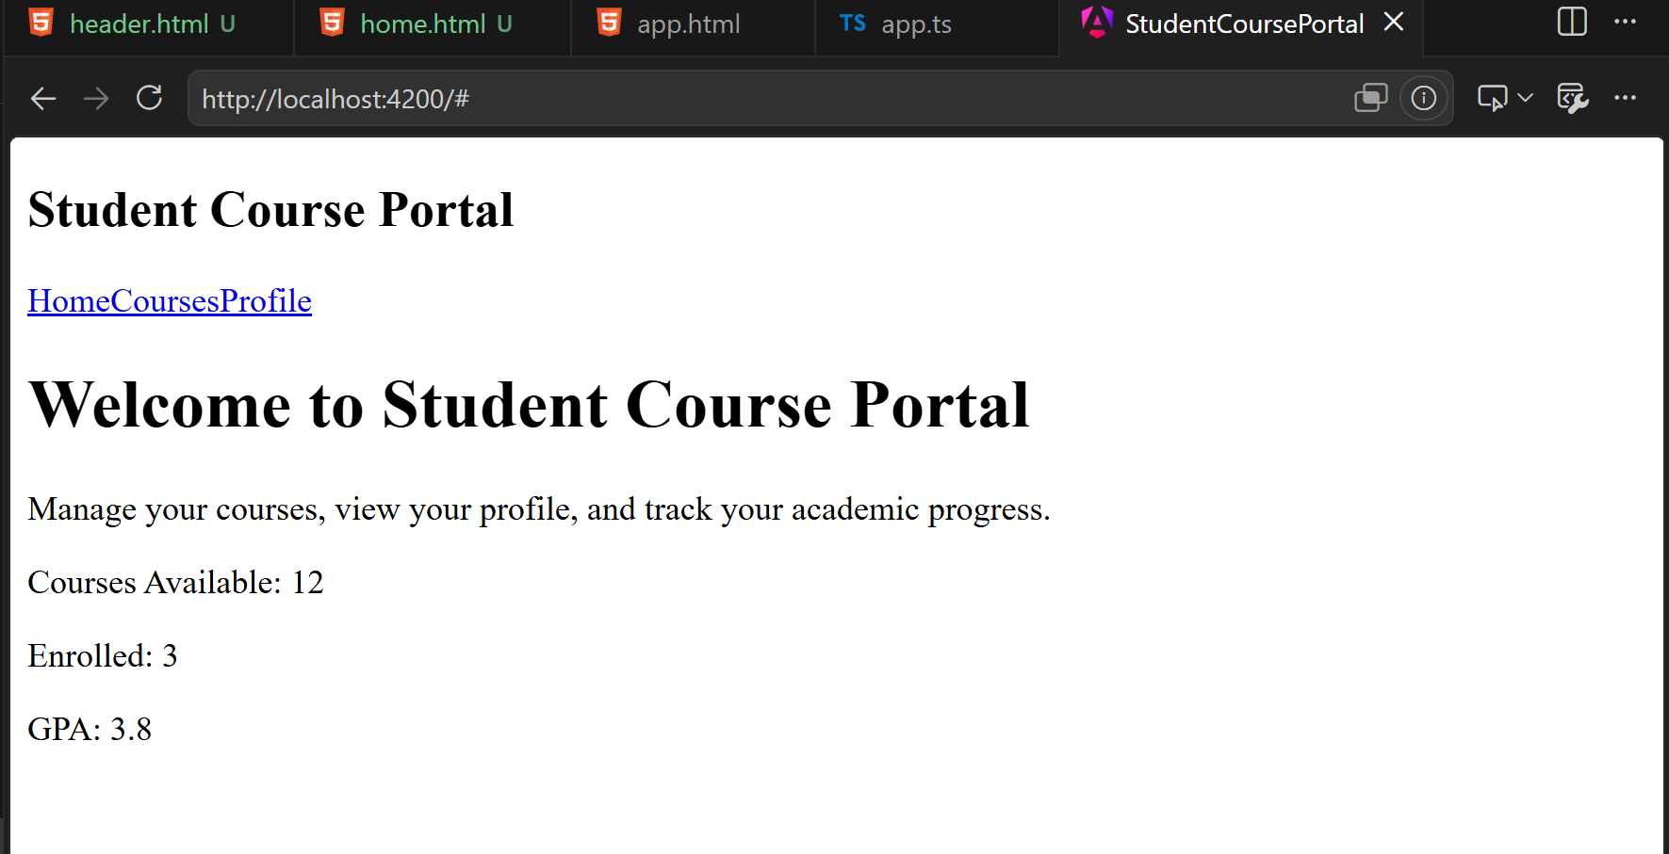

ANGULAR HANDS-ON 2 [Beginner]
Task 1 : Data Binding
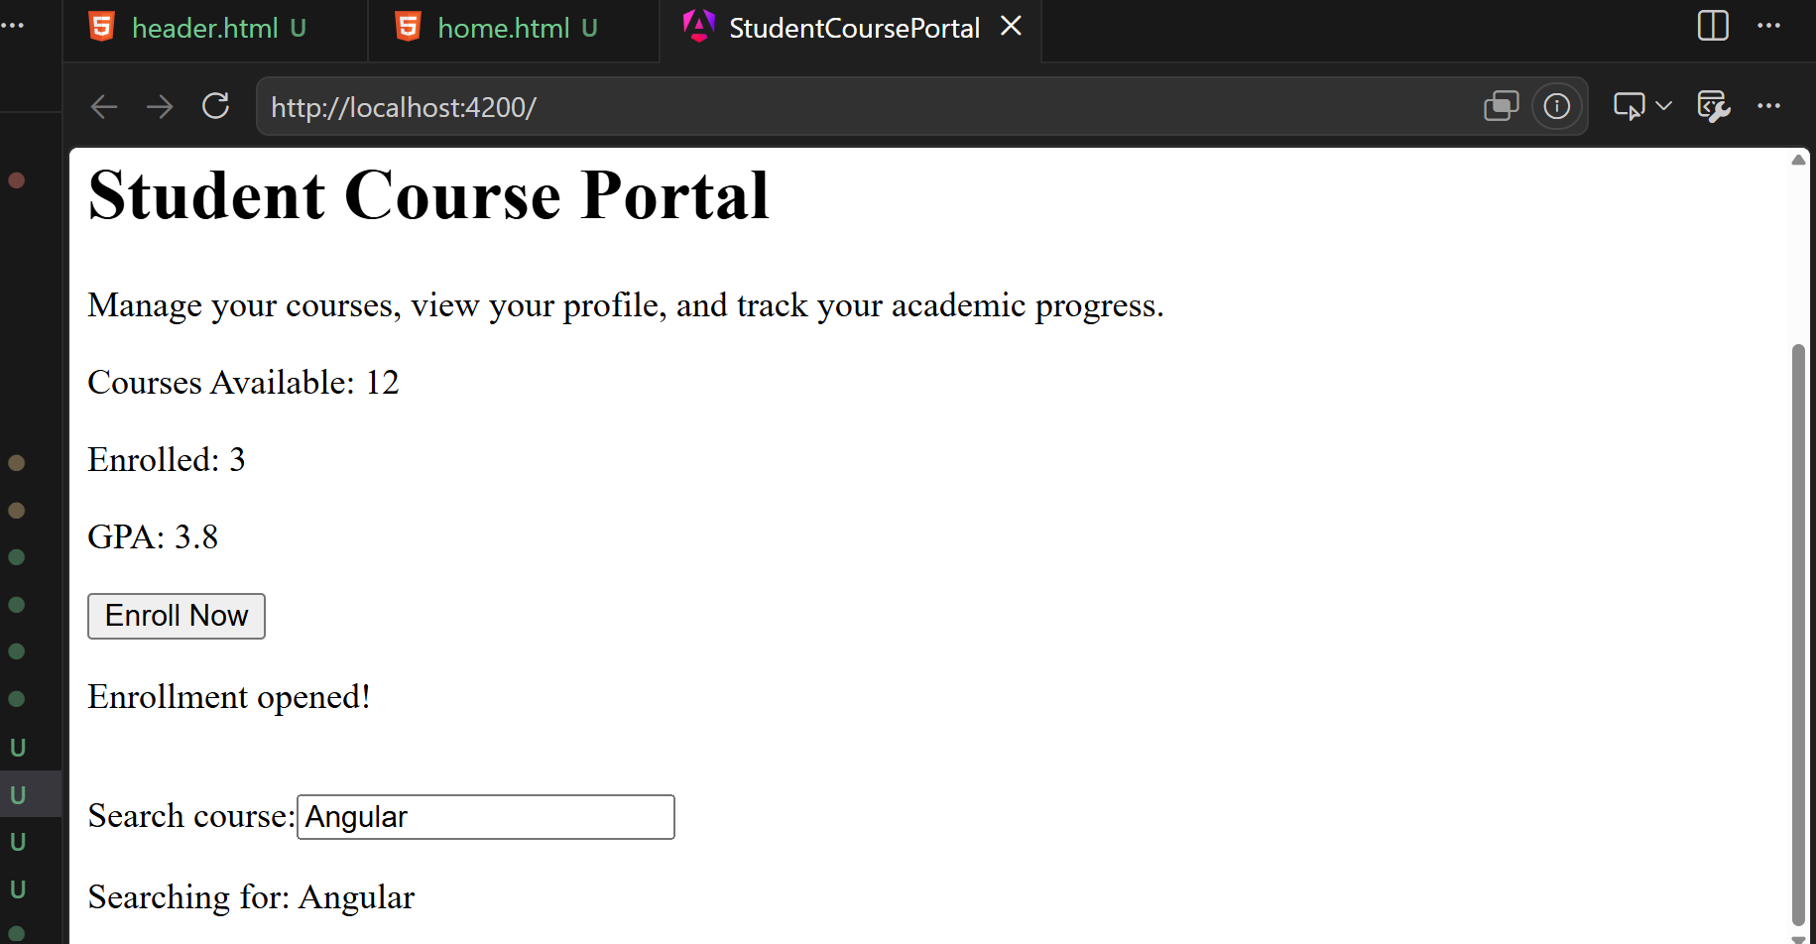

Task 2 : Lifecycle Hooks
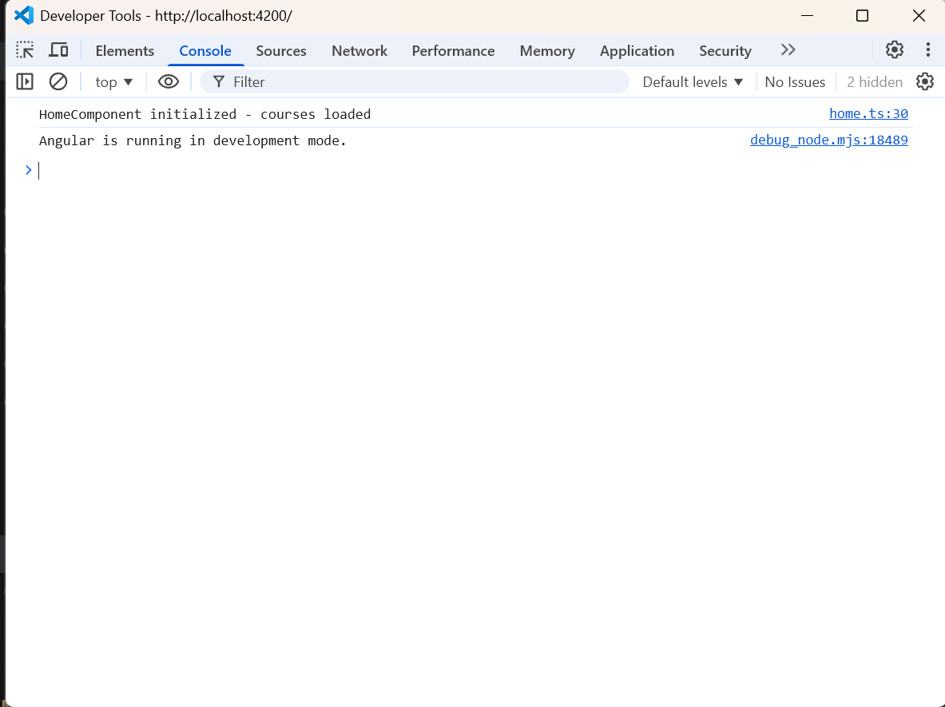
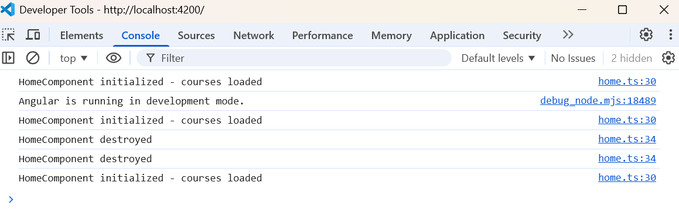

Task 3:
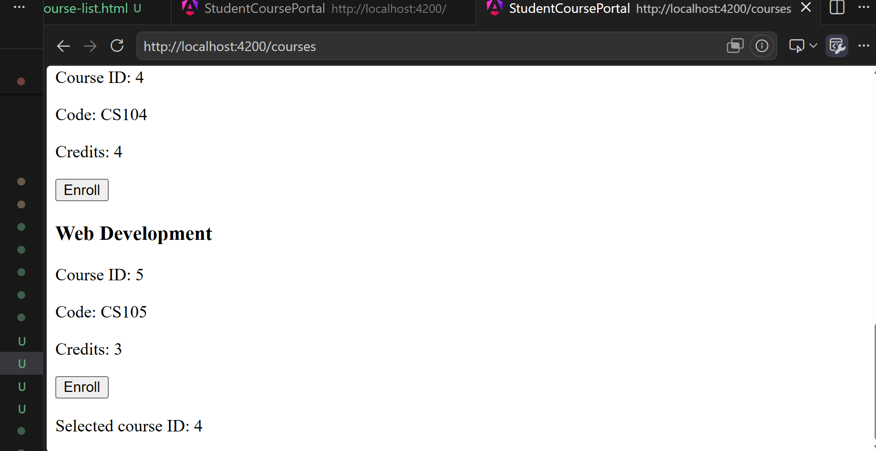

Angular Hands On 3
Task 1
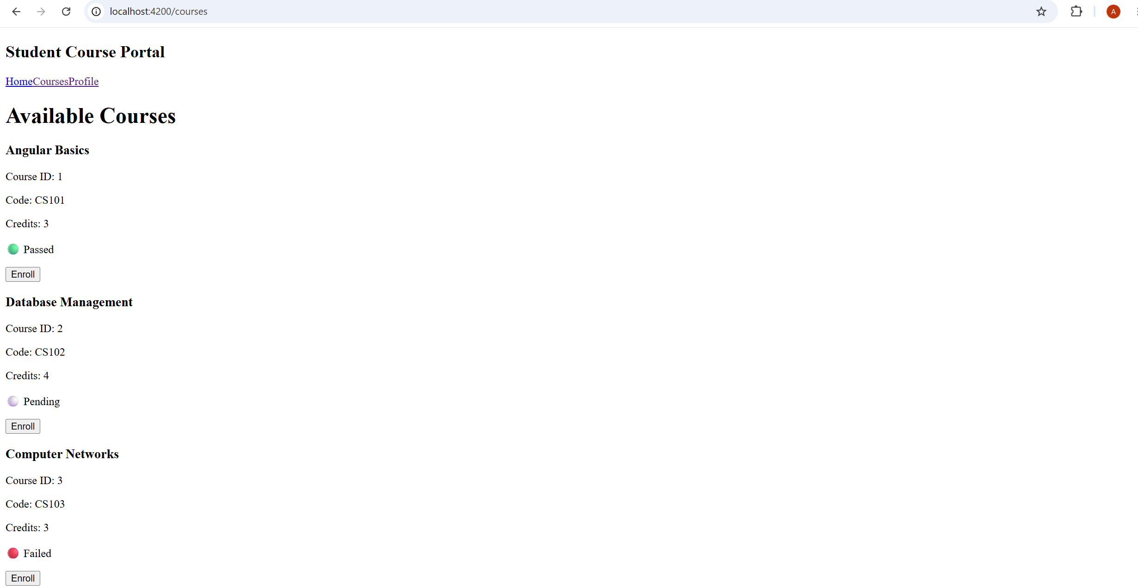

Task 2
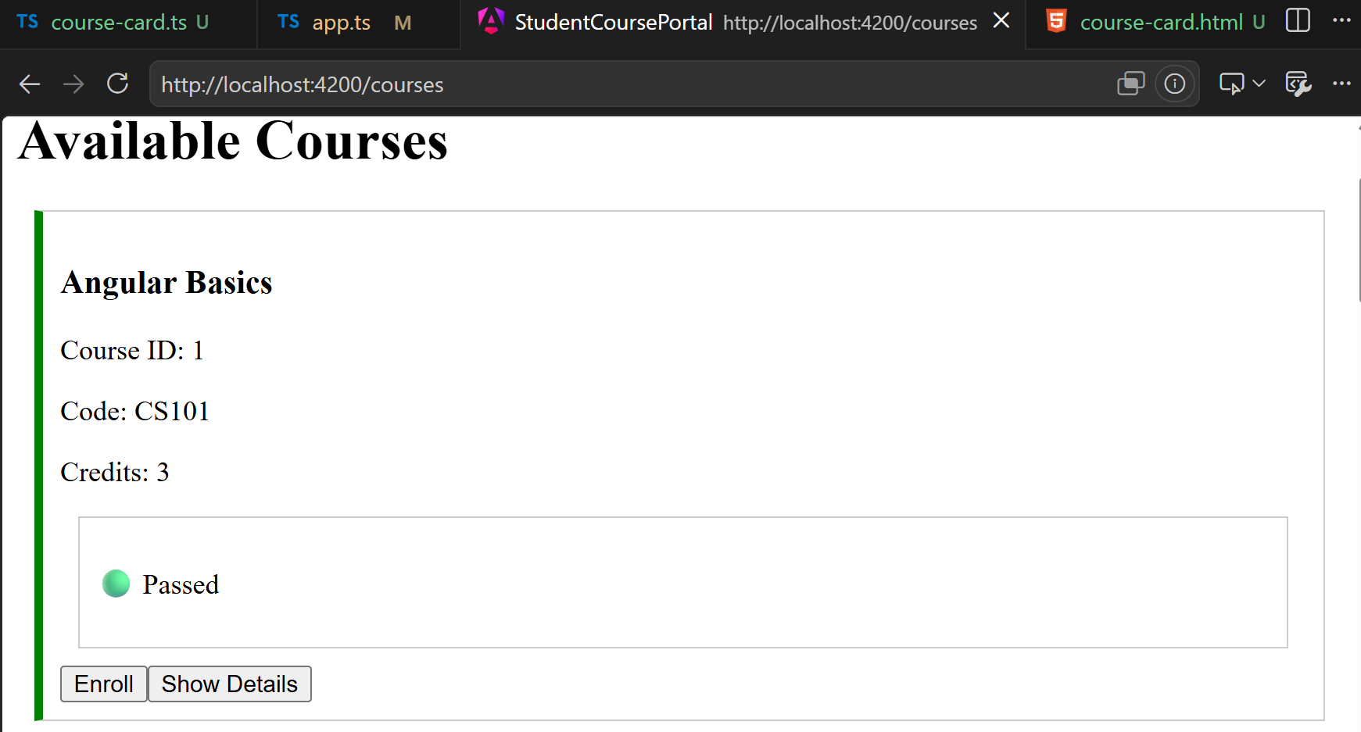

Task 3
