EX NO : 9

Monitoring Malware Using Rootkit Hunter
DATE:

AIM:
To install a rootkit hunter and find the malwares in a computer.

ROOTKIT HUNTER:
- rkhunter (Rootkit Hunter) is a Unix-based tool that scans for rootkits, backdoors and possible local exploits.
- It does this by comparing SHA-1 hashes of important files with known good ones in online databases, searching for default directories (Of rootkits), wrong permissions, hidden files, suspicious strings in kernel modules, and special tests for Linux and FreeBSD.
- rkhunter is notable due to its inclusion in popular operating systems (Fedora, Debian, etc.)
- The tool has been written in Bourne shell, to allow for portability. It can run on almost all UNIX-derived systems.

SOFTWARE USED:
Malwarebytes:
Malwarebytes is an anti-malware software used to detect and remove malicious programs such as viruses, worms, trojans, spyware, and rootkits.
It scans system files, memory, and registry entries to identify suspicious activities and ensures system security.

Step 1:

Downloaded and installed Malwarebytes from the official website.
The application was launched successfully.

Step 2:
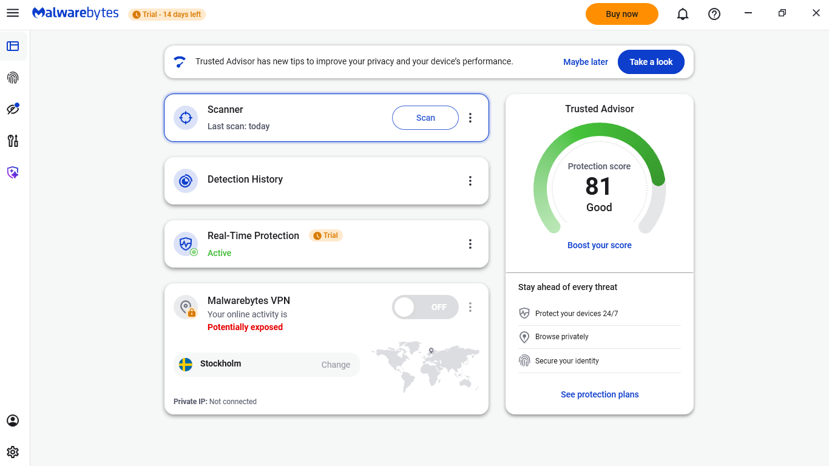
Clicked on the “Scan” option available on the dashboard to start scanning the system.

Step 3:
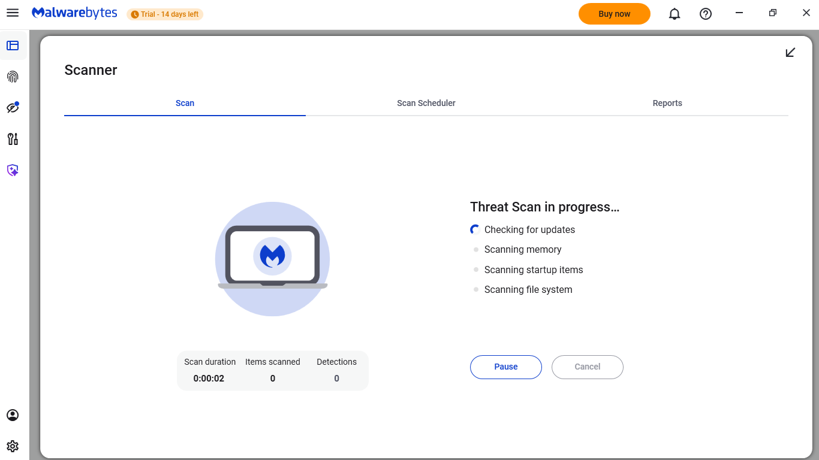
The tool scanned system files, memory, and registry for malware.
The scanning process was observed and allowed to complete.
Step 4:
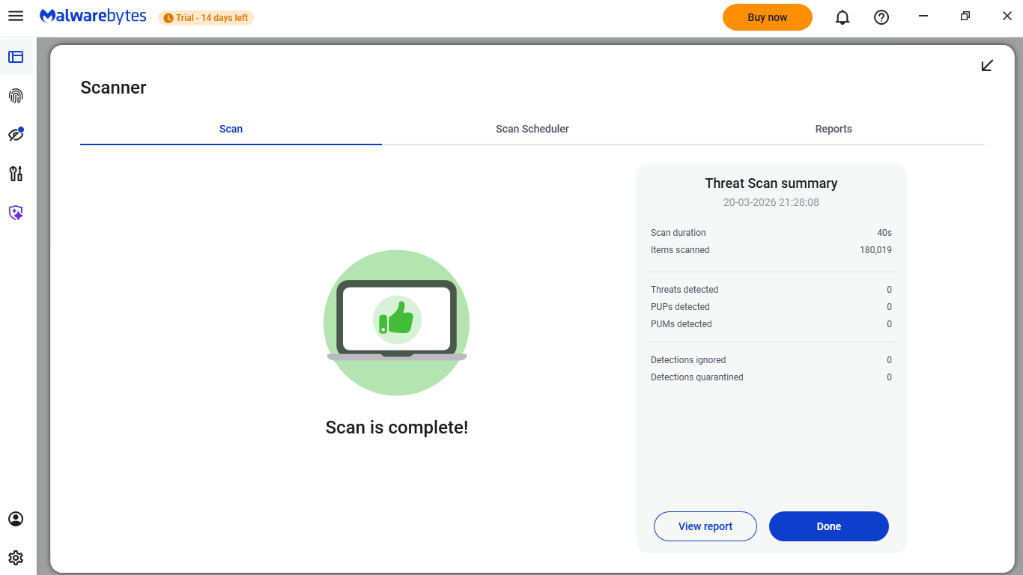
After completion, the scan results were displayed.
No malware or suspicious files were detected in the system.

Step 5:
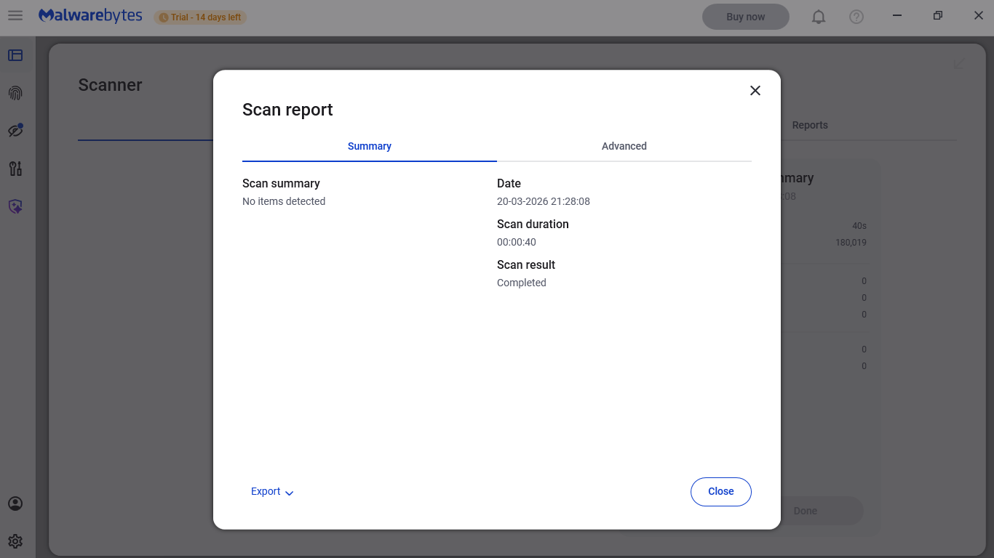

Opened the scan report after completion in Malwarebytes. Checked the scan summary and confirmed that no malware threats were found in the system.

RESULT:
The system was successfully scanned using Malwarebytes and no malware threats were found.

