Customer Shopping Behaviour Analysis
Project Documentation — Python (Data Cleaning), MySQL (Analysis), Power BI (Dashboard)

1. Project Overview
This project analyzes a customer shopping behaviour dataset to uncover patterns in spending, subscription status, discounts, product categories, and age-based purchasing trends. The workflow covers three stages:
- Data Cleaning & Feature Engineering — using Python (Pandas)
- Data Analysis — using SQL (MySQL) queries
- Data Visualization — using Power BI dashboard

2. Dataset Overview
The raw dataset (shopping_behavior_updated.csv) contains 3,900 customer records with 16 columns, including customer demographics, purchase details, ratings, subscription status, discounts, and payment methods.
Original Columns
Customer ID, Age, Gender, Item Purchased, Category,
Purchase Amount (USD), Location, Size, Color, Season,
Review Rating, Subscription Status, Discount Applied,
Previous Purchases, Payment Method, Frequency of Purchases
No missing values were found in any column (data.isnull().sum() confirmed 0 nulls across all 16 fields).

3. Python — Data Cleaning & Feature Engineering
3.1 Load the Dataset
import pandas as pd
data = pd.read_csv("shopping_behavior_updated.csv")
data.head()
Customer ID Age Gender Item Purchased Category Purchase Amount (USD) ...
0 1 55 Male Blouse Clothing 53 ...
1 2 19 Male Sweater Clothing 64 ...
2 3 50 Male Jeans Clothing 73 ...
3 4 21 Male Sandals Footwear 90 ...
4 5 45 Male Blouse Clothing 49 ...
[5 rows x 16 columns]
3.2 Statistical Summary
data.describe(include="all")
Customer ID: count 3900, mean 1950.5, min 1, max 3900
Age: count 3900, mean 44.07, min 18, max 70
Purchase Amount (USD): mean 59.76, min 20, max 100
Review Rating: mean 3.75, min 2.5, max 5.0
Gender: 2 unique (top = Male, freq 2652)
Item Purchased: 25 unique (top = Blouse, freq 171)
Category: 4 unique (top = Clothing, freq 1737)
3.3 Check for Missing Values
data.isnull().sum()
Customer ID 0 Location 0
Age 0 Size 0
Gender 0 Color 0
Item Purchased 0 Season 0
Category 0 Review Rating 0
Purchase Amount (USD) 0 ... (all columns = 0)
3.4 Standardize Column Names
data.columns = data.columns.str.lower()
data.columns = data.columns.str.replace(' ', '_')
data = data.rename(columns={'purchase_amount_(usd)': 'purchase_amount'})
data.columns
Index(['customer_id', 'age', 'gender', 'item_purchased', 'category',
'purchase_amount', 'location', 'size', 'color', 'season',
'review_rating', 'subscription_status', 'discount_applied',
'previous_purchases', 'payment_method', 'frequency_of_purchases'],
dtype='object')
3.5 Create Age Group Column
labels = ['Young Adult', 'Adult', 'Middle-aged', 'Senior']
data['age_group'] = pd.qcut(data['age'], q=4, labels=labels)
data[['age_group', 'age']].head()
age_group age
0 Middle-aged 55
1 Young Adult 19
2 Middle-aged 50
3 Young Adult 21
4 Middle-aged 45
Ages were split into 4 equal-sized quantile groups (Young Adult, Adult, Middle-aged, Senior) so revenue and sales could later be compared across life stages.
3.6 Create Purchase Frequency (in Days) Column
frequency_mapping = {
'Fortnightly': 14, 'Weekly': 7, 'Monthly': 30,
'Quarterly': 90, 'Bi-Weekly': 14, 'Annually': 365,
'Every 3 Months': 90
}
data['purchase_frequency_days'] = data['frequency_of_purchases'].map(frequency_mapping)
data[['purchase_frequency_days', 'frequency_of_purchases']].head()
purchase_frequency_days frequency_of_purchases
0 14 Fortnightly
1 14 Fortnightly
2 7 Weekly
3 7 Weekly
4 365 Annually
3.7 Load Cleaned Data into MySQL
from sqlalchemy import create_engine
username = "root"
password = "********" # replace with your own MySQL password
host = "localhost"
port = "3306"
database = "customer_behaviour"
engine = create_engine(
f"mysql+pymysql://{username}:{password}@{host}:{port}/{database}"
)
table_name = "customer"
data.to_sql(table_name, engine, if_exists="replace", index=False)
Data successfully loaded into table 'customer' in database 'customer_behaviour'.

4. MySQL — Analysis Queries
The cleaned dataset was queried in MySQL to answer specific business questions about customer behaviour.
4.1 Revenue by Gender
select gender, SUM(purchase_amount) as revenue
from customer
group by gender;
Purpose: Compares total revenue generated by male vs. female customers.
4.2 High-Spending Customers Despite Discounts
select customer_id, purchase_amount
from customer
where discount_applied = "Yes"
and purchase_amount >= (select AVG(purchase_amount) from customer);
Purpose: Finds customers who used a discount but still spent more than the average purchase amount.
4.3 Top 5 Products by Average Rating
select item_purchased, AVG(review_rating) as Average_Product_Rating
from customer
group by item_purchased
order by avg(review_rating) desc
limit 5;
Purpose: Identifies the 5 products with the highest average customer review rating.
4.4 Subscribers vs. Non-Subscribers Spend
select subscription_status, count(customer_id) as total_customer,
avg(purchase_amount) as avg_spend,
sum(purchase_amount) as total_revenue
from customer
group by subscription_status
order by total_revenue, avg_spend desc;
Purpose: Compares customer count, average spend, and total revenue between subscribed and non-subscribed customers.
4.5 Top 5 Products by Discount Rate
select item_purchased,
(100 * sum(case when discount_applied='Yes' then 1 else 0 end) / count(*)) as discount_rate
from customer
group by item_purchased
order by discount_rate desc
limit 5;
Purpose: Finds the 5 products with the highest percentage of purchases made with a discount applied.
4.6 Customer Segmentation (New / Returning / Loyal)
with customer_type as (
select customer_id, previous_purchases,
case
when previous_purchases = 1 then "new"
when previous_purchases between 2 and 10 then "returning"
else 'loyal'
end as customer_segment
from customer)
select customer_segment, count(*) as no_of_customers
from customer_type
group by customer_segment;
Purpose: Segments customers into New, Returning, and Loyal buckets based on their number of previous purchases, and counts each segment.
4.7 Top 3 Products per Category
SELECT category, item_purchased, purchase_count
FROM (
SELECT category, item_purchased, COUNT(*) AS purchase_count,
ROW_NUMBER() OVER (
PARTITION BY category ORDER BY COUNT(*) DESC
) AS rn
FROM customer
GROUP BY category, item_purchased
) AS ranked_products
WHERE rn <= 3
ORDER BY category, purchase_count DESC;
Purpose: Uses a window function (ROW_NUMBER) to rank products within each category and returns the top 3 best-selling products per category.
4.8 Repeat Buyers vs. Subscription Rate
SELECT
CASE WHEN previous_purchases > 5 THEN 'Repeat Buyers' ELSE 'Other Customers' END AS customer_type,
COUNT(*) AS total_customers,
SUM(CASE WHEN subscription_status = 'Yes' THEN 1 ELSE 0 END) AS subscribed_customers,
ROUND(100.0 * SUM(CASE WHEN subscription_status = 'Yes' THEN 1 ELSE 0 END) / COUNT(*), 2) AS subscription_rate
FROM customer
GROUP BY customer_type;
Purpose: Checks whether customers with more than 5 previous purchases (repeat buyers) are more likely to hold an active subscription.
4.9 Revenue Contribution by Age Group
SELECT age_group, SUM(purchase_amount) AS total_revenue,
ROUND(100 * SUM(purchase_amount) / (SELECT SUM(purchase_amount) FROM customer), 2) AS revenue_contribution_percent
FROM (
SELECT
CASE
WHEN age BETWEEN 18 AND 25 THEN '18-25'
WHEN age BETWEEN 26 AND 35 THEN '26-35'
WHEN age BETWEEN 36 AND 45 THEN '36-45'
WHEN age BETWEEN 46 AND 55 THEN '46-55'
ELSE '56+'
END AS age_group,
purchase_amount
FROM customer
) AS age_groups
GROUP BY age_group
ORDER BY total_revenue DESC;
Purpose: Calculates the total revenue and percentage revenue contribution of each customer age bracket.

5. Power BI — Customer Behaviour Dashboard
The final dashboard consolidates the cleaned dataset into an interactive Power BI report with slicers for Subscription Status, Gender, Category, and Location.
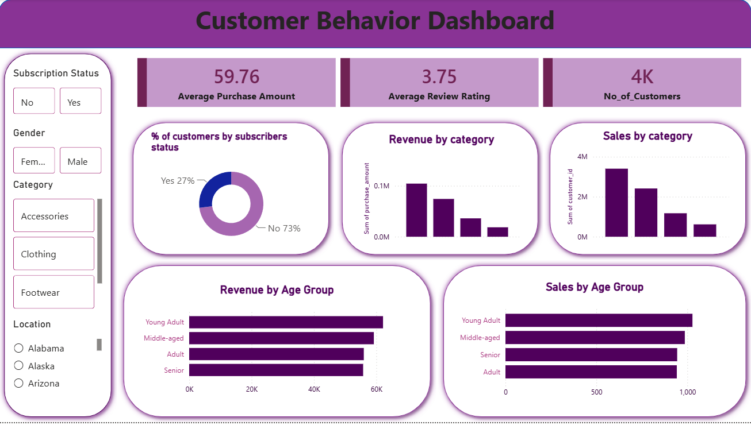
Key Metrics (KPI Cards)
- Average Purchase Amount: 59.76 USD
- Average Review Rating: 3.75
- No. of Customers: ~4K
Dashboard Visuals
- % of Customers by Subscribers Status — donut chart (No: 73%, Yes: 27%)
- Revenue by Category — bar chart of sum of purchase_amount
- Sales by Category — bar chart of sum of customer_id (purchase count)
- Revenue by Age Group — horizontal bar chart (Young Adult, Middle-aged, Adult, Senior)
- Sales by Age Group — horizontal bar chart of transaction counts by age group
Interactive Filters (Slicers)
- Subscription Status (Yes / No)
- Gender (Male / Female)
- Category (Accessories, Clothing, Footwear, and more)
- Location (state-wise)

6. Summary
This documentation covers the end-to-end workflow of the Customer Shopping Behaviour Analysis project — starting from raw CSV data, cleaning and feature engineering in Python, loading into MySQL for structured querying, and finally visualizing customer insights through an interactive Power BI dashboard.

