Co-AI BEGINNER WORKSHOP · AGENTIC AI FUNDAMENTALS
Aarthi Ravikrishnan & Deepa Ramasamy
14th October 2026
Example 1: Parsing messy clinical data into a structured CSV-
Tool: Claude (CHAT) · All data is synthetic
- Navigate to Example1_data_parsing/data folder.
- Inspect the files inside the folder by opening them separately.
  - Are the entries structured?
- Open Claude and you should see a window like this.

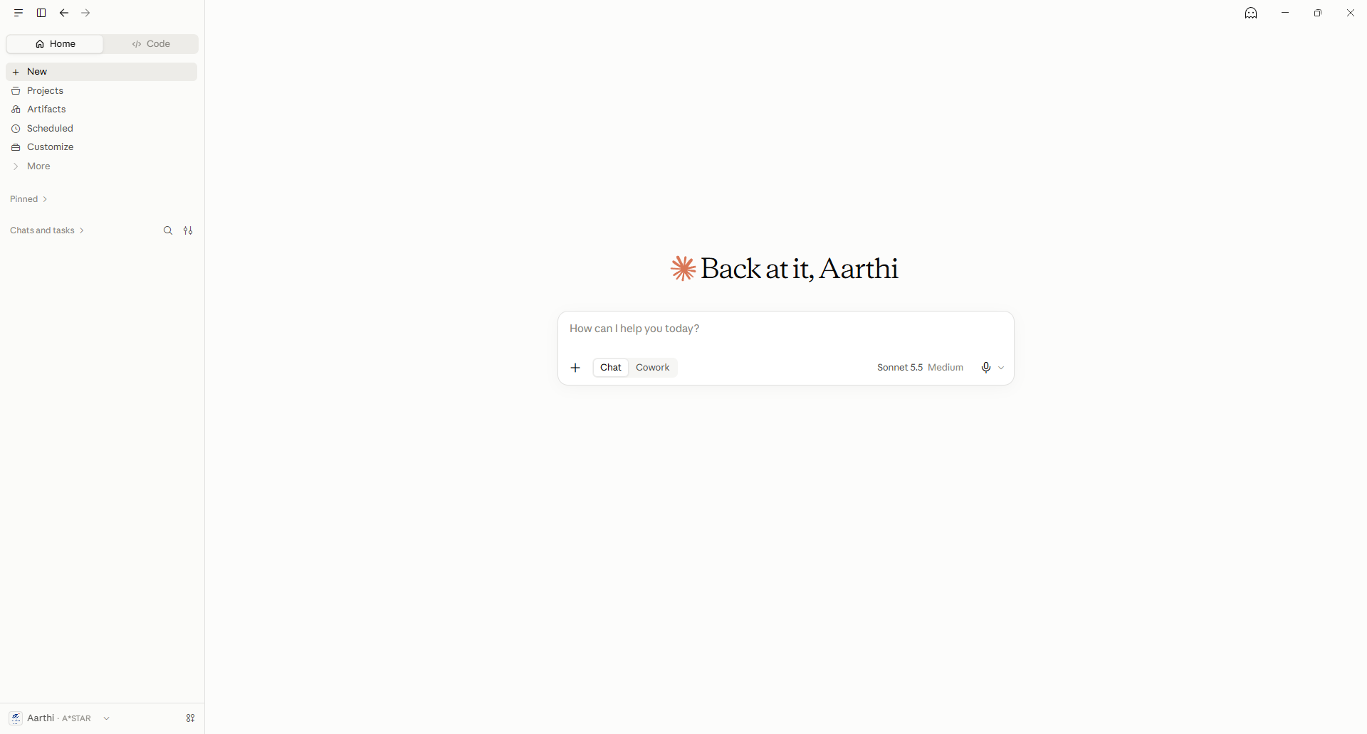

- Upload the files in the data folder using the + option (Add files or photos) in the toolbox and upload the 3 files in data folder (opened in 1).

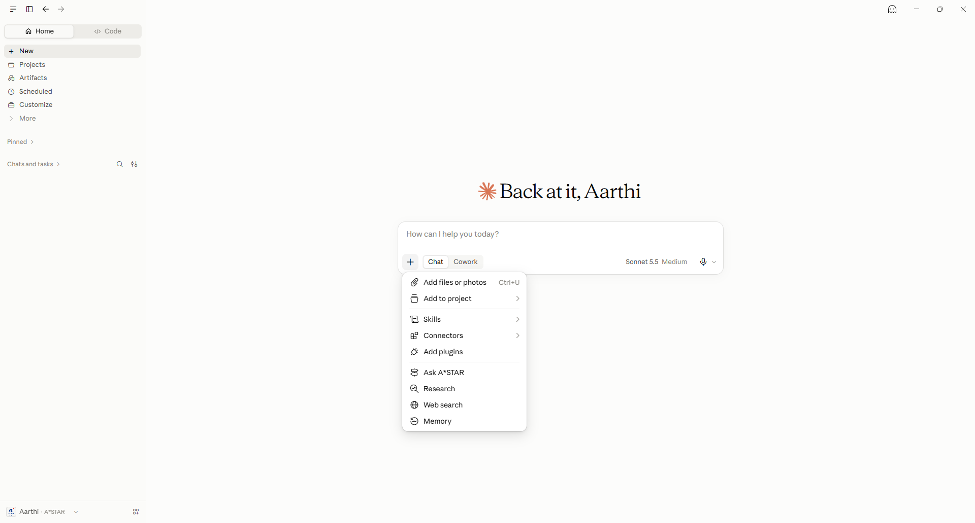
Naïve version

Example prompt
“Can you merge all these files and give a CSV file as output?”

Questions
- What do you notice about the results?
- Did it ask you for any inputs?

Beginner version

- In the same chat, attach the file skinad_instructions.md, then send a short message such as
Follow the attached SKIN-AD instructions and clean the three site files into clean_skinad.csv.

Questions
- Do you notice any difference in way output is being produced?
- Are there any differences in the output itself?

Intermediate version (1)

How to repeat this activity across multiple runs effectively?

Setup as a Claude Project

- Open Claude and click Projects.

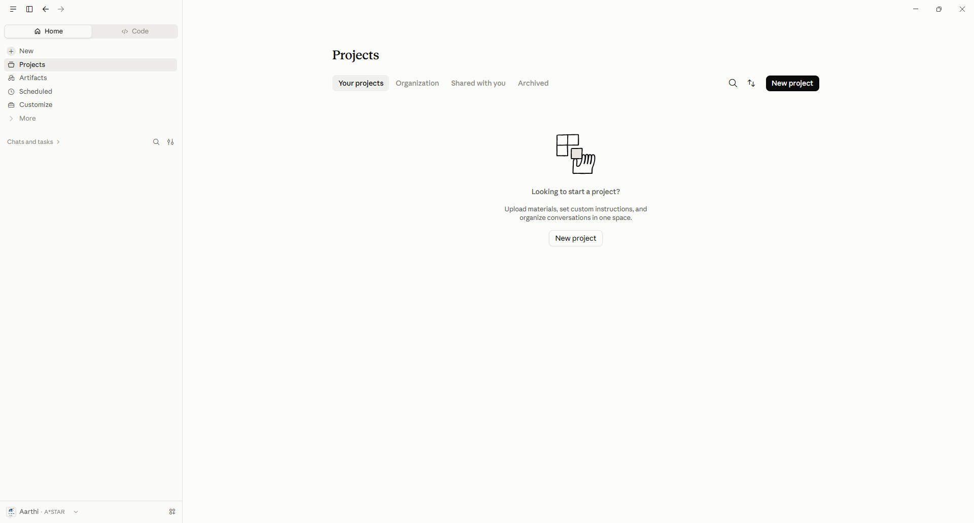

- Enter the details:

Name: SKIN-AD Data Wrangler
Description: Cleans the SKIN-AD site files into one tidy CSV that follows the study data dictionary.
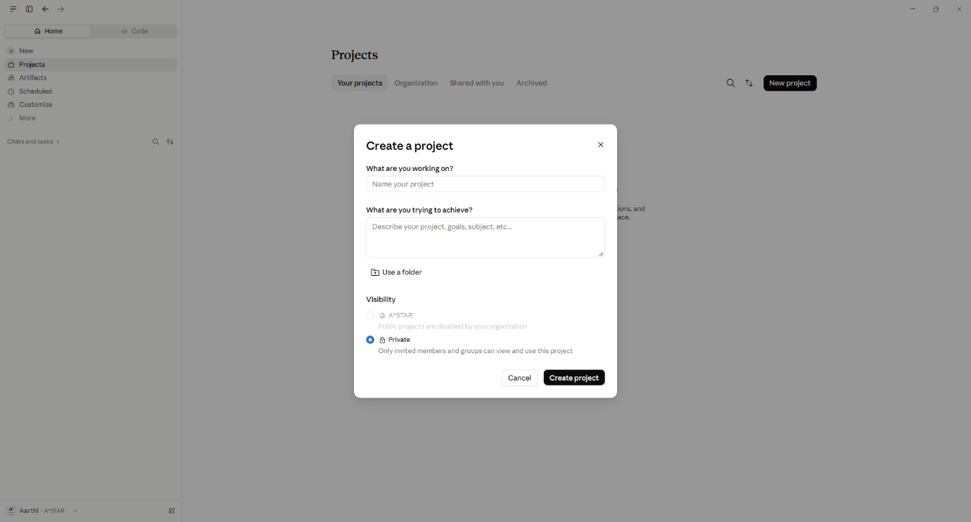
Select Create project.

- Instructions: on the project page, open Instructions (“Set project instructions”), paste the full text of the “project instructions” from the file “skinad_instructions.txt”.
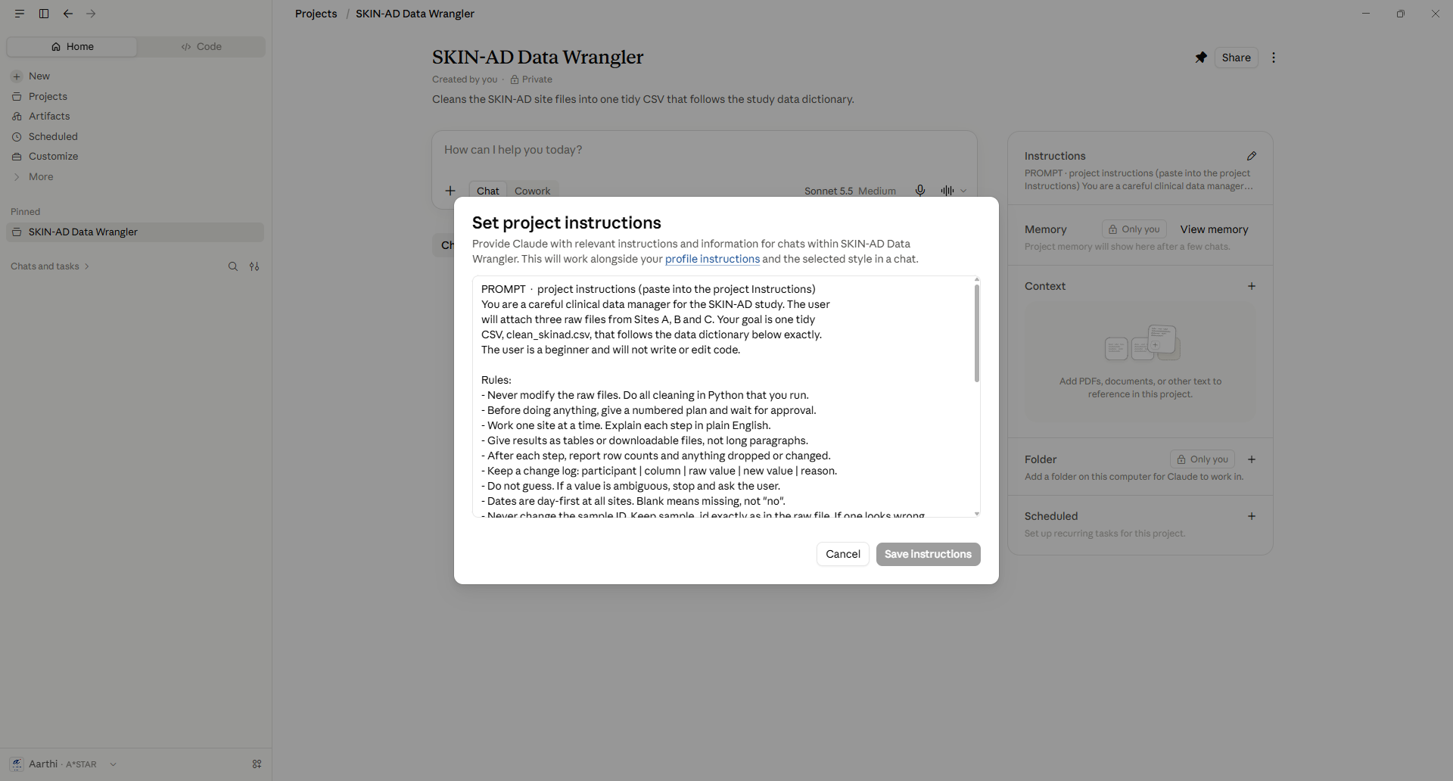

- Leave the other fields empty.

Start the work: open a new chat inside your project, attach the three files from data/ with the paperclip / + button, and send:
PROMPT · first message to Claude
Here are the three SKIN-AD raw files. Give me your plan as a numbered list.

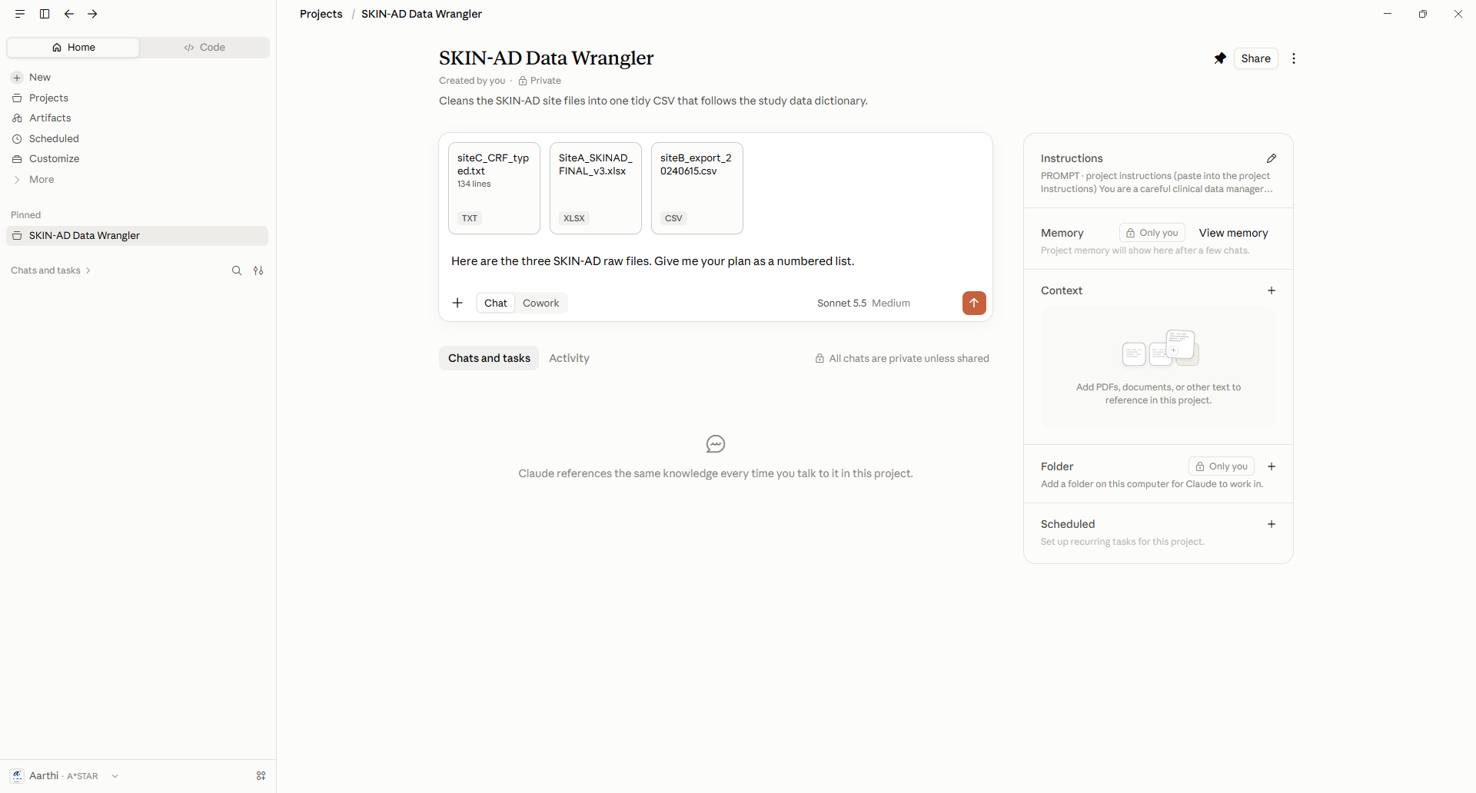

How to carefully approach this problem of merging files?

Step 1 · Look before you code

PROMPT · profile the files
Before cleaning anything, profile each file. For each one, list every
data-quality problem you can find: structure, headers, delimiters,
encoding, codes, units, missing-value markers, duplicates, inconsistent
spellings, and anything that is not stored as a plain cell value.
Give me a table: file | problem | example | proposed fix.

Now do your own inspection in Excel and Notepad, and fill in the log below. Compare it with Claude’s list. Did you miss any?
Step 2 · Site B: the “database” file
PROMPT · Site B
Start with siteB_export_20240615.csv. Load it and show me the first 10
rows as a table, plus a table of every column and its type (number,
text or date). Then clean it into the target format. Read the lines at
the top of the file before you start - they may tell you how values
are coded.
Check: Are the numeric columns actually numbers, not text? Does every participant have the expected visits? Open the raw file in Notepad and compare two rows by eye.
Step 3 · Site A & C
Repeat the same with site A and C and check for how they compare with original files.
PROMPT · Site A
Now Site A (the .xlsx). Give me a table: sheet | what it contains.
Tell me what information exists in this workbook that is NOT stored
as a normal cell value, and how you will recover it. Then clean both
visit sheets into the target format and combine them.

PROMPT · Site C
Site C is a text file of Key: value records, not a table. Split it into
one record per participant and map each key to the target column, even
when the same field is labelled differently. Show me the mapping as a
table (raw label | target column), and list any records with a missing
field.

Step 4: Combine all the three files
PROMPT · combine + validate
Combine the three sites into clean_skinad.csv, sorted by participant_id
then visit. Then run these checks and show the results as a table
(check | PASS/FAIL | details):
- exactly the 14 columns, in the dictionary order
- no duplicate participant_id + visit
- every value inside its allowed set or range (incl. SCORAD 0-103)
- plausible height, weight and BMI; visit 2 date after visit 1
- withdrawn is identical on all of a participant's rows
Give me clean_skinad.csv to download.

Now check it yourself, with no answer key. At work nobody hands you the right answer. These follow-up prompts work on any dataset:
PROMPT · check without an answer key
1. Give me the change log as a CSV to download:
participant | column | raw value | new value | reason.
2. Make a table of how many rows and participants came from each file
and how many ended up in the output. Explain any difference.
3. Pick 3 random participants and show their raw values next to their
cleaned values, side by side.
4. Is there any information in these files you might have missed:
colours, comments, hidden columns or rows, extra sheets?

Check: Open the raw files and compare those 3 participants by eye. Read the change log: does every change make sense to you?

Making this reusable – SKILLS FILE
PROMPT ·
Can you turn the instructions into a SKILLS file?

Loading SKILLS into Claude on another machine
- Navigate to Settings folder and add the skill files.

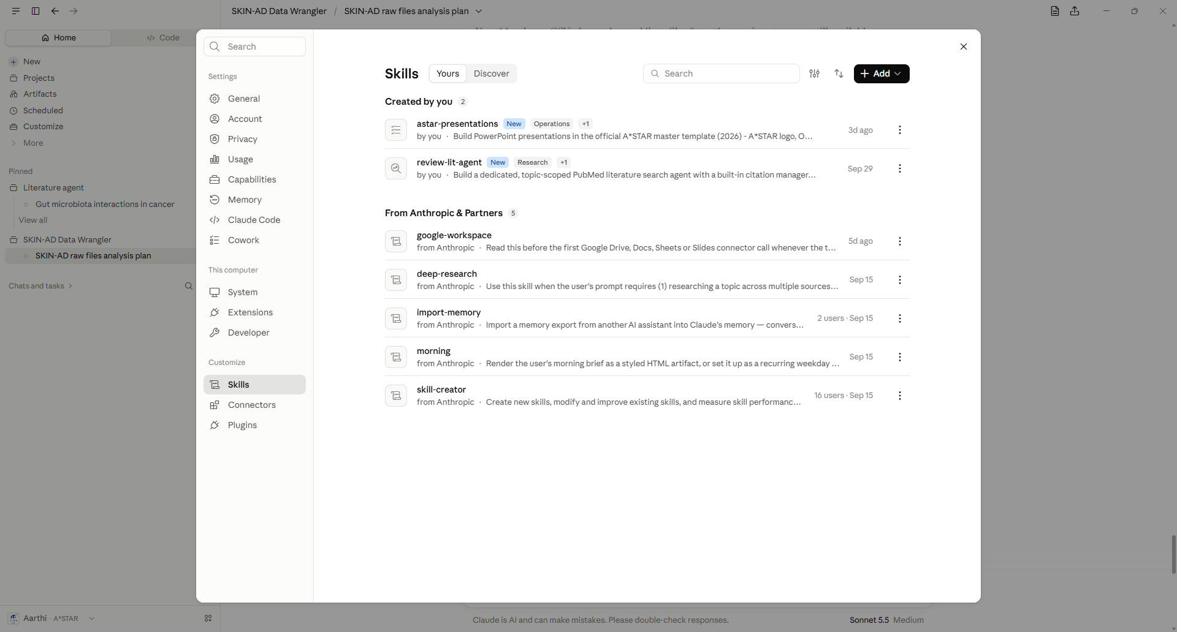
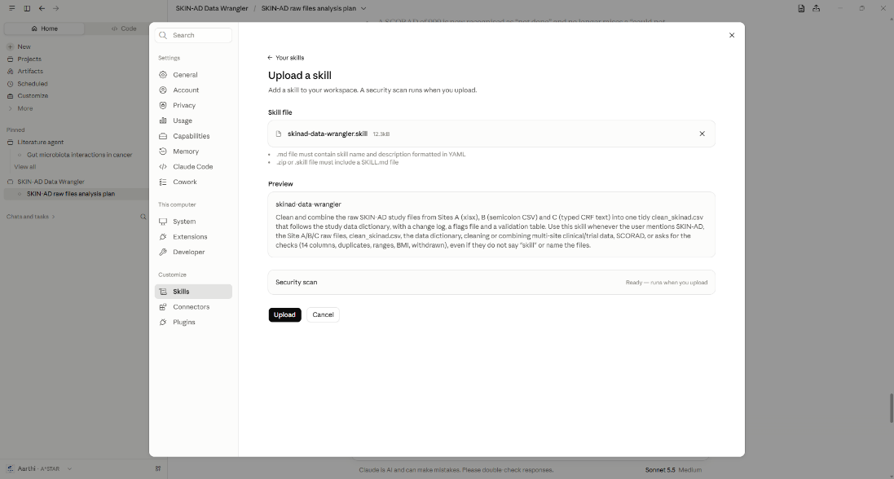

- The Skills files should be accessible via the chat prompt. Now the exact set of instructions would be available even on the chat outside the project folder.
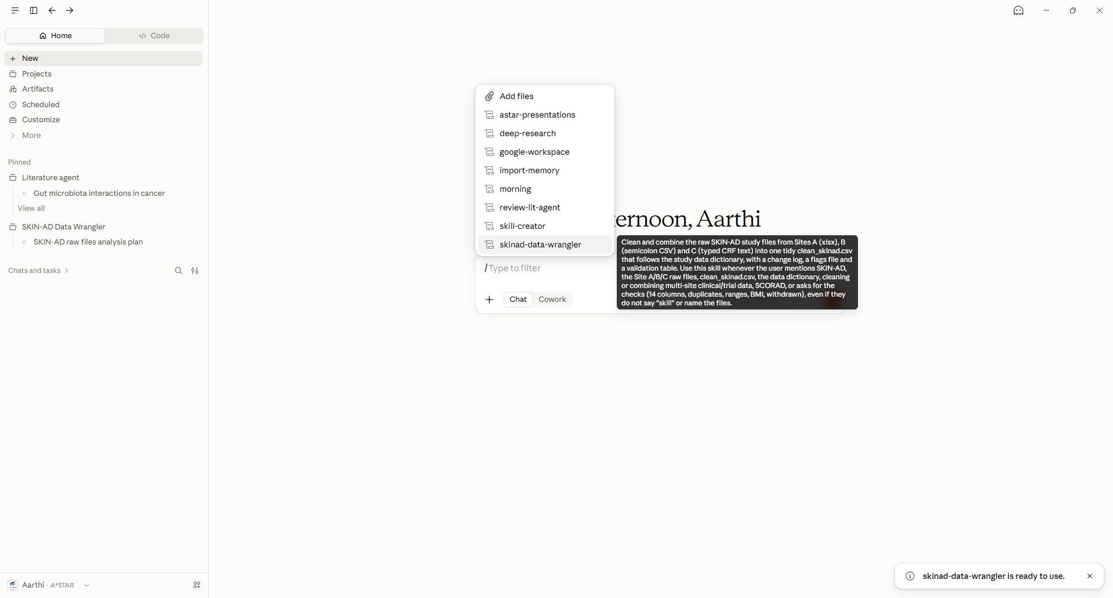

How to make a SKILL file on Claude?

