Co-AI BEGINNER WORKSHOP · AGENTIC AI FUNDAMENTALS
Aarthi Ravikrishnan & Deepa Ramasamy
14th October 2026
Hands-on 2: Making SKILLS file with A*STAR template
Tool: Claude (CHAT)
- Open Claude and new chat and enter /skill-creator.
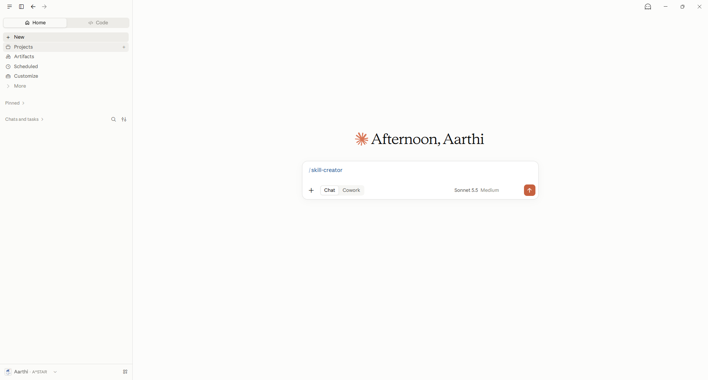

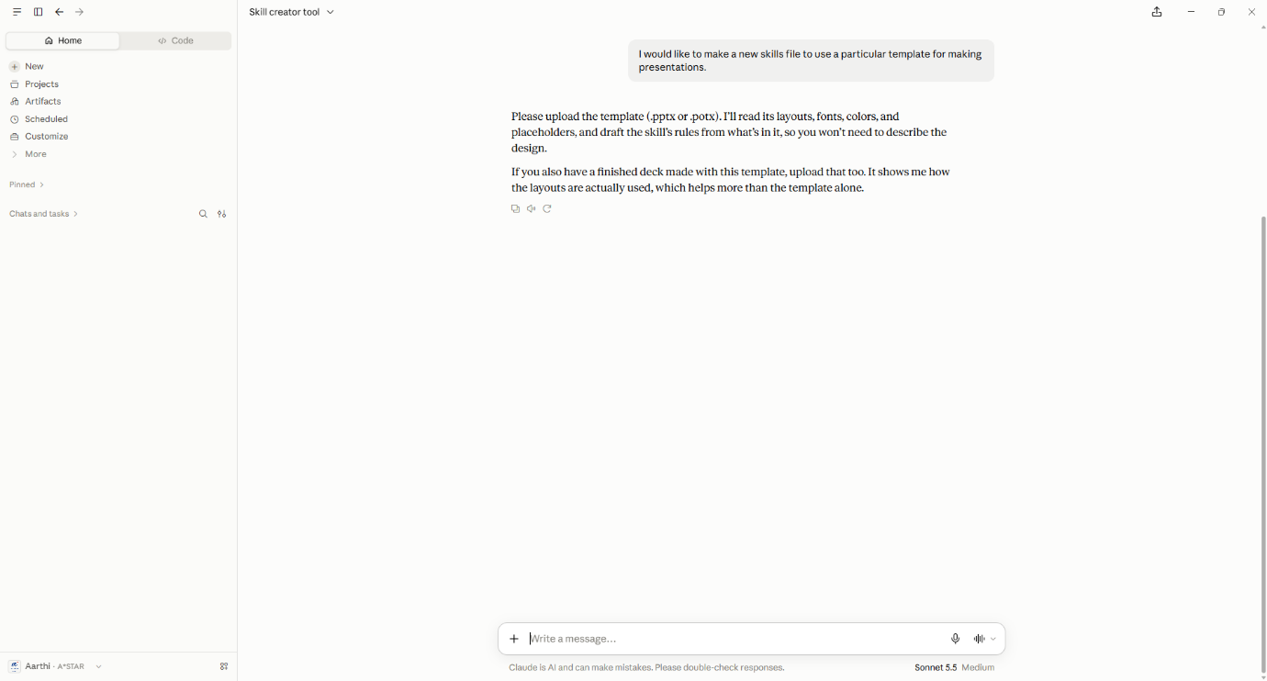
- Type the prompt:
PROMPT
I would like to make a new skills file to use a particular template for making presentations.

- Upload “ASTAR 00_MASTER_PPT_2026.potx” from Example2_astar_template/ folder using “+” option and “Add files or photos”
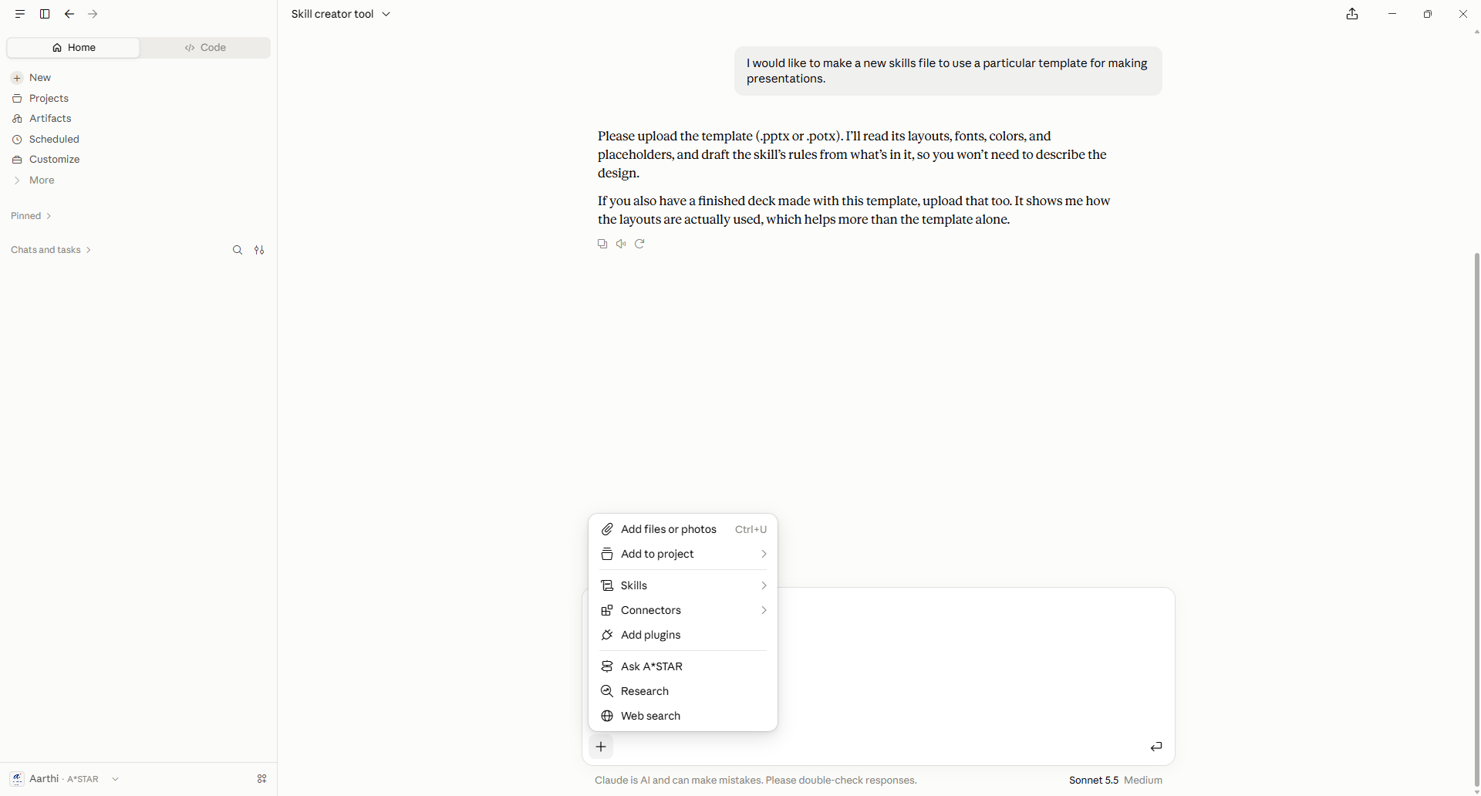

- The skills file will be generated and you can save it within Claude or locally to your computer for redistribution.
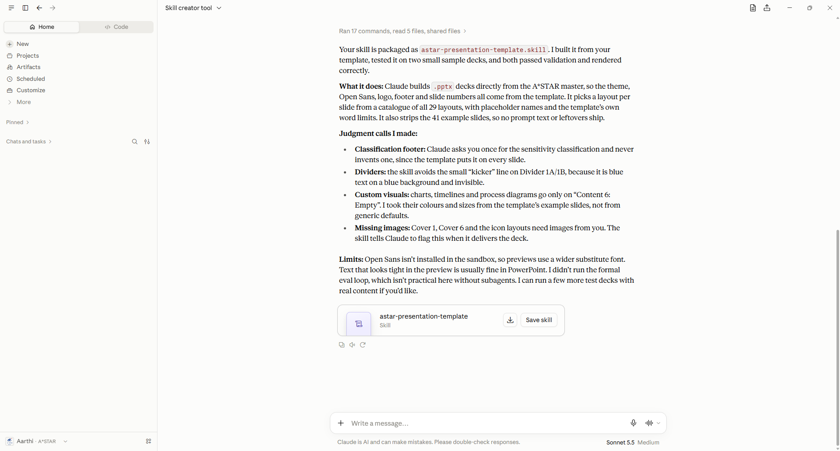
- To make your future presentations use this template, invoke the template via /astar-presentation-template option.

