Co-AI BEGINNER WORKSHOP · AGENTIC AI FUNDAMENTALS
Aarthi Ravikrishnan & Deepa Ramasamy
14th October 2026
Example 3: Searching Pubmed with Claude
From Literature Search to Gap Analysis to a Drafted Proposal

Claude can connect directly to PubMed and search the live biomedical literature from inside a normal chat — no separate database logins, no copy-pasting search strings. This handout walks through connecting PubMed once, then follows one continuous workflow: topic → search strategy → screened reading list → citations → gap map → draft Specific Aims for a proposal. A prompt library at the end gives you dozens of ready-to-adapt lines for every stage.

1. What You'll Learn
- How to connect the PubMed connector to Claude (one-time setup)
- How to turn a research topic into a reusable search + citation workflow
- How to read a screened reading list, a reference list, and a gap-analysis table
- How to carry an identified gap forward into a draft Specific Aim and hypothesis
- What to double-check before trusting any of this in a manuscript or proposal
- A large prompt library, organized by stage, to copy and adapt

2. One-Time Setup: Connecting PubMed
Step 1. Open the "+" menu. In the chat box, click Add files, connectors, and more.
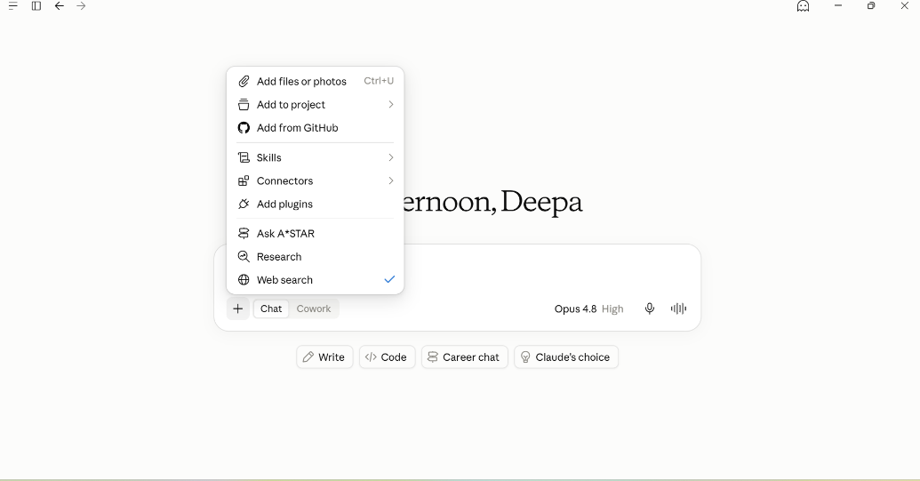
The “+” menu — Connectors is where PubMed lives.
Step 2. Go to Connectors. Choose Connectors → Browse connectors to see what's available.
Step 3. Add PubMed. Search “pubmed” and click Add. Anthropic built and maintains it.
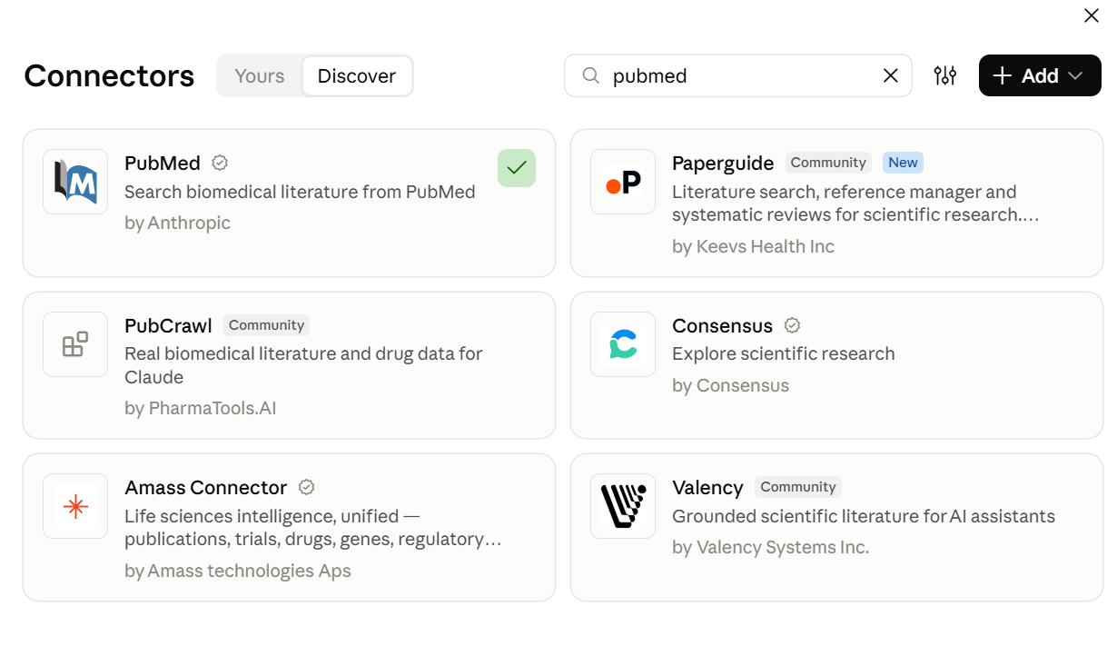
The Connectors directory — PubMed already added (green check).
Step 4. Save your workflow as a Skill (optional). If you build a search strategy you'll reuse — like a search agent for one research topic — save it as a Skill. It then triggers automatically in future chats without you re-explaining the setup.
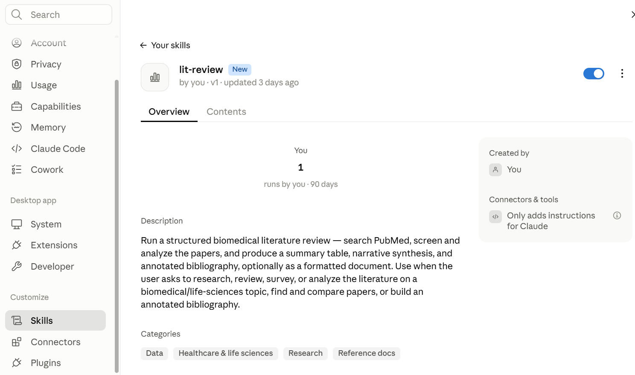
A saved Skill appears under Settings → Skills and can be toggled on or off.
Step 5. Start your query in plain English. Tell Claude your topic. Two answers help it tailor the workflow: what form you want the output in (a quick answer, a reusable Skill, or a Python script), and which citation style you need.

3. Worked Example: From Topic to Literature Review
Below is a real, condensed example. A researcher working on triple-negative breast cancer (TNBC) and its epigenetic regulation asked Claude for a dedicated search and citation workflow for their review.
Example prompt
“I am working on triple-negative breast cancer and its epigenetic regulation. I need to write a review on this topic. Can you make a dedicated literature search agent and citation module for this topic?”

What Claude builds
- Search agent — a reusable search strategy for the topic (MeSH terms + concept blocks, e.g. disease terms crossed with each mechanism of interest), with filters for study type and recency. It searches PubMed live through the connector, removes duplicates, and screens hits against inclusion criteria.
- Citation module — takes the screened records and formats them deterministically: a numbered reference list in your chosen style, plus BibTeX/RIS files ready to import into Zotero or EndNote.

Sample of the screened output
Claude returns a table like this, ranked by relevance to the review rather than by citation count (useful when much of the literature is very recent):
# | Paper | Type | Focus | Why it matters
1 | Aine et al. 2025, Nat. Commun. | Primary | DNA methylation | Genome-wide methylation map splitting TNBC into epigenetic subtypes
2 | Bartlett et al. 2022, Genome Med. | RCT | DNA methylation | Human trial linking a drug to lower methylation-based risk markers
3 | Choudhary et al. 2026, Epigenomics | Review | Multi-axis | Broad overview — good background for an introduction
7 | Ogikubo et al. 2025, Cancer Sci. | Primary | Super-enhancers | Mechanistic link between a transcription factor and metastasis
16 | Zeng et al. 2026, J. Med. Chem. | Perspective | Drug design | Framing for how to durably target the epigenome

4. Finding the Gaps in a Field
Asking Claude something like “what is the gap in this field?” prompts it to pull approximate publication counts per subtopic from PubMed, rather than just asserting an opinion. The imbalance across subtopics is itself a signal of where the open questions are:
Subtopic | ~PubMed papers | Status
Non-coding RNA (lncRNA/miRNA) | ~1,315 | Saturated
DNA methylation | ~312 | Well studied
EZH2 / Polycomb | ~131 | Moderate
Epigenetics + clinical trial | ~20 | Gap
Spatial epigenomics | ~1 | Near-absent

Claude then groups the gaps into layers a review's discussion section can use, for example:
- Translational gaps — biology is well studied but rarely reaches clinical trials or validated biomarkers
- Mechanistic gaps — findings are descriptive/correlational, with limited causal or in-vivo validation
- Methodological gaps — newer techniques (single-cell, spatial) are barely applied to the topic yet

5. From Gap to Proposal: A Drafting Workflow
A gap on its own isn't a proposal. The same conversation can keep going — carrying one identified gap through the stages a proposal actually needs:
Search → Screen → Synthesize → Spot the Gap → Draft an Aim → Stress-Test → Refine

Worked continuation: turning a gap into a Specific Aim
Continuing the TNBC example: the clinical-translation gap (“no epigenetic biomarker is prospectively validated to guide TNBC therapy”) becomes the seed for a Specific Aim. Asking Claude to draft one produces something like this:
Illustrative Aim 1 — not a literature-verified claim, a drafting starting point
Determine whether pre-treatment cfDNA methylation at BRCA1-associated promoter loci predicts pathologic complete response to neoadjuvant chemoimmunotherapy in TNBC. Hypothesis: higher baseline methylation burden reflects a more epigenetically silenced BRCA1 pathway and associates with greater sensitivity to immune-sensitizing therapy. Approach: bank pre-treatment plasma from an existing neoadjuvant cohort, run targeted methylation sequencing, and correlate results with pathologic response.

What Claude is good at here — and what still needs you
Claude can help with | You still need to
Drafting several aim/hypothesis phrasings quickly | Judge biological plausibility and real-world feasibility
Surfacing publication-count patterns across subtopics | Confirm true novelty against funded grants and trial registries
Stress-testing wording the way a reviewer might | Make the final scientific and strategic call

6. Good Habits & Things to Double-Check
Good habits & things to double-check
- PubMed's terms require attribution and DOI links whenever its data is shown — Claude keeps these in chat by design; don't strip them out if you re-share the conversation.
- Journal-abbreviation formatting is a heuristic, not the authoritative CASSI list — verify unusual journal abbreviations before submitting a manuscript.
- Author cut-off conventions (e.g. “more than 5 authors → et al.”) vary by journal — tell Claude which convention your target journal uses.
- Publication counts for gap analysis are approximate and depend on exact search phrasing — treat the order of magnitude as the signal, not the exact number.
- Claude's “importance” ranking of papers is editorial judgment based on contribution and evidence type, not a bibliometric citation count — say so if you rely on it.
- Novelty checks are your job, not Claude's — cross-check any “gap” against grants.gov, NIH RePORTER, or your field's trial registry before building a proposal around it.
- Treat a Claude-drafted Aim or hypothesis as a starting draft for your own scientific judgment, not a finished proposal — the biological-plausibility call is yours.

7. Prompt Library: From Search to a Drafted Proposal
Use this as a menu. Copy a line, swap in your own [topic], and adjust the wording to sound like you. Every prompt assumes PubMed is already connected.

Search & screen the literature
- “Search PubMed for [topic], limited to [study type] published since [year], and screen out anything not directly about [narrow criterion].”
- “Give me the highest-impact recent reviews on [topic] so I have background before I read primary papers.”
- “Compare how [subtopic A] and [subtopic B] are studied within [field] — which has more clinical-trial coverage?”
- “Build me a dedicated literature search strategy and citation module for [topic], formatted in [citation style].”

Organize citations
- “Format these references in [style] and export BibTeX so I can import into Zotero or EndNote.”
- “Deduplicate this list by DOI/PMID and flag anything retracted or preprint-only.”

Find the gaps
- “Show approximate PubMed publication counts for [topic] crossed with [subtopic 1 / 2 / 3] — where is it saturated versus sparse?”
- “Which of these gaps already has active clinical trials or recent funding? Search for [topic] plus clinical-trial registrations.”
- “Compare this field's gaps to [an adjacent field] — is there a technique that's mature there but unused here?”
- “Play devil's advocate: give me reasons each “gap” might not really be a gap — maybe it's studied under different terminology.”
- “Of these gaps, which is feasible for a small, 2-year project versus which needs a large multi-site study?”

Draft significance and background
- “Using the gap on [X], draft a two-paragraph Significance section explaining why closing it matters clinically and scientifically.”
- “Write a background paragraph that sets up [gap] as the logical next step from these papers: [list].”

Draft Specific Aims and a hypothesis
- “Turn the gap on [X] into 2–3 Specific Aims, each with a testable hypothesis and a one-line approach.”
- “Give me three alternative hypotheses for [gap], ranked by novelty versus feasibility.”
- “Stress-test this Specific Aim like a study-section reviewer — where would they attack feasibility, novelty, or rigor?”

Draft the approach and refine toward a funding mechanism
- “Draft a Preliminary Approach paragraph for Aim 1 using [technique], and flag what preliminary data I'd need to justify it.”
- “What controls or alternative analyses would a rigorous reviewer expect for [proposed method]?”
- “Rewrite this aim to fit an exploratory, 2-year mechanism with no preliminary data required, instead of a full-scale proposal.”
- “Search the web for recently funded grants on [topic] so I can check whether this aim overlaps with existing awards.”
- “Give me a one-paragraph “elevator pitch” version of this proposal for a cover letter.”
Handout prepared for the AI Beginner Workshop — Biomedical Research track.

