Co-AI BEGINNER WORKSHOP · AGENTIC AI FUNDAMENTALS
Aarthi Ravikrishnan & Deepa Ramasamy
14th October 2026
Claude for Excel
A Beginner's Handout for qPCR Data Analysis
From installing the add-in to publication-ready figures
This handout walks through using the Claude for Microsoft 365 add-in inside Excel to take a raw qPCR dataset — targets plus endogenous controls — all the way to a statistically-tested, publication-quality results sheet and chart, without leaving the spreadsheet. Tick off each box as you go.

Before You Start
☐ A paid Claude plan — Pro, Max, Team, or Enterprise. The Excel add-in is not available on the Free plan.
☐ A Microsoft 365 subscription linked to a work or school account. Personal Outlook.com accounts and non-subscription Office installs are not supported.
☐ Excel for Windows, Mac, or the web on a current Microsoft 365 build. Older Excel 2016/2019 perpetual installs will not work.
☐ On a managed work laptop: ask your IT admin to confirm the Office Store and add-ins are not blocked for your account.
☐ You're signed in to Office with the same account you'll use inside Excel.
☐ Your qPCR Ct values ready to paste into a sheet — see the template on the next page.

Key Terms You'll See
Term | What it means
Ct (cycle threshold) | The PCR cycle number where your target's signal crosses a set threshold. Lower Ct = more starting material.
Endogenous control / reference gene | A stably-expressed gene (e.g. GAPDH, ACTB) used to normalize for differences in loading or RNA quality.
ΔCt | Ct(target) − Ct(reference). Normalizes each sample to its own reference gene(s).
ΔΔCt | ΔCt(sample) − mean ΔCt(Control group). Compares a treatment sample back to the baseline.
Fold change | 2^(−ΔΔCt). How many times higher or lower a gene's expression is versus control.
FDR (false discovery rate) | A correction applied when testing many genes at once, to keep false positives under control.
SEM | Standard error of the mean — how much a group's average might vary from sample to sample.

1. Get the Add-in
☐ Search for “Claude for Microsoft 365” in the Microsoft marketplace and get the plugin for Word, Excel, and PowerPoint (also works inside Claude Cowork).

The Claude for Microsoft 365 listing in the Microsoft marketplace.

2. Sign In and Launch
☐ In Excel, open the Claude icon on the Home ribbon, sign in with your Claude account, copy the access code, and authorize it on the web page that opens.
☐ Launch Claude in Excel — the side panel opens next to your worksheet, ready to take instructions on your data.
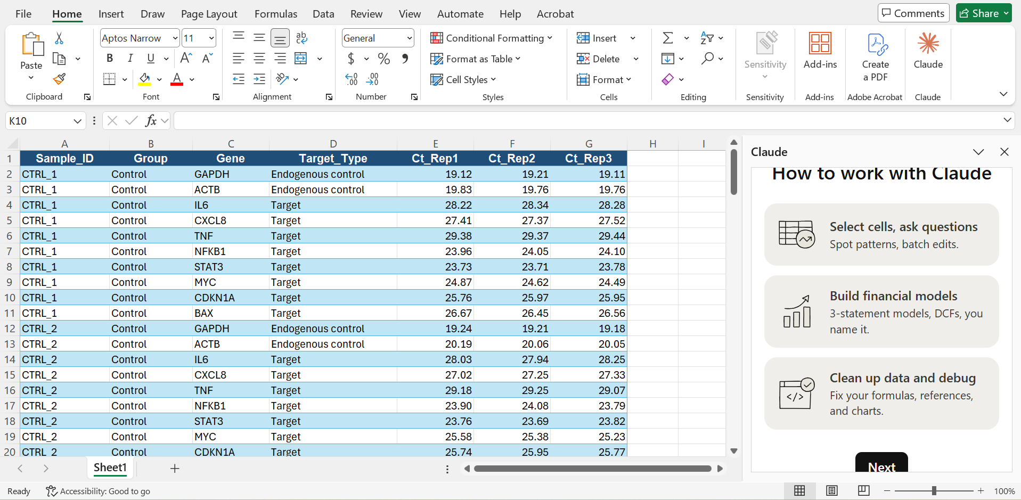
The Claude panel open alongside a worksheet in Excel.

3. Personalize Claude (one-time setup)
☐ Choose the role that matches your work — e.g. Scientist — so Claude tailors its suggestions and defaults accordingly.

☐ Browse connectors if you want Claude pulling data directly from another source instead of a pasted sheet.

☐ Check the Skills panel (Discover tab) for ready-made or saved workflows — useful once you've saved your qPCR pipeline as a skill (see Tips).
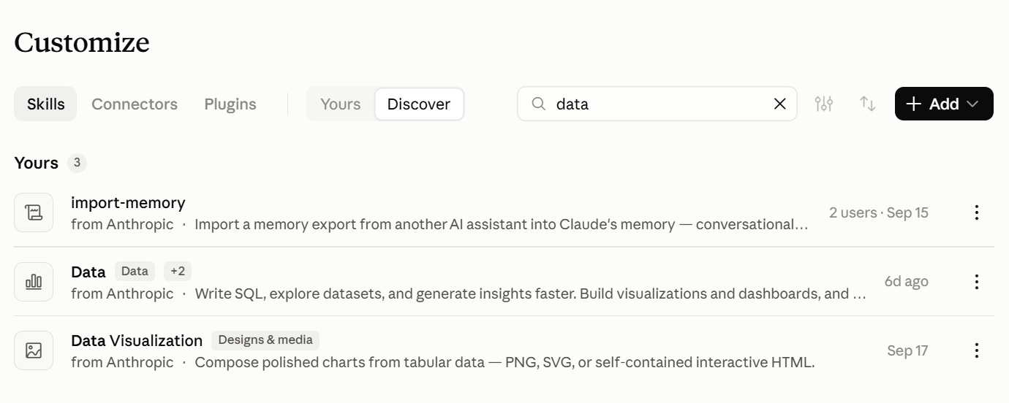
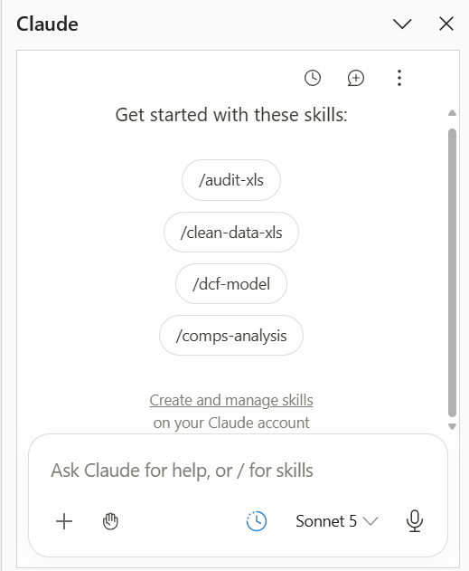
Slash-command skills suggested inside the chat box.

4. Prepare Your Data
☐ Lay out your raw Ct data with clear columns: Sample_ID, Group, Gene, Target_Type (Target vs Endogenous control), and one column per technical replicate.
Copy this header row as a starting point:
Sample_ID | Group | Gene | Target_Type | Ct_Rep1 | Ct_Rep2 | Ct_Rep3
CTRL_1 | Control | GAPDH | Endogenous control | 19.12 | 19.21 | 19.11
CTRL_1 | Control | IL6 | Target | 28.22 | 28.34 | 28.28
… | … | … | … | … | … | …
Include at least one endogenous control gene (ideally two) alongside your target genes, and give every technical replicate its own column.

5. Ask Claude to Analyze Your Data
☐ With that sheet open, describe what you want in plain language.
Example prompt
I have a qPCR data with targets and endogenous control. Can you do the analysis with relevant statistical package and provide me with the data and the figures in publication quality.

☐ Claude reads the raw data first, then proposes a full analysis plan for you to confirm before it touches your workbook — typically covering:
- Averaging technical replicates per sample/gene
- A normalization factor from the geometric mean of your endogenous controls
- The ΔΔCt method to get fold change per target gene
- A statistical test (e.g. Welch’s t-test) with a multiple-comparison correction across all genes
- A new Analysis sheet with traceable formulas, a Results summary table, and a native Excel chart
☐ Reply to steer any step — for example, asking for a non-parametric Mann-Whitney or Wilcoxon test instead of a t-test if your data doesn’t meet t-test assumptions.
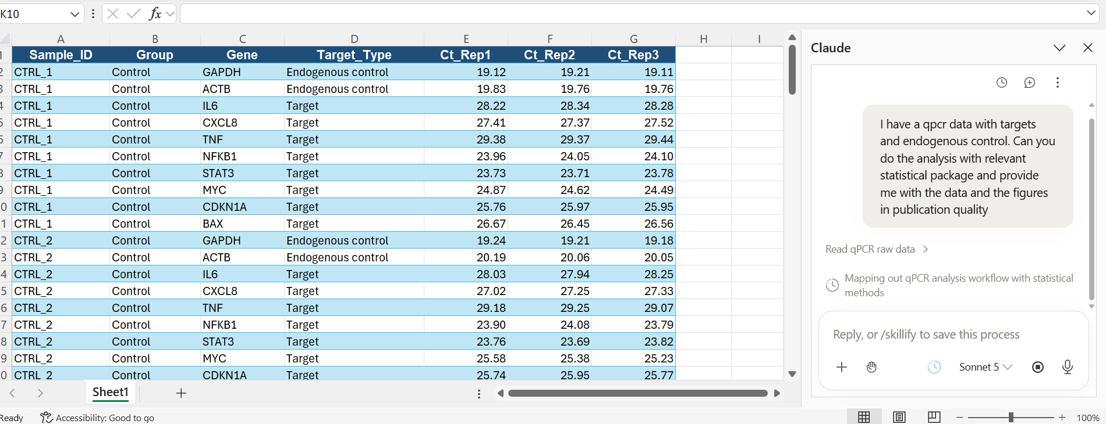
Sending the analysis request to Claude from the chat panel.
☐ When Claude is ready to write to your sheet, it asks for permission first. Choose “Allow once” to approve a single edit, or “Always allow” to let it continue for the rest of the session.
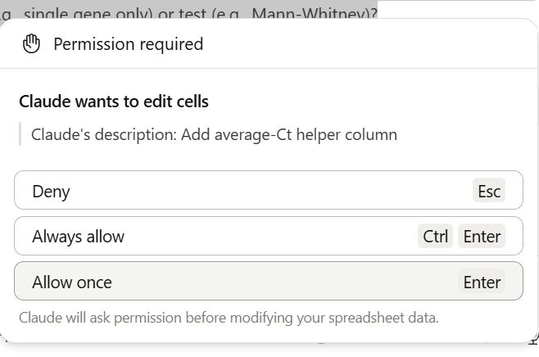
Claude asks for permission before editing any cells.

6. Review What Claude Built
Once the analysis finishes, Claude summarizes exactly what changed in the workbook — nothing is hidden or hardcoded:
- Sheet1 — an added helper column with the average Ct across technical replicates
- Analysis — the full ΔΔCt pipeline: average Ct per sample, geometric-mean reference Ct, ΔCt, and fold change, all as live formulas
- Results — the per-gene statistical test with a false-discovery-rate correction across genes, plus mean fold change ± SEM per group
- Two charts on the Results sheet, built as native Excel charts
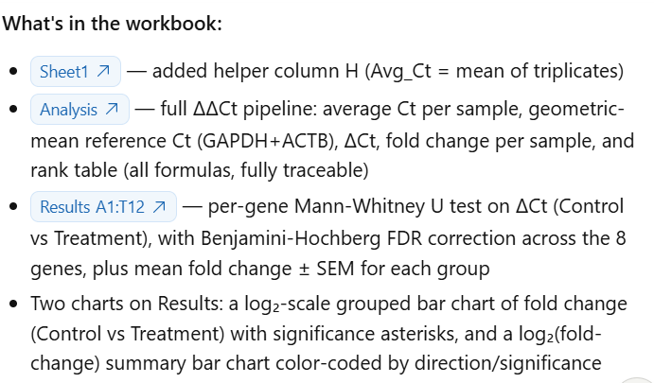
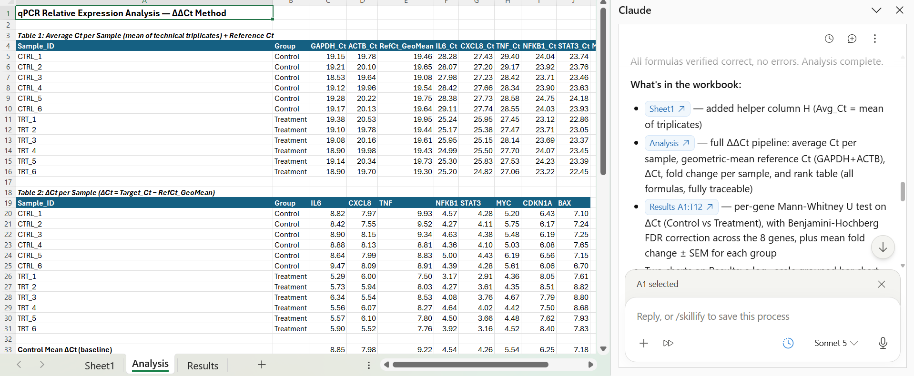
The Analysis sheet: average Ct and ΔCt tables with fully traceable formulas.

7. Publication-Ready Figures
The Results sheet includes native Excel charts — ready to copy straight into a manuscript, poster, or slide deck — with significance markers already placed over each gene.
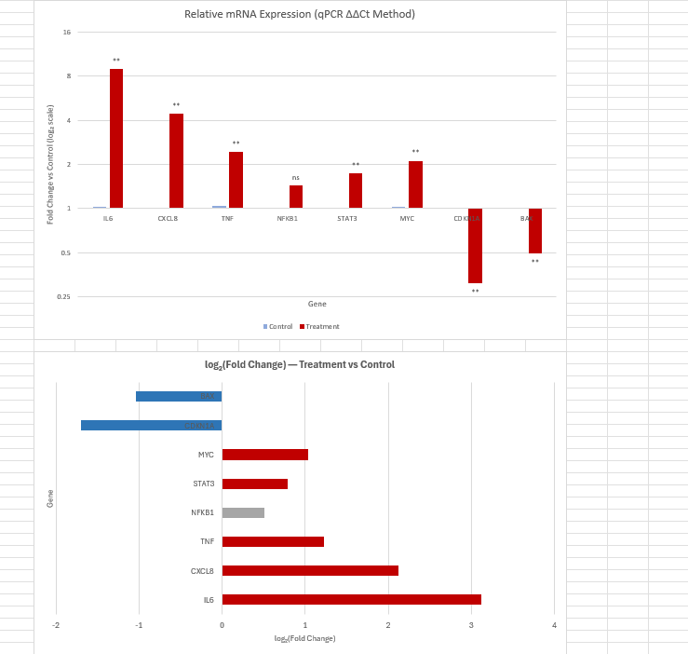
Fold-change bar chart (log₂ scale) with significance asterisks, generated automatically.

Quick Reference: The ΔΔCt Workflow
Step | What it does
Average replicates | Mean of Ct_Rep1–Rep3 per sample and gene
Reference Ct | Geometric mean of the endogenous controls (e.g. GAPDH + ACTB)
ΔCt | Ct(target) − Ct(reference)
ΔΔCt | ΔCt(sample) − mean ΔCt(Control group)
Fold change | 2^(−ΔΔCt)
Statistical test | Welch’s t-test, or Mann-Whitney / Wilcoxon on ΔCt (Control vs Treatment)
Multiple-comparison correction | Benjamini-Hochberg FDR across all genes tested
Output | Results table plus an annotated, publication-style bar chart

Troubleshooting
• Don't see the Claude icon in Excel — go to Home > Add-ins (Windows) or Insert > My Add-ins (Mac), then Refresh. Confirm you're signed in to Office with the same account used to install the add-in.
• Signed in but nothing loads — check your Claude plan — the Excel add-in needs Pro, Max, Team, or Enterprise; it isn't included on the Free plan.
• IT has disabled the Office Store — ask your admin to enable it in the Microsoft 365 Admin Center, or have them deploy the add-in directly to your account.
• Permission popup doesn't appear — it can load behind the Claude panel — check for a banner near the formula bar, or scroll up inside the panel.
• Claude's plan doesn't match your dataset — just describe what's different (e.g. only one reference gene, paired samples) and ask it to revise the plan before it edits anything.
• Numbers look different from what you expected — click into any result cell — every value is a live formula, so you can trace exactly how it was calculated.

Tips
- Type /skillify after a successful run to save the whole pipeline as a reusable skill for your next qPCR dataset.
- Ask Claude to switch statistical tests (paired vs unpaired, parametric vs non-parametric) if your experimental design calls for it.
- Prefer “Allow once” over “Always allow” on a new workbook until you're comfortable with what Claude is changing.
- Set your role to Scientist and connect any relevant data connectors up front so Claude's defaults match your workflow.

