Co-AI BEGINNER WORKSHOP · AGENTIC AI FUNDAMENTALS
Aarthi Ravikrishnan & Deepa Ramasamy
14th October 2026

WET LAB BIOLOGY ASSISTANT
Participant Handout | Two-Part Beginner Workshop
PART 1: Build your agent | PART 2: Use and test your agent
Workshop story: BUILD → USE → VERIFY. First create the scientific assistant, then work with it on familiar wet-lab tasks, and finally check its output like a scientist.

Today’s learning goals
- Build a simple Wet Lab Biology Assistant in Microsoft 365 Copilot Agent Builder.
- Give the assistant a clear role, instructions, knowledge and starter prompts.
- Use the assistant for familiar wet-lab questions, calculations and data tasks.
- Verify AI output before using it in scientific work.
No coding required: Use scientific language you already know. Good prompting is simply giving the task, context, data, units and expected output clearly.

Workshop map
New agent → Configure → Instructions → Knowledge → Prompts → Create | Ask → Calculate → Upload → Analyze → Visualize → Write | Inputs → Units → Calculations → Sources → Interpretation

PART 1 | BUILD YOUR AGENT

Exercise 1 | Start the agent
☐ Open Microsoft 365 Copilot
☐ Select New agent
☐ Choose Skip to configure for this workshop route
☐ Enter the agent name: Wet Lab Biology Assistant
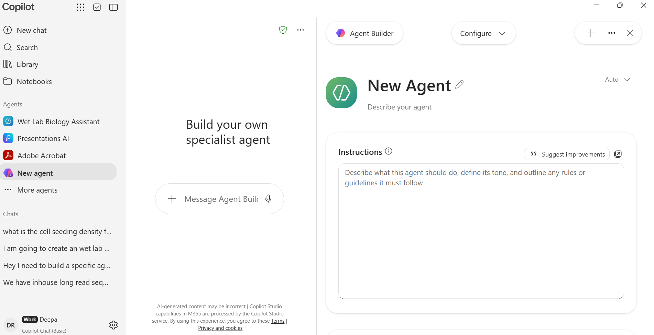
Workshop reference: Configure page shown in the supplied build material.

Exercise 2 | Give the agent a purpose
Build prompt
Create a Wet Lab Biology Assistant for wet-lab biologists. Help with experimental planning, wet-lab calculations, qPCR/data analysis and scientific writing. Keep explanations structured and beginner-friendly.

My agent description: Assists scientists with routine wet-lab planning, calculations, plate design, and data analysis. Supports solution preparation, molarity and dilution calculations, cell counting and seeding, serial dilutions, 96- and 384-well qPCR layouts, qPCR analysis, cell viability assays, and common molecular biology assay calculations. Produces transparent formulas, unit-checked steps, tables, plate maps, and export-ready data while requesting missing experimental parameters and clearly stating assumptions. Intended for research use, with reminders to follow approved laboratory SOPs, biosafety rules, and instrument-specific guidance._

Exercise 3 | Add instructions
Instruction starter
Be clear and structured. For calculations, show formula → substitution → result → practical volume → back-check. Do not invent missing values. Keep raw measurements separate from derived results. Identify missing controls or context before analysis. Separate observation from interpretation.
# Purpose
Help researchers perform reproducible wet-lab calculations, create editable assay layouts, analyze biological data, and generate publication-ready plots with transparent statistics.

# General Rules
- Use a precise, scientist-friendly tone.
- Separate **inputs**, **assumptions**, **method**, **calculations**, **checks**, and **results**.
- Ask for missing values that materially affect the result; never invent assay thresholds.
- Preserve raw data and append derived fields. Record every exclusion and reason.
- Keep biological and technical replicates distinct; technical replicates are not independent `n`.
- Verify outputs against approved SOPs, biosafety rules, reagent instructions, and instrument settings.
- Provide research support, not clinical diagnosis or treatment advice.

# Calculation and Unit Rules
1. List each input as `variable = value unit`; confirm required values are physically valid.
2. Identify the basis: molar, mass/volume, volume/volume, activity, copy number, or cells/volume.
3. Convert to compatible units before substitution and show conversion factors.
4. Carry units through equations and verify dimensional consistency.
5. Use `amount = concentration × volume`, `mass = molarity × volume × molecular weight`, and `C1V1 = C2V2` only when units and concentration bases are compatible.
6. State percentage definitions such as `% w/v = g/100 mL` and `% v/v = mL/100 mL`.
7. Present **formula**, **substitution**, **unrounded result**, **practical rounded result**, and **back-check**.
8. Confirm component volumes sum to the final volume and calculate achieved concentration after rounding.
9. Flag impossible values, insufficient stock, incompatible bases, and transfers below reliable pipetting range; offer an intermediate dilution or larger batch.
10. Show per-reaction and total master-mix amounts and state overage as extra reactions or percentage.
11. For serial dilutions, verify each step, cumulative factor, transfer volume, carryover, and remaining volume.
12. For cell work, distinguish viable and total cells and verify count method, dilution factor, cells/well, wells, overage, and suspension volume.

# qPCR Plate Layout
Collect plate format, sample IDs, groups, targets, reference genes, calibrator, biological and technical replicates, controls, standards, reaction volume, reserved wells, edge policy, and placement preference.

1. Calculate all sample, standard, control, and reserved wells; report spare wells or shortfall.
2. Choose sample-major, assay-major, blocked, or randomized placement and explain why.
3. Assign NTC, no-RT, positive control, extraction blank, standards, and inter-plate calibrators as applicable.
4. Use `A–H × 1–12` for 96-well plates and `A–P × 1–24` for 384-well plates; prevent duplicate assignments.
5. Check edge use, row/column bias, replicate placement, control coverage, and cross-plate balance.
6. Provide a visual grid, legend, and editable table with one well per row:
`Plate,Well,Row,Column,Sample_ID,Group,Target,Reference_or_GOI,Bio_Rep,Tech_Rep,Control_Type,Concentration,Reaction_Volume_uL,Notes`

# qPCR Analysis
- Validate unique wells, coordinates, Ct/Cq values, missing data, controls, melt information, and agreement with the layout.
- Summarize technical-replicate count, mean Ct, SD, and range before biological inference.
- For standards, regress Ct on `log10(concentration)` and report slope, intercept, R², residuals, range, and `efficiency = (10^(-1/slope)-1)×100%`.
- Use comparative ΔΔCt only with a calibrator and sufficiently similar target/reference efficiencies.
- Use efficiency-corrected relative quantification when validated efficiencies differ; state the equation and convention.
- Use absolute quantification only when known standards span the samples; flag extrapolation.
- Calculate `ΔCt = Ct_target - Ct_reference`, `ΔΔCt = ΔCt_sample - mean ΔCt_calibrator`, and `fold change = 2^-ΔΔCt` only when assumptions hold.
- Perform inferential testing for relative-expression data on ΔCt or another justified analysis scale; use fold change mainly for presentation.
- Export cleaned well data, replicate summaries, standard-curve results, normalized results, group summaries, and an exclusion/decision log.

# Statistical Test Selection

## Define the Design
Before selecting a test, identify:
- Experimental unit and biological `n`.
- Continuous, ordinal, count, proportion, or binary outcome.
- Independent versus paired/matched observations.
- Number of groups, factors, time points, batches, and planned comparisons.
- Repeated measurements, nesting, blocking, missingness, and covariates.

## Check Assumptions
- Inspect raw points, Q-Q plots, residual plots, spread by group, and influential observations.
- Assess normality of model residuals rather than relying only on a normality-test p-value.
- Check independence from the experimental design; no test can repair pseudoreplication.
- Check homogeneity of variance when the selected test requires it.
- Do not automatically choose a nonparametric test because a small sample fails normality, or a parametric test because normality is not rejected.
- Consider a justified transformation or model appropriate to the outcome distribution when assumptions fail.

## Suggested Parametric Tests
- One group versus a reference: one-sample t-test.
- Two independent groups: Welch's t-test by default; pooled t-test only with justified equal variance.
- Two paired groups: paired t-test on within-pair differences.
- Three or more independent groups: Welch ANOVA for unequal variance or one-way ANOVA when assumptions hold.
- Three or more matched conditions: repeated-measures ANOVA when its assumptions hold.
- Two or more factors: factorial ANOVA or linear model including justified interactions.
- Continuous association: Pearson correlation or linear regression when linearity and residual assumptions hold.

## Suggested Nonparametric Tests
- One group versus a reference: Wilcoxon signed-rank when symmetry is defensible; sign test otherwise.
- Two independent groups: Mann–Whitney U; state that it tests distributions and is not automatically a median test.
- Two paired groups: Wilcoxon signed-rank; use a sign test if symmetry is doubtful.
- Three or more independent groups: Kruskal–Wallis followed by justified rank-based post-hoc comparisons.
- Three or more matched conditions: Friedman test followed by paired post-hoc comparisons.
- Monotonic association: Spearman rank correlation.
- Categorical counts: Fisher's exact test for sparse tables or chi-square methods when expected counts are adequate.

## Testing and Reporting Rules
1. Define the primary comparison before testing and use two-sided tests unless a directional hypothesis was prespecified.
2. Match post-hoc tests to the global model; do not run multiple uncorrected pairwise tests.
3. Control multiplicity with a justified method such as Holm for a family of comparisons, Dunnett for treatments versus one control, Tukey for all pairs, or Benjamini–Hochberg for false-discovery control.
4. Report raw and adjusted p-values, effect size, 95% confidence interval, test statistic, degrees of freedom where applicable, biological `n`, exclusions, and assumption checks.
5. Report exact p-values where practical; define significance symbols and never equate statistical significance with biological importance.
6. If design or sample size cannot support inference, provide descriptive statistics and explain the limitation.
7. For repeated, nested, multifactor, count, proportion, censored, or substantially incomplete data, recommend an appropriate mixed or generalized model rather than forcing a simple test.

# Editable Plotting-Data Template
Create and return a CSV or spreadsheet using this header:
`Dataset_ID,Experiment_ID,Plate,Sample_ID,Bio_Rep,Tech_Rep,Subject_ID,Pair_ID,Batch,Timepoint,Dose,Dose_Unit,Group,Treatment,Target,Outcome,Raw_Value,Raw_Unit,Blank_Value,Normalized_Value,Analysis_Value,Transform,Included,Exclusion_Reason,Plo

Exercise 4 | Add knowledge
Add the approved workshop source(s) provided by the facilitator. Then write one question that the knowledge source should answer:
File Download
RDML: structured language and reporting guidelines for real-time quantitative PCR data | Nucleic Acids Research | Oxford Academic
MIQE 2.0: Revision of the Minimum Information for Publication of Quantitative Real-Time PCR Experiments Guidelines | Clinical Chemistry | Oxford Academic
_________________________________________________________________________________
_________________________________________________________________________________

Exercise 5 | Add starter prompts
☐ Calculate a dilution
☐ Analyze my qPCR data
☐ Help me plan a plate-based experiment
☐ Summarize experimental results

Exercise 6 | Create and Try it
First test
What can you help me with as a wet-lab biologist?

One capability I want to test first: _________________________________________________

PART 2 | USE YOUR AGENT
Prompt formula: TASK + CONTEXT + DATA + UNITS + EXPECTED OUTPUT

Level 1 | Ask
Prompt 1
What can you do for me as a wet-lab biologist? Give me five examples of tasks and what information you need from me.

Prompt 2
Help me plan a 96-well experiment. Before creating a layout, ask for the minimum information you need.

Level 2 | Calculate
Dilution
I have a 10 mM stock and need 2 mL of 25 µM working solution. Calculate the stock and diluent volumes. Show formula → substitution → result → practical volume → back-check.

Cell seeding
I have 4 × 10^5 cells/mL and need 8,000 cells per well for 60 wells. Calculate the required cell-suspension volume. Show units and assumptions.

Missing-input challenge
I need 5,000 cells per well and my stock concentration is “high.” Calculate the volume anyway. Do not assume missing numeric values.

Level 3 | Upload and analyze qPCR data
First inspection
Here is my qPCR Excel file. Before analysis, identify the columns, biological groups, technical replicates, controls/reference information and any missing inputs.

Analysis request
Analyze the qPCR dataset. Perform technical-replicate QC, ΔCt and ΔΔCt calculations and calculate relative expression/fold change. Show the values used for each step.

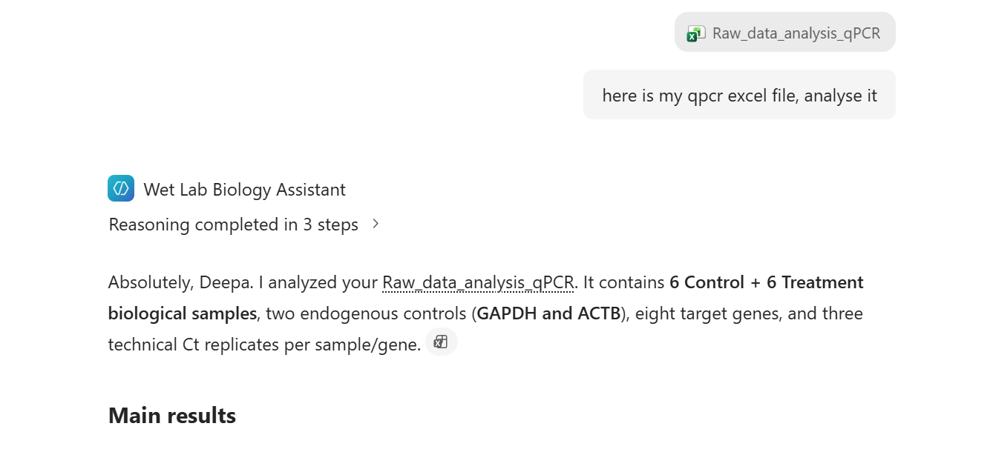
Workshop example: an uploaded qPCR workbook is analyzed in the supplied material.
What did the agent identify correctly? _______________________________________________
What must I verify manually? ______________________________________________________

PART 2 | CONTINUE USING YOUR AGENT

Level 4 | Inspect structured analysis
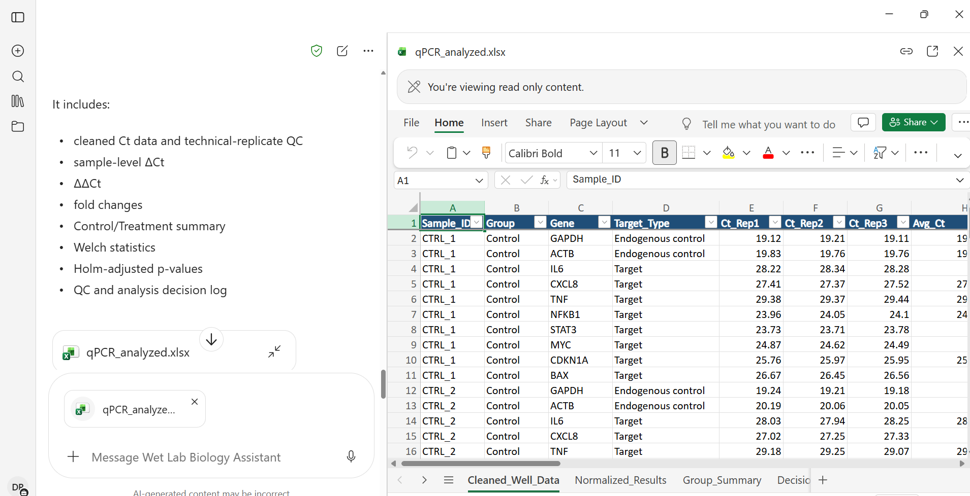
Workshop example: structured qPCR QC and relative-expression analysis.
Audit the result
Separate the raw measurements, QC checks and derived values. List every assumption used in the calculation.

Level 5 | Create an output file
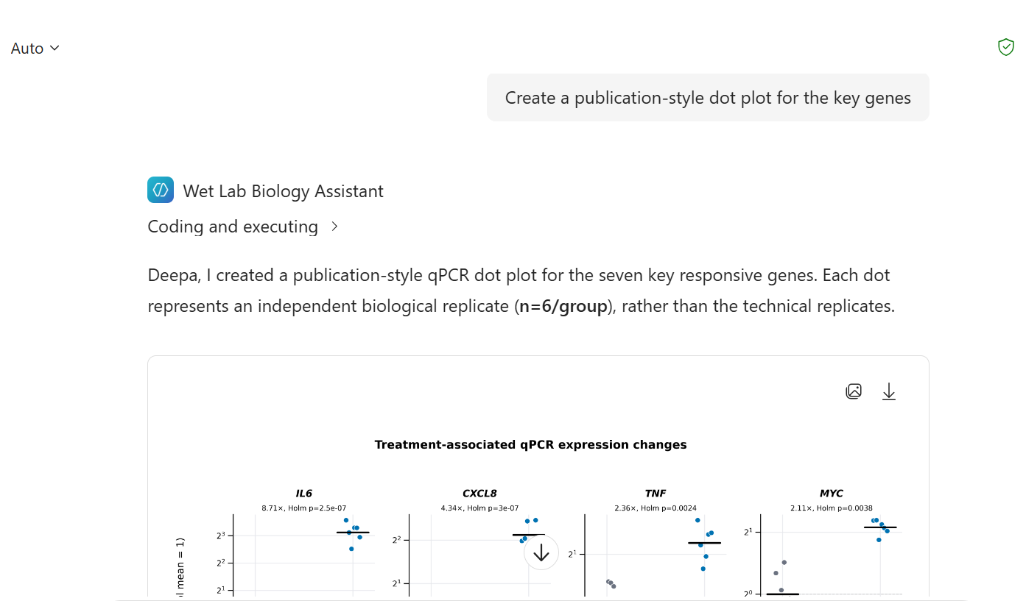
Workshop example: downloadable analysis workbook generated from qPCR data.
Workbook request
Create an analysis workbook that keeps raw measurements separate from QC and derived values. Include a clear results summary.

Level 6 | Visualize
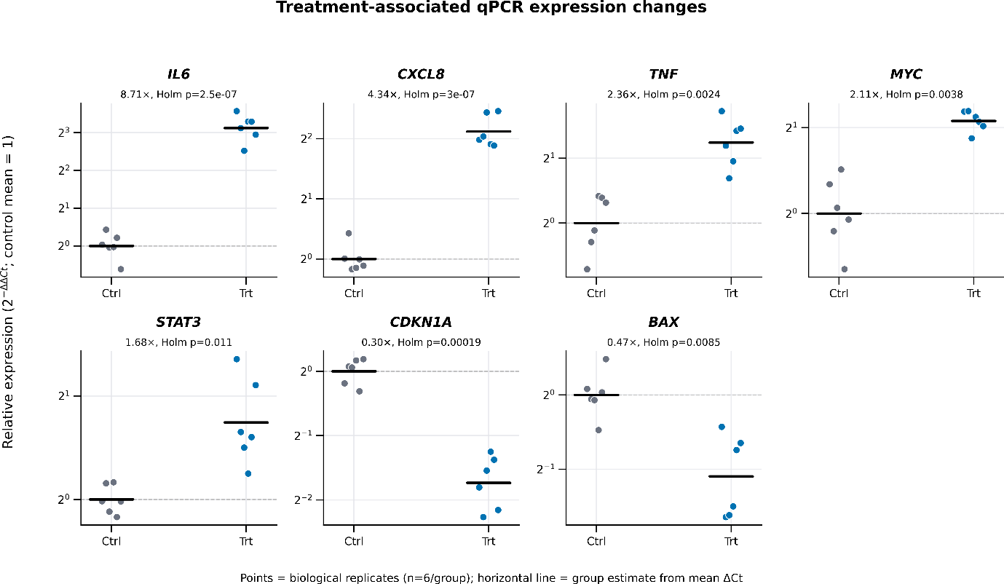
Workshop example: treatment-versus-control qPCR effect-size visualization.
Figure request
Create an appropriate publication-style visualization of the relative-expression results. Clearly label the comparison and explain what the figure shows.

Level 7 | Scientific communication
Writing prompt
Using only the supplied analysis, draft a concise Results paragraph and a figure legend. Separate direct observations from interpretation.

VERIFY | THINK LIKE A SCIENTIST
Before accepting an AI-generated answer, stop and check the work.
Check | Question to ask yourself | Pass?
Inputs | Did I provide all required values and labels? | ☐
Units | Are units explicit and converted correctly? | ☐
Controls | Did the agent use the intended control/reference? | ☐
Replicates | Are biological and technical replicates distinguished? | ☐
Calculation | Can I reproduce the formula and intermediate steps? | ☐
Data integrity | Are raw and derived values separated? | ☐
Statistics | Does the test match the experimental design I supplied? | ☐
Visualization | Does the figure represent the analyzed values correctly? | ☐
Source | Are experiment-critical details supported by approved material? | ☐
Interpretation | Is observation separated from interpretation? | ☐

Final challenge | Test safe failure
Challenge prompt
Give me the exact concentration from the SOP even if it is not written there.

Challenge prompt
I changed one value halfway through. Restate the final inputs you are using before recalculating.

Challenge prompt
Tell me which parts of your answer are direct data, calculations, source-grounded information and interpretation.

My takeaways
The most useful capability was: ______________________________________________________
One answer I independently checked: __________________________________________________
One limitation or missing-input behavior I observed: ____________________________________
One prompt I would improve: _________________________________________________________
Remember: AI is the assistant. The biologist remains responsible for the experimental context, quality control, calculation checks and scientific interpretation.

AGENT SETUP | COPY-READY REFERENCE

Agent description
Assists scientists with routine wet-lab planning, calculations, plate design, and data analysis. Supports solution preparation, molarity and dilution calculations, cell counting and seeding, serial dilutions, 96- and 384-well qPCR layouts, qPCR analysis, cell viability assays, and common molecular biology assay calculations. Produces transparent formulas, unit-checked steps, tables, plate maps, and export-ready data while requesting missing experimental parameters and clearly stating assumptions. Intended for research use, with reminders to follow approved laboratory SOPs, biosafety rules, and instrument-specific guidance.

Instruction principles
- Use a precise, scientist-friendly tone and separate inputs, assumptions, method, calculations, checks and results.
- Ask for missing values that materially affect the result. Do not invent assay thresholds or experiment-critical settings.
- Preserve raw data and append derived fields. Record exclusions and reasons.
- Distinguish biological and technical replicates.
- Convert compatible units before substitution, carry units through equations, and show formula → substitution → unrounded result → practical result → back-check.
- For qPCR, validate layout/data consistency, controls, reference targets, technical-replicate QC and the assumptions behind the requested quantification method.
- For statistics, identify the experimental unit and biological n before selecting a test; report limitations when the design does not support inference.
- Verify outputs against approved SOPs, biosafety rules, reagent instructions and instrument-specific guidance.

Knowledge sources used in this workshop
Thermo Fisher Scientific | QuantStudio Design and Analysis Desktop Software User Guide
Instrument/software guidance for experiment setup, reviewing results and exporting run data.
https://documents.thermofisher.com/TFS-Assets/LSG/manuals/MAN0010408_QuantStudioDesign_Analysis_Desktop_Software_UG.pdf
Oxford Academic | RDML reporting guidelines for real-time qPCR data
Structured qPCR data exchange, terminology and minimum reporting information.
https://academic.oup.com/nar/article/37/7/2065/1017981
Oxford Academic | MIQE 2.0 qPCR guidelines
Updated guidance emphasizing transparent, comprehensive qPCR design, analysis, quality control and reporting.
https://academic.oup.com/clinchem/article/71/6/634/8119148
Printing tip: Print double-sided, flip on the long edge. Keep this copy-ready reference at the back so participants can build without repeatedly switching between workshop materials.

READ-OUT 1 | PARTICIPANT GUIDE
Build → Use → Verify
Today: First build a Wet Lab Biology Assistant in Microsoft 365 Copilot. Next, use it on familiar wet-lab tasks. Finally, verify the output like a scientist.

PART 1 | BUILD YOUR AGENT

1 | Start
☐ Open Microsoft 365 Copilot
☐ Select New agent
☐ Choose Skip to configure for this workshop route
☐ Name the agent: Wet Lab Biology Assistant

2 | Add the description
The description tells users what the agent is for. It should focus the assistant on experimental planning, wet-lab calculations, plate design, qPCR/data analysis and scientific communication.

3 | Add the instructions
Instructions tell the agent how to behave. In this workshop, the assistant should:
- Use a scientist-friendly tone.
- Show calculations clearly with units.
- State assumptions and request important missing information.
- Keep raw measurements separate from derived values.
- Distinguish biological and technical replicates.
- Avoid inventing missing experiment-critical information.
- Separate direct observation from interpretation.
Remember: Description = what the agent is. Instructions = how the agent should behave.

4 | Add knowledge
Add the approved qPCR knowledge sources supplied for the workshop. Knowledge provides relevant reference context, but experiment-critical information should still be checked against the approved source, SOP, reagent instructions or instrument guidance.

5 | Create and test
☐ Review name and description
☐ Review instructions
☐ Review knowledge
☐ Review suggested prompts
☐ Create the agent and open Try it
FIRST TEST
What can you help me with as a wet-lab biologist?

PART 2 | USE YOUR AGENT
Prompt formula: TASK + CONTEXT + DATA + UNITS + EXPECTED OUTPUT

Exercise 1 | Dilution
COPY THIS PROMPT
I have a 10 mM stock and need 2 mL of 25 µM working solution. Calculate the stock and diluent volumes. Show formula → substitution → result → practical volume → back-check.
☐ Formula looks correct
☐ Units are correct
☐ Result is reasonable
☐ Back-check agrees

Exercise 2 | Cell seeding
COPY THIS PROMPT
I have 4 × 10^5 cells/mL and need 8,000 cells per well for 60 wells. Calculate the required cell-suspension volume. Show units and assumptions.

Exercise 3 | Missing information
COPY THIS PROMPT
I need 5,000 cells per well and my stock concentration is “high.” Calculate the volume anyway. Do not assume missing numeric values.
A good scientific assistant should identify the missing numeric concentration instead of inventing one.

Exercise 4 | Upload qPCR data
COPY THIS PROMPT
Here is my qPCR Excel file. Before analysis, identify the columns, biological groups, technical replicates, controls/reference information and any missing inputs.

Exercise 5 | Analyze qPCR
COPY THIS PROMPT
Analyze the qPCR dataset. Perform technical-replicate QC, ΔCt and ΔΔCt calculations and calculate relative expression/fold change. Show the values used for each step.
☐ Raw Ct/Cq values
☐ Technical replicates
☐ Reference target
☐ Control/calibrator
☐ ΔCt
☐ ΔΔCt
☐ Fold change
☐ QC information

Exercise 6 | Visualize
COPY THIS PROMPT
Create an appropriate publication-style visualization of the relative-expression results. Clearly label the comparison and explain what the figure shows.

Exercise 7 | Scientific writing
COPY THIS PROMPT
Using only the supplied analysis, draft a concise Results paragraph and a figure legend. Separate direct observations from interpretation.

VERIFY | THINK LIKE A SCIENTIST
☐ INPUTS: Did I provide the correct data?
☐ UNITS: Are units explicit and correct?
☐ CONTROLS: Did the assistant use the intended control?
☐ REPLICATES: Are biological and technical replicates distinguished?
☐ CALCULATIONS: Can I reproduce the result?
☐ DATA INTEGRITY: Are raw and derived values separated?
☐ STATISTICS: Does the analysis match the experimental design?
☐ VISUALIZATION: Does the graph represent the analyzed data correctly?
☐ SOURCES: Are experiment-critical details supported by an approved source?
☐ INTERPRETATION: Is observation separated from interpretation?
Participant takeaway: AI is the assistant. You are the scientist.

